Thursday 23rd April 2020
SPaG
Spellings - The prefix im before a root word starting with m or p
Practise your spellings
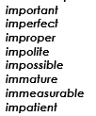
Stairsteps: Write the words as if they are stairs, adding one letter at a time. i
im
imp
impo
impol
impoli
impolit
impolite

Word of the Day – deposit

Definition ____________________________________________
_____________________________________________________
_____________________________________________________
Used it in a sentence: ____________________________________________________
_________________________________________________________________________
Word Class: ____________________________________________________
Synonyms

English - Create a comic strip of the story – example below on how you can divide your paper.
Watch the clip called ‘Once in a Lifetime’ again.
https://vimeo.com/23805703

Maths – Mental
- A netball court has a length 30m and a width 15m, what is the perimeter?
- Add 15 minutes to this time: 17:30. What might you be doing at this time of day?
- Find the answer to the Roman numerals: IX multiplied by VII.
- A rectangle is 8cm long and 4cm wide. What is the area?
- I think of a number, I subtract 7 and divide by 2, my answer is 16. What was my number?
- Calculate the number of days in December multiplied by 3.
- Find equivalent fractions to ¾ .
- Round 565 to the nearest hundred.
- What unit would you use to measure the water in a bucket?
Maths – Decimals
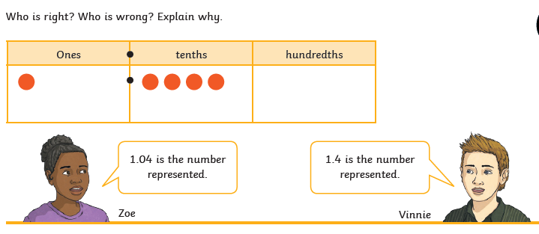

Geography
Well done you have found out lot’s about Egypt, where it is located, the key cities and its flag.
Let’s take a closer look…
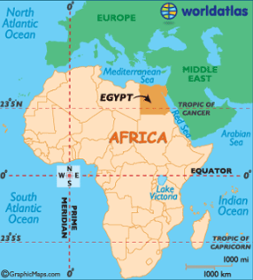
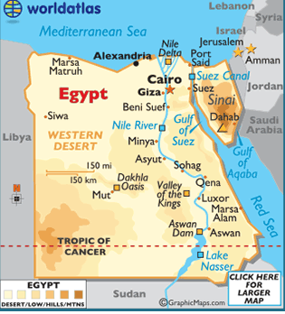
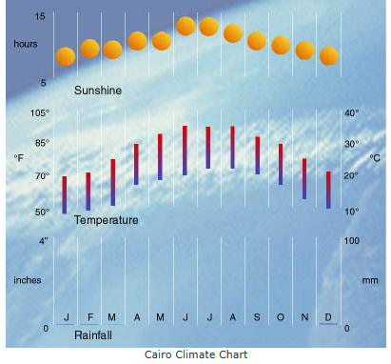
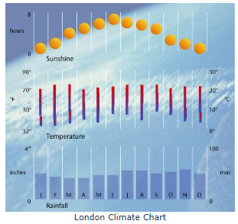

- What do you think the climate is like in Egypt? How do you know this?

- Why do you think lots of the cities are located near the river Nile?
Challenge: Compare the weather today in Ampthill compared with in Cairo

