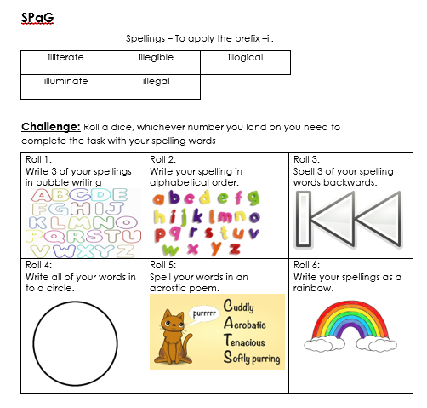

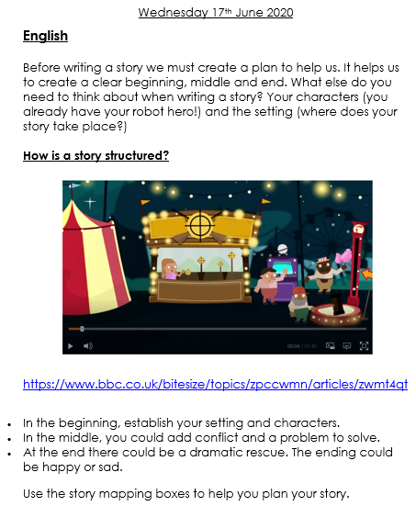

|  |  |
| --- | --- |
| **Build up**  What happens next?  How does the story hint at a problem?  **Beginning**  What happens at the beginning? Who are the main characters? Where is it set? |  |
|  |  |
| **Problem**  What is the problem within the story? |  |
| **Resolution**  How is the problem resolved/sorted out?  **Resolution**  How is this problem resolved/ sorted out?  **Resolution**  How is this problem resolved/ sorted out? |  |
| **Ending**  How does the story end?  Does it end happily? Is there a twist to the plot? |  |

