Tuesday 2nd June 2020
English
SPaG
Spellings – Suffix ly
Write each word in your spelling list backwards.

happily
angrily
gently
simply
humbly
nobly
frantically
dramatically

Word of the Day – noble

Definition ____________________________________________
_____________________________________________________
_____________________________________________________
Used it in a sentence: ____________________________________________________
_________________________________________________________________________
Word Class: ____________________________________________________
Synonyms

English – Vipers
Read the text below and then answer the Viper questions
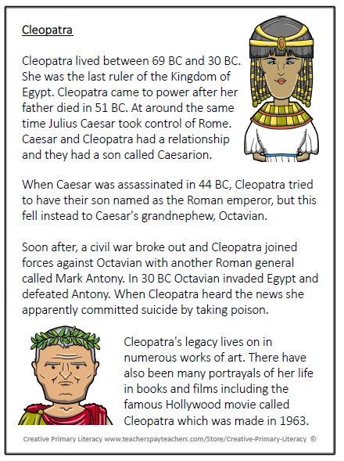

Text Title: Cleopatra
MP – What does assassinated mean?
FC – What does legacy mean?
CM – Find two words which means the same as a war between citizens of the same country.

MP/FC – How do you think Cleopatra felt when she came to power after her father died in 51 BC.

CM – What do you think Mark Antony was thinking after Cleopatra died?
MP/FC/CM – What do you think happened to Caesarion after Cleopatra’s death?
MP – Explain what happened after Octavian invaded Egypt.

FC / CM – How does Cleopatra’s legacy live on?
MP – Between what years did Cleopatra live?
FC/CM – What was the name of the famous Hollywood movie about Cleopatra and when was it made?

MP / FC – Can you summarise in two sentences Cleopatra’s life?
CM – Can you summarise why Cleopatra legacy lives on?

Maths – Main Lesson

Watch this video about equivalent fractions.
https://vimeo.com/418154572

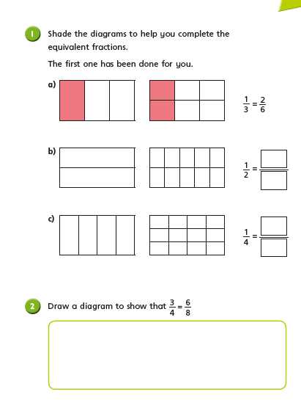

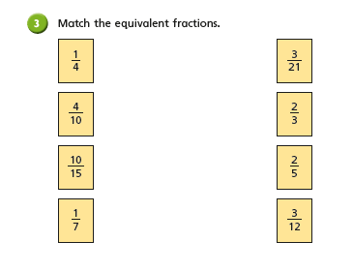

Science:
All living organisms share the characteristics of life processes (which we looked at yesterday). This is how we know they are alive! Living things have lots of other similarities, and many differences too. We can use these similarities and differences to sort the living things into groups.
Choose a way to sort these living things into two groups using the Venn diagram below. Label your groups.
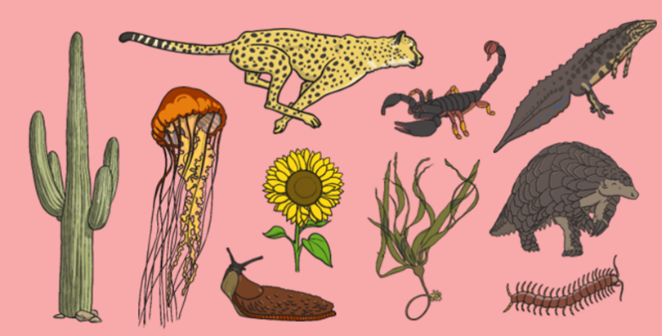

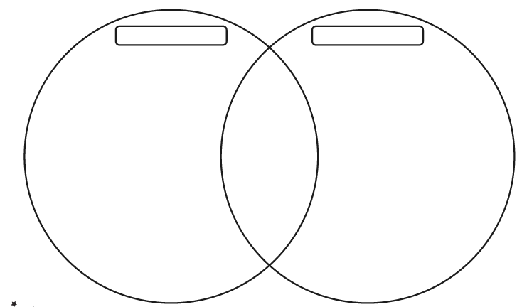

Challenge: Try this: 