Year 2 Phonics/Spelling Practice – Thursday 18.6.20.
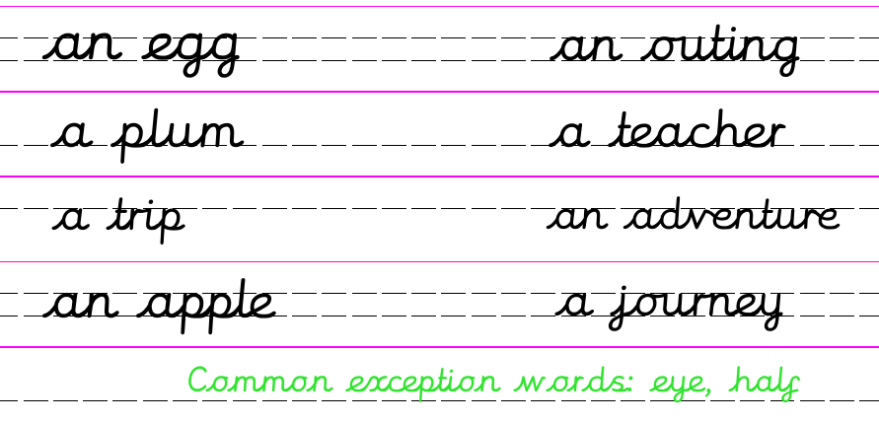
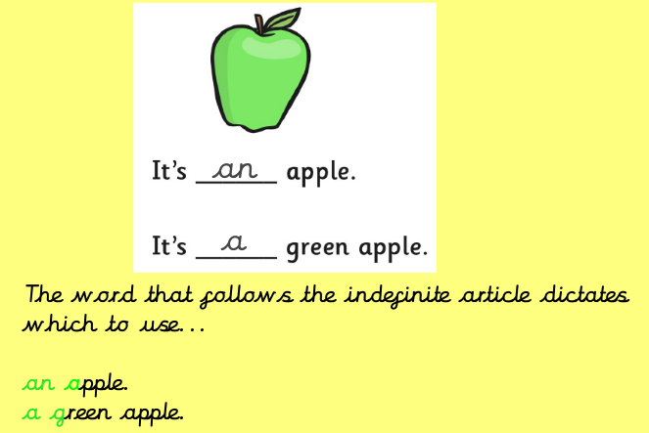
If you would like more practise make up your own sorting cards and sort them into two piles – A or An
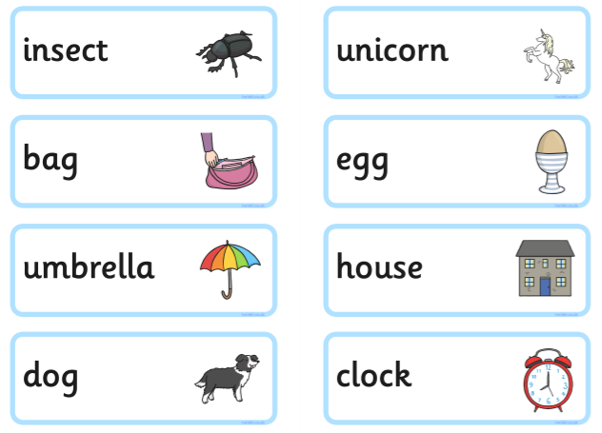
Now try these:
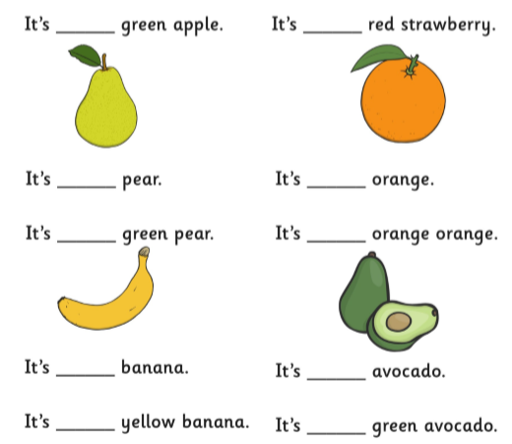

Maths 18.6.20
Find a Quarter
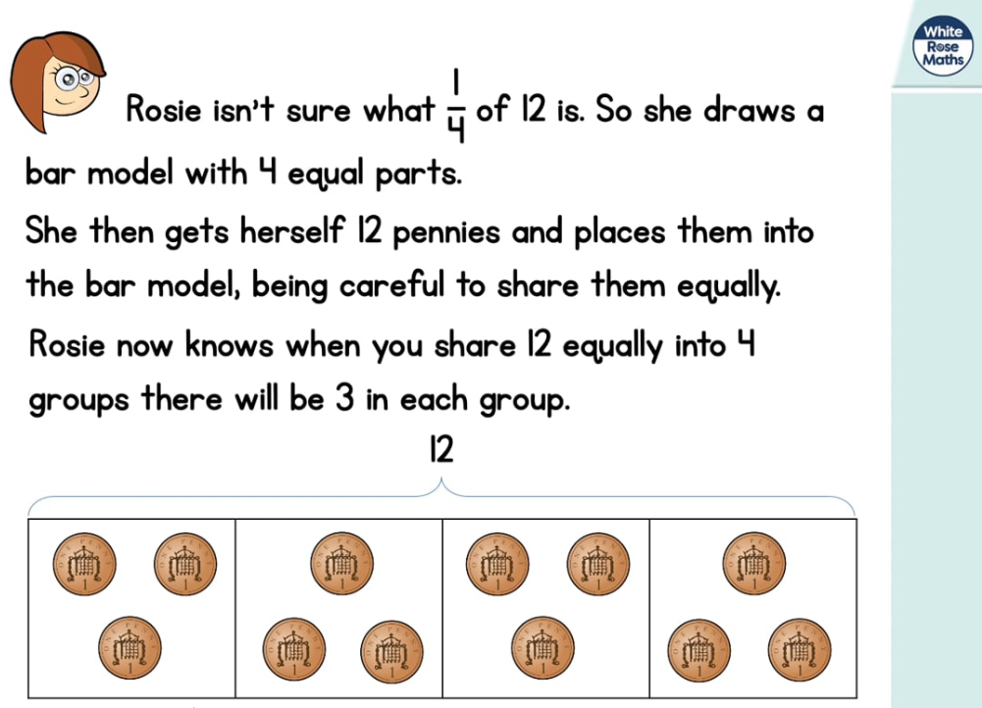
https://whiterosemaths.com/homelearning/year-2/ (Week 7 W/C 8.6.20)

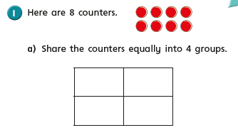
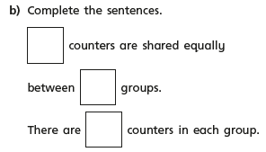

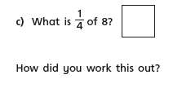

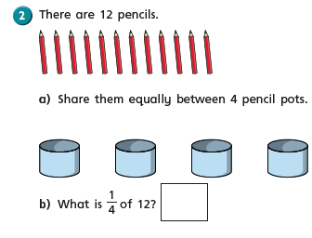
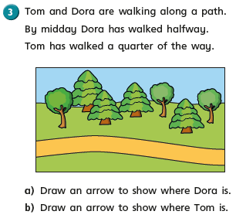

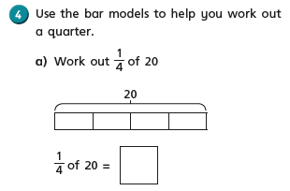
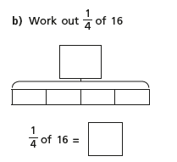
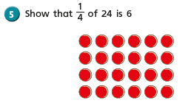
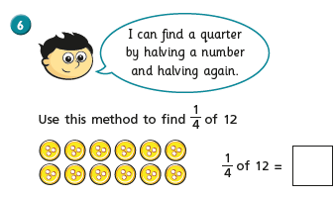
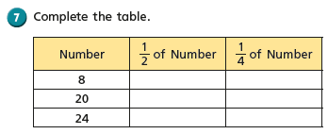
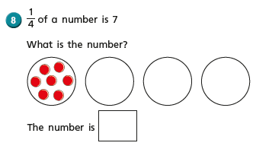

Thursday 18th June 2020 Word of the day: Renovate
WALT understand the words in the text.
I can find information in the text.

We will start today by reading a little bit more of our story.

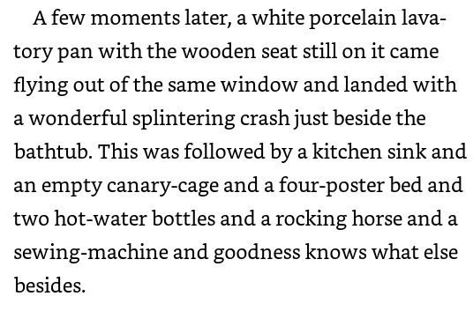
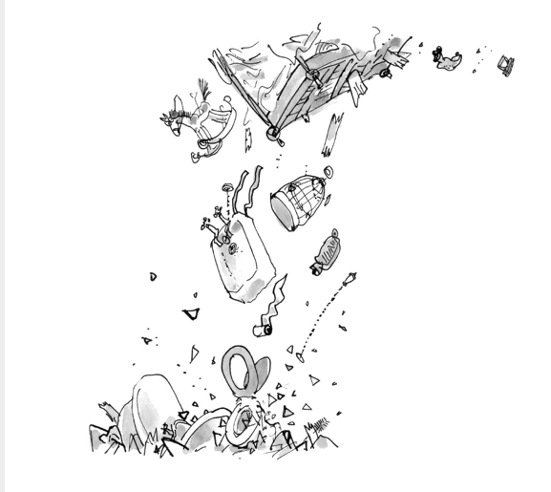

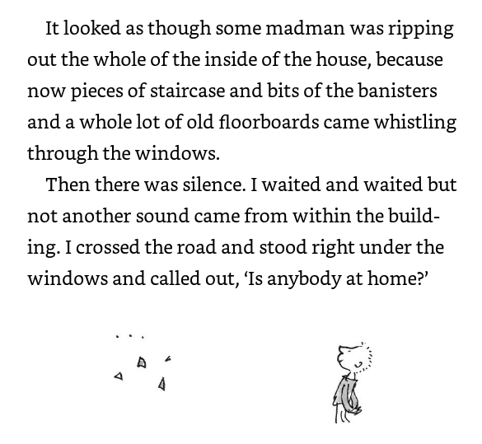
Short Task
Use a dictionary or the search engine on the computer and find out what these words mean…
splinter, rock, rip, whistle

What do you think is happening? Who is doing the throwing? Why?

Task
Draw a picture of everything that came out of the window in order, and then label it.

Extension - Think of 3 more items that could have been thrown out of the window and draw and label them too, using expanded noun phrases!

Thursday 18 June 2020
WALT make animal art out of flowers and leaves.

Last week as part of our ‘Countryside Tales’ topic you made some story stones based on Wind in the Willows. How did you get on? I have seen some photographs of some of your work and they look really good.

Today we are going to make pictures of animals using flowers and leaves. Where do you find leaves and flowers? Do they all look the same? Leaves grow on trees and other plants. They often fall off trees during the autumn months. You can find them on footpaths and in your gardens.
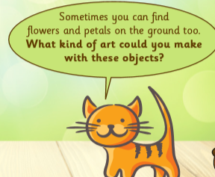 We have lots of flowers and petals in our gardens at the moment. Summer is the best time for flowers to bloom.

Some religions use flowers in their art. Do you remember making these in R.E earlier in the year? We didn’t use flowers we used coloured rice.

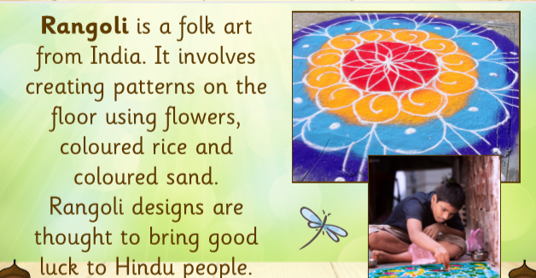

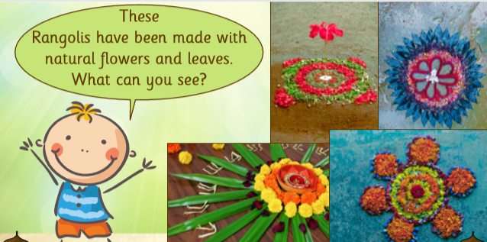
You can also create art work with leaves. Leaves have a lot of detail on them which provides natural patterns and textures. They make great art work.

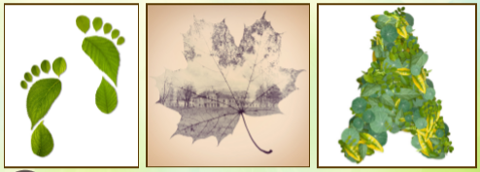

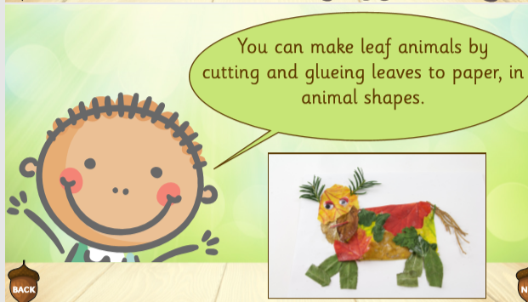

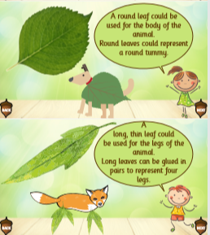

Now it is your turn. Which animal are you going to make?

