Learning Project WEEK 3 - Viewpoints
Age Range: KS1
Weekly Maths Tasks (Aim to do 1 per day) | Weekly Reading Tasks (Aim to do 1 per day)
- Working on Numbots - your child will have an individual login to access this.  - Play on The Mental Maths Train Game - practise adding, subtracting, multiplying or dividing.  - Practise counting in 2s, 5s and 10s. This game could support this.  - Look in different rooms and go on a number hunt. How many items can you find that have numbers on them? What is the largest number you can find? What is the smallest number you can find?  - Practise making shapes on this online geoboard. Once you have made the shape from one view, can you make it from another? How do you know it is still the same shape?  - Choose a number between 0 - 50. Make a poster showing how many different ways can you represent this number? | - Reading a variety of books at home. Your child could share a book everyday. This can be reading a book aloud everyday or sharing a book with an adult.  - Listen to the traditional story ‘Jack and the Beanstalk’.  - Find a set of instructions for planting a seed or a bean. Read the instructions out aloud. Can you follow the instructions and plant a seed? Remember to keep watering it!  - Read a non-fiction book  - Read an article from a newspaper or magazine to an adult.
Weekly Phonics/Spellings  Tasks (Aim to do 1 per day) | Weekly Writing Tasks (Aim to do 1 per day)
- Daily phonics - your child to practice their sounds and blend words. Interactive games found on link below.  - Phonics play  - Top Marks  - Spelling  - Spell the days of the week  - Spell common exception words  - Spelling City | - Draw a picture of your house and label it.  - Write sentences using adjectives to describe a room in your house.  - Hide and seek: Write a set of instructions on how to find something in your bedroom. Think about the positional language to help find the object.  - Diary: Keep a diary of things that happen outside one of the windows in your house. Write down sentences using suffixes. Try to use exclamation marks.  - Draw a map of one of the rooms in your house. What symbols could you have? Where will you place items?
Learning Project - to be done throughout the week: View point
The project this week aims to provide opportunities for your child to learn more about different viewpoints. Learning may focus on physical viewpoints in terms of what you can see outside of the window at home, what others can see looking into your home and then progress onto personal viewpoints and of others.

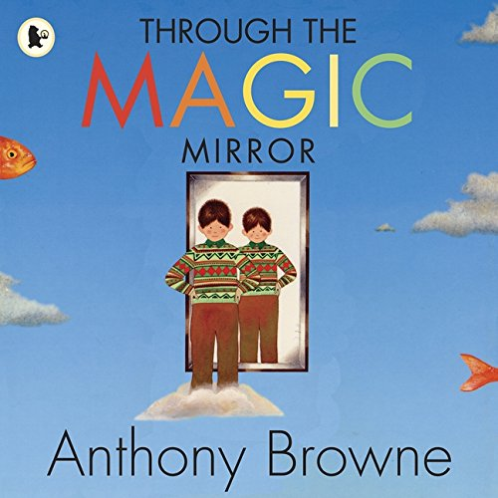
Using your senses: Ask your child to pick a window in the house. Ask them to stand there for a few minutes and take a look at what they can see and write or draw them down. Now ask them to try this activity again but this time ask them what they can hear? Write or draw these down. Ask your child to help find a piece of material in the house and then blindfold them. What can they see? Which sense do they use now? Ask them to now cover their ears and look outside the window. What do they hear?
A ‘feely bag’ - find six objects, such as a hairbrush, a tube of toothpaste, a packet of biscuits, an ice cream scoop, a packet of tissues and a wooden spoon. You will also need something to act as a blindfold. Imagine what it would be like if you could never see because you were blind and you had to learn to rely on your other senses instead. Play with a partner and see who guesses most of the objects.
Find a mirror in the house: What can they see? Imagine if they were able to walk into the mirror. What do they think you would see? Listen to the story ‘Through the Magic Mirror’ by Anthony Browne. Look at the illustrations in the book and discuss what is different. Can they create a story similar to ‘Through the Mirror’? Draw a story map first and plan their story. Using their story map, create their story and remember to think about your illustrations.
Find a place in the house. Look around what they can see. Sketch what they can see. What is on the left hand side of them? What is the right hand side of them? Does it change if they sit in another part of the house? Make a list of all the things and compare.
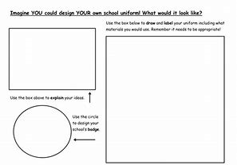
Read the stories: Goldilocks and the Three Bears, Jack and the Beanstalk and Cinderella. The characters will be going to see Judge Jenny. Can they persuade Judge Jenny to see the story from their point of view. Watch these links to help Judge Jenny to decide. Now it’s their turn… read the stories Little Red Riding Hood, Three Little Pigs and Gingerbread Man. Imagine they are going to be one of the characters from the story and an adult is going to be Judge Jenny. What would they say to Judge Jenny? How could they persuade her?
School Uniform: Tell your child that they will be presenting to the School Council about the school uniform. Do they think it is a good idea to wear a uniform or are they against wearing a uniform? Can they write down why they think they should have a uniform and then write down why they shouldn't? Design a new uniform. What would they wear? Would it be the same for girls and boys? What would they say to the school council? How would they campaign? Would they have badges, posters, events and banners to help their debate.
Could you design a new school logo? Ask your child to think about their current logo now. What does it represent ? What could they add or change? Is there something that represents their school or area recently that people would recognise? Look at the shape of the logo. Would they keep it the same or change it?
Additional learning resources parents may wish to engage with
Classroom Secrets Learning Packs - These packs are split into different year groups and include activities linked to reading, writing, maths and practical ideas you can do around the home.
Twinkl - to access these resources click on the link and sign up using your own email address and creating your own password. Use the offer code UKTWINKLHELPS.
Headteacherchat - This is a blog that has links to various learning platforms. Lots of these are free to access.
#TheLearningProjects

