Dear Puffins, Owls and Wrens!

It’s July! Time is flying by and we only have a couple of weeks left before summer holidays.
How are you all? We hope you are all well and continue to enjoy Home Learning Activities.
Please find the next week’s Home Learning pack attached to this letter. Have a go, have fun and try your best when completing the activities. We are very proud of you for continuing to complete home learning tasks and trying so hard with your learning. If you have any questions about any of the lessons/tasks, please just let us know. We are here to help.
We hope you will enjoy these new activities 😊. Please let us know how you get on. We love seeing your work and hearing about what you get up to each week.
Don’t forget to have fun and stay safe.
Also, if you enjoy getting out of the house and eating outdoors then July is the month for you, as the whole of this month is National Picnic Month!
July is also a plastic free month!
Plastic Free July is a global movement that helps millions of people be part of the solution to plastic pollution so we can have cleaner streets, oceans, and beautiful communities.
For more information visit https://www.plasticfreejuly.org/

Take care, look after yourselves and your families and keep smiling

We miss you all,
Mrs. Cox, Mrs. Milligan, Mrs. Jochacy and Mrs. Athanasiou xxxx

Year 1 Phonics activities – Summer 2 – Week 6 and Year 1 spellings

Session 1 - Monday 6th July 2020  Warm up activity – read and write tricky words and Year 1 Common Exception Words  Tricky words: any, eyes  Year 1 Common Exception Words: me, she, we, know  After reading all of the words, cover one word and write it on a piece of paper. Check the spelling and try another word. | Session 1 - Main activity  To know different pronunciations for one grapheme.  https://central.espresso.co.uk/espresso/primary_uk/subject/module/video/item105559/grade1/module63427/index.html  Watch the video to find out more about different pronunciations for ‘g’.  Sort these words into the correct hoops.
Session 2 - Tuesday 7th July 2020  Warm up activity  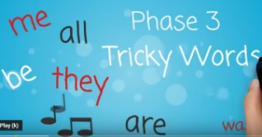  https://www.youtube.com/watch?v=R087lYrRpgY&safe=active  While watching the clip try to write down all of the tricky words included in the song.  At the end of the clip see if you can write a sentence using one or more of the tricky words you have written down. | Session 2 - Main activity  Read the words. Try both ways of saying the ‘g’ phoneme.  Can you think of words with the different ‘g’ sound? How are they spelt? Split your page into 2 and write words under each heading.
Session 3 - Wednesday 8th July 2020  Warm up activity  Recap all of phase 5 phonemes:  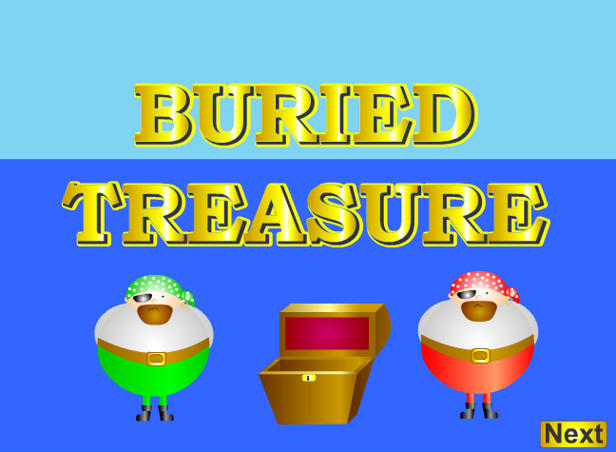  https://www.phonicsplay.co.uk/resources/phase/2/buried-treasure | Session 3 - Main activity  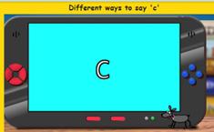  https://central.espresso.co.uk/espresso/primary_uk/subject/module/video/item104677/grade1/module63427/index.html  Watch the video to find out more about different pronunciations for ‘c’.  Sound talk each word and sort them in to the correct hoops.  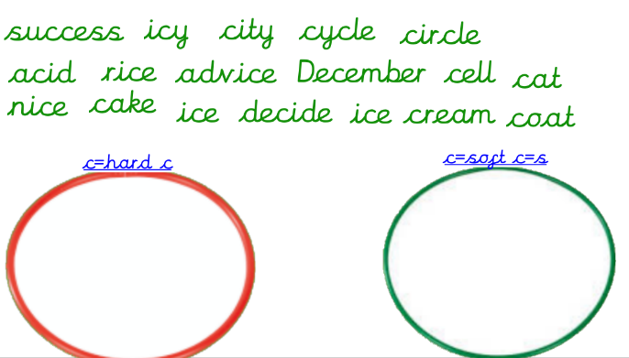
Session 4 - Thursday 9th July 2020  Warm up activity  Recap - To know alternative sounds, which use the same graphemes: short 'o' or long o?  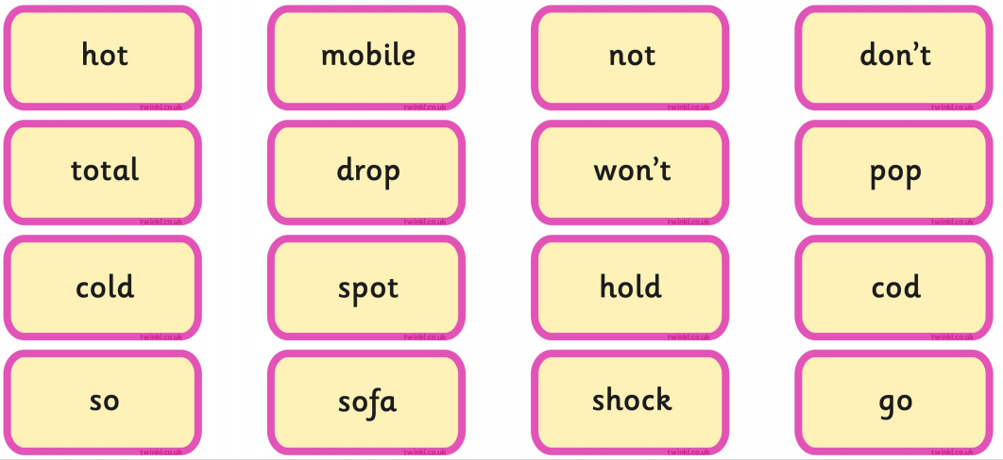 | Session 4 - Main activity  Can you think of words with the different c sound? How are they spelt? Split your page into 2 and write words under each heading.
Session 5 - Friday 10th July 2020  Warm up activity  Sing alphabet songs and recap phase 5 phonemes, using flash cards. | Session 5 – Main activity  Can you make up sentences using these words?  any, eyes, me, she, we, no  Write them down. Make sure you use a capital letter to start and a full-stop to end each sentence.

Year 1 English Activities – Summer 2 Week 6
This week’s English will be based around the book ‘Commotion in the Ocean’ by Giles Andreae. If you have the book at home, read it either on your own or to a grown up.
If you don’t have the book you can watch the video here...
https://www.youtube.com/watch?v=DgNmD7xgvz
Before reading/ watching the video, look at the book cover:
What do you think this book is going to be about?
How do you know?
Once you heard/ read the book…
What do we call this type of writing?
What sea creatures did you hear about?
Monday  6th July | Can you spot and /or think of any words to rhyme with each sea related word?  Here are the words: sand, shell, fish, sea, fin, ray  Can you find/ think of rhyming words. Write them down.  e.g. sand – band
Tuesday  7th July | Choose one of the poems from the book (you will find some examples below).  Can you spot and/or highlight (colour in) the rhyming words. Do you like the poem - yes or no? Give your reason - write this down using 'because' to give a reason.
Wednesday 8th July | What is an adjective? Can you explain?  Can you find/think of some adjectives to describe a sea creature? Choose a sea creature and describe it using at least five adjectives. Write them around your sea creature and draw a picture of it.  If you can, read your description/ adjectives to someone in your family without telling them what it is. See if they can guess  adjective - an adjective is a word that describes an animal, person, thing, or thought. Adjectives include words that describe what something looks like and what it feels like to touch, taste, or smell.
Thursday 9th July | Write sentences to describe your sea creature using the adjectives you found/ know and listed previously. Can you create a rhyming sentence?
Friday 10th July | WOW writing  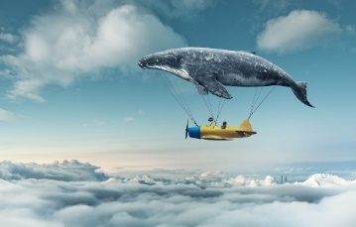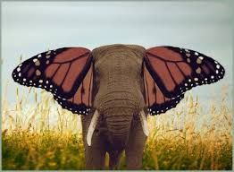  Choose a picture. You can write anything you want about it!  You must remember:  - Full stops  - Capital letters  - Finger spaces  - Re-read your writing to check it makes sense

Year 1 Maths Activities – Summer 2 week 6
This week we are:
- Begin to understand multiplication, division and doubling through grouping and sharing small quantities.
- Beginning to understand multiplication as repeated addition.
- Using arrays to represent multiplication
Vocabulary:
equal, the same, lots of, groups of, multiple of, times, multiply, multiply by repeated addition, array, row.

Monday 6th July 2020
What does ‘equal’ mean?
Watch this video to help you understand multiplication.

Feel free to pause after each section.

https://www.youtube.com/watch?v=450YCFK4Df4

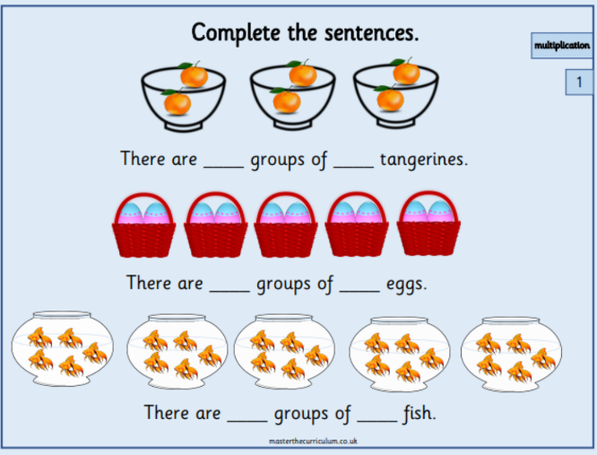
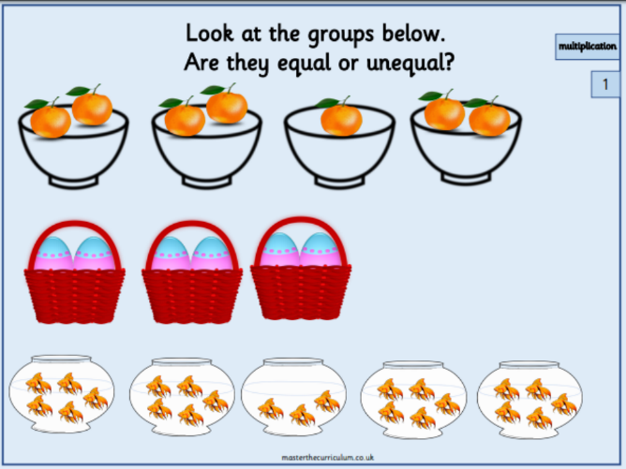
Activity:

Use practical equipment to create equal groups. Record it on a piece of paper:

_____ groups of ________

Challenge:
Practise counting in 2s, 5s and 10s. Write down the sequences.

Tuesday 7th July 2020
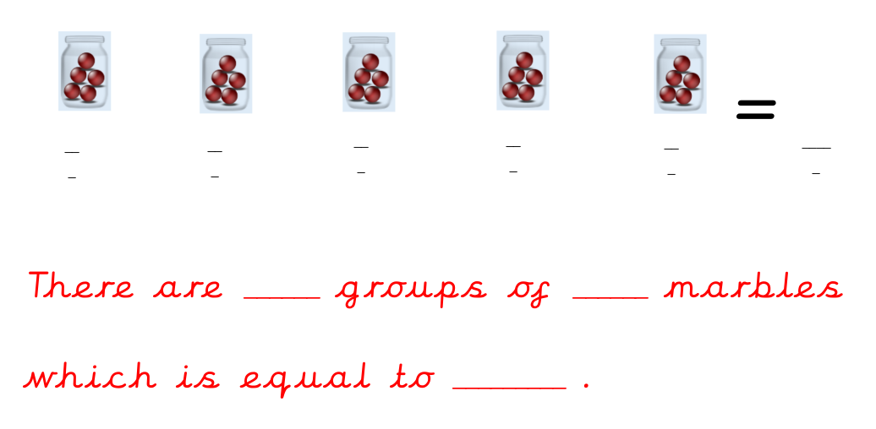

Activity:
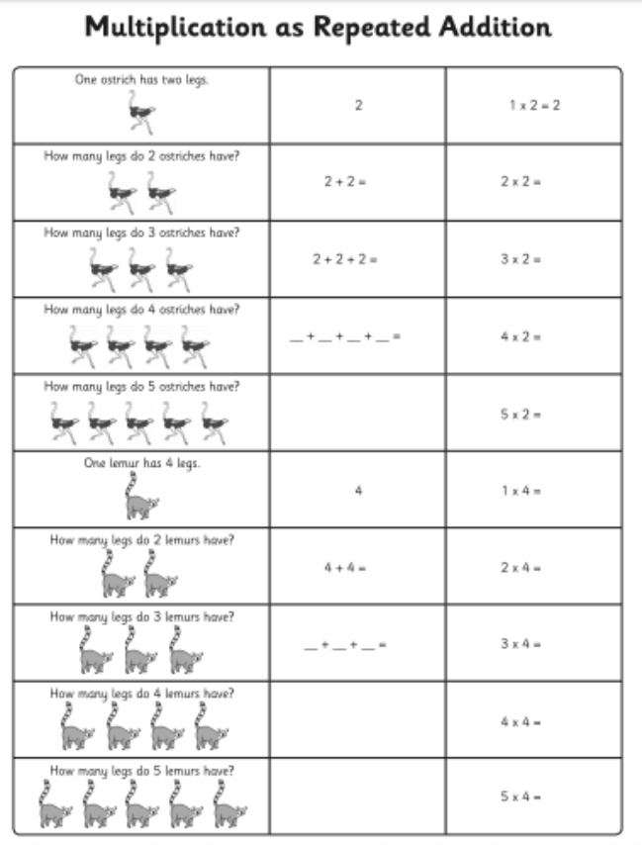

Challenge:
How many ways can you group cubes or counters to make 20?

Wednesday 8th July 2020
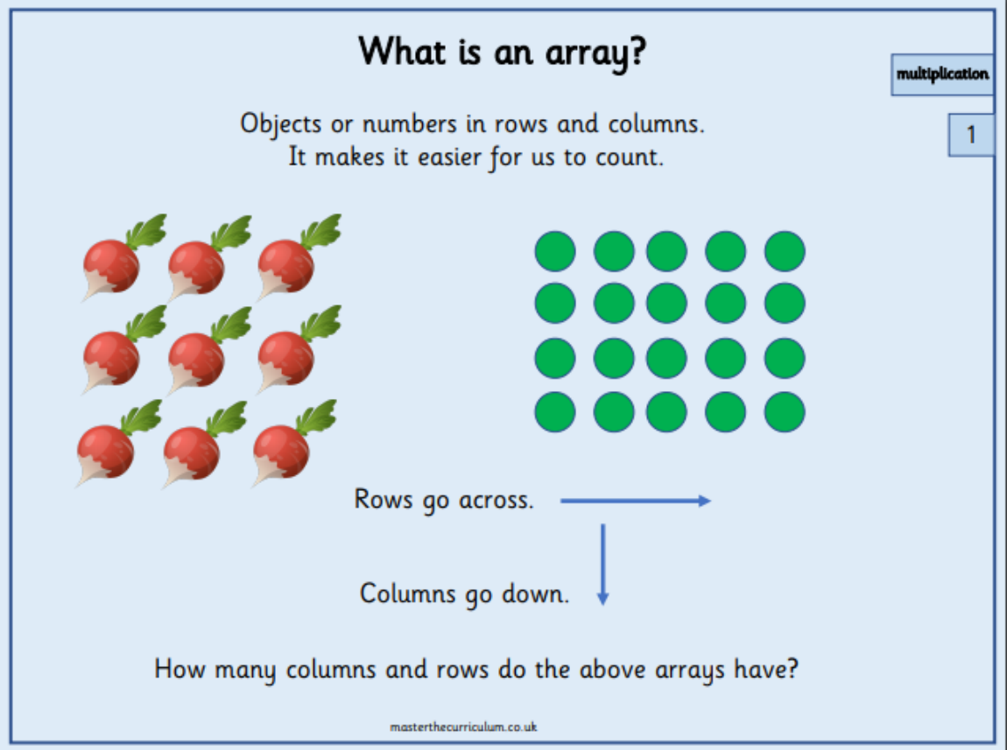

Activity:
Stick in a picture, draw or make an array on a piece of paper. Write the repeated addition sentence underneath.
e.g.

2+2+2+2+2=10

Challenge:
Choose a number up to 10. Double it and write the answer.

Thursday 9th July 2020
Activity:
https://education.abc.net.au/home#!/media/1496767/the-array

Challenge:
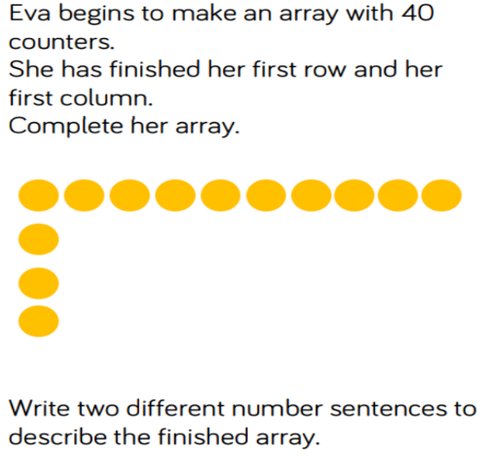

Friday 10th July 2020
Solving Problems
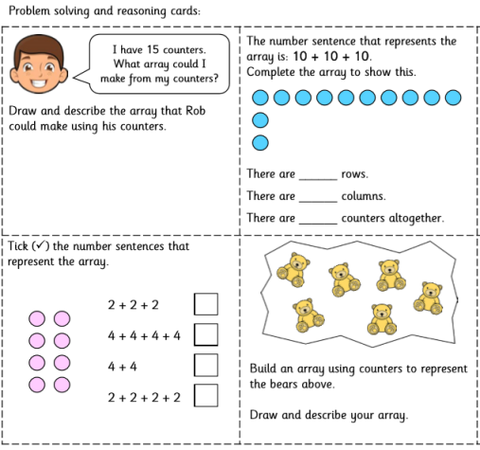

Year 1 Theme activities – Summer 2 week 6
Date: | Activity:
Monday 6th 2020 | Geography – Seas and Coasts  https://www.youtube.com/watch?v=qTgPgIc1PXg  Learn the names and interesting facts about the oceans and seas. Lesson includes practical exercises.
Tuesday 7th July 2020 | Geography  Look at these two pictures. What can you say about them? Can you find out where those two places are? How can you get there? What is the beach like? Is there something special about it? What are the differences between the two pictures?  Bora Bora Walton-on=the-Naze
Wednesday 8th July 2020 | Geography  What is the compass rose*? What does it show/ do? Can you find it on a map?  Use the map and follow the instructions.  Chose a place on the map and make your own set of instructions leading to that place. Ask someone at home to follow them to find the place you chose.  *Compass rose shows the direction of North, East, South and West. The directions help us describe where things are on a map and find our way around places.
Thursday 9th July 2020 | Geography  Be an explorer! What questions can you think of to find out about a place? (When? What? Who? Where? How?)  Choose a place on the coast and create a poster or leaflet for your chosen place. Draw your favourite activities and describe them.  Here is an example of a place and information you could use for your poster/leaflet.
Friday 10thJuly 2020 | Geography  https://www.bbc.co.uk/bitesize/topics/zx882hv/articles/zy38wmn  What is a coastal habitat?  Don’t forget to try the activity and the quiz to test what you've learned about coastal habitats.  https://www.dkfindout.com/uk/earth/coasts/

