Year 2 Phonics/Spelling Practice – w/c 13.5.20 Wednesday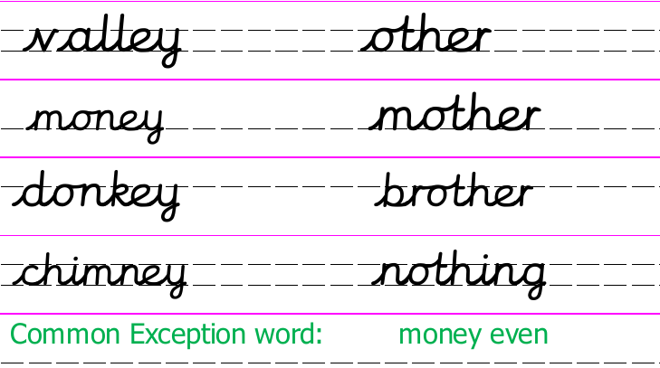
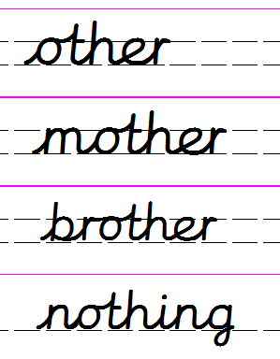
Look at these words. How is the ’o’ pronounced or said?

Here are some more. Read the words out loud. Do you know what they mean?
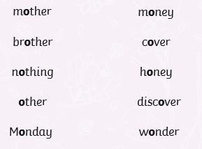
Dictation sentence to practise:
My mother has another brother.

Maths 13.5.20
Watch the video and copy and complete the questions below.
https://whiterosemaths.com/homelearning/year-2/
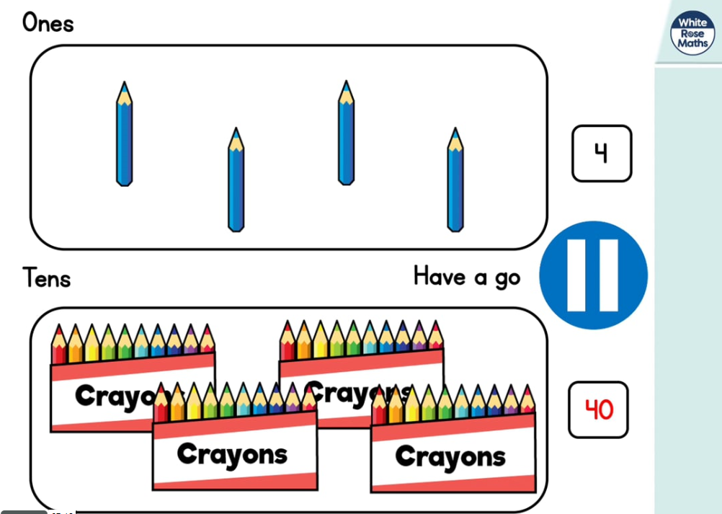
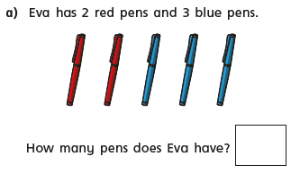
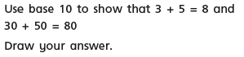
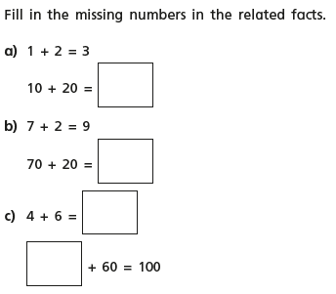
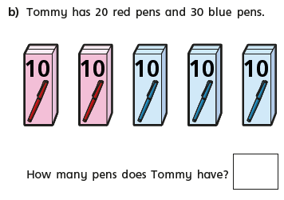
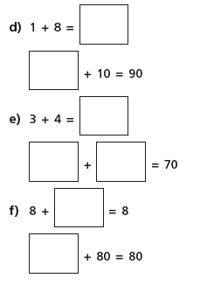
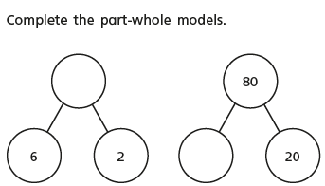
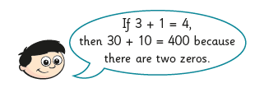
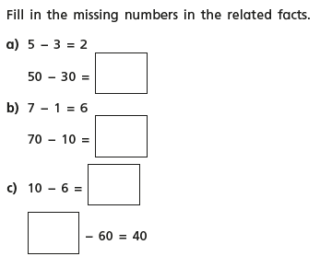

Wednesday 13th May 2020 - English
Word of the week – ‘Victory’.

Quote of the day

WALT write a diary entry.
Good Morning. Can you believe another week has passed since we wrote our diary entries! My diary entry this week is from last Friday.
Dear Diary
Today has been a big day for me! I finally ventured to the supermarket. This has been Mr Johnson and Fenella’s job over the past few weeks but today I decided enough was enough! Grateful as I am to their efforts they are not shoppers! Mr Johnson spends far too much, ignore the list and buys Freddie and Drew far too many goodies and sweets but not much actual food for meals. Fenella on the other hand is very regimental, if it’s not on the list we don’t get! Which is good for saving money but not when you realise you want to make lasagna and put the ingredients on the list but forget the actual lasagne sheets. Something as a regular food shopper for a family of six I wouldn’t forget.
I had to drop some resources off at school first, so I set off at about 9.00. It was absolutely pouring with rain when I arrived in the school car park, so I quickly put the bits in the corridor then returned to my car. After letting Mrs Bunney know that the resources wer there I headed off. I had decided that I would only go where the queues weren’t long. Waitrose in Ampthill had a very long,winding queue so I gave that a miss and headed back towards Bedford. Passing Marks and Spencers at the retail park was the same, huge queues! Finally I got to Bedford Waitrose and my heart rose as their was hardly anyone in the queue. This was a new experience for me remember, so armed with my hand sanitisor and gloves I was ready for battle. A lovely lady told me to collect a trolley and to enter the store. I was very impressed with the organisation and attitude of the staff. What heroes going out of their way to make me feel safe. I wizzed round the store, I knew exactly what I wanted and where to get it.
Despite my worries it was an easy task and I felt like I had acomplished a very important mission! Everyone was waiting in eagerness when I got home, desperate to see what goodies I had got them. It is the highlight of the week in our house getting the weekly shop, believe me. Is it the same in your house?
For tea tonight we had Italian Sausage pasta for the meat eaters and the veggies had Saffron and Goats Cheese tagliatelle (which I know sounds quite grand but I’d wanted to try the recipe for ages and had received the spices for Christmas but never got round to using them).
It was a busy day for me today and for a change a different one. I do hope my next trip to the supermarket is as successful!

Mrs Johnson

How has your week been? I look forward to reading your diaries.

Wednesday 13th May 2020
WALT understand why some people are inspired by leaders in bible stories.
Over the past three weeks we have learnt about leaders in our lives and what makes a good leader. Today we are going to read a story about Moses who is an important figure in both Christianity and Judaism. He is seen by Christians and Jews as a good, inspirational leader. They believe he has all the qualities of a good leader and that we can learn lots from his story.
- www.topmarks.co.uk/judaism/moses/moses4.htm

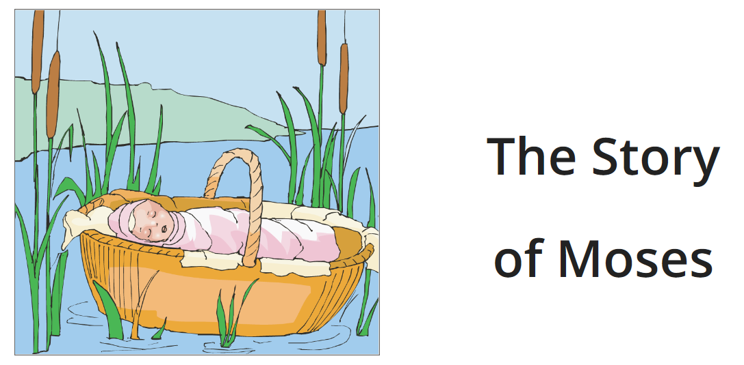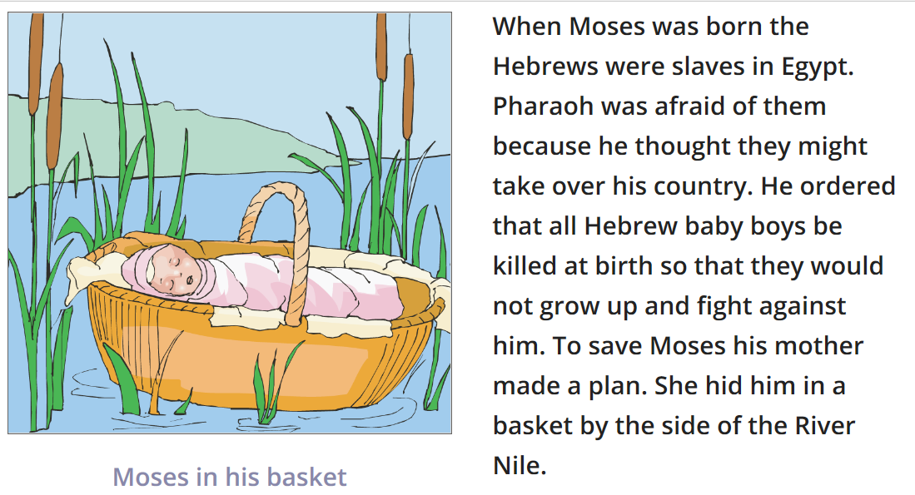
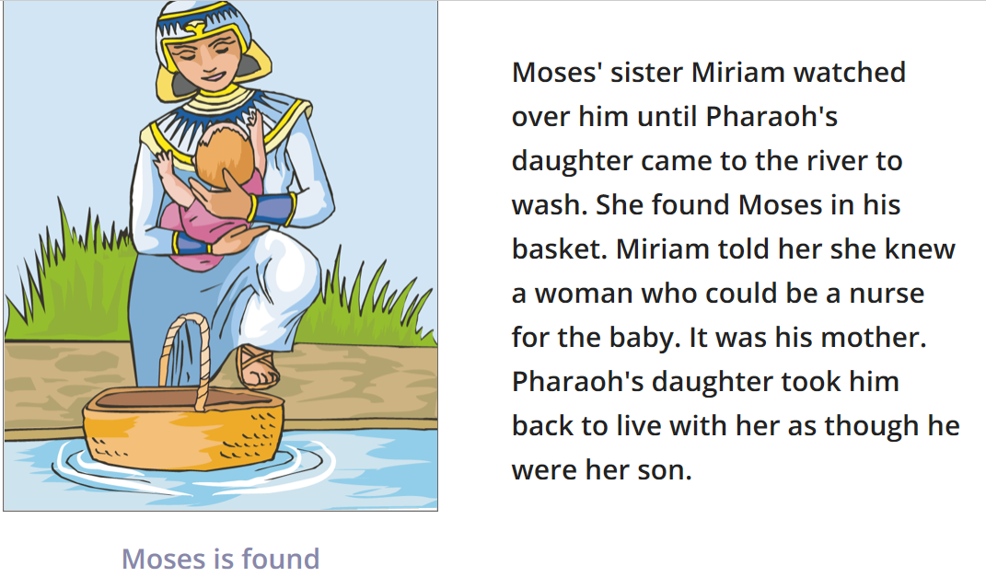
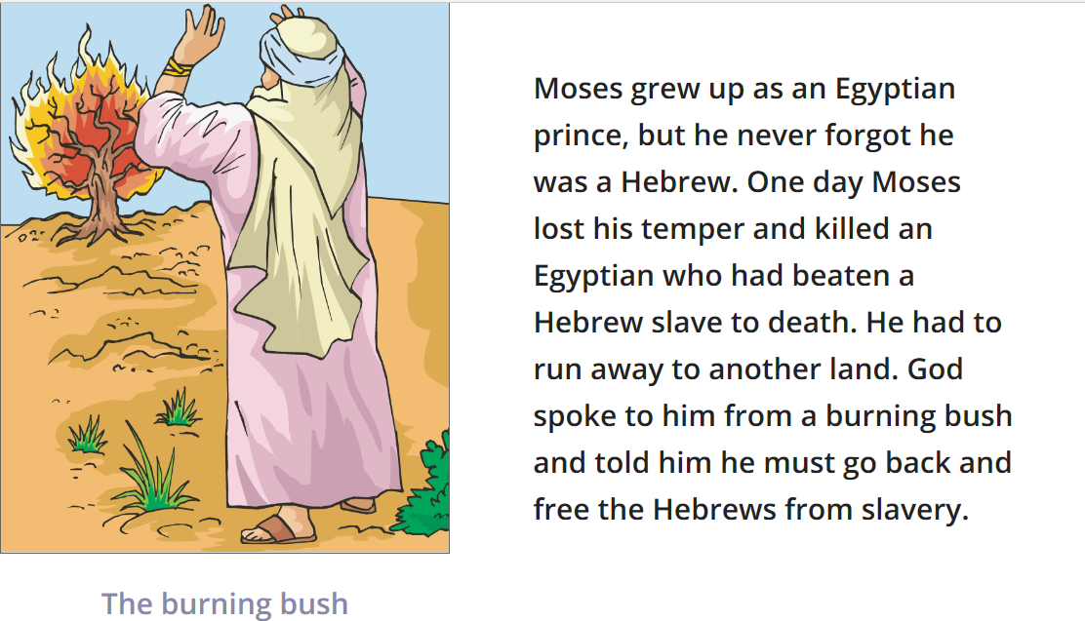

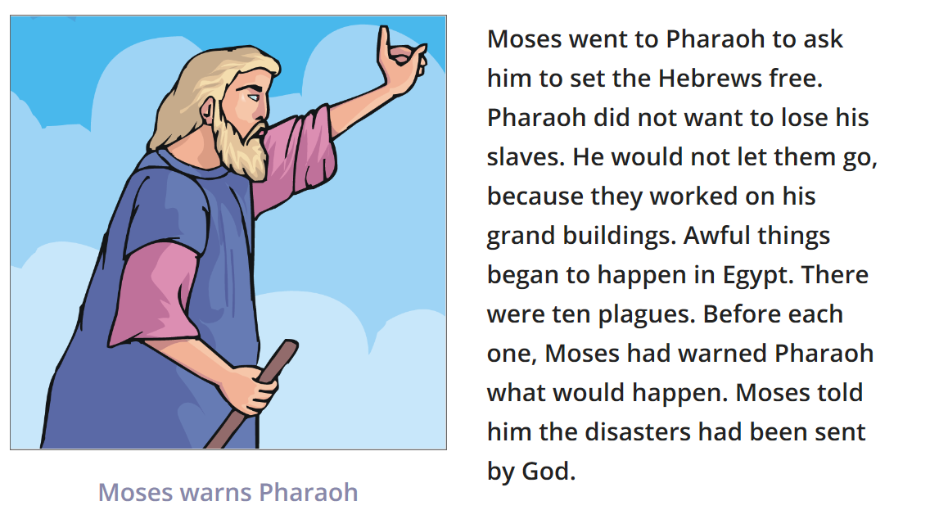

In the end the Pharaoh agreed that he would set the Hebrews free.
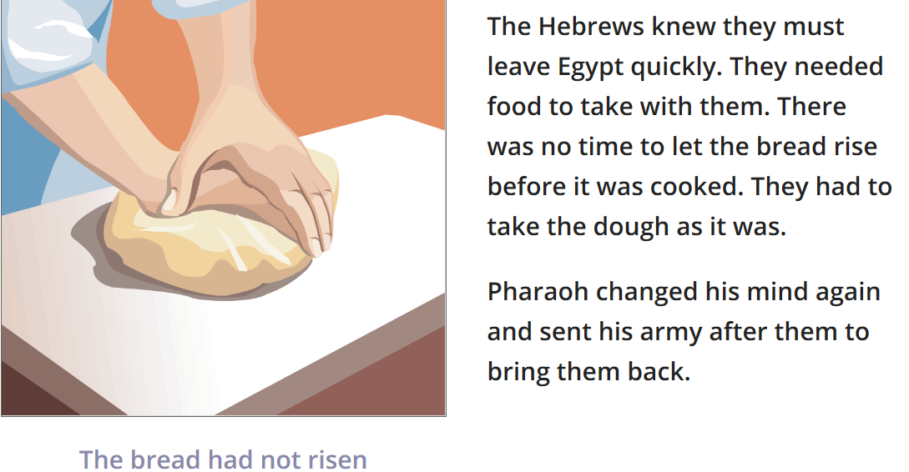

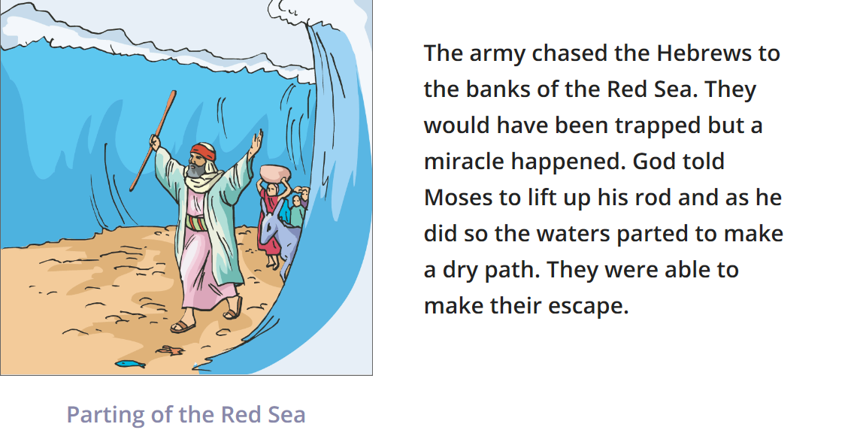

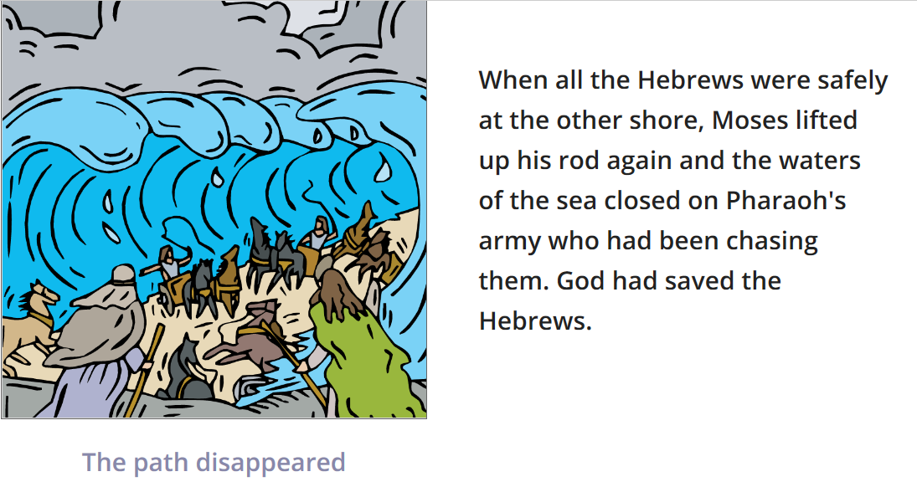
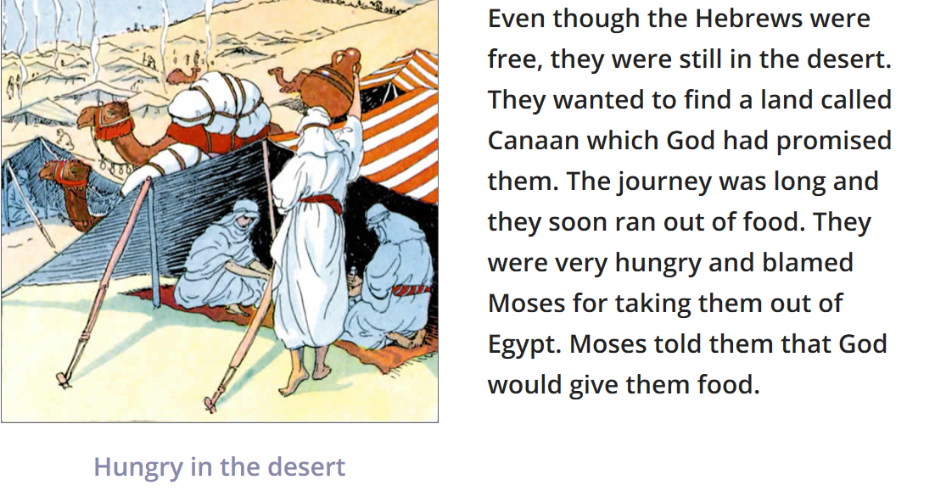

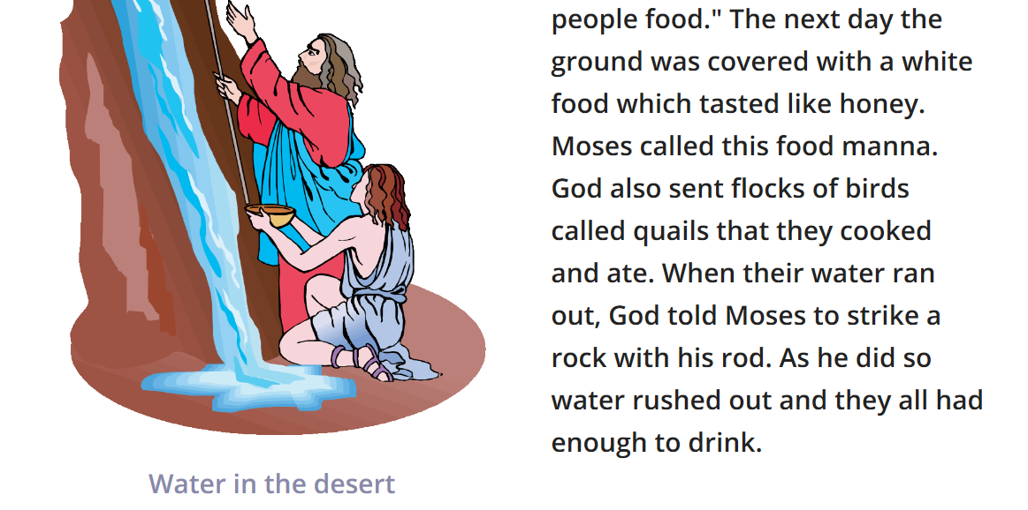
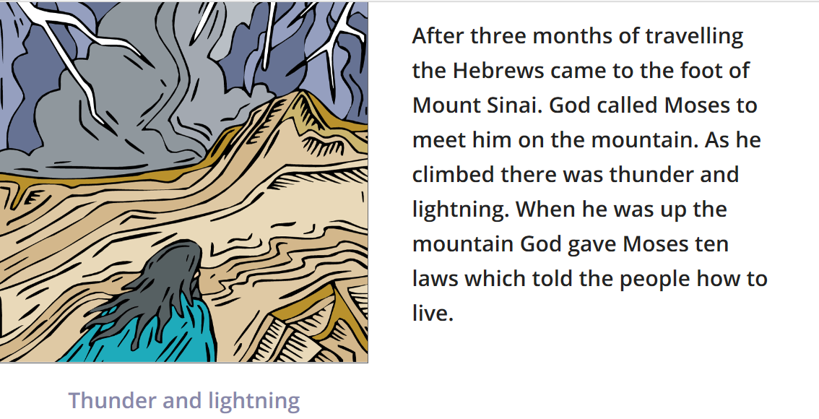

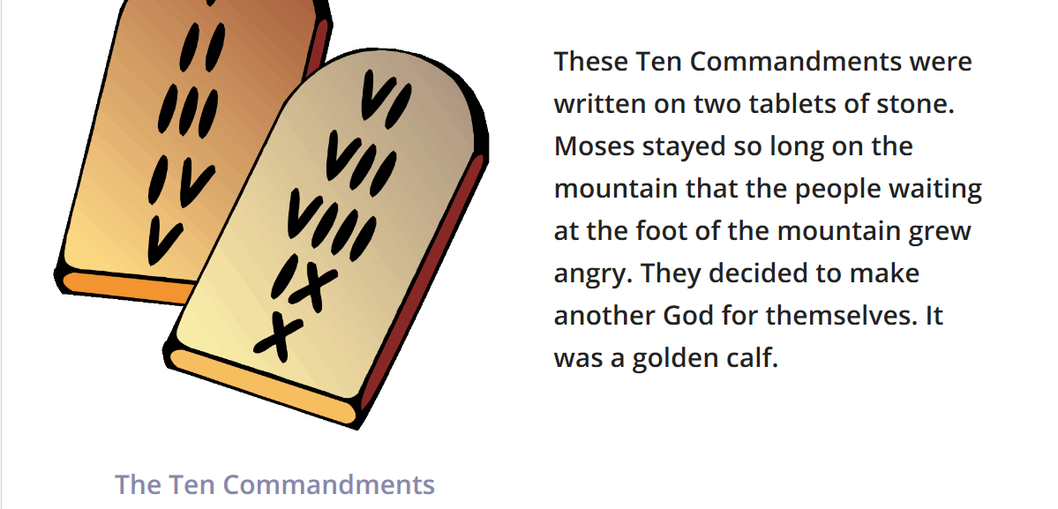
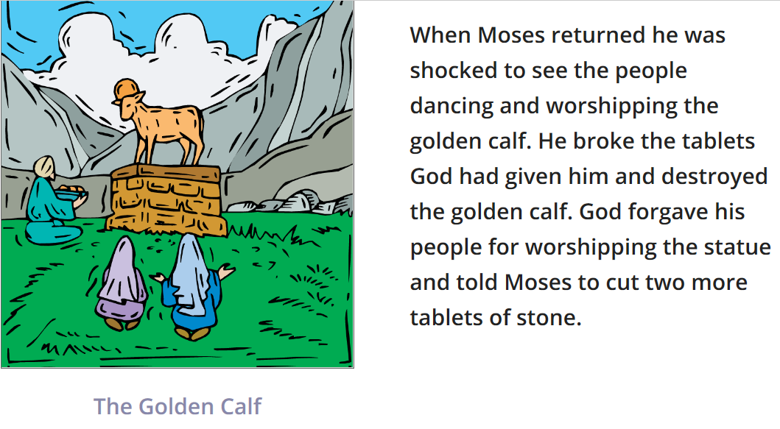
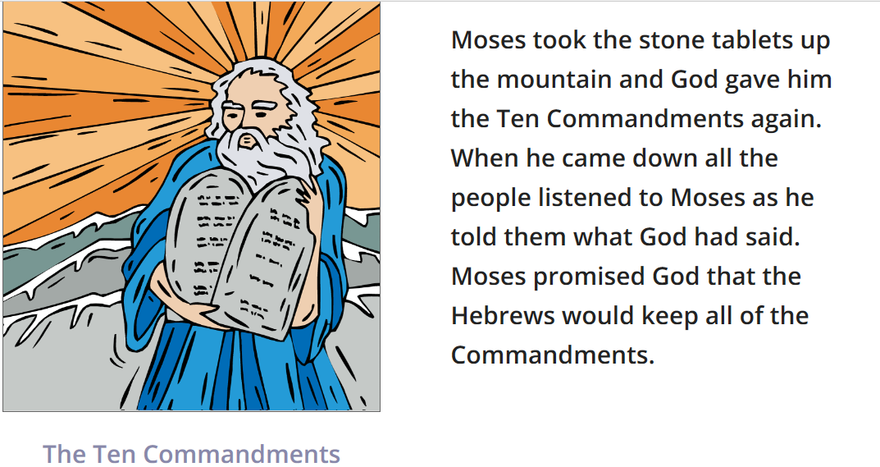

Task

Why do you think some people think Moses was a good leader.

How many reasons can you think of.
What can we learn from Moses about being a good leader?

Here are some examples.

