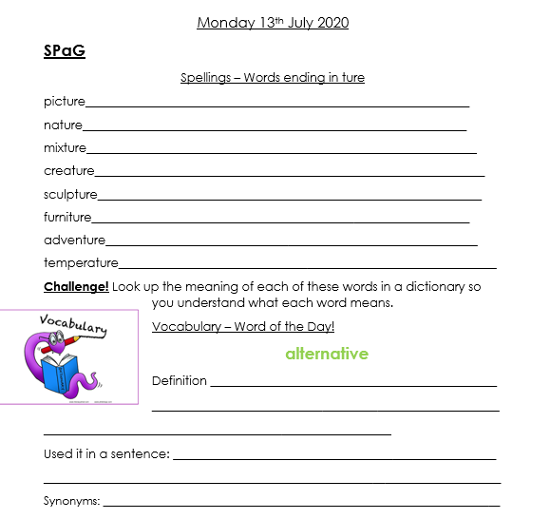

English
Choose one activity from the grid below to complete each day this week.
Write a film or book review. Discuss the plot, characters, whether you enjoyed it and why. | Write a diary entry in the role of your favourite character from one of your favourite books. | Create a new front cover for your favourite book or the book you are currently reading.
Create a poster to advertise your favourite book or film. | Create an acrostic poem that spells out your name. | Find 5 words in the book you are currently reading that you don’t know the meaning of and use a dictionary to find the definition.
Adjective Alphabet Challenge!  Can you come up with an adjective for each letter of the alphabet? | Write a character description for a member of your family. What do they look like? How do they behave? | Write a story involving members of your family. Do they have to defeat a monster? Find something they have lost?
Read this extract from ‘100 Adventures to have Before you Grow Up.’ https://www.lovereading4kids.co.uk/extract/17065/100-Adventures-to-Have-Before-You-Grow-Up-by-Anna-McNuff.html  Write a list of adventures you would like to go on. | Draw a comic strip for the book you have most recently read or for your favourite book. | Write a list of verbs. Play charades with a family member. Can they guess the verb?
Write a letter to a character in a book you have read to find out more about them. | Write on alternative ending for the book you have most recently read or for your favourite book. | Retell a traditional tale from another character’s point of view. E.g. The Three Little Pigs from the wolf’s point of view. Cinderella from the step mothers point of view.

