Friday 3rd April 2020
SPaG
Spellings – To apply the prefix super-
superhero | superfluent | superman | superstore
superpower | superstar | supernatural | supermarket

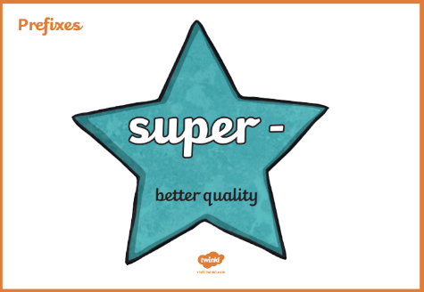
Challenge! Use all of your spelling words in a short story that makes sense! Underline your words with a ruler.
___________________________________________________________________________________________________________________________________________________________________________________________________________________________________________________________________________________________________________________________________________________________________________________________________________________________________________________________________________________________________________________________________________________________________________________________________________________________________________________________________________________________________ ____________________________________________________________________________________________________________________________________________________________________________________________________________________________________________________________________________________________________________

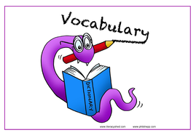
Vocabulary – Word of the Day!
trudge
Definition _______________________________________________
_________________________________________________________
_________________________________________________________
Used it in a sentence: ____________________________________
___________________________________________________________________________
Synonyms: _______________________________________________________________________
English
Summarise
Summarise the clip using the big 5 to help you!
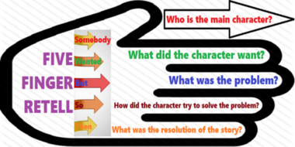
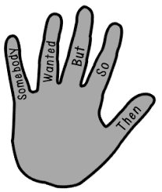

____________________________________________________________________________________________________________________________________________________________________________________________________________________________________________________________________________________________________________________________________________________________________________________________________________________________________________________________________________________________________________________________________________________________

Maths
Four Awesome Operations
Addition (using column method)  555 + 109 | Subtraction (using column method)  690 - 526 | Multiplication (using grid method)  34 x 8 | Division (using sharing of place value counters)  22 ÷ 8
Adding and Subtracting lengths
Using your fantastic knowledge of column addition and subtraction calculate the length problems below. Be careful, as you might need to convert the measurements first!
- 239cm + 302cm =
Prove it!
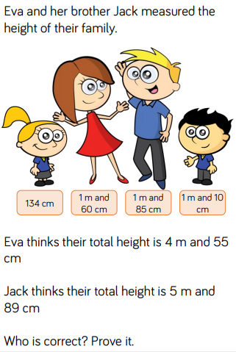

- 322cm – 202cm =

- 3m and 99cm + 622cm =

- 4m – 333cm =

- 29mm – 2cm =

- 5cm and 8mm + 48mm =

- 2m and 22cm – 204cm =

- 49mm + 4cm and 8mm =

- 200cm – 1m =

- 662cm + 590mm =

Science

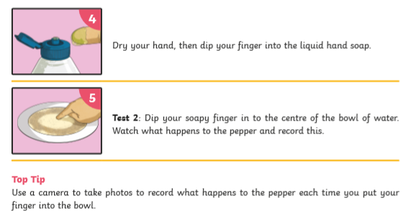
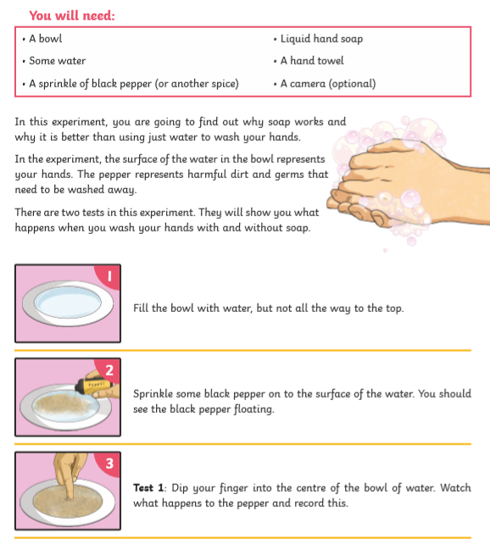

Challenge! Explain what happened in each test.

Test 1
________________________________________________________________________________________________________________________________________________________________________________________________________________________________

Test 2
________________________________________________________________________________________________________________________________________________________________________________________________________________________________

Why was there a difference in how the pepper behaved when the soap was added?
________________________________________________________________________________________________________________________________________________________________________________________________________________________________

Explain why we should use soap to wash our hands.
________________________________________________________________________________________________________________________________________________________________________________________________________________________________

