Year 2 Phonics/Spelling Practice – Wednesday 24.6.20.
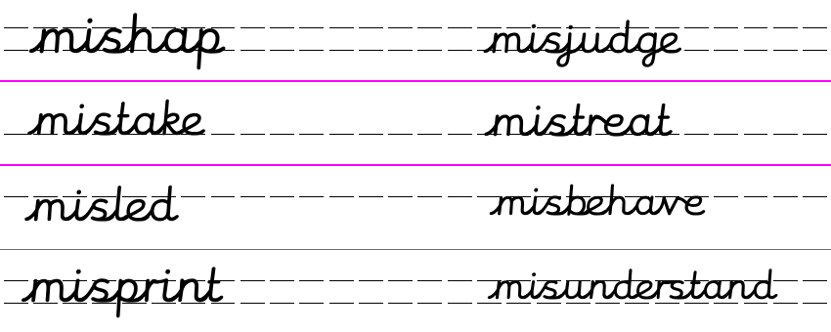
Practise: Quick write - Set a timer for 1 minute – how many mis- words can you write down before the timer finishes?
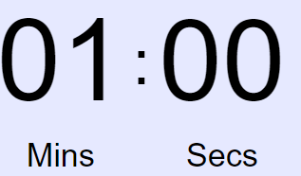

____________________________________________________________________________________________________________________________________________________________________________________________________________________________________________________________________________________________________________________________________________________________
Perhaps try again and see if you can beat your score! Remember to check afterwards to see if you spelled them correctly.
Dictation:
Ask someone to read out the sentence to you.
If I misunderstand I can always check with my teacher.
Maths 24.6.20
Sort 2-d and 3-d shapes
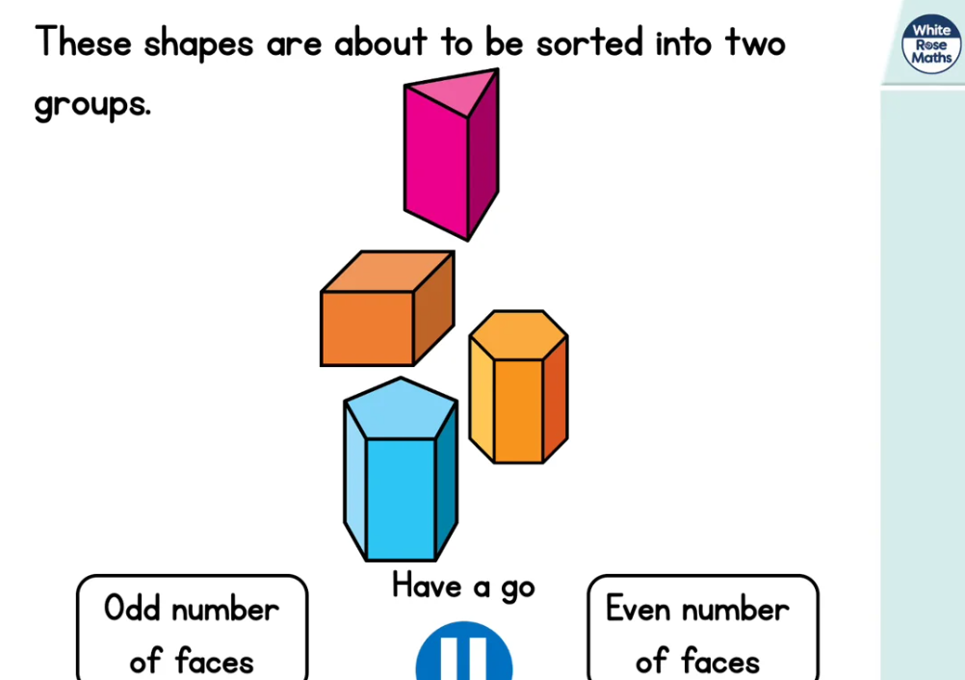
https://whiterosemaths.com/homelearning/year-2/ (Week 8 W/C 15.6.20)
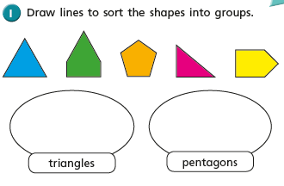
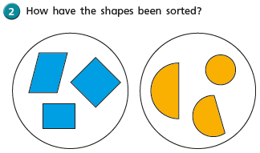
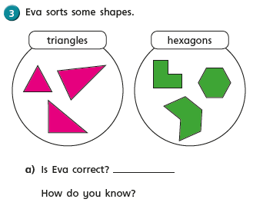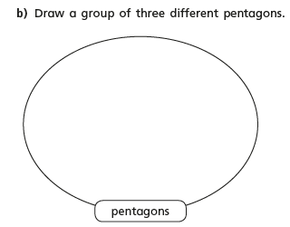

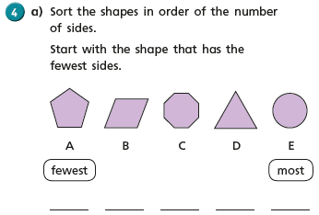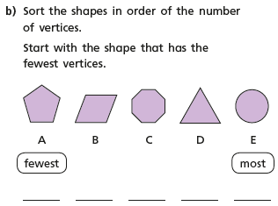
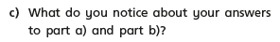

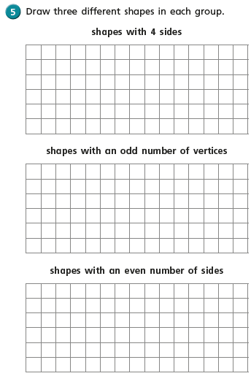
Wednesday 24th June 2020 Fun fact of the day: Honeybees navigate by using the sun as a compass.
WALT: write an information text.
Yesterday we wrote our information text about Pelicans. How did you get on? What exciting facts did you learn about Pelicans? They are really extraordinary creatures aren’t they.
Today we are going to be doing the same task but looking at Giraffe.
I will go through the videos below on my daily English loom video.

https://www.bing.com/videos/search?q=Everything+you+wanted+to+know+about+Giraffe&&view=detail&mid=72C0327E9DDD8E71E40072C0327E9DDD8E71E400&&FORM=VRDGAR&ru=%2Fvideos%2Fsearch%3Fq%3DEverything%2520you%2520wanted%2520to%2520know%2520about%2520Giraffe%26qs%3Dn%26form%3DQBVDMH%26sp%3D-1%26ghc%3D1%26pq%3Deverything%2520you%2520wanted%2520to%2520know%2520about%2520giraff%26sc%3D0-42%26sk%3D%26cvid%3DA8B1C8745FEB483AB031DC4ACB9F8794
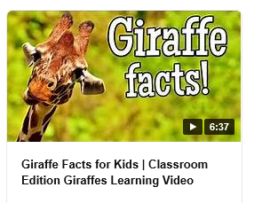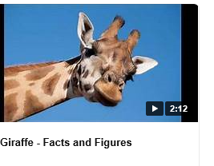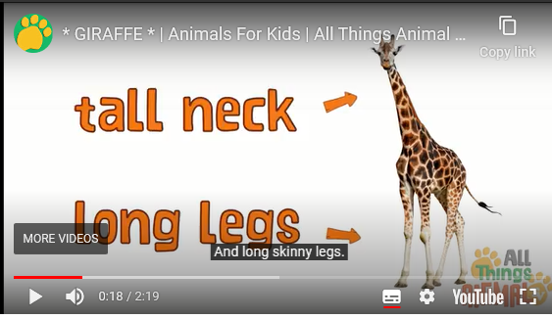
As I said yesterday, I would watch the videos a couple of times and write down in rough any key facts, or press pause on your tablet and copy them down.
I have attached another sheet you could use but remember you can use your own layout if you wish.
Don’t forget: to include headings, captions, drawings with labels and facts about Giraffe.
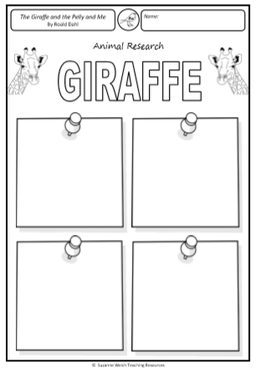
Wednesday 24th June 2020
RE - WALT understand what is the good news that Christians believe Jesus brings.
WILF That you can write about the good news that you would like to hear.
Jesus would travel with his twelve disciples across the land bringing people the ‘good news’. The good news was often stories that taught a lesson about how to life our lives. These are called parables. We have looked at parables in our R.E lessons on school. Can you remember any of them?
We had the story of ‘The Good Samaritan’. This story told us how we should help all people regardless of their beliefs. There is the story of ‘The Lost Sheep’. The shepherd didn’t give up on that sheep did he? He made sure each and every one of his flock was safe.

You have all been at home keeping safe but are desperately waiting for some good news that you can come back to school Today I want you to imagine this dreadful disease has gone away and that things are finally getting back to normal. The children of Russell Lower School have returned to school, the restaurants and cafes in Ampthill are open. Children can now play at the park and have playdates with all their friends. You can even have birthday parties!
I would like you to create the front page of a newspaper, telling the people of Ampthill the ‘good news’.

Don’t forget to give your newspaper a name. e.g. ‘Ampthill Gazette,’ or ‘The Daily Gossip’, ‘The Good News’
Make sure you have an eye catching heading e.g. ‘Guess who’s back!’ ‘Russell Returns’, ‘Back to the past’ ‘Normality Rules Ok’.

Add pictures, subheadings. Make your writing interesting by using adjectives, nouns, verbs and adverbs.
I look forward to your reading your reports and who knows by the time you have finished them they may well be the ‘good news’ we are all waiting for.
I think this is a big task, so I would like you to take two weeks on this task.

