Year 2 Phonics/Spelling Practice – Friday 12.6.20.
Last week we tried to learn lots of Year 2 common exception words – can you remember which sound they had in common?

We need to learn to spell them all before the end of Year 2!
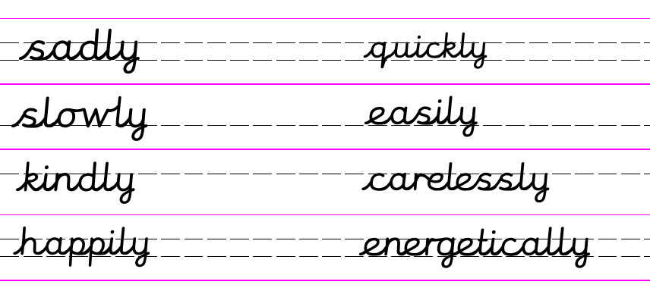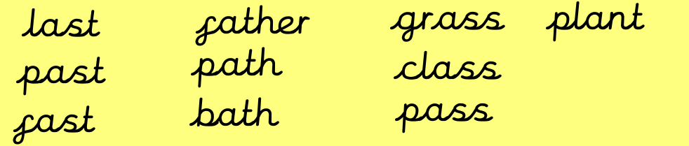
The word ‘after’ sounds like it contains the ‘ar’ sound but it is spellt with an ‘a’. Some people will pronounce it as ‘a’ depending on where they live or come from in England.
Lots of other Year 2 common exception words contain this spelling too!

Use your time today to see if you can still spell them. If you find any of them tricky, then practise them using your rainbow writing.
Can you use these common exception words as well as an adverb to write sentences?

ie. I sadly knew it was past my bedtime because it was slowly getting dark on the path.

Maths 12.6.20 Sharing
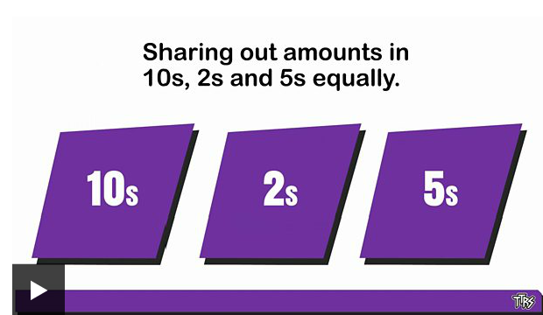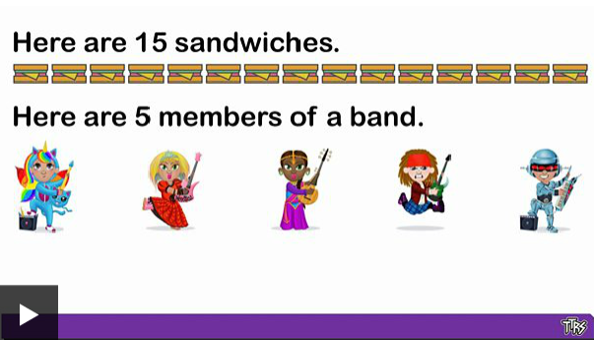
Use this link to watch the two BBC Bitesize videos. You can also try the online tasks.
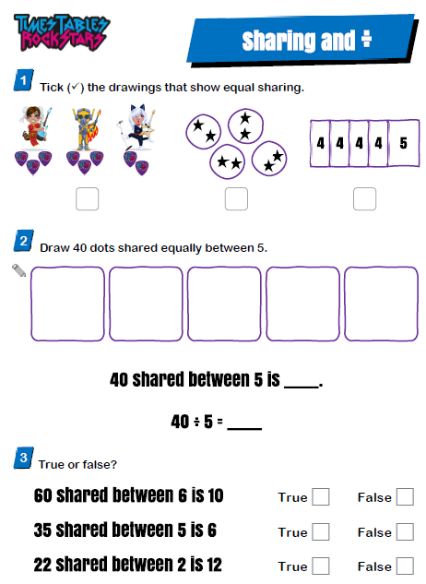
https://www.bbc.co.uk/bitesize/articles/zfxtnrd

English - Friday 12th June 2020
WALT to use the features of a play script
WILF I can use the features of a play script; speech, characters, adverbs, stage directions.

Yesterday we wrote our descriptions of Mole's experience in the Wild Woods.
Let's find out what Rat was up to.... If you can ask an adult to read to you.

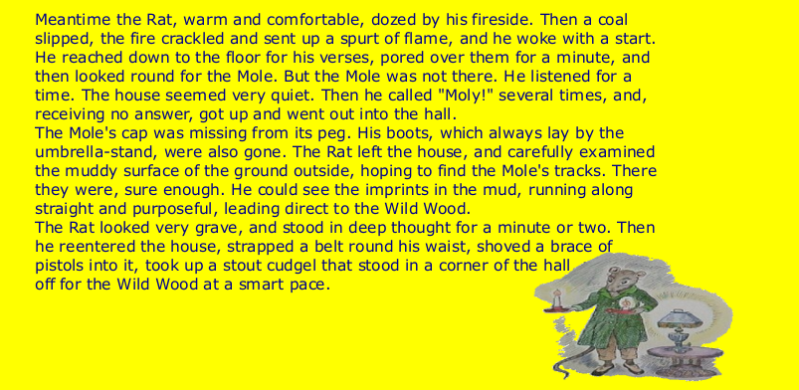
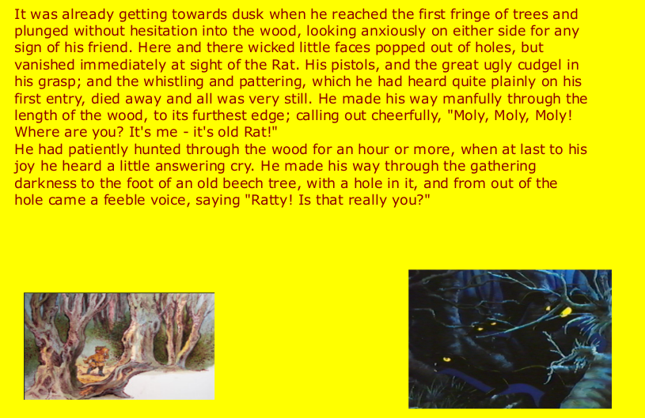

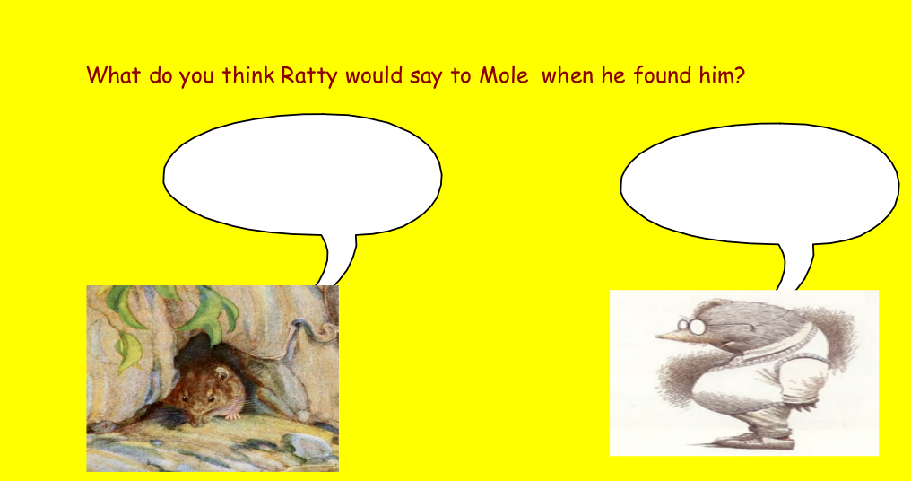

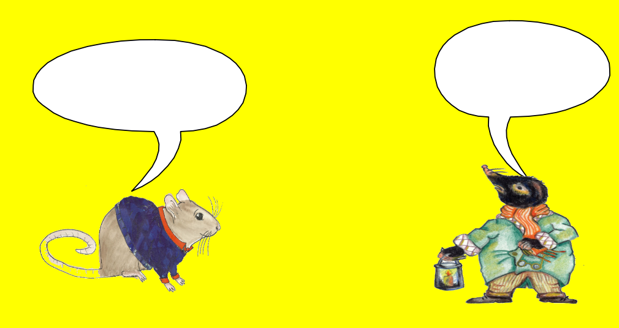

We are going to have a go at writing a short playscript. It will be of Ratty and Mole talking to each other. When have you used a playscript? (Our Christmas play). Do you know any features of a playscript?
I have written a short WAGOLL to show you.

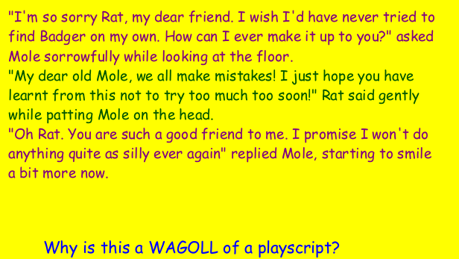

I have included directions and description to help you to understand what they character is doing and how they are doing it, e.g Rat said gently while patting Mole on the head. We know from this what Rat is doing but also that he is not cross with Mole as he is speaking gently.

TASK
Can you write a short playscript of a conversaton between Rat and Mole? I can be from any part of the story. Don’t forget to add as much detail as possible so that it is clear what they are doing and how they are doing it.

Science 12.6.20
WALT: to understand that animals can be classified into 6 groups
Follow this link to the BBC Bitesize website where you can watch 6 short clips on animal groups:
https://www.bbc.co.uk/bitesize/articles/z4svgwx
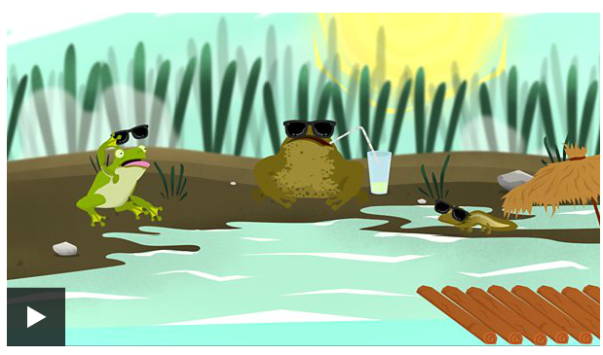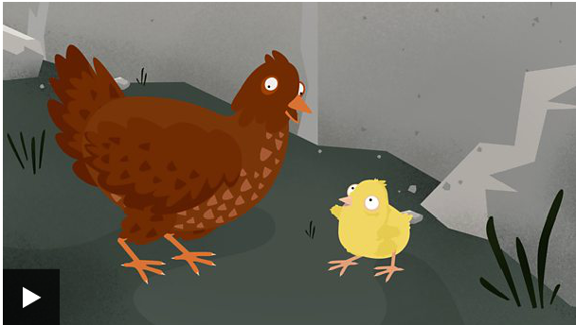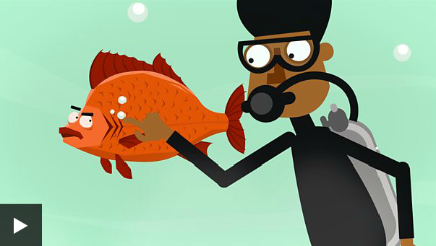
Amphibians Birds Fish
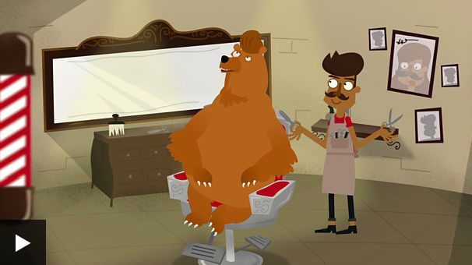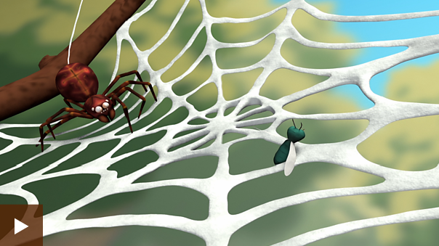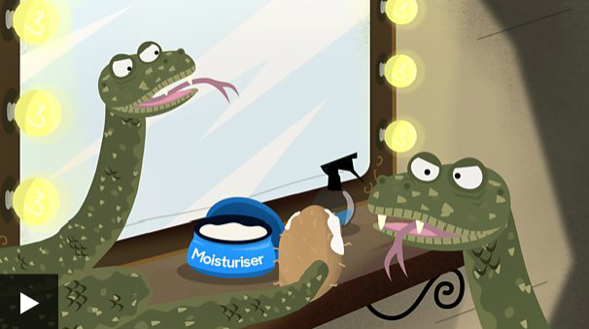
Mammal Minibeasts Reptiles
