Thursday 11th June 2020
SPaG
Spellings – Words with a zhuh ending spelt sure
Write each word in your spelling list using two different colours. Write the constants in one colour and the vowels in another colour.
leisure
unsure
leisure
measure
closure
treasure
pleasure
composure
enclosure

Word of the Day – focus

Definition ____________________________________________
_____________________________________________________
_____________________________________________________
Used it in a sentence: ____________________________________________________
_________________________________________________________________________
Word Class: ____________________________________________________
Synonyms

English
In tomorrows work you will be conducting the mummification process on a tomato.

Who was the god associated with the embalming and mummification process?

What do you already know about the Ancient Egyptian mummification
process?

The picture below should help you remember or you can watch the video from yesterday.

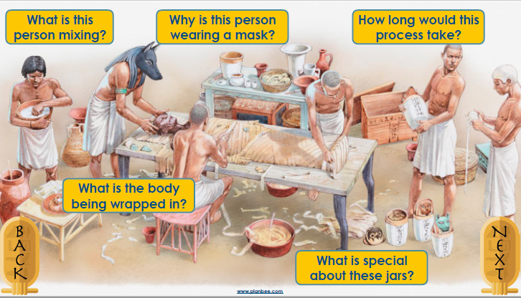

This is a flow chart to remind you of the process.
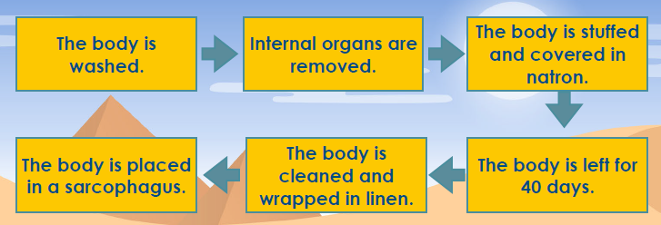

Task
Match the pictures of the Ancient Egyptian mummification process with the equivalent step in mummifying a tomato. If you don’t have a printer you can draw the pictures.

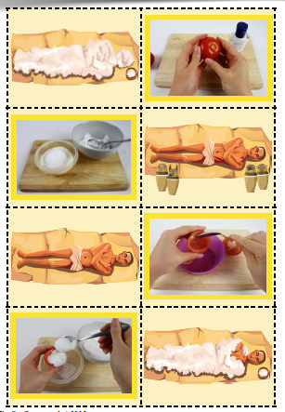

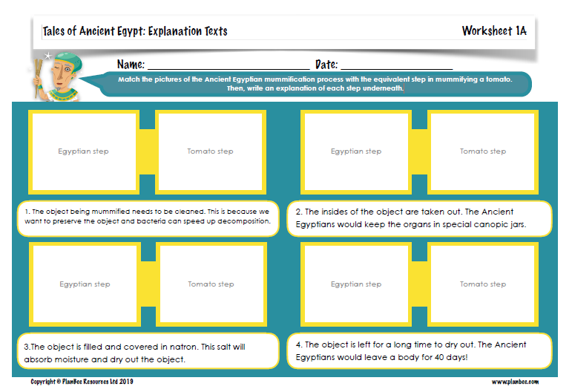

Maths

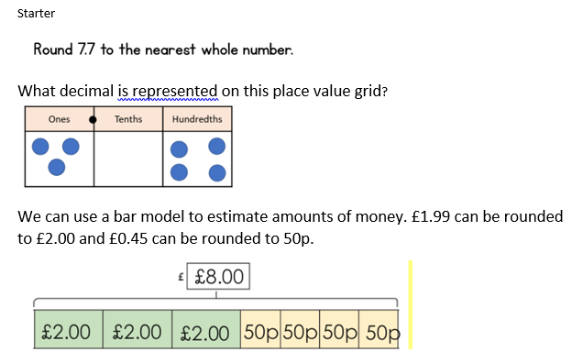
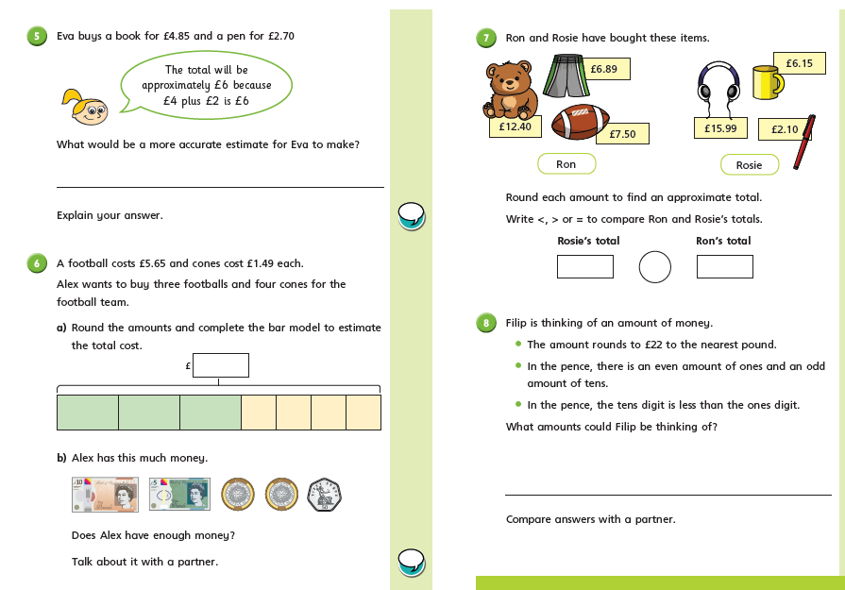

Science
Choose an animal that you love, maybe it’s one you want to find out more about, you could choose one from yesterday’s lesson.
Find out the following information and make a fact file about it.
-Where in the world does it live?
-What is its habitat like?
-What do they eat? Is it a Carnivore/ herbivore/ omnivore?
- Where does it sit in the food chain (what eats it? What does it eat?)
- How long does it live?
- Are there any interesting facts?

