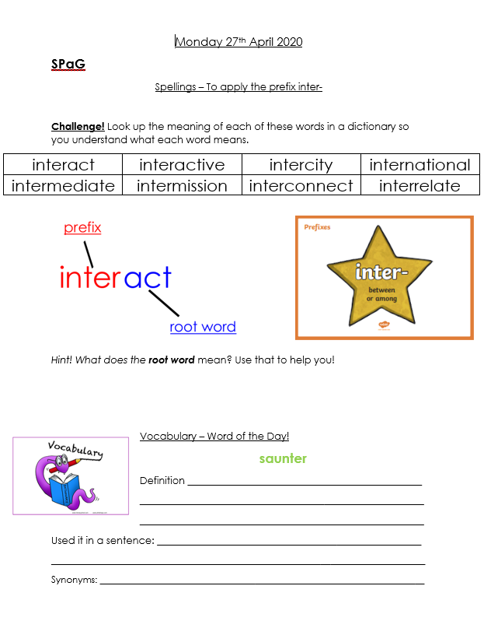

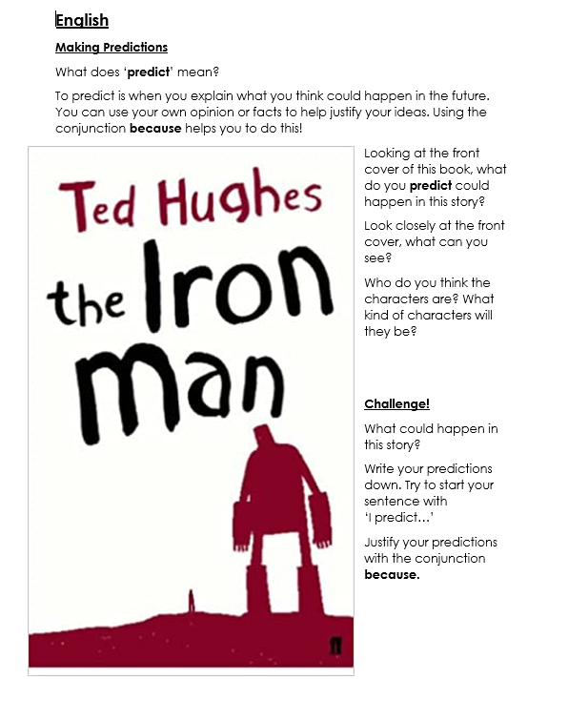

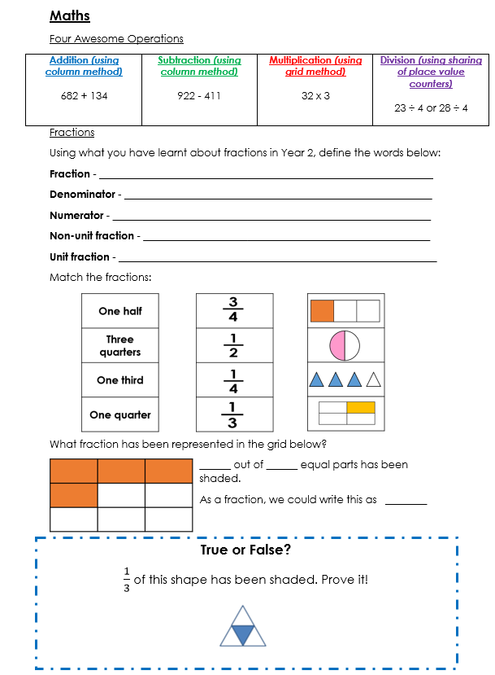

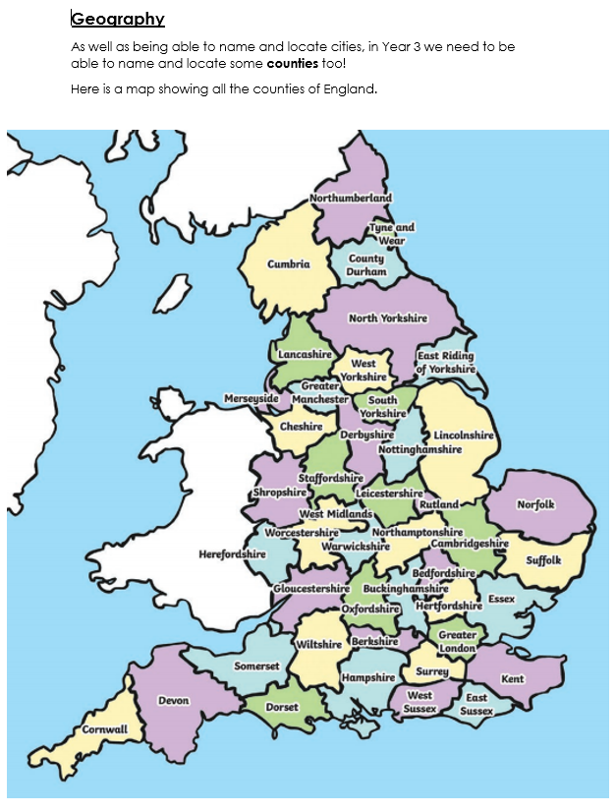

Challenge!
- Put the counties in alphabetical order.
- Order the counties from largest to smallest.
- Order the counties based on how many letters they have in their name.
- Find out something about one of the counties you have never heard of.
- Have a go at this online map quiz where you have to locate English counties https://online.seterra.com/en/vgp/3146 You might want to have the counties map with you to help!

Please do not feel you have to do all these challenges – choose the ones you like!

