Sports Premium 2019-20
What is the Sports Premium?
The Government is providing additional funding for the next academic year 201 to 2020 to improve provision of physical education (PE) and sport in primary schools. This funding has been provided jointly by the Departments for Education, Health and Culture, Media and Sport. This funding is ring-fenced and therefore can only be spent on provision of PE and sport in schools.
Each school will receive £16,000, plus £10 for each pupil in years 1 – 6.
The total that Russell Lower will receive this year, is £19090 (+£4500 carryover) Total- £23,590
Schools must use the funding to make additional and sustainable improvements to the quality of PE and sport they offer.
This means we should use the premium to:
- develop or add to the PE and sport activities that our school already offers
- make improvements now that will benefit pupils joining the school in future years
The Impact of this Funding to Date

The DfE vision for Primary PE and Sport Premium is that “all pupils leaving primary school will be physically literate and have the knowledge, skills and motivation necessary to equip them for a healthy, active lifestyle and lifelong participation in physical activity and sport”. To achieve self-sustaining improvement in the quality of PE and sport in our school we need to demonstrate how we are achieving this against the following indicators: -
- The engagement of all pupils in regular physical activity - the Chief Medical Officer guidelines recommend that all children and young people aged 5 to 18 engage in at least 60 minutes of physical activity a day, of which 30 minutes should be in school
- The profile of PE and sport being raised across the school as a tool for whole school improvement
- Increased confidence, knowledge and skills of all staff in teaching PE and sport
- Broader experience of a range of sports and activities offered to all pupils
- To increase participation levels in competitive sport and healthy activity of pupils.
Possible uses of the funding include:
- hire qualified sports coaches to work with teachers
- provide existing staff with training or resources to help them teach PE and sport more effectively
- introduce new sports or activities and encourage more pupils to take up sport
- support and involve the least active children by running or extending school sports clubs, holiday clubs and Change4Life clubs
- run sport competitions
- increase pupils’ participation in the School Games
- run sports activities with other schools

How do we intend to spend the funding during 2019 - 20?
At Russell Lower we intend to use the sports premium funding to:
Objective | Estimated Cost | Impact link to 5 indicators
- Join the Redborne School Sport Partnership (SSP). This provides support for local schools including professional development for teachers and entry into all local school festival and transition events. | £1,750 | Increased confidence, knowledge and skills of all staff in teaching PE and sport  To increase participation levels in competitive sport and healthy activity of pupils.  A range of festivals attended including Paralympic  The engagement of all pupils in regular physical activity.  The profile of PE and sport being raised across the school as a tool for whole school improvement
- Children to take part in sports ambassador training. (16 pupils)  Sports Ambassadors to lead lunchtime games for all pupils on rotation throughout the week. | Included in above cost. | To increase participation levels in competitive sport and healthy activity of pupils.  To increase the engagement of all pupils in regular physical activity.  The profile of PE and sport being raised across the school
- YST Membership at level 2: | Included in above cost
- All pupils to be offered new sport experiences. Premier multi sports club in Spring/Summer term to target least active pupils within school. | £300  £0- Cancelled due to school Covid-19 closures. | The engagement of all pupils in regular physical activity.  The profile of PE and sport being raised across the school as a tool for whole school improvement  Broader experience of a range of sports and activities offered to all pupils
- Specialist PE CPD for coordinator. | £150  £0- Cancelled due to school Covid-19 closures. | Increased confidence, knowledge and skills of all staff in teaching PE and sport
- Yr4 Bikeability course for all who were interested. | (£210 for 3 x sessions so all of Y4 can partake.)  £0- Cancelled due to school Covid-19 closures. | The profile of PE and sport being raised across the school  To increase participation levels in competitive sport and healthy activity of pupils.  Broader experience of a range of sports and activities offered to all pupils
- Scoot sessions for KS1 | £ (£70 for ½ day of 3-4 sessions of 10 each)  £0- Cancelled due to school Covid-19 closures. | The profile of PE and sport being raised across the school  To increase participation levels in competitive sport and healthy activity of pupils.  Broader experience of a range of sports and activities offered to all pupils
- Purchase festival jackets so children to feel proud to play competitive sport for their school. | £500 (estimated)  £0- Not purchased due to higher costing of Outdoor gym (point 9.) | The profile of PE and sport being raised across the school as a tool for whole school improvement To increase participation levels in competitive sport and healthy activity of pupils.
- Outdoor fitness gym on the field for KS2 pupils.  Astroturf around outdoor gym / access to the gym | £17 500 (estimate)  £19 000 | The profile of PE and sport being raised across the school as a tool for whole school improvement Broader experience of a range of sports and activities offered to all pupils The engagement of all pupils in regular physical activity
- Swimming for year 3 in addition to the core offer for year 4 pupils. | £2000 (£1000 lesson and £1000 coach) | Broader experience of a range of sports and activities offered to all pupils The engagement of all pupils in regular physical activity
- PE HUB membership | £444 | Increased confidence, knowledge and skills of all staff in teaching PE and sport  The profile of PE and sport being raised across the school as a tool for whole school improvement  The engagement of all pupils in regular physical activity
Estimated Expenditure | £22,922
Actual Expenditure | £23,194
Total sports premium | £23,590

Impact

Point above/pictures | Key actions | Anticipated outcome – green if achieved Additional outcome red | Sustainability for the future
- Join the Redborne School Sport Partnership (SSP). | Through RSSP Children are given the opportunity to attend a range of festivals and transition events.  To enter all sports competitions through Redborne School partnership with both A and B teams | Pupils are more active, healthier and engaged in sports activities.  We have signed up for all events with over the max number of teams available.  All children in year 4 to attend a transition event and 1 additional event  All children in year 3 to attend at least one event  All children in year 2 to attend at least one event.  12 children from Year 1 (gifted and able) to attend an event  Pupils who attend the festivals are awarded a certificate and these are presented in our whole school assemblies in order to raise the profile of PE.  There is a large emphasis placed on the fact that the children are representing their school and to do their best, but the main message portrayed is for the children to enjoy themselves and have fun.  See Evolve for feedback about each festival/event.  CPD to be disseminated.  Not all outcomes achieved regarding all pupils attending festivals due to cancellations across spring and summer terms. | Children experience interschool sports festivals and therefore will be more confident to put themselves forward for these in the future.  CPD is disseminated to other staff members.  To allocate funding to be part of RSSP (bespoke package tailored to our needs) if needed in the future.
- 16 Sports Ambassadors to lead lunchtime games for all pupils on rotation throughout the week. | Train ambassadors  Set up equipment boxes  Set up activities  Monitor the impact of lunch time activities | All 16 of the sports ambassadors (50% of which are PPG) to enjoy the training and provide them with skills to enable them to work with and initiate sports activities with pupils in all year groups of the school at lunch times.  To offer the ‘personal challenge’ in order to target a wider selection of children.  To disseminate some of their training to year 3’s during the summer term.  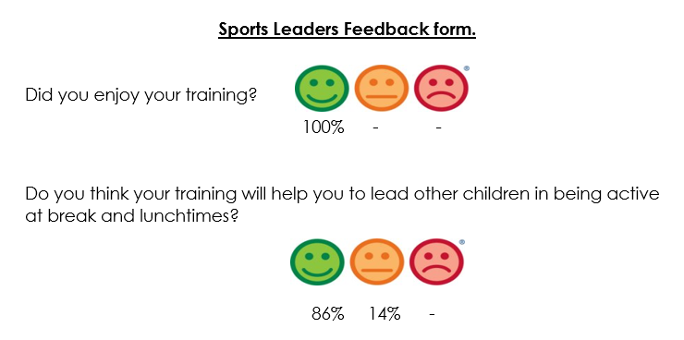  Sports Ambassadors were unable to attend the final training session due to Covid-19 closures. This meant that they could not complete their final challenge of hosting a sports festival for the KS1 children during the Summer term.  Year 3 children unable to be trained due to school closure in the summer term. However, the year 3 Sports Ambassadors from this year will hold training in the Autumn term (2020) for new year 3 and 4 children. | Children to disseminate skills further down the school. Year 4 sports ambassadors to begin training (taster sessions) year 3 children in the Autumn term 2020.
- YST Membership at level2 | RSP package includes this | Access to online resources, topical updates, exclusive offers, discounts and priority access to YST National PE & School Sport Awards & National Programmes – used for resources and staff training  Nationally recognised badge of excellence for PE and school sport.  Whilst we would have liked to have received the Platinum school games sports mark this year, due to Covid-19 closures this was nationally impossible. We received the Gold school sports mark due to our commitment to PE and sport across the Autumn and Spring terms and hope to achieve the Platinum in 2020-21. | Use this membership to upskill current staff/PE lead and further raise the profile of PE/sport within school.  Consider the impact of this and whether we need Level 2 if it needs paying for moving forward.
- All pupils to be offered new sport experiences. | Least active children able to attend an in-school club. | Autumn term audit to discover least active children in school. These children will then be offered a school-funded club to attend in the Spring/Summer term.  Find out if all PPG children are in at least one club over the year. If this is not the case, offer a club to them  Club attendance  Autumn 1-  Ks1- 48 chn / Ks2- 36 chn  Autumn 2-  Ks1- 56 chn/ Ks2- 48 chn  Autumn total- 188 chn/321 chn on role attended sports clubs at school.  Spring 1-  Ks1- 53 chn/ Ks2- 38chn  Spring 2-  Ks1- 58 chn/ Ks2- 35chn  Spring total- 184/321 chn on role attended sports clubs at school.  By the end of the Spring term, there were 6/163 (3.68%) KS2 children and 8/158 (5%) KS1 children who had not engaged in a sports club. These children were offered a paid-for club to attend in the Summer term. However, they could not attend due to Covid-19 school closures.  2 PPG children had not participated in any extra-curricular sports by the end of the Spring term due to declining the paid for clubs by school. | To continue to offer these types of clubs as extra-curricular.  Complete these questionnaires at the beginning of each year to gage the number of least active children and target them into joining a club.
- Specialist PE CPD for coordinator. | PE co-ordinator to attend the PE conference in March 2020.  To have highly skilled staff teaching PE within our school.  To learn new techniques and find out about new local initiatives. | Increased confidence and understanding of PE lead.  To develop PE skills.  To find out more around how to improve and develop PE within Russell.  Postponed until 2021 due to Covid-19 closures. | To budget for in future years if needed.
- Yr4 Bikeability course for all who were interested. | To teach year 4 children to ride their bicycles safely  Bikeability for all year 4 children who expressed interest.  To offer to all children as an opt out rather than opt in. | At Level 1 new riders learn to control and master their bikes in a space away from traffic such as a playground or closed car park.  At Level 1 you can:  prepare yourself and your bike for cycling  get on and off your bike without help  start off, pedal and stop with ta control  pedal along, use gears and avoid objects  look all around and behind, and control the bike  share space with pedestrians and other cyclists  Postponed until 2021 due to Covid-19 closures. | To budget for in future years if needed.
- Scoot sessions for KS1 | To teach year 2 children to scoot safely to school.  Scootability for all year 2 children who expressed interest.  To offer to all children as an opt out rather than opt in. | Children are confident with an active travel method to get to school  Children enjoy being active  Children are more active more of the time  Postponed until 2021 due to Covid-19 closures. | To budget for in future years if needed.
- Purchase festival jackets so children to feel proud to play competitive sport for their school. | To buy a set of sports jackets which the children will wear over their PE kits when attending competitive sports festivals. | Children are more engaged in competitive sports. Children to have pride in their school and a sense of team spirit.  Postponed until 2020-21 due to overspend on outdoor fitness gym. | To purchase in Autumn 2020 term.  Replace as and when needed down the line.
- Outdoor fitness gym on the field for KS2 pupils.  Astroturf around outdoor gym / access to the gym | To offer child-led learning during all outdoor times, including break and lunchtimes.  Extend KS2 play area so that it can be used in all weathers. Children will be able to be more active, more of the time.  Children will be able to access the outdoor gym equipment and trim trail in all weathers.  The gym equipment will be able to be used as part of the personal challenge, by sports ambassadors. | Children able to independently work on their own fitness during break and lunch times as well as during planned PE sessions using the equipment.  Children will be able to be more active, more of the time.  Children will be able to access the outdoor gym equipment and trim trail in all weathers.  The gym equipment will be able to be used as part of the personal challenge, by sports ambassadors.  Used by key worker groups during school closure provision to keep children active and engaged in the new type of schooling.  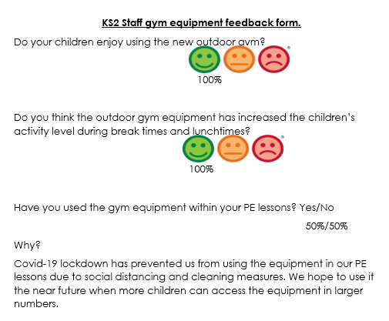  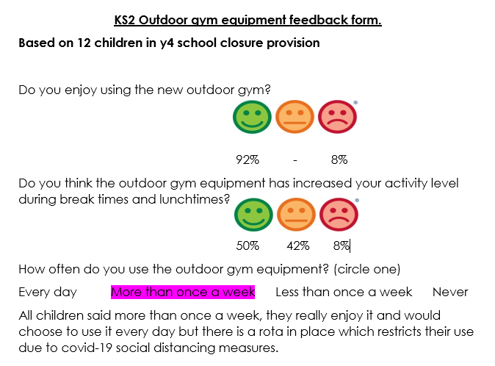 | To budget for repairs in future years if needed.
- Swimming for year 3 | Swimming for year 3 | Children’s swimming skills are increased  Children’s water confidence is increased  Children’s activity levels are increased  Year 4 children (19-20) who received this extra swimming last year have had much better competitive swimming results at the inter-school competition with Team 2 coming first.  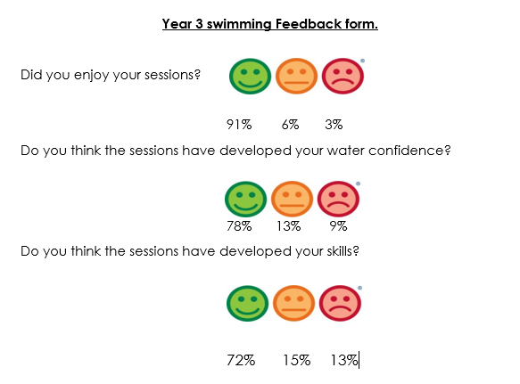  The breakdown of KS2 swimming targets into 2 years’ worth of lessons rather than the core year 4 lessons alone (PE milestone document) should ensure that more children achieve the expected swimming KS2 milestones before they leave year 4. | To budget for extra swimming sessions in the future if needed.  Children will have experience in the water before their curriculum requirement in year 4.  Children will maintain/develop these skills through their life.
- PE HUB membership | To ensure the sports resources within the school are up to date and conducive to learning and development both within and outside of curriculum time. | Staff feel confident in delivering sessions and have the resources available to do this to a high standard.  Children enjoy playtimes and are fully engaged in a range of activities.  Children are able to engage in physical activity inside and outside  Additional half-terms worth of planning on PE Hub specifically designed for socially distanced PE has proved vital to keep children active both in school and at home during the Covid-19 closure.  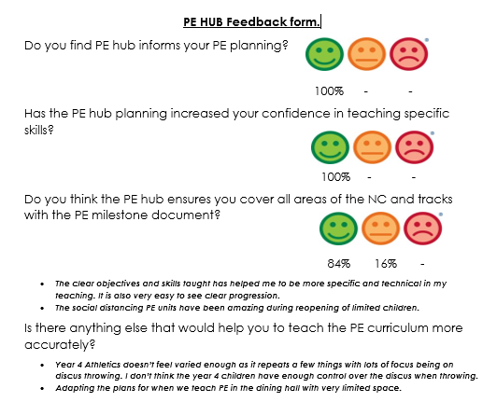 | To annually review the impact of the PE hub on in school planning and ensure all PE milestones (milestone document) are being met with the aid of PE Hub.  Budget for in future years if needed.

Festival participation
Our emphasis is placed on ensuring that as many children participate in as many festivals as possible. We do not focus on sending our ‘best’ children but rather ensuring parity and fairness.
Year | Date | Festival | Number of teams | Outcome
2 | 3,10,19 | KS1 Multiskills | 3 | Non-competitive
4 | 16.10.19 | TAG RUGBY | 2 | Non-competitive
3 | 25.11.19 | DANCE | 1 | Non-competitive
3/4 | 28.11.19 | INCLUSIVE TABLE CRICKET | 2 | Non-competitive  Value for integrity
3 + 4 | 15.1.20 | SITTING VOLLEYBALL | 2 | Non-competitive
4 | 21.1.20 | YEAR 4 TRANSITION | 3 | Non-competitive
2 | 24.1.20 | KS1 GYMNASTICS | 1 | 5th out of 8 teams
3 | 24.1.20 | KS2 GYMNASTICS | 1 | 6th out of 9 teams
3 + 4 | 27.2.20 | FOOTBALL | 2 | Postponed due to weather until May 2020- Subsequently cancelled due to school Covid-19 closure
4 | 11.3.20 | SWIMMING | 2 | Team 1 Large pool- 7th/10  Team 2 Small Pool- 1st/ 10 teams
2 | 13.3.20 | KS1 MULTISKILLS | 3 | Non-competitive
3 | 30.3.20 | NETBALL | 2 | Cancelled due to school Covid-19 closure
2 | 29.4.20 | KS1 FOOTBALL | 2 | Cancelled due to school Covid-19 closure
4 | 12.5.20 | QUAD KIDS | 3 | Cancelled due to school Covid-19 closure
4 | 20.5.20 | KWIK CRICKET | 2 | Cancelled due to school Covid-19 closure
4 | 1.6.20 | YEAR 4 TRANSITION | 4 | Cancelled due to school Covid-19 closure
3 | 23.6.20 | TENNIS | 2 | Cancelled due to school Covid-19 closure
2 | 7.7.20 | KS1 QUAD KIDS | 3 | Cancelled due to school Covid-19 closure

Possible Next Steps for the use of the Sports Premium for 2020-2021 from staff and children

- Purchase festival jackets so children to feel proud to play competitive sport for their school.

