Tuesday 31st March 2020
SPaG
Spellings - Word Families based on common words, showing how words are related in form and meaning.
Practise your spellings – try making a fortune teller to help practise the words.
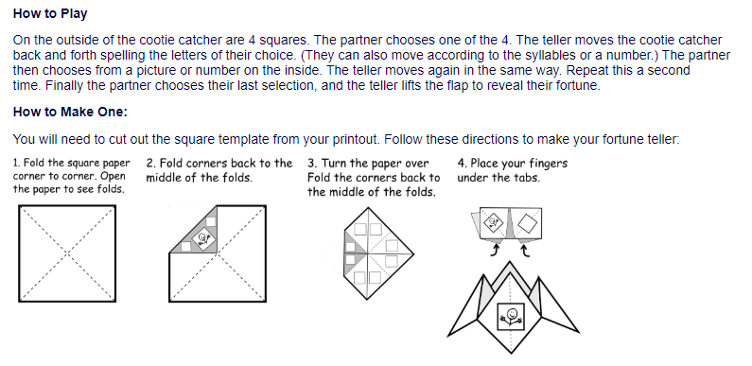
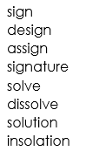

Word of the Day – content

Definition ____________________________________________
_____________________________________________________
_____________________________________________________
Used it in a sentence: ____________________________________________________
_________________________________________________________________________
Word Class: ____________________________________________________
Synonyms

English
Watch the clip called ‘Once in a Lifetime’ again.
https://vimeo.com/23805703
Odd Ones Out
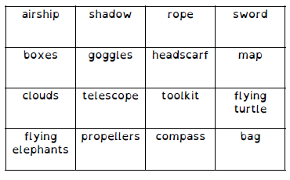
If you were telling the story which creature might you choose instead of a turtle? Why?
_______________________________________________________________________________________________________________________________________________________________________________________________________________________________________________________________________________________________________________________________________________________________________________________

Draw your animal below

Maths – Mental

1) What is the next number? 30, 40, 50
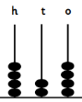
2) Write the number

3) What is the sum of 7, 9 and 5?

4) Take 1 from 300.

5) How many faces does a cube have?

6) 39 x 10 =

7) Which is the odd number? 675 642 348 374

8) 15 + 13 + 26 =

Maths – Place Value

1) Is 278 closer to 200 or 300?

2) Is 278 closer to 270 or 280?

3) Is 278 closer to 275 or 280?

4) 452 = 400 + 50 + 2
452 = 300 + 150 + 2
452 = 200 + 200 + 52
Find 2 more ways to partition 452.

5)Find 4 ways to partition 653.

History – Romans
