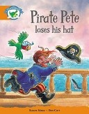
Name: .
Pirate Pete Loses His Hat
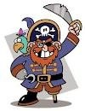
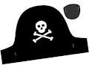
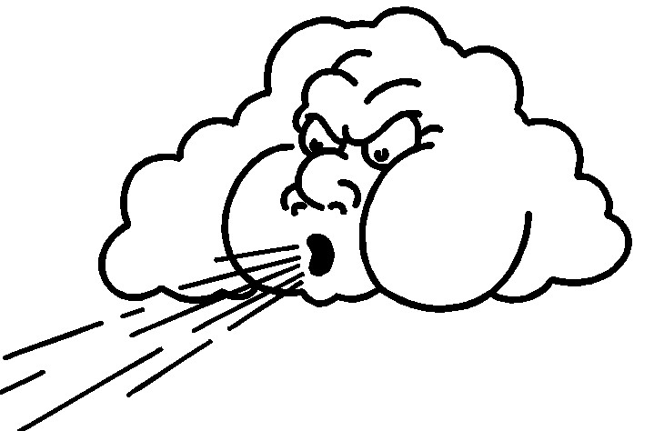
Susan Akass and Ben Cort
Pete was a pirate.
He had a parrot called Beaky and he had a big hat.
One day the wind blew the ship up and down.
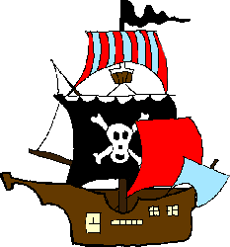
“I don’t like the wind”, said Pete.

“I don’t like the wind”, said Beaky.

The wind blew the hat into the sea.
“Help, help!” said Pete. “I want my hat.”

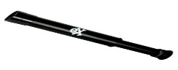
Pete got a telescope.
“What can you see?” said Beaky.
Beaky got a telescope. “I can see the hat”, said Beaky.

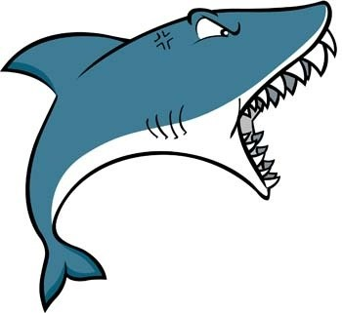
“Can you?” said Pete.

“Yes”, said Beaky. “I can see a hat and I can see a big shark!”

- Pete was a a.) ship
b.) shark
c.) pirate
- What was the name of Pete’s parrot?
a.) Peck
b.) Beaky
c.) Parrot
- What blew the ship up and down?
a.) the wind
b.) the rain
c.) the sun
- Where did the hat get blown to?
a.) into the ship
b.) into the tree
c.) into the sea
- Underline the animals in the story: dog, parrot, bug, shark, cat
- What happened to Pirate Pete’s hat? _____________________________________________________________________________________________________________________ ___________________________________________________________.

