Friday 19th June 2020
SPaG
Spellings – Words with a chuh spelt ture
Create a word search using the words in your spelling list. Write the spelling words in the grid below. Words can go forwards, backwards, up, down and diagonally. Finish by filling in the remaining spaces with random letters.
nature
future
pasture
gesture
mixture
picture
puncture
creature

Word of the Day – disaster

Definition ____________________________________________
_____________________________________________________
_____________________________________________________
Used it in a sentence: ____________________________________________________
_________________________________________________________________________
Word Class: ____________________________________________________
Synonyms

English
Today you need to go back and edit your newsletter / blog.
Task:
1. Read your work carefully.

2. Check your spellings using a spelling strategy.

3. Have use checked for capital letters in the wrong place or missing ones?

4. Can you add some more interesting punctuation marks example ! , ' ?

5. Uplevel your sentences to make your work more interesting and by adding at least 5 adjectives, 3 adverbs and using a thesaurus to uplevel 3 words.

Once you have finished your work can you either ask a member of your family or send a photo of your work to a friend from Year 4 and complete 2 stars and a wish on their work.

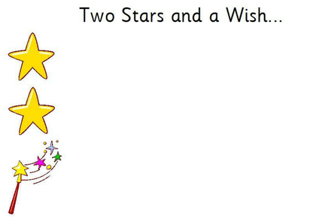

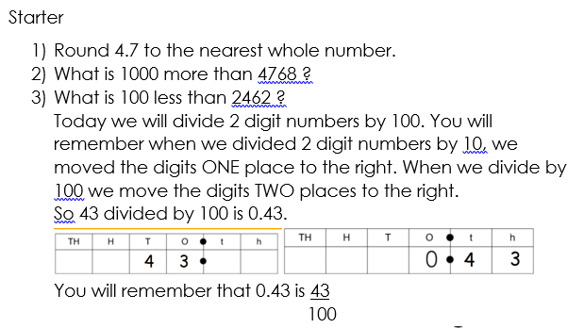
Maths

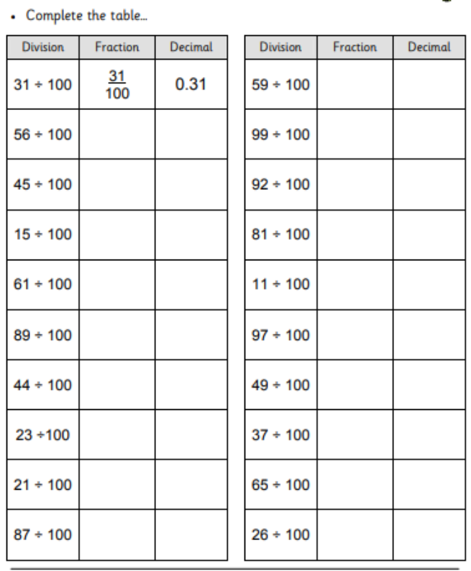

PSHCE
Think of a time when you have been kind to others. What did you do?
How do you feel thinking about this?...
How did the other people feel?

What is the best thing that has happened this week?

