Hello Puffins, Owls and Wrens!

How are you all? We hope you are all well and continue to enjoy Home Learning Activities. We also hope you are enjoying the weather and have fun.
Please keep us posted and let us know how you are getting on. Did you enjoy any of the activities in particular? Do you have any favourites? We love hearing from you. 😊
Please find the next week’s Home Learning pack attached to this letter. Have a go and as always try your best. We are very proud of all of you for trying hard and completing the activities we sent you every week. We can’t wait to see how you are going to impress us and your grown-ups this week! If you have any questions about any of the activities, please just let us know. We are here to help.
We hope you will enjoy these new activities 😊 Don’t forget to have fun and stay safe especially when out in the sun. Keep cool and well hydrated.

If you enjoy getting out of the house and eating outdoors then July is the month for you, as the whole of this month is National Picnic Month!
Also, July is a plastic free month!
Plastic Free July is a global movement that helps millions of people be part of the solution to plastic pollution so we can have cleaner streets, oceans, and beautiful communities.
For more information visit https://www.plasticfreejuly.org/

Take care, look after yourselves and your families and keep smiling

We miss you all,
Mrs. Cox, Mrs. Milligan, Mrs. Jochacy and Mrs. Athanasiou xxxx

Year 1 Phonics activities – Summer 2 – Week 5 and Year 1 spellings

Session 1 - Monday 29th June 2020  Warm up activity – read and write tricky words and Year 1 Common Exception Words  Tricky words: because  Year 1 Common Exception Words: your, they, be, he  After reading all of the words, cover one word and write it on a piece of paper. Check the spelling and try another word.  At the end of the clip see if they can write a sentence using one or more of the tricky words they have written down. | Session 1 - Main activity  To know different phonemes which use the same graphemes: long or short 'i'.  Stretch and blend these words – which phoneme does the ‘I’ grapheme make?  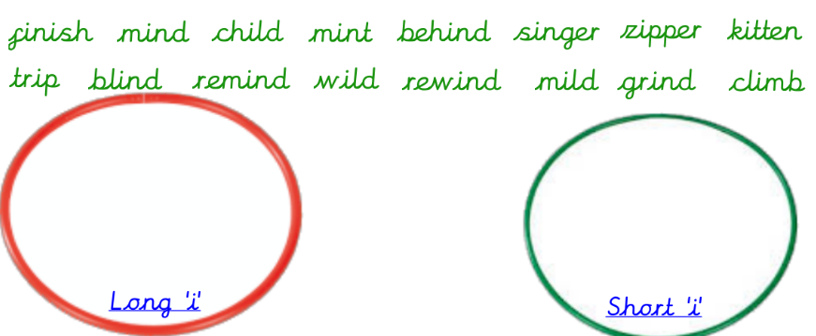  Can you sort these words into the correct hoops?
Session 2 - Tuesday 30th June 2020  Warm up activity  Recap phase 4 phonemes using ‘Roll and Read’ game  Roll your dice, read a word from the numbered column and colour it in when correct. | Session 2 - Main activity  Can you think of words with the long or short ‘I’ phoneme? How are they spelt? Split your board into 2 and write words under each heading.
Session 3 - Wednesday 1st July 2020  Warm up activity – Recap phase 5 phoneme flashcards  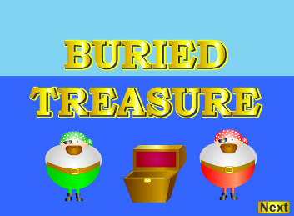  Play buried treasure – phase 5 – e-e  https://www.phonicsplay.co.uk/resources/phase/2/buried-treasure | Session 3 - Main activity  To know different phonemes which use the same graphemes: long or short 'o'.  Can you sort these words into the correct hoops?  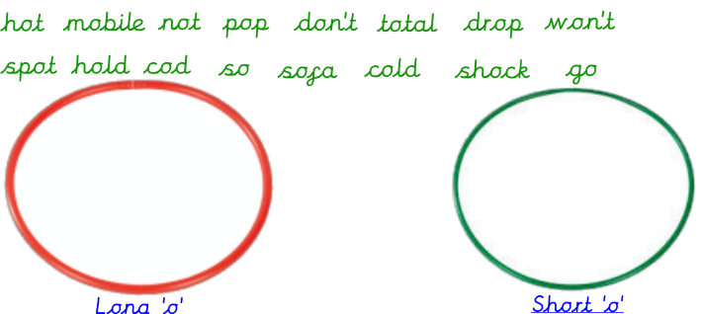
Session 4 - Thursday 2nd July 2020  Warm up activity  Practise reading the words and identify which long 'i' sound it is e.g. ie, igh, i-e  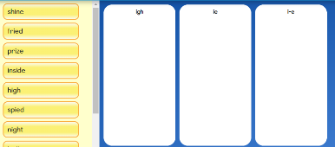  https://central.espresso.co.uk/espresso/primary_uk/subject/module/activity/item819127/grade1/module63425/index.html | Session 4 - Main activity  Stretch and blend these words. What sound does the ‘o’ grapheme make?
Session 5 - Friday 3rd July 2020  Warm up activity  Can you read all of these phonemes in 1 minute?!  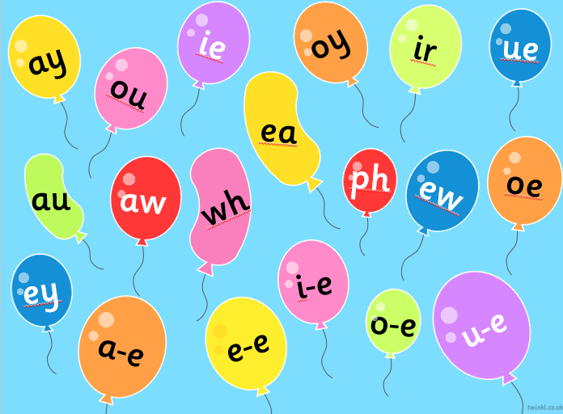 | Session 5 – Main activity  Can you think of words with the alternative ‘o’/’o’ sound? How are they spelt? Split your paper into 2 and write words under each heading.

Year 1 English Activities – Summer 2 Week 5
This week’s English will be based around the book ‘Grandad’s Island’ by Benji Davies. If you have the book at home, read it either on your own or to a grown up.
If you don’t have the book you can watch the video here...
https://www.youtube.com/watch?v=vqDtPXeV7cU
Before reading/ watching the video, look at the book cover:
What do you think this book is going to be about?
What characters might we meet?
Do you think it is going to be fiction or non-fiction?
Monday  29th June | Discuss points after reading the story:  Why did Grandad say, "No...no, I don't think I will."  What does the word prised mean? "Syd carefully prised it open."  Why did the journey seem a lot longer without Grandad?  Did you enjoy the story? Why?  What was your favourite part?
Tuesday  30th June | In English books draw a picture of your Grandad/ special person and then write some words and/or sentences to describe what they look like (appearance) and how they act (personality).
Wednesday 1st July | What do you think Grandad saw, heard, smelt and did on the island?  How does he feel on the island?  Discuss and then write down your ideas.
Thursday 2nd July | 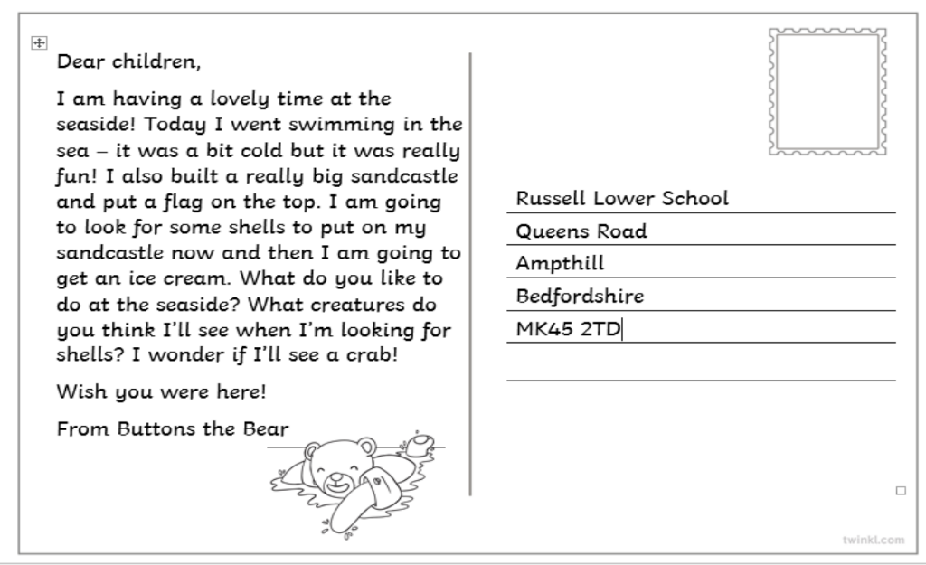  Here is an example of a postcard.  Write a postcard in the role of Grandad to Syd. Remember to use capital letters, finger spaces, full stops, question marks and exclamation marks.
Friday 3rd July | WOW writing  Choose a picture. You can write anything you want about it!  You must remember:  - Full stops  - Capital letters  - Finger spaces  - Re-read your writing to check it makes sense

Year 1 Maths Activities – Summer 2 week 5
This week we are:
- counting to and across 100, forward and backwards, beginning with 0 or 1, or from any given number.
- Reading and writing numbers to 100 in numerals
- Counting in multiples of 2s, 5s and 10s
- Looking at the value of different coins and notes

Vocabulary:
- count, forwards, backwards, groups, quickest way, most efficient , hundred square, how many altogether etc.

Monday 29th June 2020

Use the link below (100s square to practise counting forward and backwards, beginning with 0 or 1, or from any given number. You can also explore number patterns and counting in multiples.
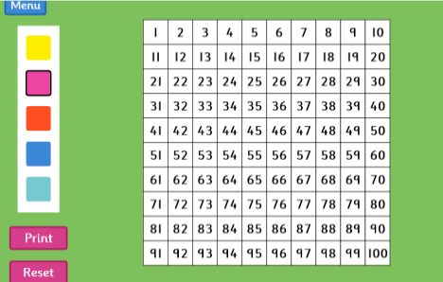

https://www.topmarks.co.uk/learning-to-count/paint-the-squares
Activity:
Pick a number card (10 – 50) and represent the number using your own base ten equipment.
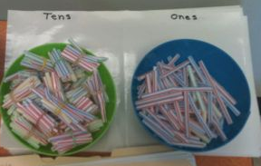
Homemade base ten equipment examples:
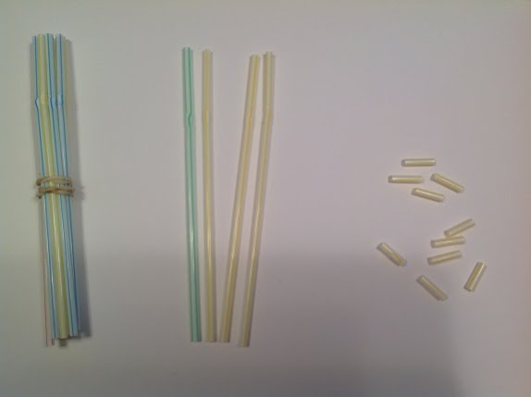
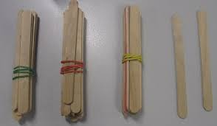
Challenge:
Try the same activity with numbers up to 100.

Tuesday 30th June 2020

Activity:
Can you partition these two-digit numbers?
84 67 49 56 73
Complete the stem sentence for each number:
e.g.
84 has 8 tens and 4 ones.

Challenge:
Choose a number. Can you write one more and one less than the number you picked? Then write how many tens and how many ones are there in your number.

Wednesday 1st July 2020
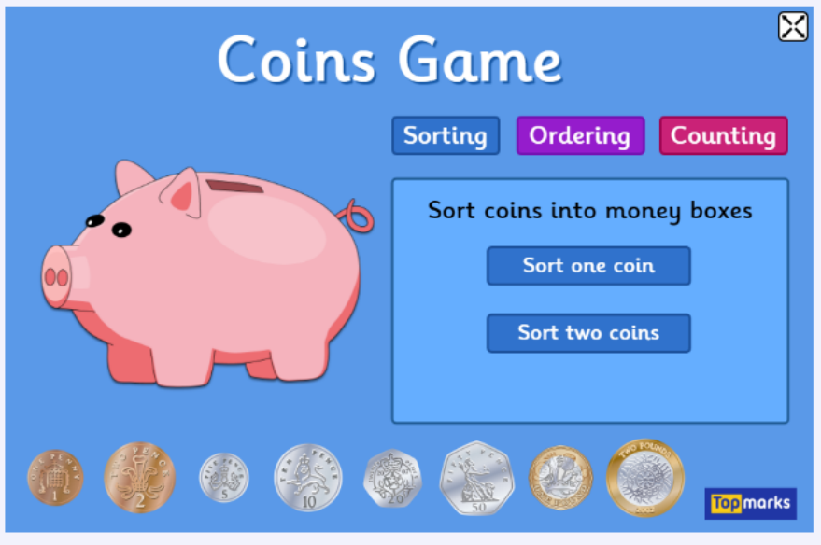
https://www.topmarks.co.uk/money/coins-game

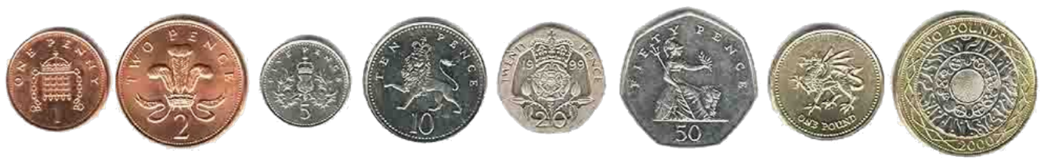
If you can, find these coins and sort them into pounds and pence.
How can you write pence in short?
What does the pound sign look like?

Activity:
Use the coins to make totals to 20p.
Challenge:
Choose 2 coins. Can you choose the correct sign to compare? < = or >

Thursday 2nd July 2020
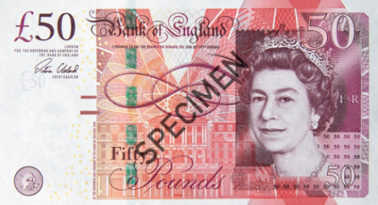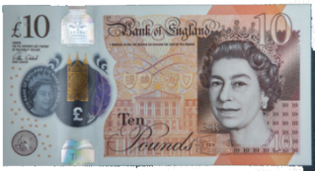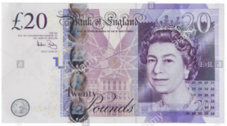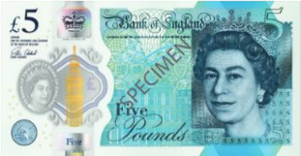
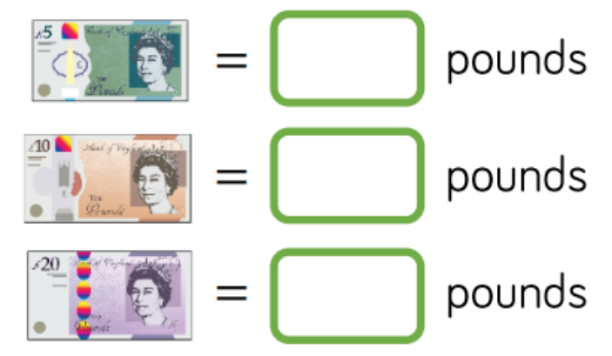

Can you name each note?
What is the same about each
note?
What is different about each note?

Activity:
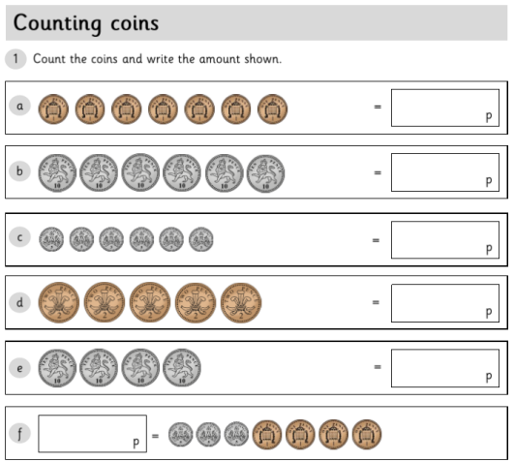

Challenge:
Can you order your coins from the least value to the most?

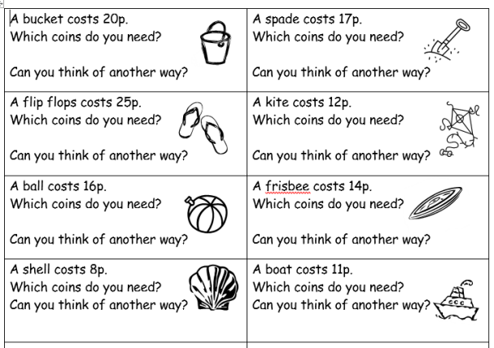
Friday 3rd July 2020

Year 1 Theme activities – Summer 2 week 5
Date: | Activity:
Monday 29th June 2020 | Art - mix primary colours and describe how to make secondary colours with them.  Can you guess what the 3 primary colours are (blue, yellow, red)?  There are 3 special colours known as primary colours. These colours can be mixed together to create all the other colours.  Create a colour wheel showing primary colours.  Next, divide a piece of paper into 3 columns with 3 headings (red, yellow and blue) then list as many things as you can think of that are red, yellow and blue.
Tuesday 30th June 2020 | Art - mix primary colours and describe how to make secondary colours with them.  Look at some of the work by Piet Mondrian who mainly painted using primary colours.  Create work based on the art of Piet Mondrian.  You will need: a sheet of paper/card; some masking tape; red, yellow, blue and black paint; paintbrushes. Lay the masking tape in straight lines over the paper to make square and rectangular sections.  Choose which primary colour you want to go in each box and paint them in. You can paint some boxes black too if you want to. When the paint is dry, you can carefully remove the masking tape. Be careful not to rip the paper.  Use a ruler and felt tip to draw straight lines around and between the shapes. You now have a piece of artwork in the style of Mondrian!
Wednesday 1st July 2020 | Art  What are secondary colours?  What colour do you think we would get if we mixed:  - red and yellow?  - red and blue?  - Blue and yellow?  (orange, purple and green are secondary colours because they are made from mixing primary colours together)  Have a go at mixing colours together.
Thursday 2nd July 2020 | Art  Complete the colour wheel by mixing primary colours to make secondary colours. Make sure you place the colours in the correct section of the wheel!
Friday 3rd July 2020 | Art - mix primary colours and describe how to make secondary colours with them, and add white to colours to make tints and add black to colours to create shades.  Spend some time practising mixing different shades of a colour. Choose your favourite colour and then paint each section of your design (A3) a different shade of that colour.  Here are some examples. You can make lighter shades of a colour by adding white and darker shades by adding black.

