Thursday 2nd July 2020
SPaG
Spellings – Words with the sh sound spelt ch
Arrange the words in your spelling list into alphabetical order. Remember, if two words start with the same letter then look at the second letter. If the second letter is the same then look at the third letter...
chef
chute
chalet
machine
brochure
parachute
ricochet
moustache

Word of the Day – frantic

Definition ____________________________________________
_____________________________________________________
_____________________________________________________
Used it in a sentence: ____________________________________________________
_________________________________________________________________________
Word Class: ____________________________________________________
Synonyms

English – Use chapter 14 of The Twits - The House, The Tree and The Monkey Cage
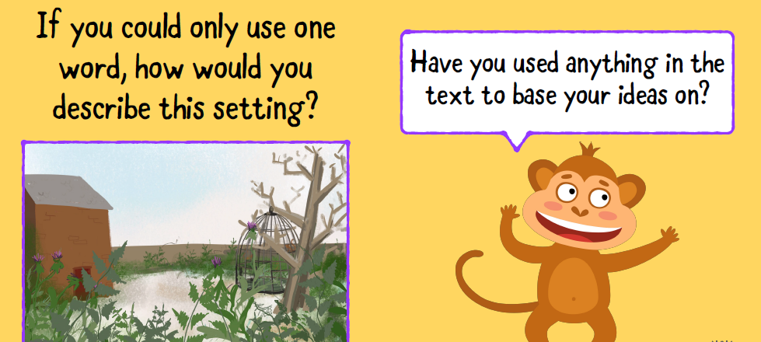
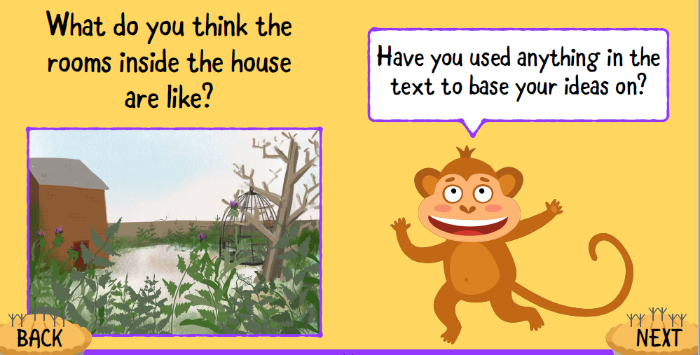
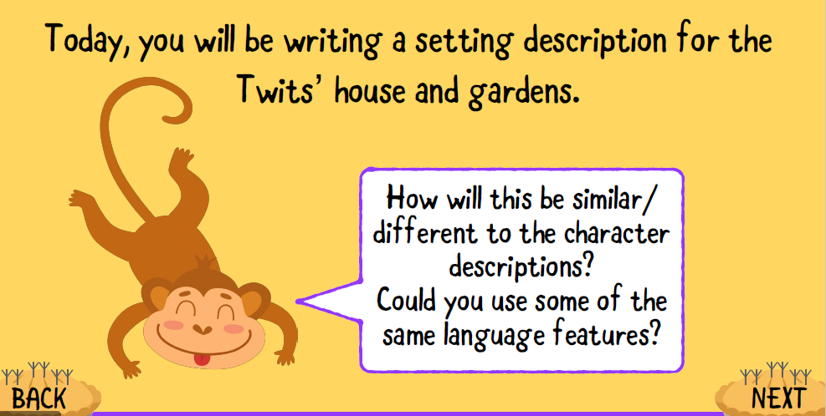
Task
Describe the house or the garden. Try to use a fronted adverbial which adds information about where the action is happening as well as similes and adjectives to make your descriptions more interesting.
Maths
- ¼ + ¼ =
- 3/5 + 2/5 =
- 4/5 + 4/5 =
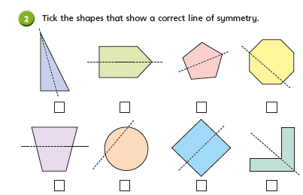
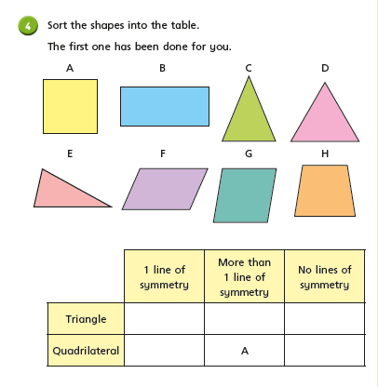

Geography
Yesterday we leaened about Biomes. Can you remember what a biome is? Can you name one?
Today we are going to look closely at climate zones.
Think- How would you describe our climate in the UK?
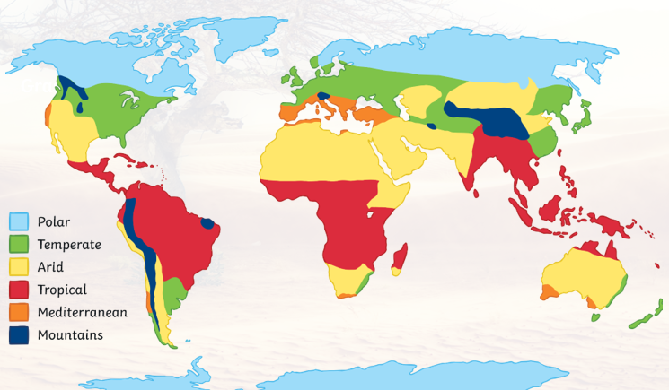
Task- complete the table below:
Climate | Description | Example of a country
Polar |  | Antarctica
Temperate | Cold winters and mild summers
Arid |  | The Sahara desert
Tropical | Hot and wet all year around
Mediterranean |  | Spain
mountain | Very cold, sometimes wet all year

Challenge: Imagine you are on holiday anywhere in the world. Write a postcard describing the landscape and the climate. You could include the type of weather you are experiencing, the plants you see and the animals!

