Tuesday 22nd April 2020
SPaG
Spellings - The prefix im before a root word starting with m or p
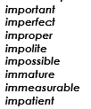
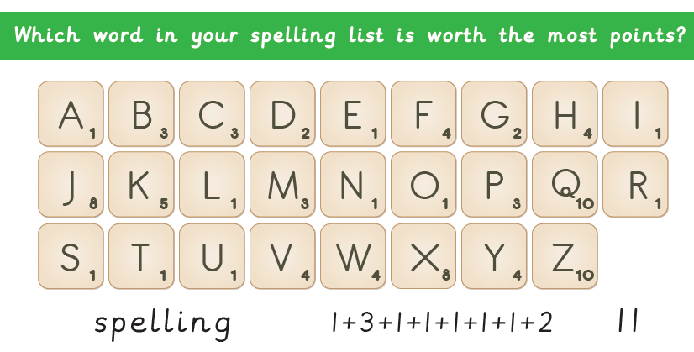
Practise your spellings

Word of the Day – shabby

Definition ____________________________________________
_____________________________________________________
_____________________________________________________
Used it in a sentence: ____________________________________________________
_________________________________________________________________________
Word Class: ____________________________________________________
Synonyms

English
Watch the clip called ‘Once in a Lifetime’ again.
https://vimeo.com/23805703
Imagine that the clip you watched was part of a story book. Create a front cover for the book to show what the book is about.

Maths – Mental
- Write the next 3 numbers in the sequence: 125, 150, 175
- 62 x 5 =
- ¼ + ¼ + ¼ =
- 210 + 72 = 300 - ?
- Write the time 2:40 in digital time and in words.
- Write all the multiples of 7 up to 91.
- Round 134 to the nearest ten.
- Some March nights were really cold. One night it was 7 degrees less than 4 degrees. What was the temperature?
- Write fractions which are equivalent to 4/5.

Maths – Decimals
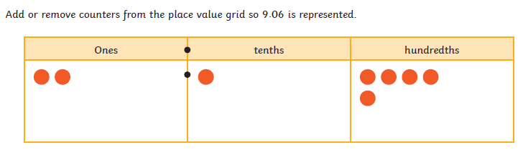

Geography
You will need colouring crayons/felt pens and an atlas/ the internet.
What is Egypt’s flag? Colour the one below OR you could draw your own.

Challenge: What does the flag represent? Why are there three colours? What is the bird? Could you annotate your flag with things you have found out about its meaning?

