Thursday 23rd April 2020
SPaG
Spellings – To apply the prefix sub
subtotal | subtitle | substitute | subplot
subheading | subdivide | submerged | subtropical

Challenge! Create your own word search using your spelling words!

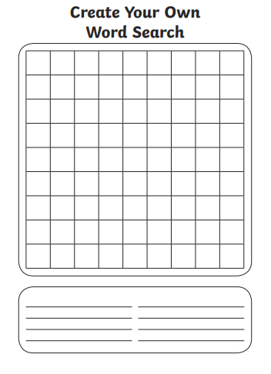

English

Challenge! Write a postcard or a letter to a friend or a family member telling them all about one of your days at home this week. Can you include some personification, a simile or a metaphor and some fronted adverbial phrases?

Maths
Four Awesome Operations
Addition (using column method)  282 + 513 | Subtraction (using column method)  902 – 322 | Multiplication (using grid method)  52 x 3 | Division (using sharing of place value counters)  12 ÷ 8
Money
Complete the money word problems below using everything you have done over the last two days! Some of the word problems involve addition and some involve subtraction.
- Abby needs to buy some cotton wool, some water and a bottle of shampoo. The cotton wool costs 30p, the water costs 60p and the shampoo costs 99p. How much does Abby spend altogether? Give your answer in pounds.
- Carter buys flowers for his mum at the market. The flowers cost £5.67. Carter has £8.44. How much change would he get if he gave the shopkeeper all his money?
- Mr. Syrett buys 2 DVDs. One costs £4.56. The other costs double this amount. How much does he spend altogether?
- Mugs cost £2.13 in the shop. Amy wants to buy 4. When she gets to the till, the shopkeeper gives her 30p off her total because she is buying more than one. How much does Amy pay altogether?
- Grace sells 4 t-shirts. The most expensive one sells for £3.40. The cheapest one sells for £1.20. The other two t-shirts sell for the same amount – each one costs double the amount of the cheapest t-shirt. How much money does Grace make altogether?
Birthday Cake
Dora spends £7 and 76p on a birthday cake.
She pays with a £10 note.
How much change does she get?
The shopkeeper gives her six coins for her change.
What coins could they be?

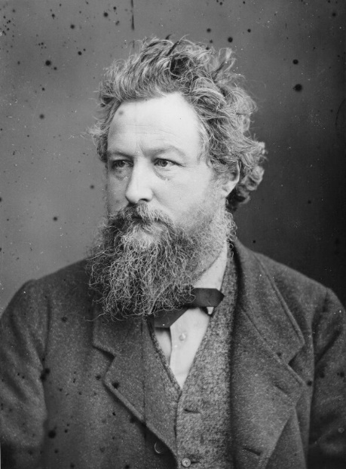
Art
In Art we are going to be taking inspiration from the great William Morris.

Challenge! Find out the answers to these questions about William Morris.

- Who was William Morris?
- What kind of art did he make?
- What did he include in his art?
- What movement did he start? Why did he start it?

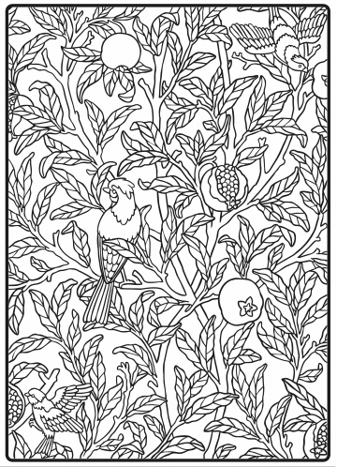

You might like to have a go at colouring one of his designs or you could try to draw your own.

