Dear Puffins, Owls and Wrens!

How are you all? We hope you are all well and enjoying the Home Learning Activities.
We always love to hear what you’ve been up to and how you got on with the activities. Were there any activities you particularly liked? Let us know. We look forward to seeing your work and photos 😊
We hope you enjoy the change in the weather and manage to find ways to keep busy.
Please find the next week’s Home Learning pack attached to this letter. Have a go and as always try your best. We are very proud of all of you for trying hard and completing the activities we sent you every week. We can’t wait to see how you are going to impress us and your grown-ups this week! If you have any questions about any of the activities, please just let us know. We are here to help.
We hope you will enjoy these new activities.
Also, here is a riddle for you to solve
Q: What has a face and two hands, but no arms or legs?
For a bit more challenge, here is a brain teaser - two images of a picnic scene with seven differences between them. Can you find them?
Take care, look after yourselves and your families and keep smiling
We miss you all,
Mrs. Cox, Mrs. Milligan, Mrs. Jochacy and Mrs. Athanasiou xxxx
P.S. You will find the answers to the riddle and brain teaser at the end of this pack.

Year 1 Phonics activities – Summer 2 – Week 3 and Year 1 spellings

Session 1 - Monday 15th June 2020  Warm up activity – listen to the ‘tricky word song’  Encourage your child to sing along and have a go at writing the words.  https://www.youtube.com/watch?v=R087lYrRpgY  At the end of the clip see if they can write a sentence using one or more of the tricky words they have written down. | Session 1 - Main activity  o split e digraph  (o_e – e.g., rode, nose, spoke, token)  Introduction to o split e digraph – watch the video to introduce the sound.  You will need to login to ‘Espresso’ which can be accessed from the school website – ‘kids area’ and follow the link  https://central.espresso.co.uk/ (once logged in please go to – Espresso/Key Stage1/ English/Phonics / Ash’s Phonics /o-e)  https://central.espresso.co.uk/espresso/primary_uk/subject/module/video/item92160/grade1/module63425/index.html  Have a go at making a list of split digraph o_e words together.  If for any reason you are unable to access Espresso then please use the YouTube link below which will give you some split digraph i words to read.  https://www.youtube.com/watch?v=VpTIpkgU1fY  Read some o split e digraph words: rope, bone, cone, broken
Session 2 - Tuesday 16th June 2020  Warm up activity – Tricky words and Year 1 Common Exception Words:  through, mouse, are, was, were  Write down the words on a piece of paper. Use look, say, cover, write and check to practise those words.  Look – have a look at one of the words  Say – say the word out loud  Cover – cover the word  Write – write the word down on a separate piece of paper  Check – uncover the word and check your spelling | Session 2 - Main activity  Have fun reading and sorting i_e split digraph real and nonsense words!  Divide a piece of paper into 2 (nonsense and real words) and sort/write down the words. Remember to add sound lines and buttons.  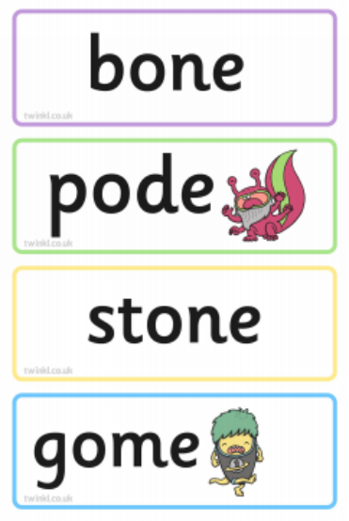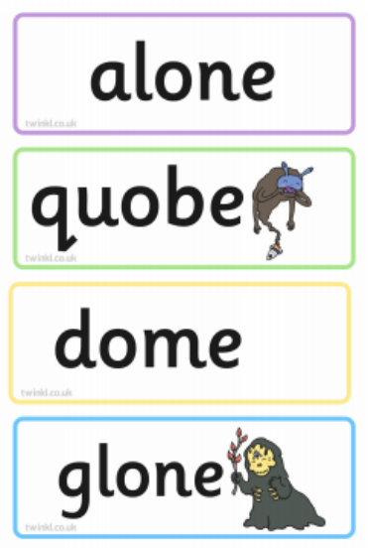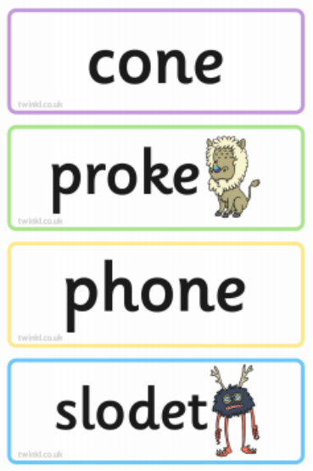
Session 3 - Wednesday 17th June 2020  Warm up activity – Recap phase 5 phonemes/ digraphs (2 letters together that make one sound)  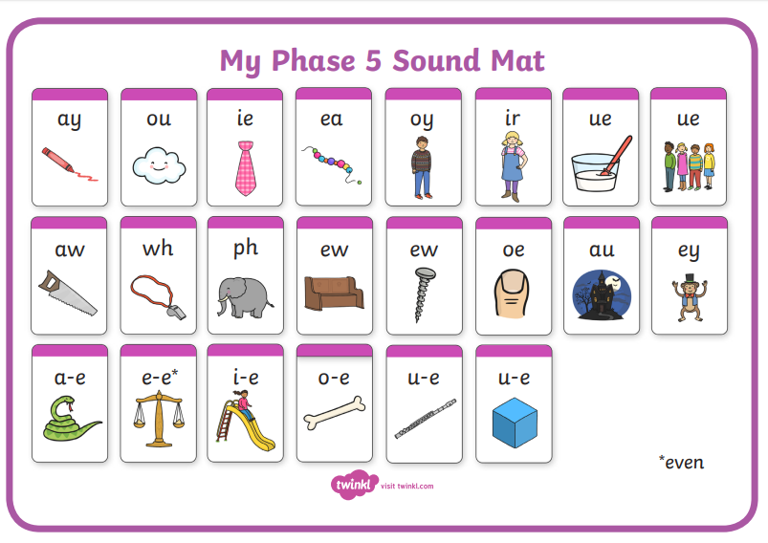  How many digraphs can your child write in 2 minutes? Maybe you could have a go too and see who gets the most! Encourage your child to check your words. Did you miss any? | Session 3 - Main activity  Practise spelling the o split e digraph words  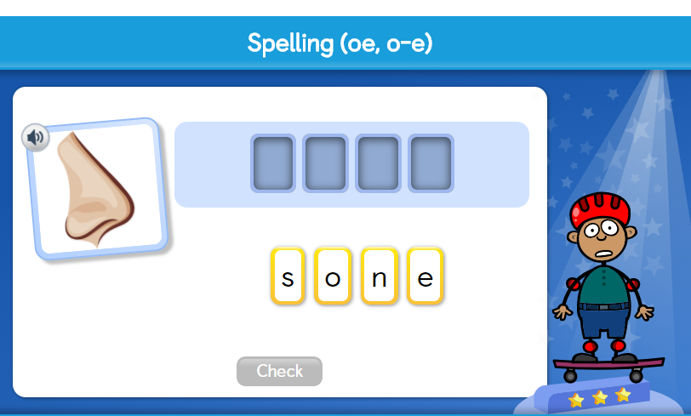  https://central.espresso.co.uk/espresso/primary_uk/subject/module/activity_index/item63425/grade1/index.html
Session 4 - Thursday 18^{h} June 2020  Warm up activity –  How many words with split digraph o_e can you make in 2 minutes? | Session 4 - Main activity  Can you think of words with the long o sound? How are they spelt? Split your paper into 4 and write words under each heading.
Session 5 - Friday 19th June 2020  Warm up activity – phase 3 and phase 5 sounds  How many o_e split digraph words can you think of and write in 1 minute? | Session 5 – Main activity  Can you write a sentence/ sentences with o_e split digraph words? Try to include one or more of these tricky words: through, mouse, are, was, were.  You could model by writing a sentence down first and ask your child to highlight the tricky words they can see or you could write a sentence down and say it to your child asking them to write it down without seeing it! After they wrote it down you could show them your sentence so that they can check their spellings.

Year 1 spellings
Weekly spellings:

Dear Parents/ Carers,
This week we will continue to practise last week’s spellings. Please continue to practise them at home as you had been doing before school closed. We find the ‘look, read, cover, write, check’ approach the best way to learn the spellings.
At school the children are usually ‘tested’ on their spellings on a Monday. Please feel free to keep to this structure.
The children should hopefully remember which group they were in for their spellings. If any children from group 1 or 2 want to challenge themselves with more spellings please feel free to let them have a go.
Group 3
Monday 15th June 2020
Group 2
Monday 15th June 2020
Group 1
Monday 15th June 2020

Year 1 English Activities – Summer 2 Week 3
This week’s English will be based around the book ‘The Rainbow Fish’ by Marcus Pfister. If you have the book at home, read it either on your own or to a grown up.
If you don’t have the book you can watch the video here...
https://www.youtube.com/watch?v=r9mryuEKkKc
Before reading/ watching the video, look at the book cover, where do you think this story is going to be set?
Do you think it is a fiction or non-fiction book? Why?
Monday  15th June | You are going to make your own lollipop stick characters from the story and have a go at retelling the story. Remember to explore how the different characters felt at different points in the story.  Before you start, record some adjectives (*) on a piece of paper to help you when retelling the story. Have a think: How did Rainbow Fish felt when blue fish asked for a scale? How do you think the blue fish felt when Rainbow fish said, ‘Get away from me!’ What advice would you give to Rainbow Fish? Why?  When Rainbow Fish shared his scales with everyone, How did this make Rainbow Fish feel? How did it make the other fish feel?  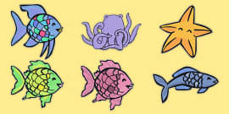  https://www.twinkl.co.uk/resource/t-t-1304-the-rainbow-fish-stick-puppets  *adjective - an adjective is a word that describes an animal, person, thing, or thought. Adjectives include words that describe what something looks like and what it feels like to touch, taste, or smell.
Tuesday  16th June | Think about the story and what you wrote/ discussed yesterday. In your own words write about a time when someone would not share with you. Describe how the person behaved and how it made you feel.  Think about:  How did you feel? Why?  What did you say? Why?  What did you do? Why?  Can you also add details of how you solved the problem?
Wednesday 17th June | Write two sentences in the speech bubbles (*) giving advice to Rainbow Fish. Remember to use capital letters, full stops and finger spaces. Can you use a question mark in one of your sentences?  *A speech bubble shows what a character is saying.
Thursday 18th June | Create a set of instructions to teach people how to look after a pet (rainbow) fish.
Friday 19th June | Complete the book review using the page below or answer the following questions from the page:  - What is the setting?  - Who is the main character?  - What happens first?  - What happens next?  - What happens last?  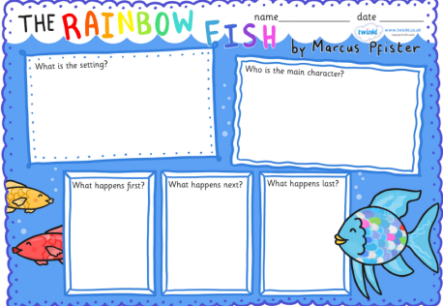

Year 1 Maths Activities – Summer 2 week 3
This week we are looking at sequencing and time (telling the time to the hour and half hour).
Do you know what sequencing is? Have a think and share your idea/s with someone.
Sequencing - arranging things in particular order
Vocabulary:
before, after, next, first, finally, today, yesterday, tomorrow, morning, afternoon, evening, sort, order
telling the time, hour, o'clock, minute hand - longer hour hand - shorter, hands, clock face.

Monday 15th June 2020
Activity:
Write about your day by sequencing events in chronological order using the words: before, after, next, first, today, yesterday, tomorrow, morning, afternoon and evening.
e.g. Today I woke up early in the morning and got out of bed. I got dressed before I had my breakfast. Next I brushed my teeth and after that I went to school.

Challenge:
Describe a special day to a friend. Use the words; before. After, first, next, morning, afternoon and evening.

Tuesday 16th June 2020

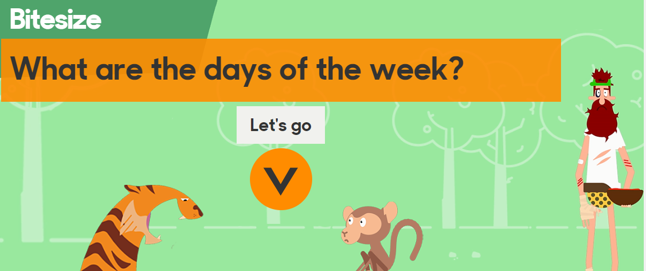
https://www.bbc.co.uk/bitesize/topics/zrqqtfr/articles/ztjg39q
Activity:
Fill in the missing days and complete the sentences.
Today is Thursday, yesterday was_________________________
Today is Monday, yesterday was ________________________
Today is Sunday, yesterday was _________________________
Today is Wednesday, tomorrow is _______________________
Today is Friday, tomorrow is _____________________________
Today is Tuesday, tomorrow is___________________________
Yesterday was Saturday, today is _______________________
Yesterday was Tuesday, today is ________________________
Yesterday was Wednesday, today is ___________________

Wednesday 17th June 2020
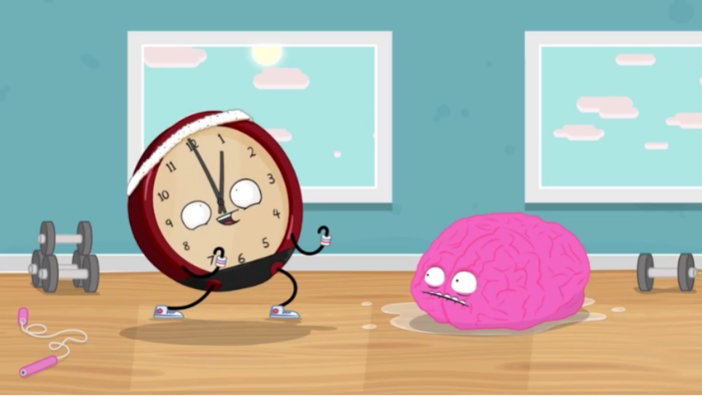
https://www.bbc.co.uk/bitesize/topics/zhk82hv/articles/zcmdwxs
Activity:
https://www.topmarks.co.uk/time/teaching-clock
clink the link to teaching clock, practise o’clock times
Challenge:
Use chalk to draw your own clock. Remember your clock needs to have a face, numbers, an hour hand and a minute hand.

Thursday 18th June 2020
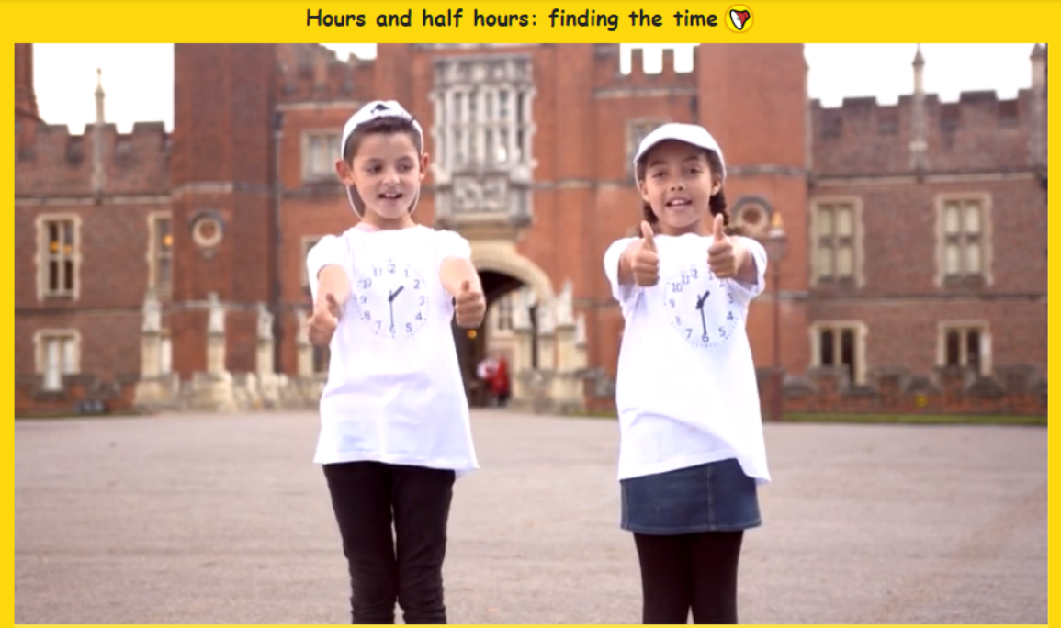
https://central.espresso.co.uk/espresso/primary_uk/subject/module/video/item868417/grade1/module849349/index.html

Activity:
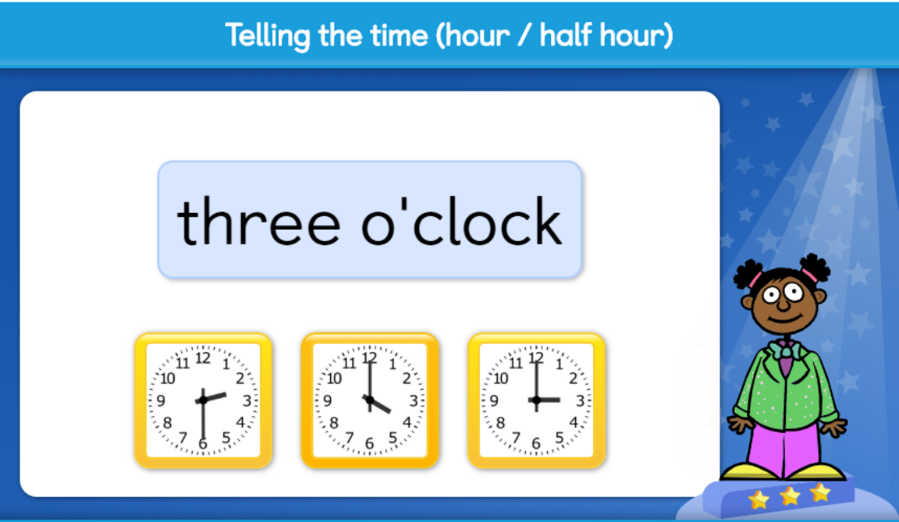 Have fun practising some half past times.
https://central.espresso.co.uk/espresso/primary_uk/subject/module/activity/item871587/grade1/module849349/index.html

Challenge:
Use your clock faces to make some o'clock times.
Can you challenge yourself to make some half past times?

Friday 19th June 2020

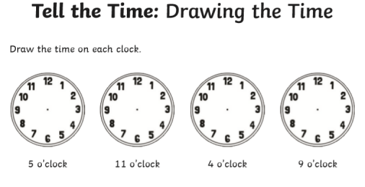
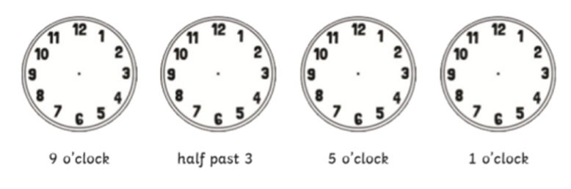
Challenge – word problems
Bart leaves for football at 10 o’clock.  It takes him one hour to get there. What time does he get there?  Draw the time on the clock. |  | 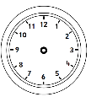
Laura goes swimming at 9 o’clock. She swims for 1 hour. What time does Laura get out of the pool?
Draw the time on the clock.
The Angry birds go to the cinema. They arrive at 3 o’clock. The film lasts one hour. What time do they leave the cinema?
Hello Kitty goes shopping. She goes on the bus which takes one hour. If she sets off at 11 o’clock, what time does she get there?
The children start dancing at 6 o’clock. They finish an hour later. What time do they finish dancing?

Year 1 Theme activities – Summer 2 week 3
Date: | Activity:
Monday 15th June 2020 | National Nature Photography Day (15 June)  Each year, June 15 is designated by the North American Nature Photography Association (NANPA) to promote the enjoyment of nature photography, and to explain how images are used to help conservation and protect plants, wildlife, and landscapes both locally and globally.  https://vimeo.com/415610518  Create a scavenger hunt for birds, butterflies, insects, rocks, and other natural sights likely to be close to you. But don’t just list what you’ve found. Take photos!
Tuesday 16th June 2020 | Science – Identify and name a variety of common wild and garden plants.  Identifying wild flowers.  Cut out and/ or match pictures to the correct description.  Which is your favourite and least favourite wild flower? Explain why you chose those flowers. For an extra challenge write down your choices explaining why you picked those plants.
Wednesday 17th June 2020 | Science – parts of plants  Make a picture of a plant and label it with the parts of the plant. Write a sentence next to each label to describe their functions.
Thursday 18th June 2020 | Science – plants  Go for a walk. While you are outside, see if you can spot and name any plants? Write down names of the plants you see.  At home divide a page in two. Write headings: Evergreen and Deciduous and stick the pictures under the correct heading.  Each tree is shown in two seasons. The left side is the tree in the summer. The right side is the tree in the winter  Can you write a sentence explaining how evergreen and deciduous trees are different?  Evergreen - this means they always have leaves on their branches. Most evergreen trees are conifers.  Deciduous - this means they shed their leaves in the autumn. Most deciduous trees have ﬂowers in the spring.
Friday 19th June 2020  Summer solstice 2020 is on  Saturday, 20th June | Science  Summer solstice is an exciting astronomical event that heralds the start of summer fun. The summer solstice is that one day of the year where we have the most hours of daylight. It’s also when the sun will rise to its highest point in the sky. These astronomical wonders happen because the Earth’s pole is at the point where it is the most titled towards the sun.  Go on a summer solstice nature walk.  What better way to celebrate summer solstice than to go outside.  While you are outside find a nice sitting spot and use all your senses to notice and record how nature looks, sounds, smells, feels and tastes on the summer solstice. A summer nature walk is a wonderful opportunity for nature journaling.  Nature walk journal pages – use these if you want or make your own:  https://www.backwoodsmama.com/wp-content/uploads/2019/05/My-Summer-Nature-Walk.pdf

Here are the answers to the riddle and brain teaser on the first page:
Answer to the riddle: A clock.

7 differences:

