Year 2 Phonics/Spelling Practice – Tuesday 14.7.20.
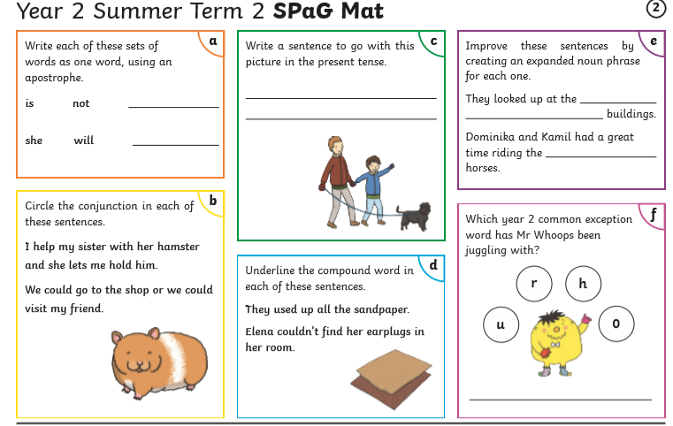
Maths 14.7.20
Time: Telling the time to five minutes
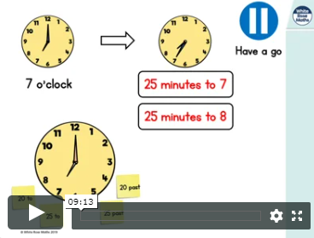
https://whiterosemaths.com/homelearning/year-2/ (Week 12 W/C 13.7.20 Lesson 1)
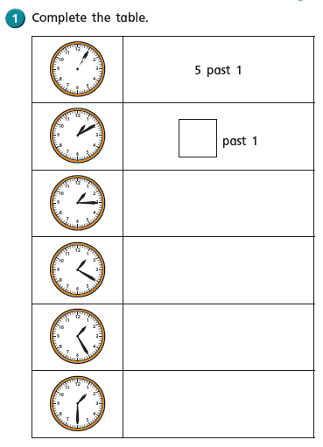
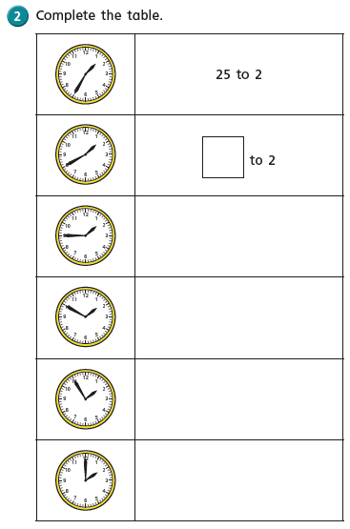

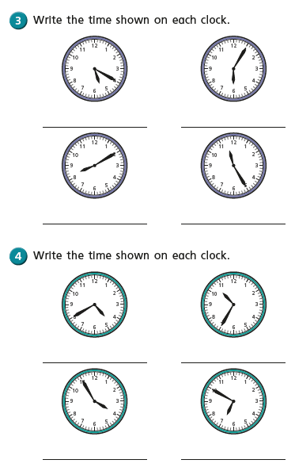

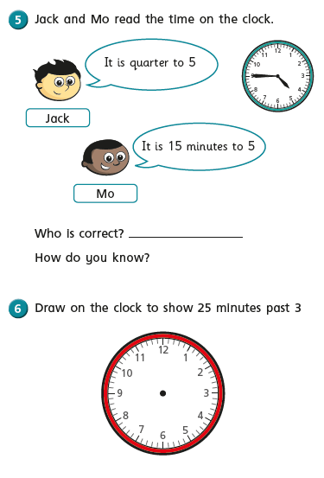

Geography – Map Skills Lesson 5:
WALT: use an atlas to find places in the UK

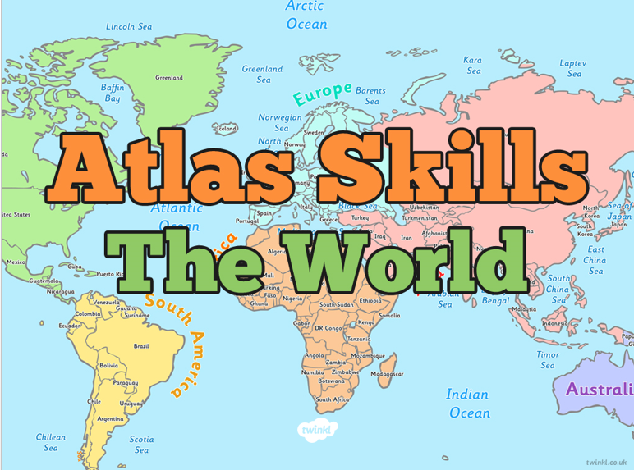

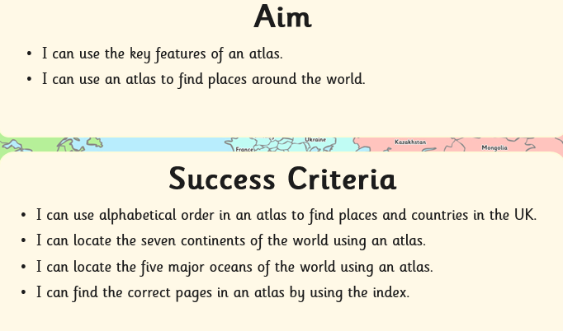

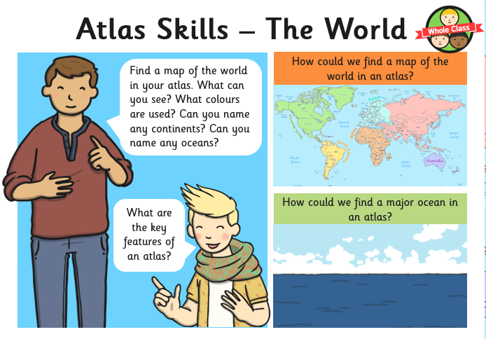
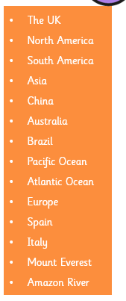
Try to find these places using your atlas. Use the index carefully, write down the page number, then find the continent, country, place or feature.

If you have access to Twinkl and a printer, you might want to try this activity:

