Friday 22nd May 2020
SPaG
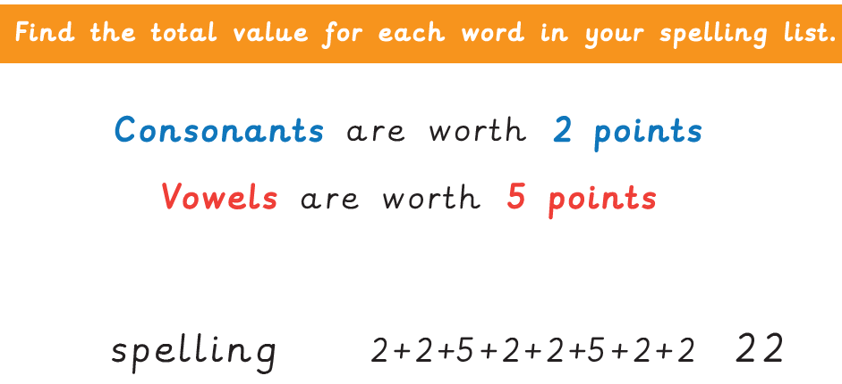
Spellings – Prefix – re
redo
refresh
return
reappear
revenge
remember
retrieve
redecorate

Word of the Day – extraordinary

Definition ____________________________________________
_____________________________________________________
_____________________________________________________
Used it in a sentence: ____________________________________________________
_________________________________________________________________________
Word Class: ____________________________________________________
Synonyms

English
Today you will be writing a biography about Cleopatra VII. You can use the work you did yesterday to help you. Your writing needs to be set out in paragraphs. Below are some sentence starters to help.

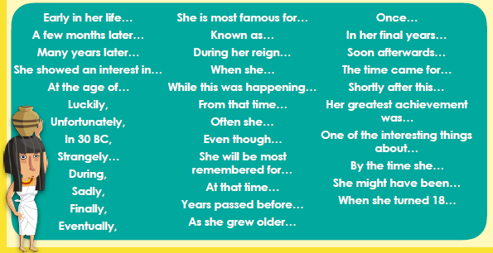

Maths – Mental
53 - 32 = 21 We can prove this by calculating 32 + 21 = 53, we use the inverse.
Find the missing number then make all possible number sentences for the following numbers:
- 67 ? 110
- 248 ? 300
- 542 ? 550
- 1254 ? 1204

Maths – Main Lesson - Let’s look at decimals on a place value grid again.

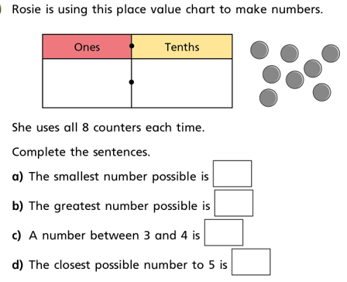

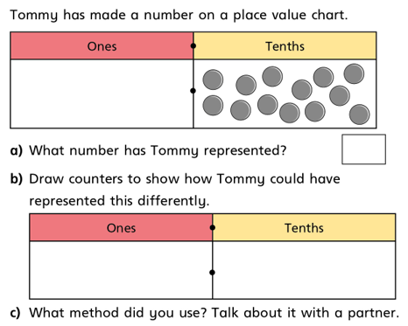

PSHCE
It’s the end of another week, we’ve all worked hard, it’s time to reflect

