Monday 30th March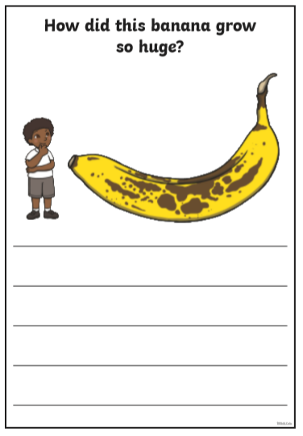
Tuesday 31st March 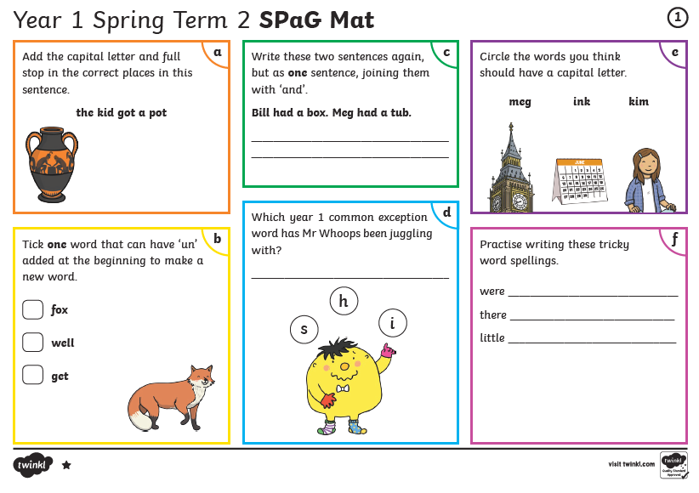
Wednesday 1st April
Reading Comprehension Activity

Video of story
https://central.espresso.co.uk/espresso/primary_uk/subject/module/video/item1217572/grade1/module1217337/index.html
Espresso – KS1 – English – Books – videos – Tadpole’s Promise

Comprehension questions
https://central.espresso.co.uk/espresso/primary_uk/subject/module/activity/item1217776/grade1/module1217337/index.html
Espresso – KS1 – English – Activities – Tadpole’s Promise (Comprehension questions based on the story)

Thursday 2nd April

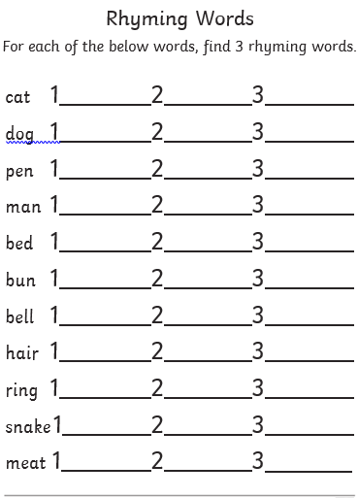

Friday 3rd April
