Tuesday 31st March 2020

**SPaG**

Spellings – To apply the prefix super-

|  |  |  |  |
| --- | --- | --- | --- |
| superhero | superfluent | superman | superstore |
| superpower | superstar | supernatural | supermarket |

**Challenge!** Write each of your words using dots. Then, join the dots with a coloured pencil to make your word.

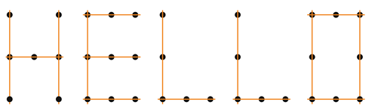



Vocabulary – Word of the Day!

**monstrous**

Definition _______________________________________________

_________________________________________________________

_________________________________________________________

Used it in a sentence: _____________________________________________________

___________________________________________________________________________

Synonyms: _______________________________________________________________________

**English**

Watch the clip called ‘The Catch’ again.

What different settings can you identify?

Choose a part of the clip that you would like to create a setting description for. Use the five senses to help you!

Use the box below to help you plan the things you want to describe in detail.

Now pick your top three to include in your setting description. Remember quality over quantity. Write your setting description using no more than six sentences! Can you include a range of descriptive and figurative language?

____________________________________________________________________________________________________________________________________________________________________________________________________________________________________________________________________________________________________________________________________________________________________________________________________________________________________________________________________________________________________________________________________________________________

**Maths**

Four Awesome Operations

|  |  |  |  |
| --- | --- | --- | --- |
| **Addition *(using column method)***  607 + 228 | **Subtraction *(using column method)***  519 - 450 | **Multiplication *(using grid method)***  32 x 3 | **Division *(using sharing of place value counters)***  65 ÷ 5 |

Perimeter

Solve the word problems using all your knowledge of perimeter!

1. As part of his daily exercise, Josh wants to run around the perimeter of a rectangular field. The two long sides of the field are 80m each and the two short sides are 35m each. How far would Josh run if he ran around the perimeter of the field?
2. Zoe bakes a rectangular cake and wants to decorate with a ribbon around the perimeter. She measures the cake with a ruler and finds that the long side is 24cm long and the short side is 14cm long. How much ribbon will she need to go around the cake?
3. James wants to measure the perimeter of his bedroom. His bedroom is an exact square. He measures one side to be 4m and 3cm long. What is the perimeter of James’ room?
4. Mr. Syrett has a hexagonal fish tank. He wants to decorate the tank with plants around the perimeter of the tank. One side of the tank measures 15cm. What is the total perimeter of the tank?

**Problem Solving**

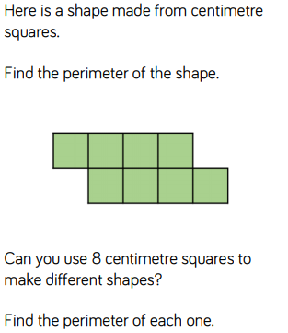

1. Mrs. Walker is updating the playground. She would like to install a large petting zoo. She has measured the area she would like to put it in. There are three sides to the area: one-side measures 12m, one measures 16m and the final one measures 14m. How much fence will she need to buy to go around the petting zoo?

**History**

**Challenge!** Compare and contrast a Stone Age camp and a modern home. Do they have any similarities?

|  |  |  |
| --- | --- | --- |
| **A Stone Age Camp** | **Both Homes** | **A Modern Home** |
| **____________________________________________________________________________________________________________________________________________________________________________________________________________________________________________________________________** | **____________________________________________________________________________________________________________________________________________________________________________________________________________________________________________________________________** | **____________________________________________________________________________________________________________________________________________________________________________________________________________________________________________________________________** |

