Russell Lower School – Adult Well-being Scale
Everyone goes through challenging times and ‘pinch-points’. We all care about each other at Russell Lower School and want to help each other as we are a team. You can use the well-being scale to help you, help yourself.
- Recognise and ‘label’ how you are feeling using the scale as a guide
- Talk to a trusted colleague, or speak to Nicki or Louise – they will ALWAYS make time for a well-being chat
- Ask yourself – ‘what can I do to move JUST ONE SPACE down the well-being scale towards a healthier me?’
- Act when you are at 6 not 9!
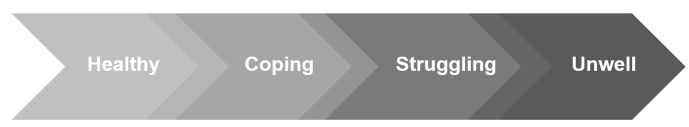
Possible Actions to move one place back: Take 5 minutes out in a quiet space, go for a walk, get a cup of tea, plan a night ‘off’, talk to a friend, go outside and take deep breaths, get someone to take over, share your worries – whatever works for you!
ACT NOW

