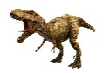
SWANS, SWIFTS & DOVES - AUTUMN 2023 - 1st half term
DINOSAUR DISCOVERY

Personal Social and Emotional Development  - Indoor and outdoor rules  - Value – Respect  - New Beginnings  - Talking about the contents of their ‘My Special Things’ box  - Building respectful relationships with adults and other children  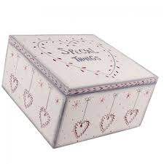  - Stories about how they and others show feelings – e.g. The Colour Monster, The Colour Monster goes to School, The Huge Bag of Worries  - Circle time sessions | Communication and Language  - Understanding how to listen carefully and why listening is important  - Learning new vocabulary – herbivore, carnivore and dinosaur names  - Using new vocabulary through the day, e.g. in role play situations  - Listen carefully to rhymes and songs, paying attention to how they sound  - Sound discrimination and voice sounds  - Learn rhymes, poems and songs |  | Physical Development  - Further develop the skills they need to manage the school day successfully, e.g. turn-taking and lining up and waiting  - Develop their small motor skills so that they can use a range of tools competently, safely and confidently  - Combine different movements with ease and fluency  - Dressing and going to the toilet independently  - Body Management Unit 1  - Gymnastics Unit 1  - Writing their name and creating handwriting patterns
Literacy  - Listening to stories – e.g. Peace at Last and Starting School  - Dinosaur stories - If I had a dinosaur, The dinosaur who lost her voice, Mad About Dinosaurs, Harry and the bucketful of dinosaurs  - Rhyme and alliteration  - Oral segmenting and blending  - Recognising words with the same initial sound  - Clapping syllables in words  - Learning the letter sounds – s,a,t,p,I,n,m,d,g,o,c,k  - Writing own name  - Using print and letter knowledge in their writing | Mathematics  - Matching and sorting buttons  - Story - The Button Box  - Comparing amounts  - Comparing size, mass and capacity  - Story – Dear Zoo  - Exploring patterns  - Making fruit kebab patterns  - Creating patterns using natural materials  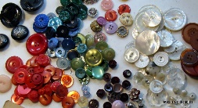  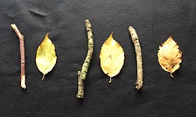  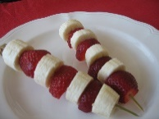 | Understanding the World  - Talking about members of their immediate family and community  - Naming and describing people who are familiar to them  - Traditions – designing a Christmas card |  | Expressive Art and Design  - Listening attentively, moving to and talking about music, expressing their feelings and responding  - Exploring and engaging in music making and dance, performing solo or in groups  - Learning to sing nursery rhymes and action songs:  - Pat-a-cake  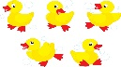  - 1, 2, 3, 4, 5, Once I Caught a Fish Alive  - This Old Man  - Five Little Ducks  - Name Song  - Things for Fingers  - Exploring high sounds and low sounds using voices  - Charanga unit Me!
RE
- Being special. Where do we belong?
Computing
- Learning that information can be retrieved from books, computers and mobile digital devices
- Learning to click the left button on a mouse to create dots
- Learning to hold and drag the mouse using the left button

