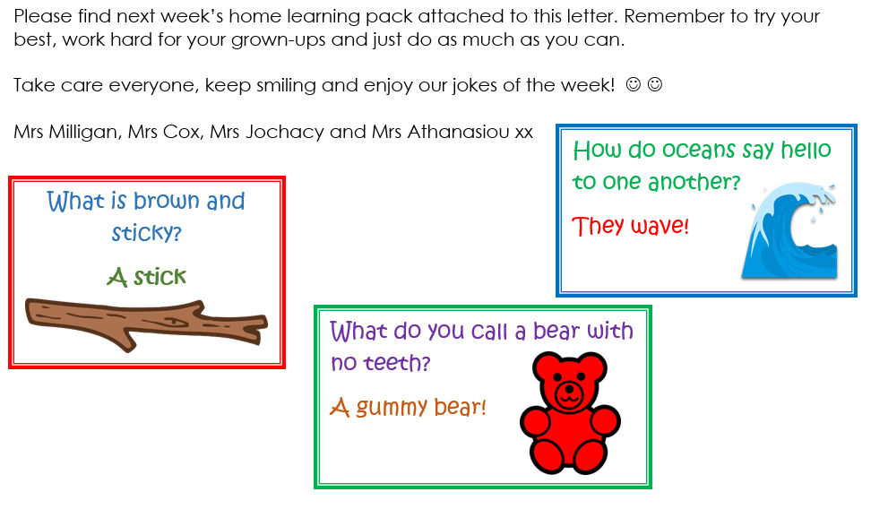
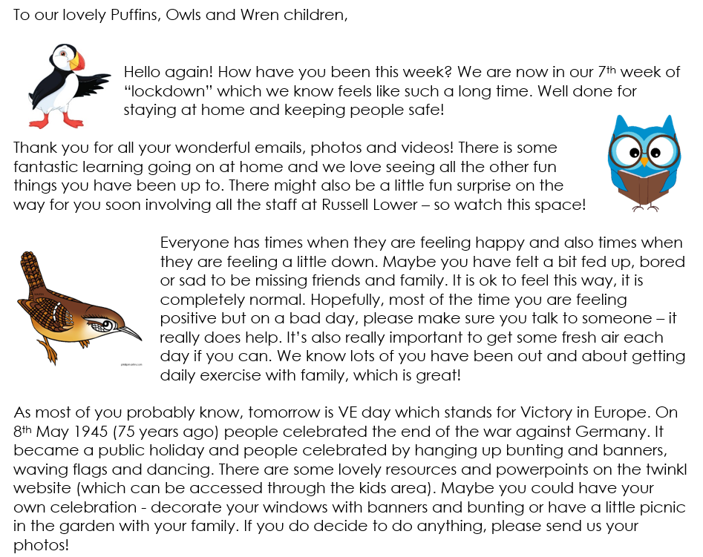

Year 1 Phonics activities – Summer 1 – Week 4 and Year 1 spellings

Session 1 - Monday 11th May 2020  Warm up activity – Recap ‘split digraph a’ from last week.  2 minute challenge!  How many split digraph a words can your child write in 2 minutes? Maybe you could have a go too and see who gets the most! Encourage your child to check your words. | Session 1 - Main activity  Split digraph e  (e__e – e,g, these, theme, concrete, complete)  Introduction to split digraph e – watch the video to introduce the sound.  You will need to login to ‘Espresso’ which can be accessed from the school website – ‘kids area’ and follow the link  https://central.espresso.co.uk/espresso/primary_uk/subject/module/video/item90337/grade1/module63425/index.html  (once logged in if the above link does not take you straight there then please go to – Key Stage1/ English/Phonics / Ash’s Phonics /e-e)  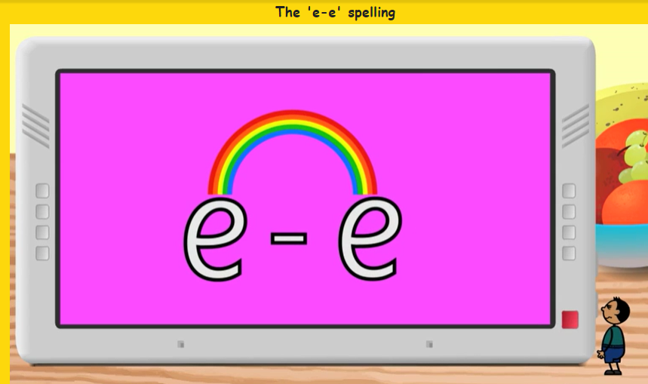  Have a go at making a list of split digraph e e words together.  If for any reason you are unable to access Espresso then please use the YouTube link below which will give you some split digraph e words to read.  https://www.youtube.com/watch?v=kFuETDoqVnA  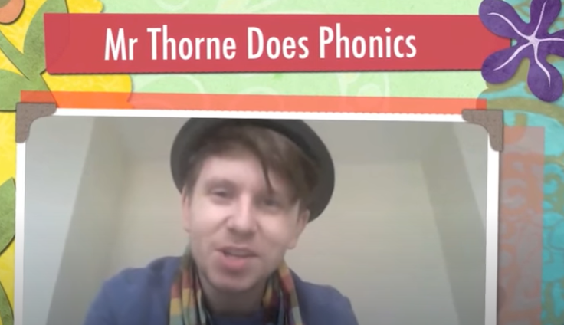
Session 2 - Tuesday 12th May 2020  Warm up activity – listen to the ‘tricky word song’  The children enjoy these at the beginning of our phonics sessions – we encourage the children to sing along and have a go at writing the words.  https://www.youtube.com/watch?v=R087lYrRpgY  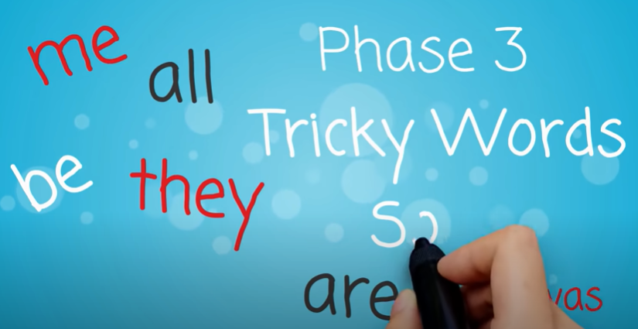  See if they can write a sentence using one or more of the tricky words they have written down. | Session 2 - Main activity  Play ‘hangman’ with split digraph e_e words e.g. delete, compete, swede, these etc.  When drawing the ‘lines’ you could draw a sound line for a digraph and a dot (sound button) for 1 letter making 1 sound.  e.g. – ‘complete’ . . . . . . . .  Children to guess and adult to write the letter/s at the bottom of the page/ board if it is incorrect and draw parts of the hangman picture. If correct write the letter/s in the correct place.
Session 3 - Wednesday 13th May 2020  Warm up activity– Phase 3 digraphs (2 letters together that make 1 sound)  Use the sound mat below– choose a digraph/trigraph (igh, ear, ure, air) and ask your child to write it down/make it with magnetic letters/paint it outside on the pavement using paint brushes and water/chalk etc.  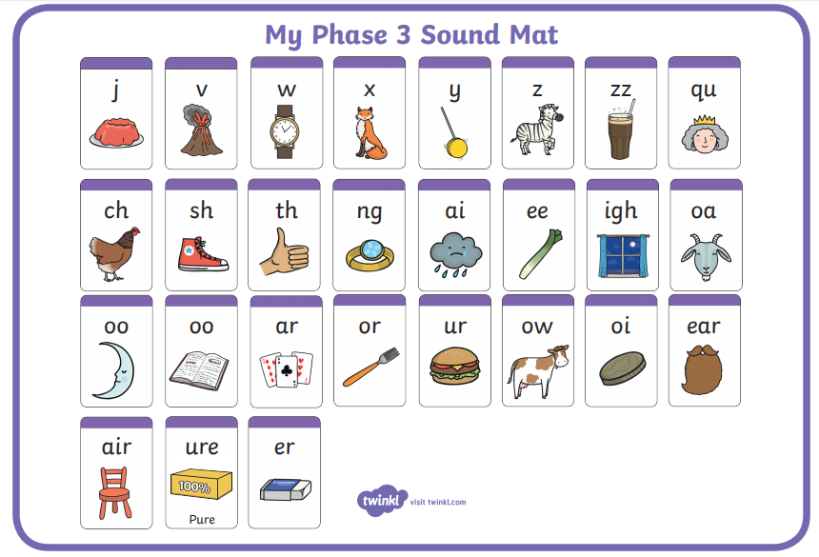 | Session 3 - Main activity  Write out the list of words below – challenge your child to write as many sentence as they can using these words. They could think of a sentence for you to write and then they could be the ‘teacher’ and check it is correct!  these  delete  complete  Pete  concrete  even
Session 4 - Thursday 14th May 2020  Warm up activity – listen to the ‘tricky word song’  Encourage your child to sing along and have a go at writing the words.  https://www.youtube.com/watch?v=3NOzgR1ANc4  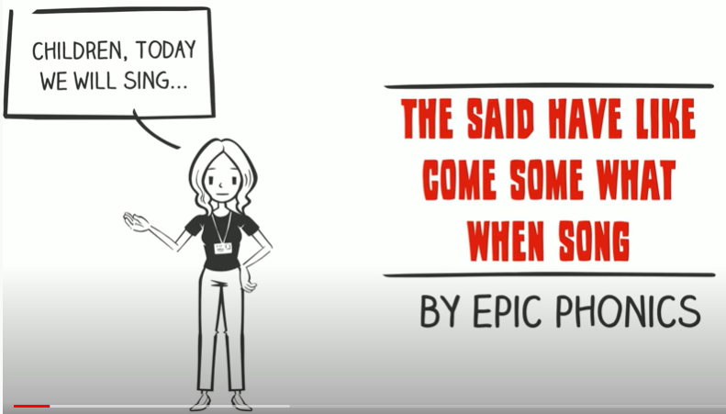  See if they can write a sentence using one or more of the tricky words they have written down. | Session 4 - Main activity  Play ‘BINGO’ with split digraph e_e words:  Real and nonsense words:  these geme  theme flene  concrete splete  Pete drepe  delete kete  Ask your child to write these words on post its or chopped up paper so everyone playing can see them (or an adult could write them out).  Each player splits their board into 4 quarters and then chooses 4 words to write down, one in each quarter.  The words could then be turned over or put in a bag/ box for the bingo caller to pull out and read. The first person to cross off all 4 of their words is the winner!
Session 5 - Friday 15th May 2020  Warm up activity– Phase 5 digraphs (2 letters together that make 1 sound)  Use the sound mat below– choose a digraph and ask your child to write it down/make it with magnetic letters/paint it outside on the pavement using paint brushes and water/chalk etc.  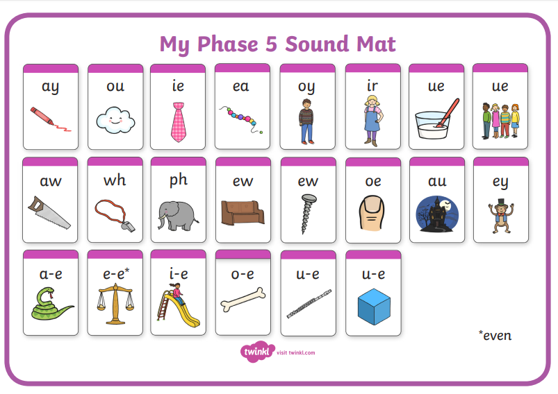 | Session 5 – Main activity  You can either print out and play the split digraph e-e game below or you could have a go at making your own!  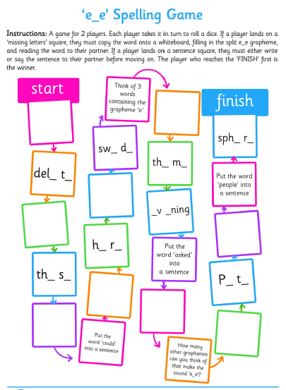

Weekly spellings:
We will be continuing to add weekly spellings to the bottom of the phonics planning. Please continue to practise them at home as you had been doing before school closed. We find the ‘look, read, cover, write, check’ approach the best way to learn the spellings.
At school the children are usually ‘tested’ on their spellings on a Monday. Please feel free to keep to this structure.

The children should hopefully remember which group they were in for their spellings. If any children from group 1 or 2 want to challenge themselves with more spellings please feel free to let them have a go.
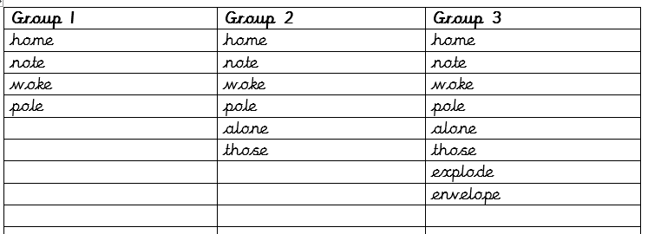
Year 1 English Activities – Summer 1 Week 4

Monday  11th May | Write a book review about your favourite book. Remember to include the title and author, setting and characters. Give a brief description of the story and say why you liked/didn’t lie the book. Give the book a rating out of 5 stars!
Tuesday  12th May | 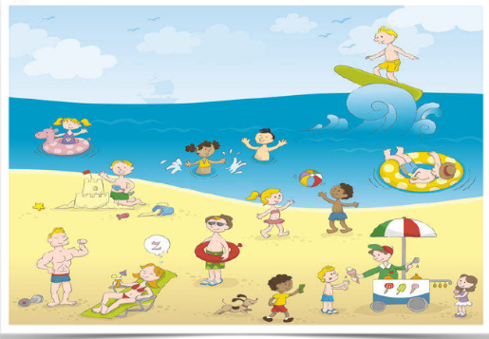  Can you imagine yourself at the beach? Using your five senses write a description of what you would see, hear, feel, smell and taste.
Wednesday 13th May | Listen to, or read loud a story at https://www.bbc.co.uk/cbeebies/stories  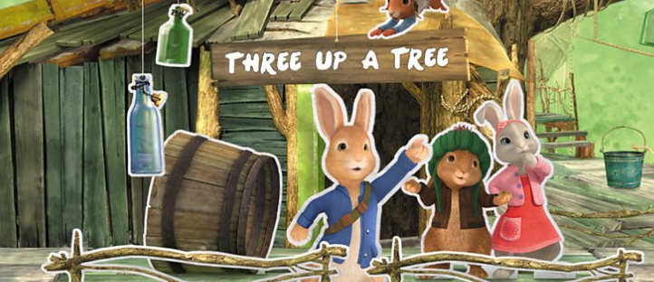
Thursday 14th May | Watch  Espresso – Home – English1 – Poetry – Books – Hey diddle, diddle  https://central.espresso.co.uk/espresso/primary_uk/subject/module/book/item1124487/grade1/module1122235/index.html  and  Espresso – Home – English1 – Poetry – Books – Pussy cat, Pussy cat  https://central.espresso.co.uk/espresso/primary_uk/subject/module/book/item1125428/grade1/module1122235/index.html  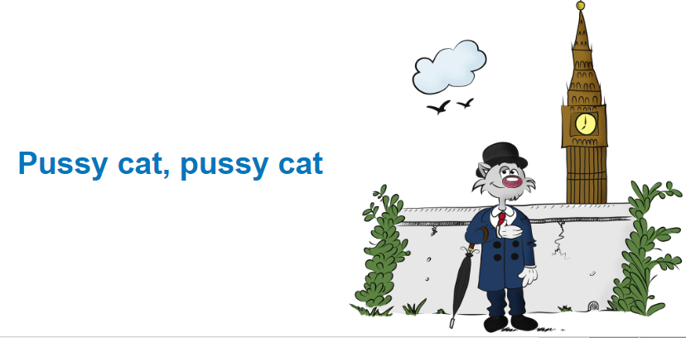  Can you write all the rhyming words you heard in the nursery rhymes?
Friday 15th May | Can you add the suffix ‘ing’ to these verbs? Remember to write the whole word with the new ending.  Paint, play, cook, walk, jump, scream, help, teach, sing, wash.

Year 1 Theme Activities – Summer 1 Week 4
Date: | Activity:
Monday 11th May 2020 | Science – looking closely at humans in different seasons.  How do humans prepare/adapt for each season? Discuss and write down what you think/ find out. Here are some questions which you may use as a guide to help you:  What do we wear in each season? What does your family do to prepare for each season (e.g. do you store wood, open the garden shed in the summer)?  What happens on a farm in the fall? Do you think a farmer does different things in the spring? Does a fisherman have to work differently in the spring and fall?
Tuesday 12th May 2020 | PSHRE - Personal, Social, Health, Relationships and Emotional Development  To learn the importance of, and how to, maintain personal hygiene.  What is personal hygiene and why is it important? How can you practise good personal hygiene habits? Discuss and make a poster of ways we can maintain personal hygiene.  https://www.theschoolrun.com/personal-hygiene-learning-children
Wednesday 13th May 2020 | Geography  Use a map of the world to find a country you have been to. Did you go to the seaside there? What do you know about the seaside? What is the seaside like? Why do we go there? Write a report/ poem about what it is like going to the seaside.
Thursday 14th May 2020 | History  Write a postcard home, written 100 years ago, describing a seaside holiday. It must sound as if it is not just yesterday. First, think of a few things you would find at the seaside during Victorian times then have a look at the example of an old postcard.  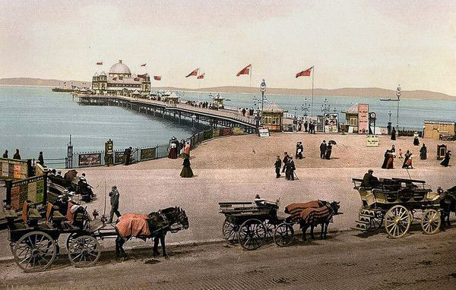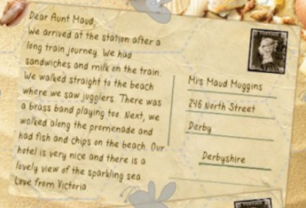
Friday 15th May 2020 | 17th May is National Children’s Day UK  National Children's Day UK is all about the importance of a healthy childhood and protecting the rights and freedoms of children so that they can grow into happy, healthy adults.  If you want to create a special day for the child/children in your life, here are some suggestions of activities you could plan:  https://www.nationalchildrensdayuk.com/creativity--imagination.html  https://www.nationalchildrensdayuk.com/ideas-page.html

Year 1 Maths Activities – Summer 1 Week 4
This week we are going to be working on Numbers to 100 and Place Value (understanding what each digit in a number represents).
Please follow the Oak National Academy link below:
https://www.thenational.academy/online-classroom/year-1/maths#subjects
Or google: The National Academy – Online classroom – find lessons – subjects – Year 1 – maths.
At the bottom of the page, you will find 5 lessons (one per day) relating to reading and writing numbers to 100. The lessons start with a short quiz, followed by a teaching video and some online worksheets/questions to work on. All you need is a pencil and some paper.

Below is the sequence of lessons:

Monday 11th May | To recognise, read and write numbers to 100
Tuesday 12th May | To explore the components of numbers within 100
Wednesday 13th May | To explore the components of numbers within 100
Thursday 14th May | To apply knowledge of number bonds
Friday 15th May | To find one more and one less and ten more and ten less

Please email your teachers if you have any questions or need support accessing this resource.

