Dear Puffins, Owls and Wrens!

Hello to you all! How have you been? Have you had a nice weekend? If you have celebrated VE Day, let us know? We would love to know what you’ve been up to in the last week.
Thank you very much for all your emails. We love all the work, photos and videos you’ve been sharing with us. Please keep sending those in, we look forward to hearing from you 😊
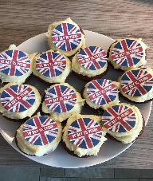
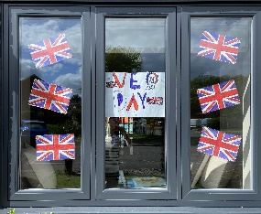
We thought we will share some of the things we’ve been up to with you as well. To celebrate VE Day, Mrs. Cox made some fantastic decorations with her sons and had a picnic with tea and scones on the front lawn.
Mrs. Milligan enjoyed a street party with her neighbours while keeping a safe distance. She has also been growing sunflowers and peas with her family. Her daughter made a rainbow cake as well!
Mrs. Jochacy celebrated by having a BBQ while both of her boys enjoyed their paddling pool. They also planted cress seeds and have been doing lots of online quizzes to keep in touch with her family.
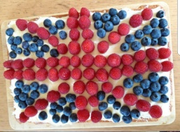
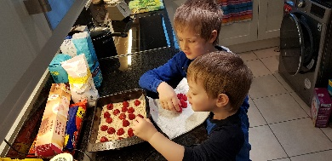
Mrs. Athanasiou made a cake with her boys and celebrated VE Day by having a picnic in the garden and listening to music. Over the weekend she’s been busy in the garden planting tomatoes and cucumber.
Lastly, as you might have already seen the staff have put together a message to you all which can be viewed at: https://www.youtube.com/watch?v=0sq7wAz74l0 You can also find it on the School or PTA Facebook page and our website. We hope you like it.
Please find the next week’s Home Learning pack attached to this letter. Have a go and try your best. We are very proud of all of you for trying hard and completing the activities we sent you every week. We can’t wait to see how you are going to impress us and your grown-ups this week!

Take care, look after yourselves and your families and keep smiling!
We miss you all,
Mrs. Cox, Mrs. Milligan, Mrs. Jochacy and Mrs. Athanasiou xxxx

Year 1 Phonics activities – Summer 1 – Week 5 and Year 1 spellings

Session 1 - Monday 18th May 2020  Warm up activity – listen to the ‘tricky word song’  Encourage your child to sing along and have a go at writing the words.  https://www.youtube.com/watch?v=3NOzgR1ANc4  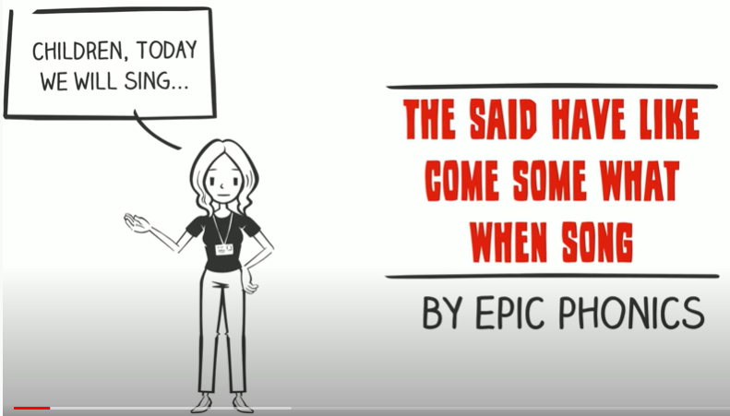  See if they can write a sentence using one or more of the tricky words they have written down. | Session 1 - Main activity  Split digraph i  (i__e – e,g, time, fine, shine, inside)  Introduction to split digraph i – watch the video to introduce the sound.  You will need to login to ‘Espresso’ which can be accessed from the school website – ‘kids area’ and follow the link  https://central.espresso.co.uk/ (once logged in please go to – Espresso/Key Stage1/ English/Phonics / Ash’s Phonics /i-e)  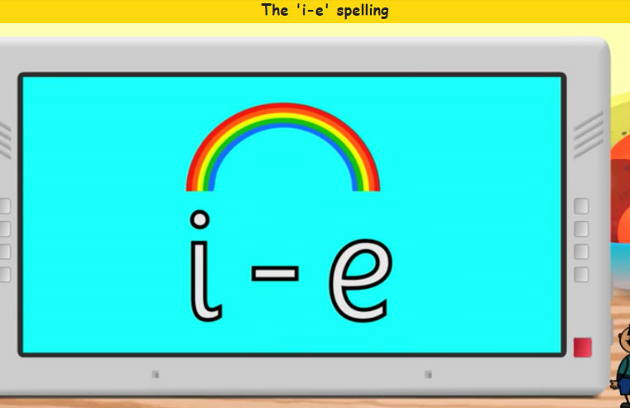  Have a go at making a list of split digraph i_e words together.  If for any reason you are unable to access Espresso then please use the YouTube link below which will give you some split digraph i words to read.  https://www.youtube.com/watch?v=4-swf3Gy_40
Session 2 - Tuesday 19th May 2020  Warm up activity– Phase 3 digraphs (2 letters together that make 1 sound)  Use the sound mat below– choose a digraph/trigraph (igh, ear, ure, air) and ask your child to write it down/make it with magnetic letters/paint it outside on the pavement using paint brushes and water/chalk etc.  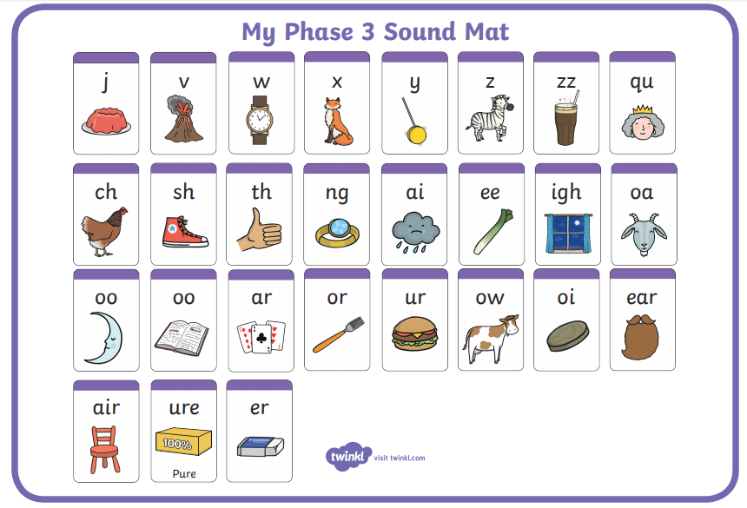 | Session 2 - Main activity  Play ‘4 in a row’  Make a grid with split digraph i_e words in it e.g.  line time inside shine  kite write pine slime  slide invite mice knife  side drive bike like  Take it in turns to read a word aloud. If your partner agrees it is correct then cover it with a counter. Try and get 4 correct in a row in a certain time.
Session 3 - Wednesday 20th May 2020  Warm up activity –  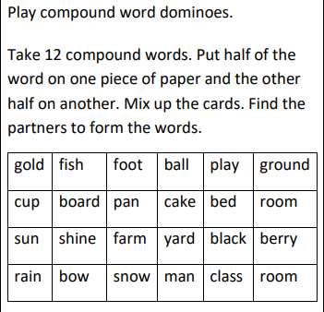 | Session 3 - Main activity  Hopscotch  Draw a grid on the floor with numbers 1 – 10 in a hopscotch grid formation.  Write ten words on post-it notes that contain the split digraph i_e and place one in each square.  Throw a stone/counter, hop to where it lands and read the word in the square.
Session 4 - Thursday 21st May 2020  Warm up activity – Recap ‘split digraph e’ from last week.  2 minute challenge!  How many split digraph e words can your child write in 2 minutes? Maybe you could have a go too and see who gets the most! Encourage your child to check your words. | Session 4 - Main activity  Play ‘Matching Pairs’  Using words with the split digraph i_e. List as many words as you can (e.g. time, fine, line, slide, smile, inside, bride, shine, invite).  Write each word twice on different pieces of paper. Mix them up and turn over all the words so they are face down,  Take it in turns to find matching pairs!
Session 5 - Friday 22nd May 2020  Warm up activity– Phase 5 digraphs (2 letters together that make 1 sound)  Use the sound mat below– choose a digraph and ask your child to write it down/make it with magnetic letters/paint it outside on the pavement using paint brushes and water/chalk etc.  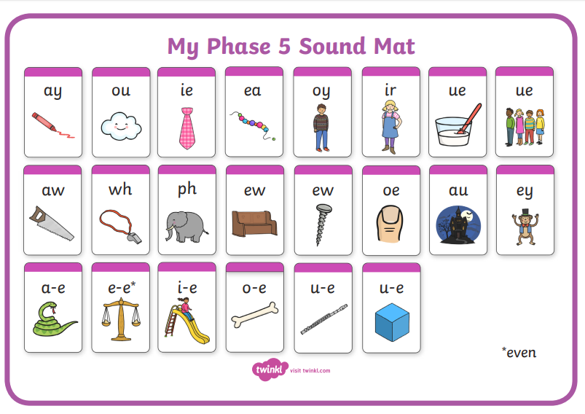 | Session 5 – Main activity – Tricky words  Children to choose words and think of a sentence.  Children to say the sentence and then write it down.  They could ask you to write their sentence down and then be the teacher and check it! Or you could think of a sentence, write it down and ask your child to highlight the tricky words they can see!  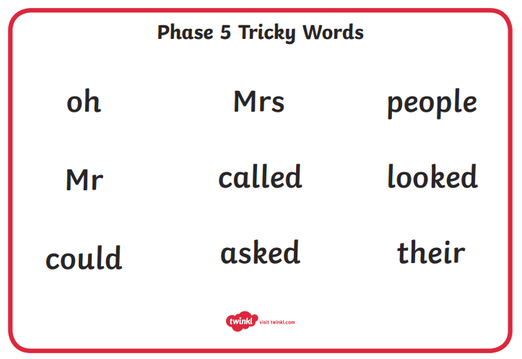

Year 1 spellings are below

Weekly spellings:

We will be continuing to add weekly spellings to the bottom of the phonics planning. Please continue to practise them at home as you had been doing before school closed. We find the ‘look, read, cover, write, check’ approach the best way to learn the spellings.
At school the children are usually ‘tested’ on their spellings on a Monday. Please feel free to keep to this structure.

The children should hopefully remember which group they were in for their spellings. If any children from group 1 or 2 want to challenge themselves with more spellings please feel free to let them have a go.
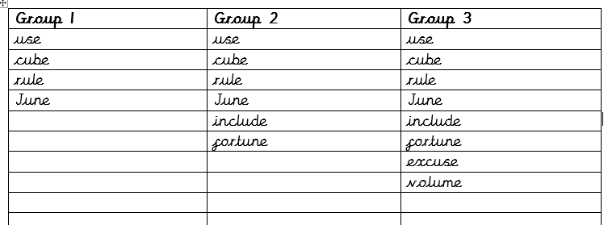

Monday  18th May | Watch  Espresso – Home – English1 – Old Bear stories – Videos – Ruff  https://central.espresso.co.uk/espresso/primary_uk/subject/module/video/item996052/grade1/module996141/index.html  Then take the comprehension quiz:  Espresso – Home – English1 – Old Bear stories – Activities – Ruff quiz  https://central.espresso.co.uk/espresso/primary_uk/subject/module/activity/item996230/grade1/module996141/index.html
Tuesday  19th May | Think about your favourite toy. What might your toy do while you are at school? Write a short story about your toy’s adventure.
Wednesday 20th May | Find 5 different objects in your house. Ask your child to write a sentence about it. Can they add an adjective (describing word) to make their writing more exciting? Remember full stops, capital letters and finger spaces between the words!
Thursday 21st May | Watch ‘Catch it’  https://www.literacyshed.com/catchit.html  Can you retell the story in your own words to someone in your house?  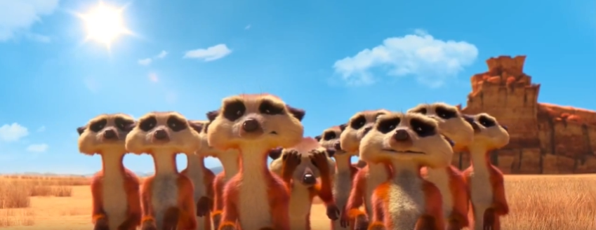
Friday 22nd May | Design a wanted poster for the vulture from the short clip ‘Catch it’ you watched yesterday? Remember to draw a picture of him and write a description of his appearance and personality. You also need to let people know what his ‘crime’ is and if there is a reward!  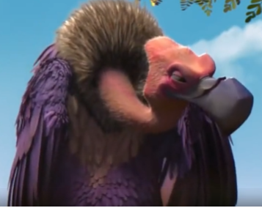
Year 1 English Activities – Summer 1 Week 5

Monday 18th May – Making equal groups
This week we are learning about grouping objects into equal groups.
Do you know what the words equal and unequal mean? Can you explain or show your adult?
Watch this short video about grouping objects: https://www.bbc.co.uk/bitesize/topics/zqbg87h/articles/z3tvcj6
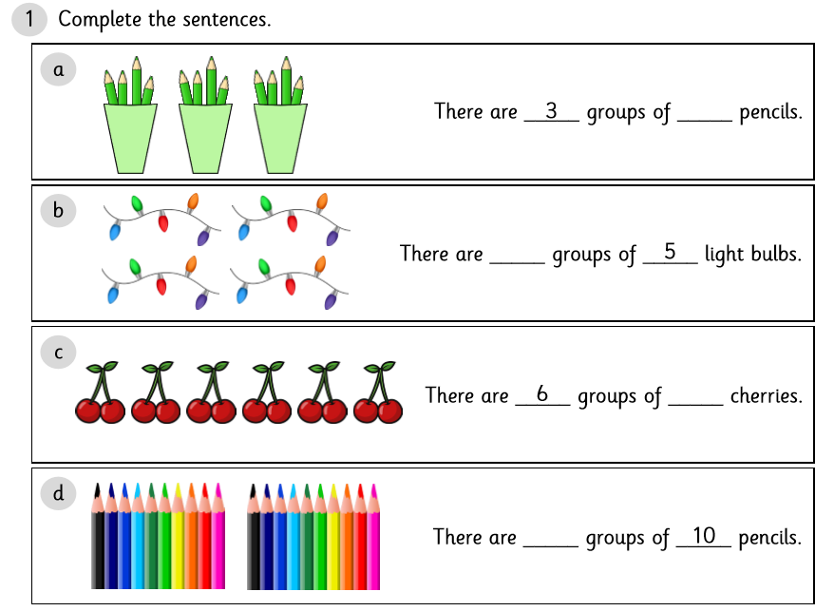
Can you find a set of objects around your house and put them into equal groups? e.g. 20 blocks of lego or 12 pencils or 15 toy cars. Tell your adult how many groups you have and how many are in each group. Remember each group has to have an equal (same) amount. Then have a go at the activities below:

Can you explain how many groups there are and how many are in each group?
How many do you have altogether?
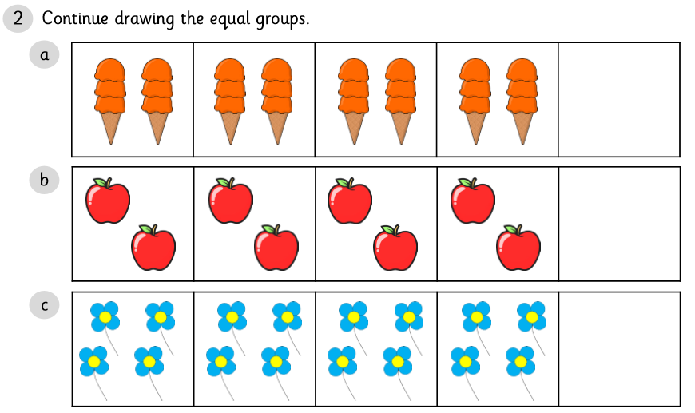

Tuesday 19th May – Add equal groups
Yesterday we learnt how to make equal groups. Today we are going to use equal groups to find a total by adding the same number again and again. This is called repeated addition or sometimes it’s called an array.
Watch this short video about counting in groups:
https://www.youtube.com/watch?v=XOyOVDMjUdo
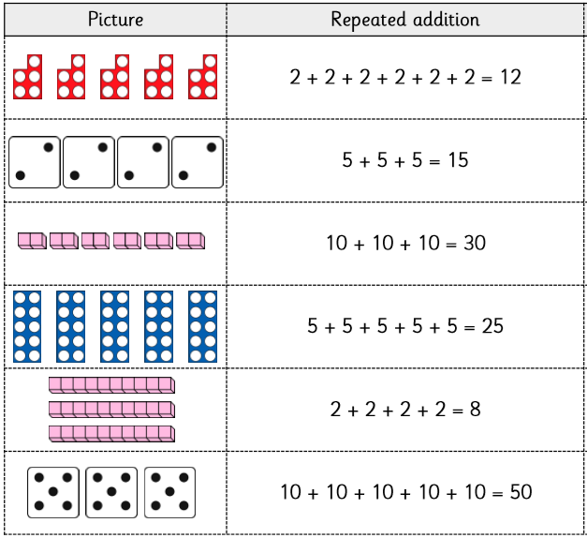
Activity: Can you cut and match each picture to the correct repeated addition (array)?
Challenge:
Have a go at grouping some of your own objects. Can you say the sentence out loud explaining how many groups you have, how many objects in each group and how many altogether?
e.g. There are 2 cars in each group. 2 + 2 + 2 + 2 = 8
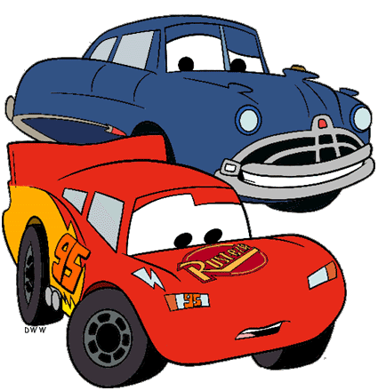
There are 4 groups of cars which is equal to 8.

Wednesday 20th May – Making doubles
Today we are going to explore doubling with numbers up to 20.
Remember that ‘double’ is two groups of a number or an amount (twice as many). When we double, we add the same amount again e.g. 3 + 3, 6 + 6, 9 + 9
Watch this short numberblocks video called ‘double trouble’
https://www.bbc.co.uk/iplayer/episode/b08q4jkq/numberblocks-series-2-double-trouble
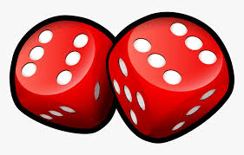
Play the game doubles:
Take turns to roll 2 dice. If you roll a double you score a point. The first person to reach 3 points wins the game!
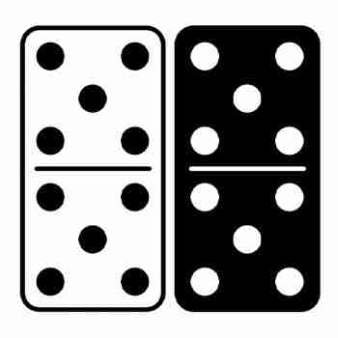
If you have a set of dominoes at home, you could find all the doubles in the box. Can you double the number and find the total?

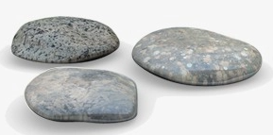
Collect some pebbles or stones from outside. Sit opposite a partner. Set out a group of stones or pebbles. Can your partner double it by making the same quantity again? Take turns to practise doubling the amount e.g. ‘double 3 equals 6’
Play this doubles game:
https://www.topmarks.co.uk/maths-games/hit-the-button
Choose ‘doubles’ and select ‘doubles to 10’
How many doubles can you find before the time runs out?
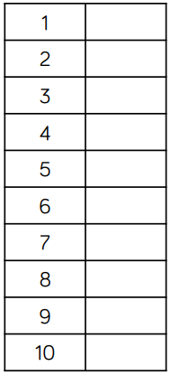

Challenge:
Complete the table by doubling each number.
What pattern do you notice?
Can you explain the pattern to your adult?

Thursday 21st May – Halving Numbers
Today we are going to explore halving with numbers less than 20. Remember that ‘halving’ means sharing an amount into 2 equal groups. It is the opposite of doubling.
If you have a computer, watch this short video on Discovery Education Espresso called ‘Halving as the inverse of doubling’
https://central.espresso.co.uk/espresso/primary_uk/subject/module/video/item785328/grade1/module784709/index.html?source=search-all-all-all-all&source-keywords=halving%20numbers
Can you count how many spots there are altogether, then halve the number of spots using the ladybirds to help you?
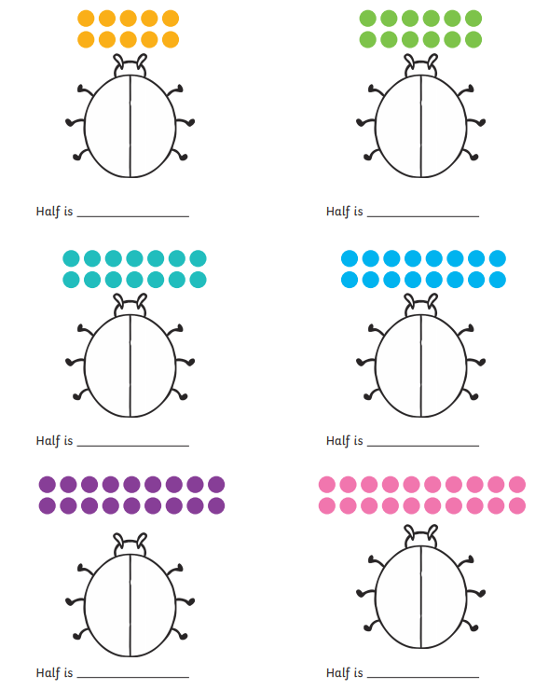

Challenge: Practise halving numbers quickly by playing this game. Select ‘Halves to 10’ only.
https://www.topmarks.co.uk/maths-games/hit-the-button
Friday 22nd May – Read and write numbers from 1 to 10 in words.
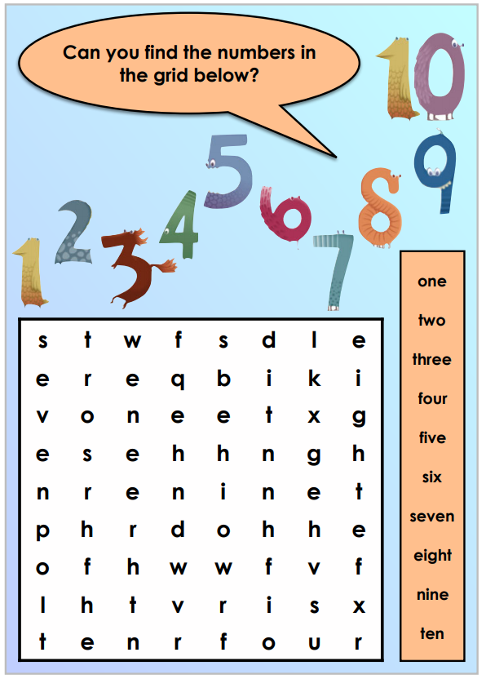
Today we are going to practise reading and writing the numbers 0 – 10 as numerals and words.

Challenge: Practise spelling these words without looking at your wordsearch! Can you write the numerals next to the spelling of each word?
Year 1 Theme activities – Summer 1 Week 5
Date: | Activity:
Monday 18th May 2020 | Geography – oceans  How many oceans are there? Can you name all of them? Can you locate the oceans on a map or a globe?  Here are some games and activities which will help you learn more about oceans.  https://gowild.wwf.org.uk/regions/oceans-games-and-activities.html  This website has lots of interesting information about oceans and marine life and some really great photos as well!  https://www.amnh.org/explore/ology/marine-biology/what-is-marine-biology
Tuesday 19th May 2020 | PSHRE - Personal, Social, Health, Relationships and Emotional Development  What vocabulary can you use to describe different feelings? Write down the feelings you know/ can think of. Watch the video clip about feelings.  https://www.youtube.com/watch?v=akTRWJZMks0  What makes you happy? How could you make someone else happy when they are sad? What makes you grumpy? What do you do when you are grumpy or sad? What could you do to stop someone from feeling grumpy or sad?
Wednesday 20th May 2020 | Science – World Bee Day  The purpose of World Bee Day is to raise awareness of the importance of pollinators, the threats they face and how they help our planet.  What do you know about bees? Are the bees important? Why? Discuss.  https://www.youtube.com/watch?v=ia5HQfa5WtE  https://www.daysoftheyear.com/days/world-bee-day/
Thursday 21st May 2020 | History – changes within living memory  Look at the two pictures. Which one represents seaside in the past and which one represents the seaside now? Can you explain why you think so? What do you spot any differences?  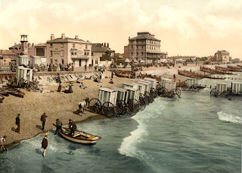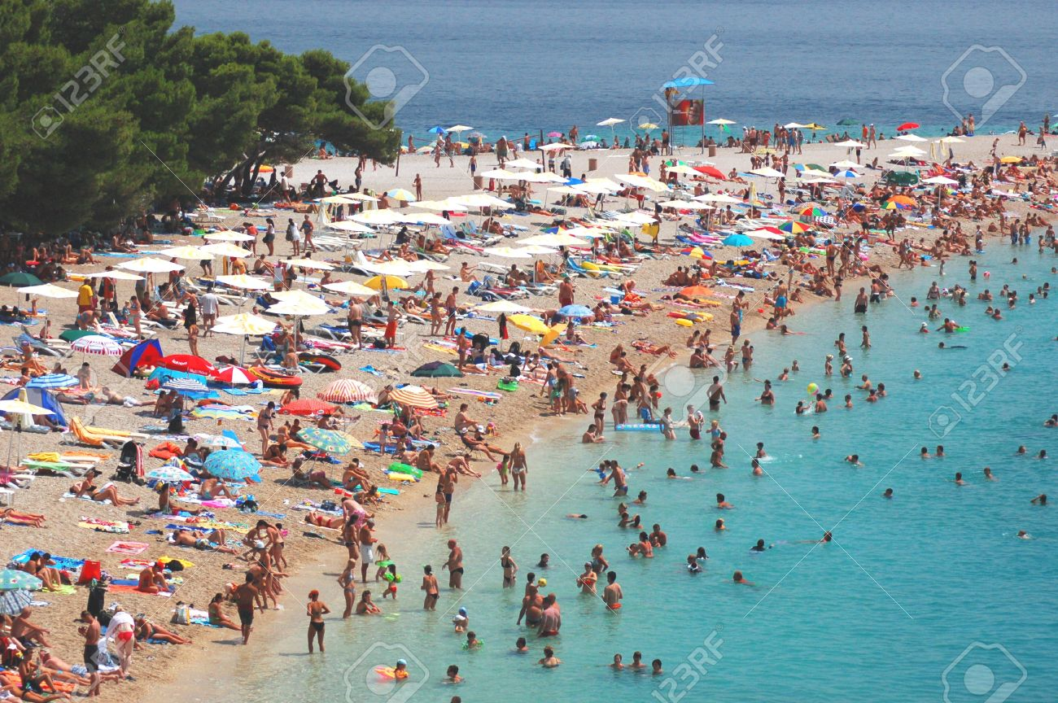
Friday 22nd May 2020 | Art  Look at some paintings of J. M. W. Turner.  https://www.google.co.uk/search?q=turner+sea+paintings&source=lnms&tbm=isch&sa=X&ei=mvKmVJzdK8iyUfiLgaAL&ved=0CAgQ_AUoAQ&biw=1362&bih=617  Discuss why you like particular paintings, explaining how it makes you feel.  Mix colours to create a range of hues appropriate to paintings of the sea.  Use the techniques of adding salt to watercolours to create different effects of texture and patterning.  https://www.youtube.com/watch?v=OyYI0cEN5jA&list=WL&index=60  Things you will need:  A3 and A5 white paper  Paint brushes  Watercolour paints  Table and sea salt  Cotton wool  Paper towels

