Year 2 Phonics/Spelling Practice – Tuesday 7.7.20.
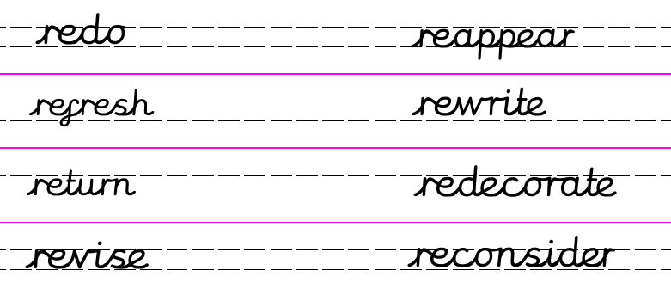
Each day use your best Russell handwriting to practise writing your spelling words out. Try using different colours if it helps you to remember the words – or even try writing in paint, sand, glitter, rice or cornflour – just for fun!
Add this week's prefix to these words
(Note the root words are all verbs and the meaning of the verb is changed by the prefix):
________view _____appear ______fresh _______turn

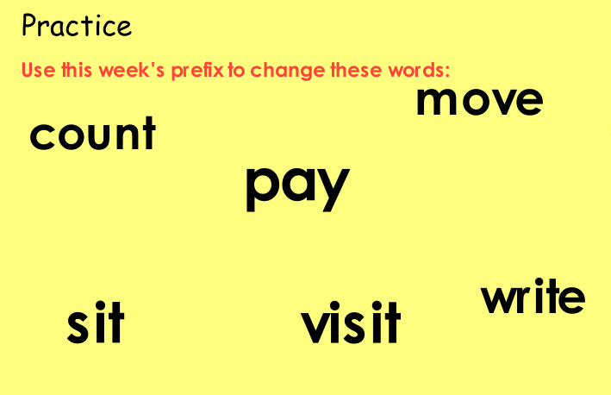
Dictation:
Ask someone to read out the sentence below so that you can write it down – try not to look until after you’ve written it. Check your punctuation and spelling.
Please reconsider and rewrite your letter.
Maths 7.7.20
Measure mass in kilograms
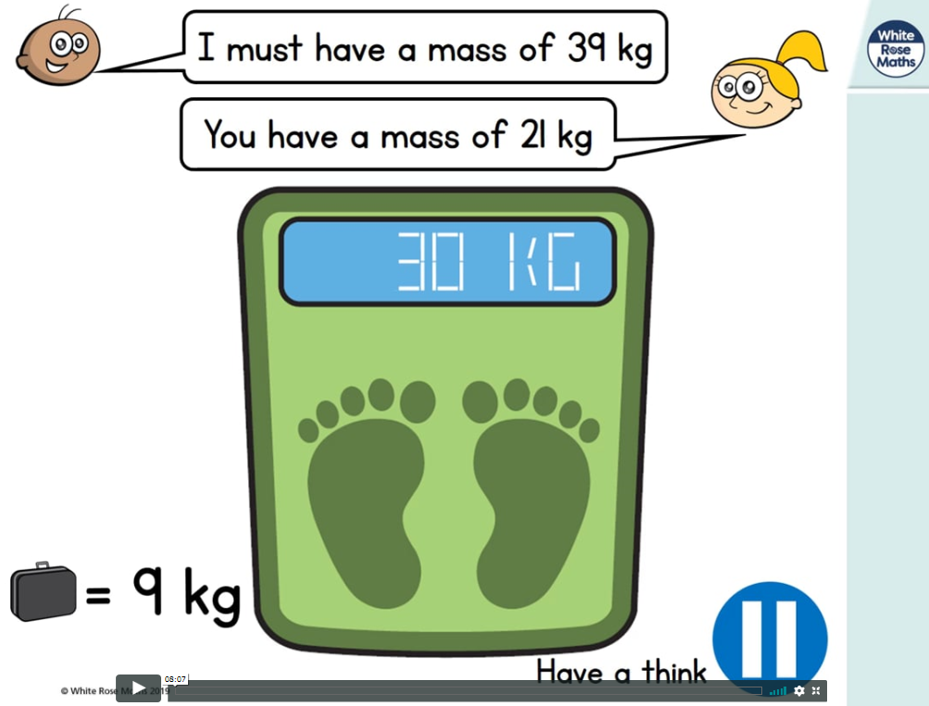
https://whiterosemaths.com/homelearning/year-2/ (w/c 29.6.20)
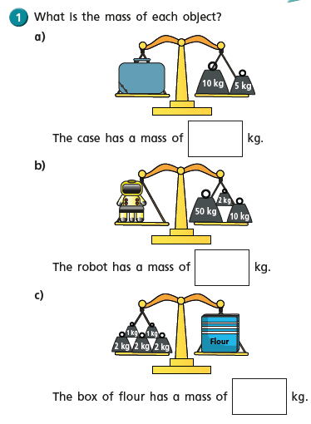
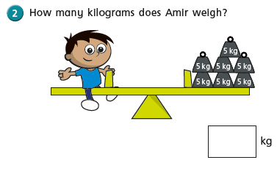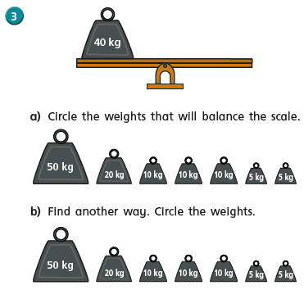
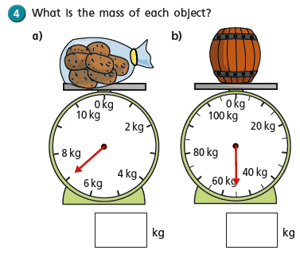
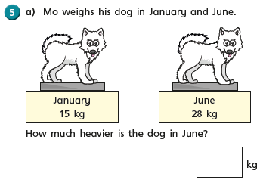
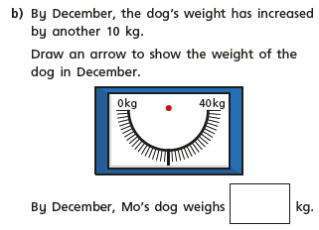

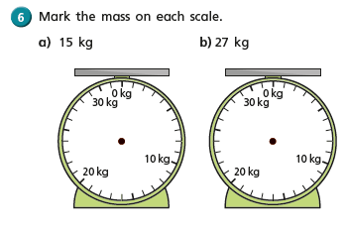
English - Tuesday 7th July 2020
Fun fact of the day: Your ears and nose never stop growing!!
Word of the day: Notorious.
WALT write a newspaper entry.

Good morning. How did the diary writing go? I hope you enjoyed it. Today we are going to continue to think about what happened at the Duke’s estate. We have heard from the Pelly how his day went but I bet that the attempted theft of the Duchess’s jewellery would probably make the newspaper, especially as the notorious ‘Cobra’ was responsible. I would imagine too that it would make great news that a Giraffe, Pelican, Monkey and a little boy were the heroes of the hour too.

What makes a good newspaper report?
Catchy heading – Crafty Cobra caught. (Using alliteration always makes for a good heading!)
Sub headings. Millions of pounds of jewels at risk!
Photograph or picture – A picture of the Pelly or the Duke.
Caption – Perfect pelican snatches the infamous ‘Cobra’ in his super powered beak, risking all to save the Duchess’s heirlooms.
Written in the third person in the past tense.
Give your newspaper a title e.g Hamphire’s Daily Diary or The News of the Day,
The Gazette ………… Here are a couple of examples.

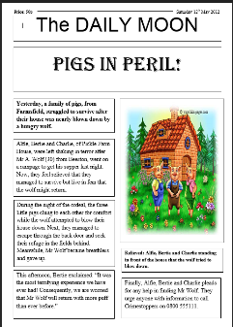
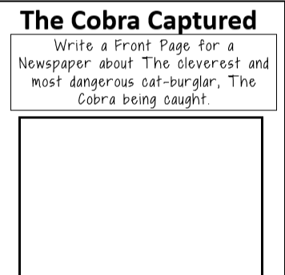

Geography – Map Skills:
WALT: use an atlas to find places in the UK

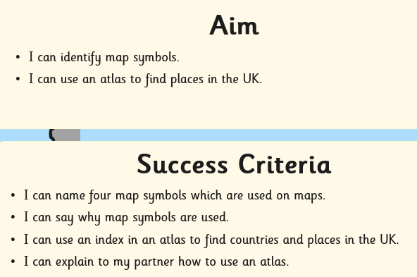

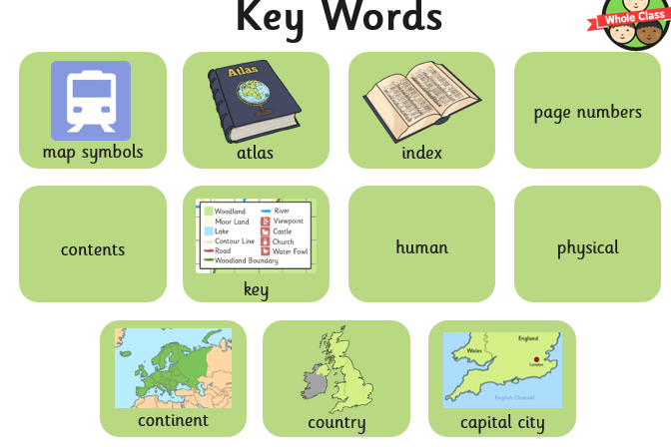

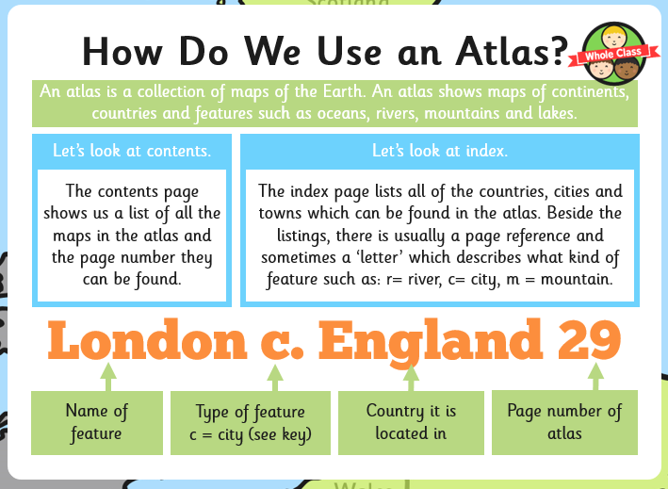
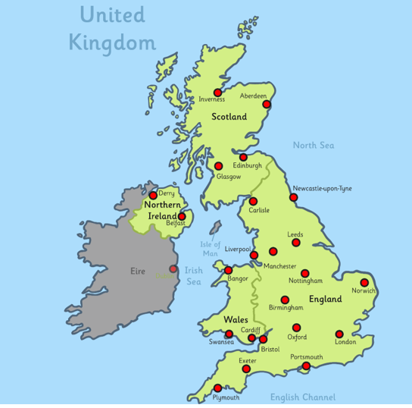

If you have an Atlas at home, use it to find these places. Use the index carefully, write down the page number, then find the country, place or feature.

