**Year 2 Phonics/Spelling Practice – Thursday 16.7.20.**

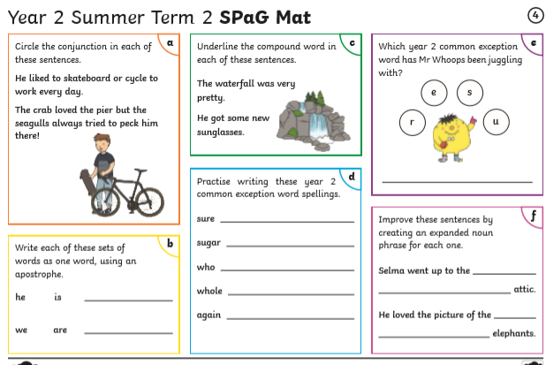

Maths 16.7.20

Time: Find durations of time

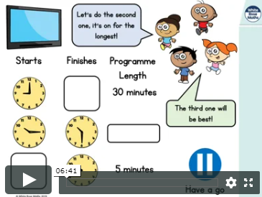

<https://whiterosemaths.com/homelearning/year-2/> (Week 12 W/C 13.7.20 Lesson 3)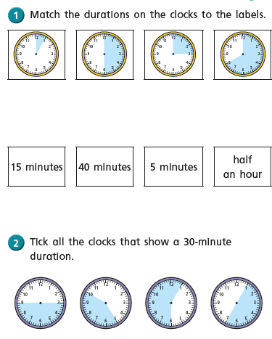

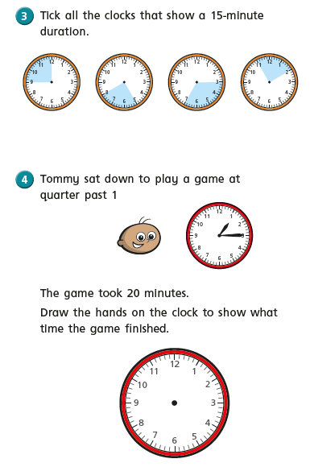

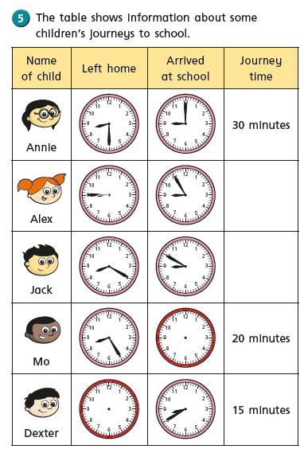

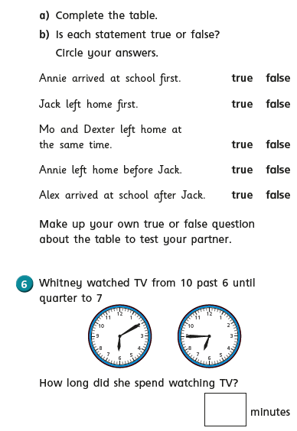

Art 16.7.20

Following last week’s lesson on self-portraits, please follow the BBC bitesize link to look at some videos about artists known for self-portraits.

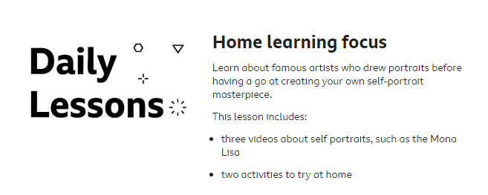

<https://www.bbc.co.uk/bitesize/articles/zmcp7yc>

Last week we looked at Vincent Van Gogh and his self portraits.

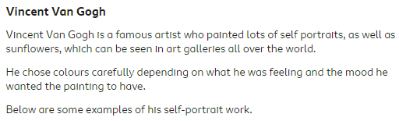

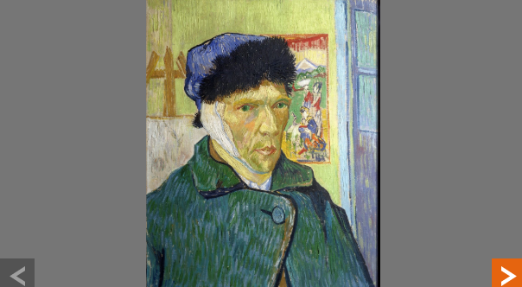 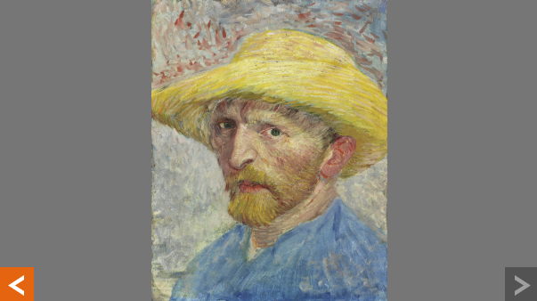

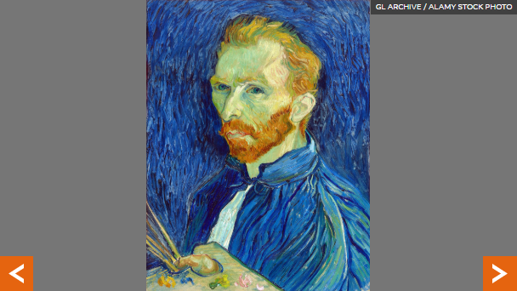

Today we are also looking at **Giuseppe Arcimboldo.**

