Year 2 Phonics/Spelling Practice – Friday 3.7.20.
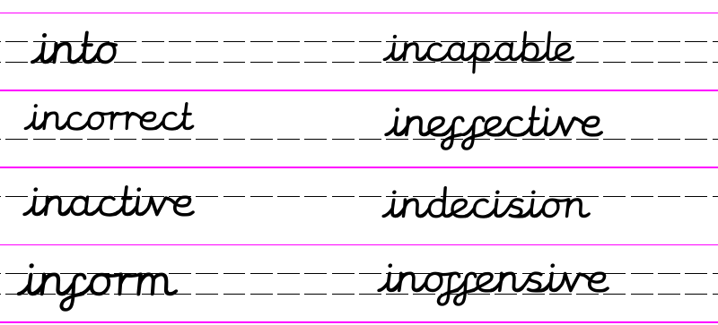
Today we’ll practise what we’ve learned this week:
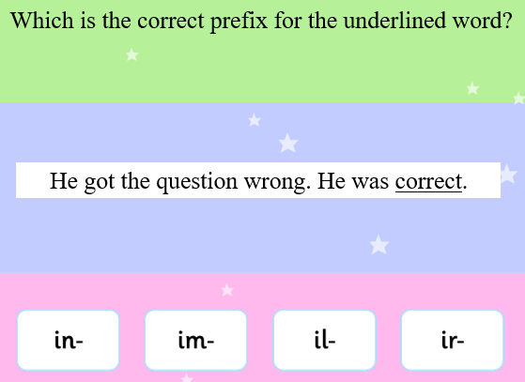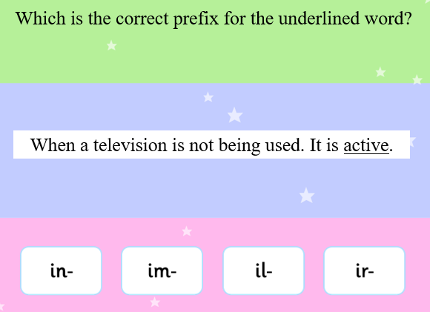
Sentence writing practise:
Complete the sentences and then use this week’s words to write
two sentences of your own. 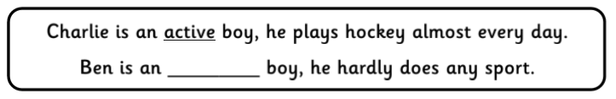
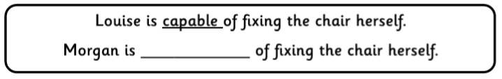
Maths 3.7.20
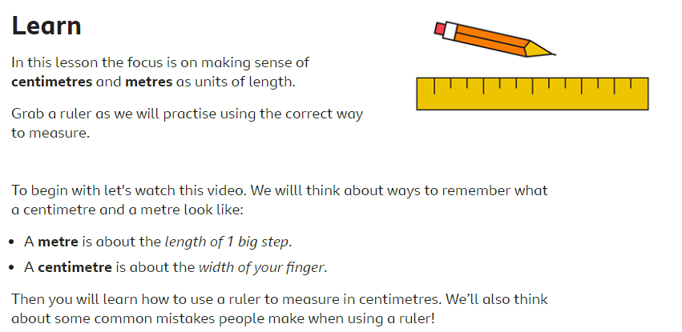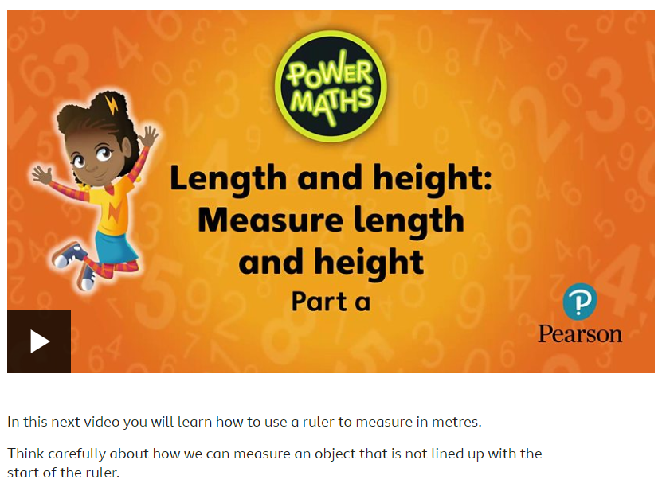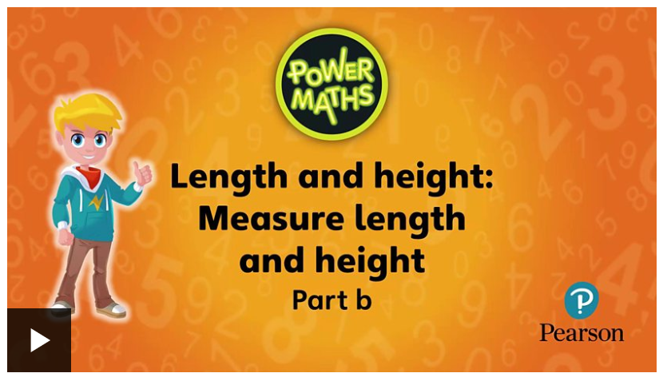
https://www.bbc.co.uk/bitesize/articles/zcbwr2p
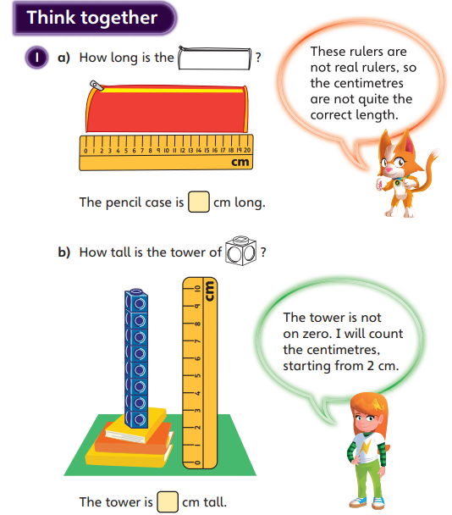
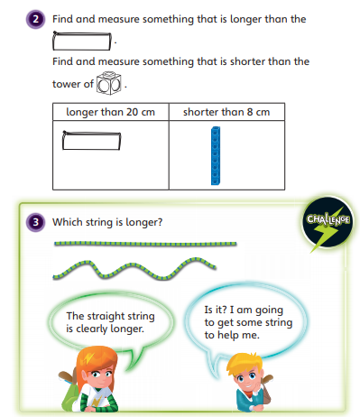

Now we are going to compare some capacity. 1 litre is equal to 1000ml
less than a litre, greater than a litre, equal to a litre
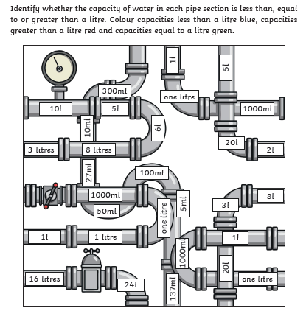

English - Friday 3rd July 2020
Fact of the day: Did you know that parrots and rabbits can see what is behind them without turning their heads!
WALT identify the features of an acrostic poem. We will write an acrostic poem about a Giraffe and or a Pelican.

Good morning.

How did you get on yesterday? Today to complete our acrostic poetry we are going to write an acrostic about a Giraffe and or a Pelican. Have another look at yesterday’s power point to remind yourselves. Can you also decorate your page like some of you did yesterday?

Have fun and most of all a lovely weekend.

Mrs Johnson

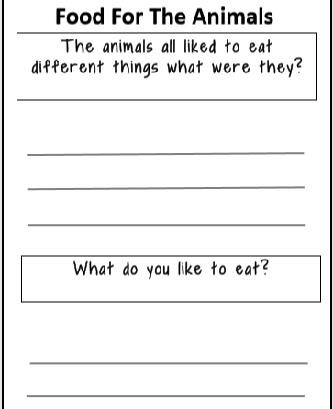

Computing - 3.7.20
Internet Safety
Follow the link https://www.bbc.co.uk/bitesize/articles/zq3gp4j to find out about how to be safe online.
