Day 4 - Week Beginning 13th July 2020 – English
SPaG
Words with the k sound spelt with que
Arrange the words in your spelling list into alphabetical order. Remember, if two words start with the same letter then look at the second letter. If the second letter is the same then look at the third letter...
mosque
unique
antique
plaque
cheque
boutique
picturesque
grotesque

Word of the Day – remote

Definition ____________________________________________
_____________________________________________________
_____________________________________________________
Used it in a sentence: ____________________________________________________
_________________________________________________________________________
Word Class: ____________________________________________________
Synonyms

English
Today use your plans from the previous lesson to write your recipes. You can choose to use the template on the next page. Use the features checklist to ensure you have all the necessary features of instructions.

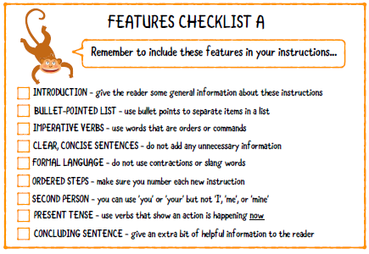

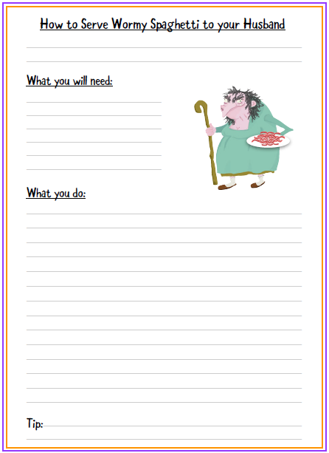

Day 4
Starter
- 432 + 886
- 432 – 319
- 149 ÷ 7
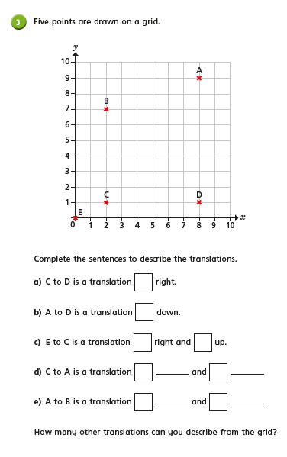
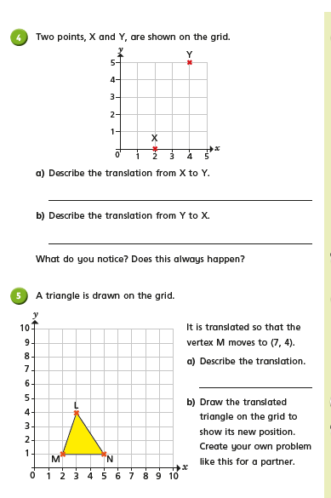

Day 4 PSHCE
Hooray! You’ve made it to the end of term! A whole 13 weeks of home learning, we are very proud that you have reached this point, Well done!
Take a moment to reflect on this academic year
