Teaching and Learning Policy 2022-2025 – Executive Summary
The aim of this policy is to ensure the highest possible level of progress and attainment for all children within an ambitious, broad and balanced curriculum, designed to give children the knowledge and cultural capital they need to succeed in life. Everyone in the Russell Lower School community has the ‘Right to Learn’.
At Russell Lower School we believe that effective teaching and learning encompasses a range of inter-linked activities and processes.
- High expectations and a positive climate characterised by respectful interactions are two strongly supported elements of effective education. All children should be held to high standards of behaviour. At Russell Lower School we aim to have a high expectancy culture. Teaching staff emphasise that all children can learn and behave well, and communicate that belief consistently and frequently to children. Emotion Coaching and a Growth Mindset are used
- A high-quality curriculum. Our curriculum follows the EYFS curriculum and the National Curriculum. It was designed to meet the needs of our children, in our context. There is a strong emphasis on developing core skills in literacy, maths, but also personal, social, healthy lifestyles and emotional skills. We aim to educate the whole child using our whole school curriculum. We aim to use research-based approaches, with proven impact. At Russell Lower School we use ‘Rosenshine’s Principles of Effective Instruction’ and the EEF’s ‘Great Teaching Toolkit’ as our guiding models. This has enabled us to identify a set of classroom strategies which teachers employ in the classroom creating an environment conducive to effective learning
- Inclusive high-quality teaching and learning for all is the recognised starting point for effective learning. This is supported by additional short-term interventions delivered by the teacher or other staff to accelerate learning for pupils with the potential to ‘catch up’ and/or reach age related norms by the end of the intervention. In some cases, additional highly personalised provision is available that is tailored to an individual’s specific needs
- Teaching effectiveness is the single most important factor in school effectiveness. (Ofsted January 2019). Teaching effectiveness is a combination of quantity and pace of instruction – having the opportunity to learn and cover content (curriculum) and the time children engage in active learning during a lesson. Attendance, Safety and Quality First Teaching are our ‘non-negotiables’
- Learning is defined as a change in long-term memory. Children know more and remember more. We therefore need to use approaches that help children integrate new knowledge into the long-term memory and make connections that foster understanding. Retention of knowledge will not happen if the working memory (short term) is overloaded. This suggests organising learning in small chunks which do not need too much memory capacity (4 – 5 things maximum) works best. Our lesson structure aims to provide this
- Formative assessment (everyday assessment for learning which is part of normal classroom practice) has been found to have a significant positive effect on attainment and is designed to inform the teacher about their children’s performance, knowledge and skills, and this information is then used to plan next steps, lessons or remediation to improve children’s learning and achievement. A key part of this type of assessment is feedback to children to help them to learn more effectively. We prioritise ‘full’ verbal feedback and over the shoulder ‘marking’ as they are most effective with our age children. Summative assessment is more useful for general quality control and to provide a picture of how well a child, or group, has performed over time. Teachers will usually make use of end of half term/term and unit assessments
- Consistency is one of the key factors that distinguishes effective schools. This means ensuring that practices are aligned. This is achieved by creating a strong, shared vision and ethos, ensuring accountability and creating learning within school so best practice can spread quickly. We look for ‘visible consistencies’ in all we do and ‘how’ we are
Each of these activities and processes is discussed in detail within the policy, but it is only by ensuring that they are interlinked that Russell Lower School will provide high quality teaching across the school, resulting in the highest levels of attainment and progress for all children.

Teaching and Learning Policy
Spring 2022
Review Spring 2025
Introduction

The aim of this policy is to ensure the highest possible level of progress and attainment for all children within an ambitious, broad and balanced curriculum, designed to give children the knowledge and cultural capital they need to succeed in life. Everyone in the Russell Lower School community has the ‘Right to Learn’.

The curriculum lies at the heart of education. It determines what learners will know and be able to go on to do by the time they have finished that stage of their education. The curriculum is coherently planned and sequenced towards cumulatively sufficient knowledge and skills for the next stage in children’s education. Our curriculum is a progression model: we have subject-specific milestones that focus on progression through content and skills learned.

At Russell Lower School, we are a knowledge-engaged school, where knowledge underpins and enables the application of skills and we develop both. We also aim to develop life skills such as resilience, a growth mind-set and perseverance, alongside our school values and four Russell Rights. See more on this below in our ‘Whole School Curriculum’.

The Curriculum

Our curriculum follows the EYFS curriculum and the National Curriculum. It was designed to meet the needs of our children, in our context. There is a strong emphasis on developing core skills in literacy, maths, but also personal, social, health and emotional skills. There are opportunities to apply these across the curriculum. Our curriculum is coherently planned and sequenced using ‘Milestone’ documents in each subject in each year group. However, we consider the Russell curriculum to be so much more that the individual subjects. We aim to educate the whole child using our whole school curriculum:
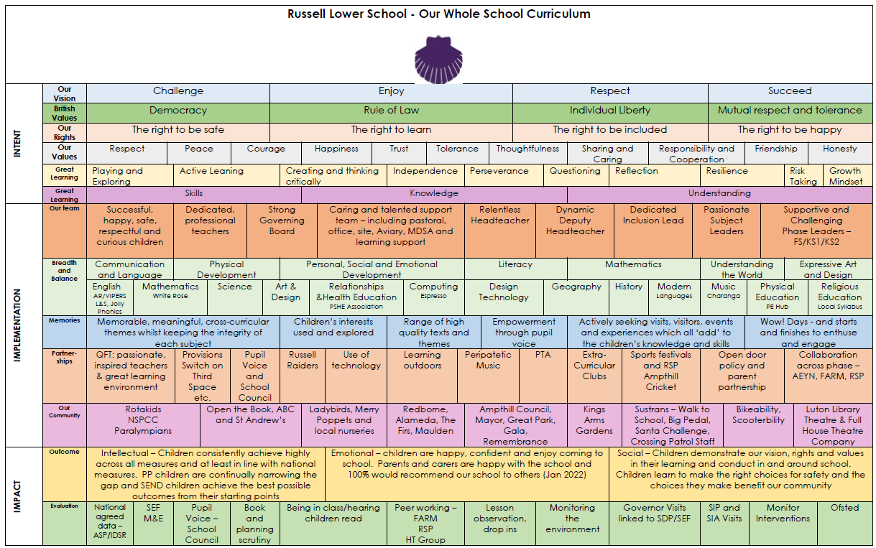

For more details, please see the curriculum area of our website.

To ensure the highest possible levels of progress and attainment for all the children who attend Russell Lower School, it is essential that there is a shared understanding of what constitutes highly effective learning and the highly effective teaching that enables this to occur. We aim to use research-based approaches, with proven impact.

As curriculum lies at the heart of education, and subject knowledge lies at the heart of the curriculum, then it follows that teachers need solid knowledge: content knowledge and understanding of the subjects they teach. As well as this, they need to know how to teach that particular subject (pedagogical knowledge), and more generally how to teach effectively. At Russell Lower School we use ‘Rosenshine’s Principles of Effective Instruction’ and the EEF’s ‘Great Teaching Toolkit’ as our guiding models.

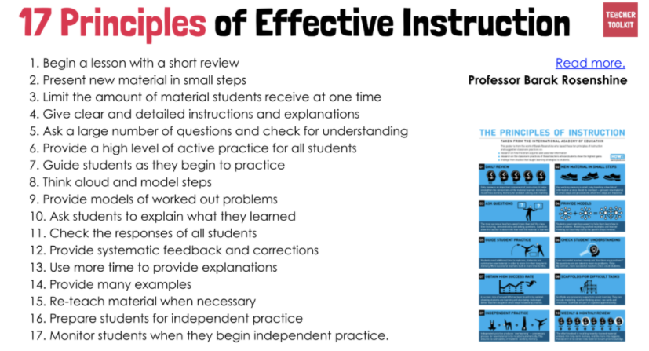

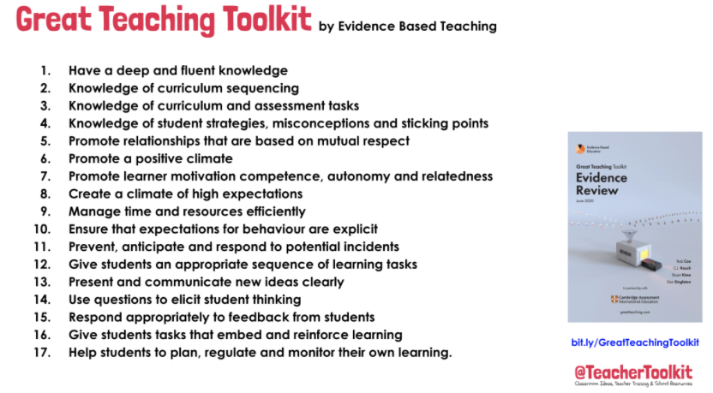

Linked classroom strategies used at Russell include:

- Teaching from our Curriculum Map, using the Milestones effectively
- Begin a lesson with a short review – such as Flashback 4. Continue to engage in regular reviews, checks and ‘tests’ in all subjects
- Less is more – less teacher ‘talk’ and fewer words on Lynx slides
- Asking of ‘deep’ questions such as ‘how do you know?’ ‘justify’ or ‘explain’
- Modelling of thinking aloud while demonstrating, and use of ‘prompts’ to scaffold children temporarily as needed
- Present small amounts at a time and give time for practice (first guided, then independent)
- Checking for understanding using ‘Pose, Pause, Pounce, Bounce’ – banning of hands up
- Providing systematic feedback and corrections throughout the lesson, and ensure children ‘act’ upon it
- Boost vocabulary by explicitly teaching and using it in every lesson
- Provide scaffolds (temporary) to support with misconceptions
- Named subject leaders for all subjects
- Emotional Coaching strategies to support great behaviour for learning
- Promotion of the four Russell Rights (to learn, to be safe, to be included and to be happy) in everything we do
- Have high expectations in everything we do
- Building in a high level of success. This is crucial for retaining motivation, progressing and embedding knowledge.
- Give purpose to teaching and learning linked to real life events
- Create fun and engaging lesson to support motivation and enthusiasm

As experts in teaching and learning, teachers take the lead when meeting the needs of all children, including those with lower ability, higher ability, Pupil Premium, SEND and those children identified via Pupil Progress Meetings and assessments/data as needing to make the most or accelerated progress. Therefore, in lessons, it is the teacher, not the LSA, who will predominantly work with these children, ensuring that their progress is at least as good as their peers.

For more information regarding higher ability children, please see our ‘Excellence for All’ Policy.

This practice enables staff at Russell to meet the current Ofsted expectations (from EIF):

- Teachers present subject matter clearly, promoting appropriate discussion about the subject matter being taught. They check learners’ understanding systematically, identify misconceptions accurately and provide clear, direct feedback. In so doing, they respond and adapt their teaching as necessary without unnecessarily elaborate or differentiated approaches.

- Teachers create an environment that promotes a focus on the learner. The resources and materials that teachers select reflect an ambitious learning intention of a coherently planned curriculum, sequenced towards cumulatively sufficient knowledge and skills for future learning and employment.

- Over the course of study, teaching is designed to help learners remember in the long term the content they have been taught and to integrate new knowledge into larger concepts.

- Teachers and leaders use assessment well, for example to help learners embed and use knowledge fluently or to check understanding and inform teaching. Leaders understand the limitations of assessment and do not use it in a way that creates unnecessary burdens for staff or learners.

Leadership and CPD

Leadership is crucial to good learning and teaching.
Research has found (Ofsted 2019) that Instructional leaders are most effective. They have a pedagogical and curricular vision and expertise. An instructional leader promotes common approaches to factors such as teaching and behaviour management in the school, monitors teaching, and makes sure that professional development (CPD) focuses on teaching and learning.

At Russell Lower School we do this using the following:

Common approaches to teaching and learning – via Rosenshine’s Principles of Effective Instruction and EEF’s Great Teaching Toolkit
Common approaches to behaviour management: Behaviour Policy and Emotional Coaching

We aim to have effective CPD, and believe it is most effective when:
- Good quality and evidence based
- It is part of a longer programme, not just ‘one off’
- Has follow-up, practice and support
- Is relevant to the everyday work of teachers
- Is differentiated by teachers’ starting points, and should not just have a one-size-fits-all approach
- Allow teachers to engage in peer learning and collaboration
- Subject knowledge and pedagogy (effective teaching) are equally important, and generic topics (e.g. assessment for learning) are embedded within a particular subject
- It has clear goals and progression
- It has some external input
- It builds into classroom practice and experimentation

Research on effective teaching

Teaching effectiveness is the single most important factor in school effectiveness. (Ofsted January 2019).

Teaching effectiveness is a combination of:

- Quantity and pace of instruction – having the opportunity to learn and cover content (curriculum) and the time children engage in active learning during a lesson

Research (Ofsted) on teaching effectiveness suggests that achievement is likely to be maximised when teachers actively present material and structure it by:

- Providing overviews and/or reviews of objectives
- Outlining content to be covered and signalling transitions between different parts of the lesson
- Calling attention to the main ideas
- Reviewing main ideas

These elements can occur at different points in a lesson or over a sequence of lessons. Rosenshine’s Principles of Effective Instruction are used as a clear and consistent set of expectations and framework at Russell Lower School

Other factors with large effects of the effectiveness of teaching are:

- Clarity of presentation – communicate clearly and directly without going beyond the children’ level of comprehension or ‘overloading’ with teacher talk or ‘wordy’ Lynx files
- Teacher talk is focused on academic content and mostly involves asking questions (and getting children to question each other) and giving feedback rather than ‘extended lecturing’
- Receiving and responding to timely feedback (EEF toolkit 2020 +8 months)
- Mastery is developed by checking children’ understanding and helping them clarify and verbalise their thinking
- Targeted questioning (no hands up most of the time to maximise engagement) deepens understanding by taking children’ partially correct answers and getting children to extend them further (including explaining and justifying some), and if an answer is incorrect the teacher moves on swiftly, whilst encouraging quieter children to have a chance to answer. A mix of recall and higher-order questions works best, but the balance will change according to where a lesson sits in a sequence of lessons and the child being questioned
- Children can be encouraged to ask questions, which can be aimed at the class first, before being answered by the teacher
- Group activities and paired work can contribute effectively to learning, but to work effectively, must be clearly structured with each child having a clear role. Teachers must also ensure children have sufficient prior knowledge before group work, or the danger is reinforcing misconceptions and children becoming passive
- Information is presented with a degree of repetition, particularly in the form of repeating and reviewing key concepts
- Adapting teaching – for example by providing focused support for children not making progress or further challenge and extending/deepening understanding and knowledge – is likely to improve outcomes

In the Early Years:

- The most effective provision combines direct teaching and child-led activities, focuses on a particular discrete skill i.e. counting, and allocates a set amount of time to it
- High quality provision includes both play and adult-directed activities and minimises time spent on classroom management (transitions, waiting for turns etc.)
- Play should be planned. Well planned play is important to help children practise the use of knowledge and build up skills, to explore and make sense of the world around them.
- Effective pedagogy consists of both teaching and the provision of instructive and stimulating learning environments and routines. These need to be well-planned with clear goals on what learning is intended
- It is important to create a language rich environment and for adults to engage children in ‘sustained shared thinking’ where adults engage in longer two-way communication with the child to develop their thinking and model language
- Activities to develop letter knowledge and early phonics, storytelling and reading to the class (talking about what has been read and extending spoken vocabulary) are all key
- Prioritising early reading and maths has a very positive impact

Learning and Memory

Learning is defined as a change in long-term memory. We therefore need to use approaches that help children integrate new knowledge into the long-term memory and make connections that foster understanding.

Retention of knowledge will not happen if the working memory (short term) is overloaded. This suggests organising learning in small chunks which do not need too much memory capacity (4 – 5 things maximum) works best.

Strategies include:

- Spaced, repetitive practice where knowledge is rehearsed for short periods over a longer period of time
- Block learning into chunks and repeat over time
- Interleaving so instead of AAABBBCCC, ABC, ABC, ABC
- Retrieval practice – recalling something you have learned in the past – Flashback 4, ‘testing’ via flashcards, test or concept map or through cross-curricular links for example
- Elaboration – describing and explaining something learned to others in some detail, or where children make their own connections between ideas or explain them
- Dual coding – presenting information both visually and verbally

Assessment

Formative assessment (everyday assessment for learning which is part of normal classroom practice) has been found to have a significant positive effect on attainment and is designed to inform the teacher about their children’s performance, knowledge and skills, and this information is then used to plan lessons or remediation to improve children’s learning. A key part of this type of assessment is feedback to children to help them to learn more effectively. In order for it to have benefit, two things need to happen:

- Children are given advice on how to improve
- Children act on the advice using materials provided by the teacher, by going to the teacher for help, or by working with other children

On-going, formative assessment to check children’s understanding of the main curriculum elements and responding appropriately by adapting teaching works most effectively. Information gathered identifies gaps in knowledge, skills and depth of understanding and informs and improves curriculum design and teaching.

Please see our Marking and Feedback policy for more information.

Summative assessment is more useful for general quality control and to provide a picture of how well a child, or group, has performed over time. Teachers will usually make use of end of half term/term and unit assessments. Teachers will assess children using Classroom Monitor. There is a ‘data deadline’ to provide a summative judgement each term. This assessment data is then analysed in Pupil Progress Meetings. At Russell Lower School, we also use: statutory assessments such as the EYFSP, Year 1 Phonics Screening, Year 2 ‘SATs’ and Y4 Multiplication Checks.

Please see our Assessment Policy for more information.

Use of low stakes testing can be valuable as retrieval practice is effective. The ‘testing effect’ is that it helps learners recall knowledge previously learned. ‘Gap analysis’ is also used and effective.

Pre-assessment in advance of a ‘unit’ of work is highly effective. Teaching can then be adapted to meet needs more effectively.

High expectations and a positive culture

High expectations and a positive climate characterised by respectful interactions are two strongly supported elements of effective education.

All children should be held to high standards of behaviour. It is important to remember that expectancy effects can manifest themselves through allowing children of whom the teacher has low expectations to behave worse and be off task more often than high-expectancy children, and through giving them more consequences and fewer rewards than are given to high-expectancy children. At Russell Lower School we aim to have a high expectancy culture. Leaders emphasise that all children can learn and behave well, and communicate that belief consistently and frequently to children and staff.

Good whole-school behaviour management is achieved through our culture of inclusion, Emotional Coaching and our Behaviour Policy which is consistent and fairly and rigorously applied. The expectations run through the school culture, leadership, and child and teacher behaviours.

For behaviour management, consistency and fairness are vital. Consistency across practices is important for children, who benefit from clear expectations of what is typically going to happen in lessons and of what is expected of them. Emotional Coaching is used to support children to understand that all feelings are valid and understandable and that we all experience them, but that it is how we respond to these feelings that matters. We aim to support children to have strategies to enable them to self-regulate most of the time and make reasonable adjustments for children with SEND.

In the Early Years:

Young children benefit from a warm and empathic, but also rule-based environment. Developing self-regulation and the ability to follow direction are important elements of early child development and are assisted by an environment in which clear rules are consistently enforced. There is evidence that clear discipline and behaviour policies that prioritise talking through conflicts characterises effective behaviour management in early years settings. Our Emotional Coaching and Behaviour Policy enable us to achieve this in almost all cases.

We strive to create a positive and empathic environment, in which staff know and care about children, and share their expectations clearly and enable the children to have the means of achieving these goals. Self-belief is significantly related to attainment. Creating a supportive environment with clear boundaries is particularly important. This means that, while Russell Lower School is a supportive and caring school, it is also a disciplined, orderly environment with clear, though not stifling, rules and procedures (Muijs & Reynolds, 2017). At Russell Lower School, we provide children with responsibilities and roles through which they can develop self-confidence (monitors, Year 4 helpers, sports ambassadors, school council etc).

Equally, being highly organised and having an enabling learning environment are key so that ‘not a second’ of time is wasted.

Attendance

Two factors are key if children are to learn effectively: they attend school well (we aim for 97%) and spend the maximum amount of time on task. This is achieved by working with parents to improve attendance via rigorous monitoring and by ensuring that teachers’ time is fully used for teaching (not a second wasted) and that during that time children are on task. Punctuality is equally important at all points of transition in the day.

Consistency

At Russell Lower School, we aim to maximise consistency whenever possible. Consistency is one of the key factors that distinguish more effective from less effective schools. This means ensuring that practices are aligned. This is achieved by creating a strong, shared vision and ethos, ensuring accountability and creating learning (INSET/SDMs etc.) within school so best practice can spread quickly. This reduces in-school variation and ensures that practices that have been identified as effective for improving learning and raising child achievement are adopted as widely as possible across all areas and subjects.

Pedagogy – How we teach at Russell Lower School

At Russell Lower School we believe that effective teaching and learning encompasses a range of inter-linked activities and processes:

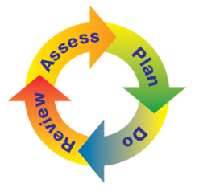
Quality first teaching is always the first requirement of the ‘do’ stage. This is good or better teaching in all classrooms using our agreed ‘milestones’ and on-going formative assessment. This includes how adults and the environment are planned for and used to support children’s learning in the most effective way. The diagram below is a simple explanation of our approach:

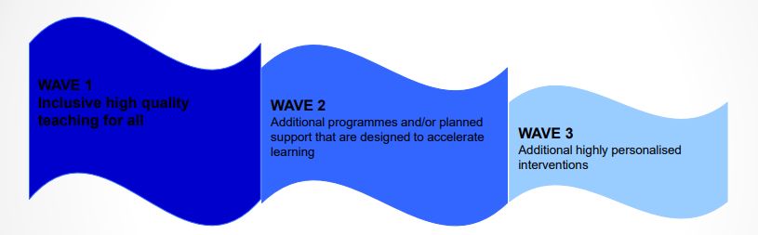

Wave 1  Quality First Teaching  Inclusive high-quality teaching and learning for all | Wave 2  Additional short-term interventions  Interventions delivered by teacher, LSA, 1:1 tutor, Pastoral, intervention leads designed to accelerate learning for pupils with the potential to ‘catch up’ and reach age related norms by the end of the intervention | Wave 3  Long term need  Additional highly personalised provision that is tailored to individual’s specific difficulties.  Planned and implemented by Teacher, parents, SENDCo/Inclusion lead, Outside agencies such as Ed Psych, S&L etc. and 1:1 LSAs
- Whole school/class rules and rights  - Structured school and class routines  - Reward systems and consistent use of the behaviour policy  - Dedicated PSHRE lesson focused on the classes needs  - Differentiated delivery & resources – considering all styles of learning  - Talk Partners  - Differentiated questioning and expectations  - Differentiated learning task – 3 levels and star challenge with steps to success  - Use of in-class resources such as writing frames, word mats, maths resources  - Increased visual aids  - Visual whole class emotions display  - In-class support from LSAs/teacher as required  - Values display and reference  17 principles of effective instruction  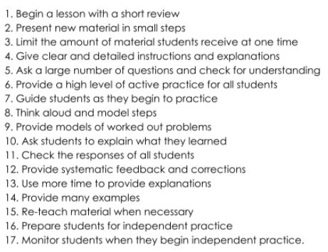  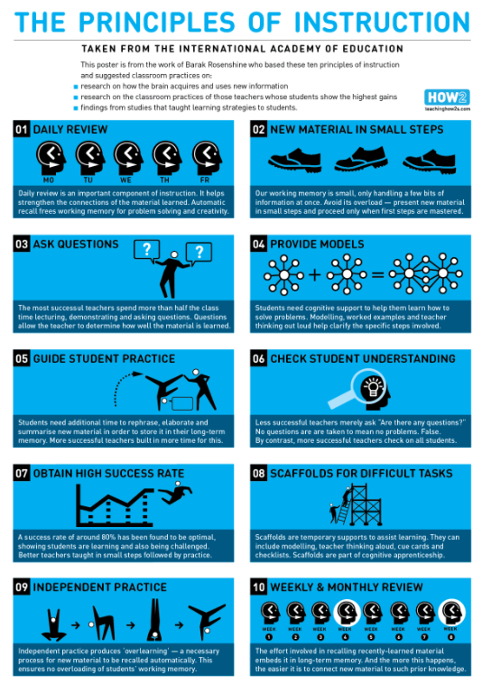 | - Gap/need clearly identified through diagnostic assessment/observations  - Relevant provision identified from the Russell provision list – could take the structure of below:  - Group support from LSA/teacher in subject areas – either within class or small group work outside of classroom such as rising stars maths, switch on handwriting, phonics  - 1:1 activities such as daily reading, Switch on reading/writing/full  - Provision set with clear SMART focused targets and time limited and then reviewed for impact  - Possible use of external agencies – NTP such as Third Space maths 1:1 tuition  - Work with Pastoral Support Team  - Individual reward system linked to provision such as dojos  - Class teacher has a full understanding of the intervention and how to integrate learning into the classroom – they have overall responsibility | - Termly MAP with SMART focused targets  - Fully differentiated curriculum/planning  - 1:1 precision teaching  - 1:1 support in class  - Tailor made/specialist resources  - Access to IT for recording purposes  - Support from external agencies e.g. Ed. Psych., EY advisory, ASD team, OT, SALT  - Support for alternative forms of communication e.g. Makaton  - Home – school record  - Class teacher has a full understanding of the intervention and how to integrate learning into the classroom – they have overall responsibility
Personalisation through adaptations
• By content - adapt what you want the children to learn or how they gain access to knowledge, skills and understanding
• By task- allocate different tasks to achieve same goal
• By outcome - what is the child expected to produce?
• By learning needs - Visual, aural, kinaesthetic
• Use of additional support - effective deployment to support learning
• By time - time allocated for task adjusted to meet need
• By scaffolding - writing frames, word lists, visual timetables
• By resources - accessible, appropriate and supportive
• By technology - use of ICT/APPS to ensure accessibility
• By peer group support - buddies, group work, peer tutoring
• By feedback - teachers give individual feedback and set individualised goals and targets
• By teaching strategy - focus on the vital role that teacher’s play in facilitating learning and removing the barriers to learning

Some examples of strategies commonly used in classrooms:

- Visual timetables/displays
- Three levels of ‘differentiated task’ for all lessons.
- Personalised spellings/number bonds/times tables for all children.
- Individual reading progress for all children from Foundation stage (not group reading)
- Now/next
- Tray systems
- Button timers/Egg Timers
- Writing slopes
- Ergonomic pencils/pencil grips/variety of writing tools
- Use of ICT – Sound buttons, IPADS, Computer suites.
- Adapted tasks – cloze procedures
- Provisions – Switch On reading, writing, handwriting
- Maths pre-teach/support, Third Space Tutoring
- 5-minute phonics
- Phonics intervention
- Speech and Language – Lift off to language, Individualised SALT.
- Enlarged fonts/texts/test materials
- Coloured backgrounds
- Pictorial resources
- Seating positions
- Staff support
- Precision teaching

For further information regarding inclusion, please see our SEND policy and information report on the website.

