Tuesday 7th July 2020
English
SPaG
Practise your spellings – try making a fortune teller to help practise the words.
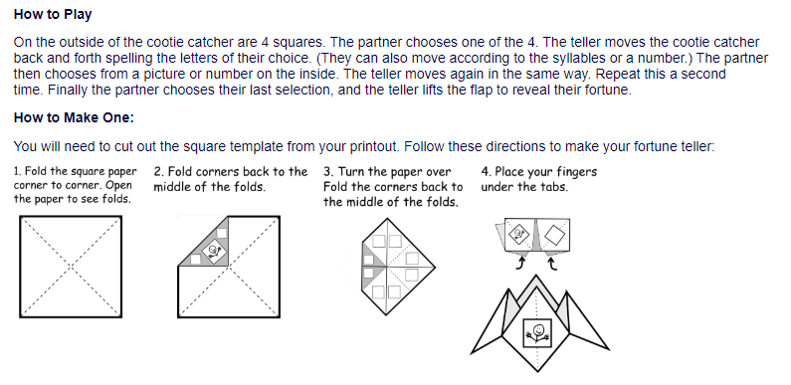
Words spelt with a g sound spelt gue
league - tongue
vague
plague
meringue
synagogue
epilogue
monologue

Word of the Day – sluggish

Definition ____________________________________________
_____________________________________________________
_____________________________________________________
Used it in a sentence: ____________________________________________________
_________________________________________________________________________
Word Class: ____________________________________________________
Synonyms

English
Today we will be looking at features of a play script.
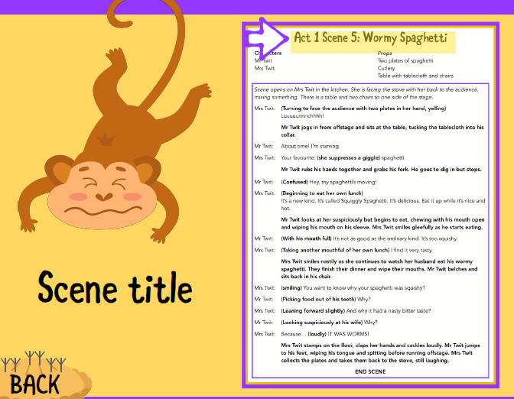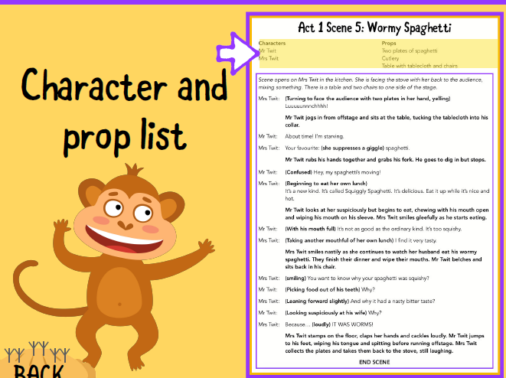
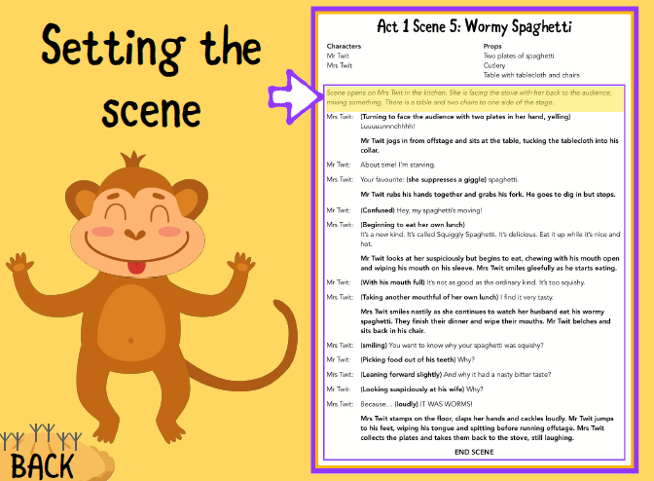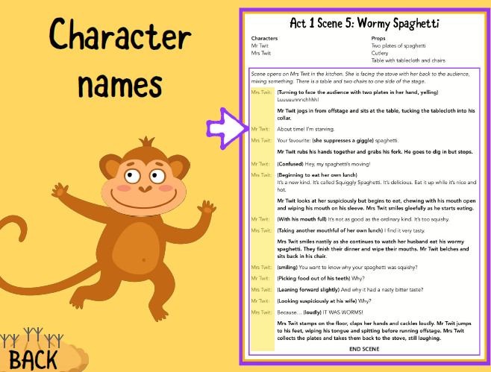
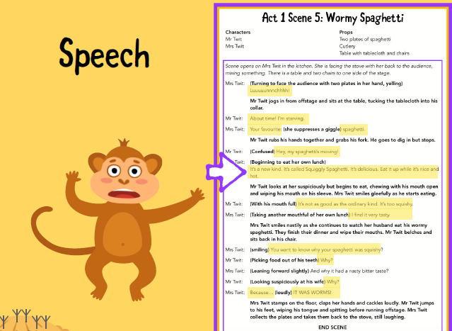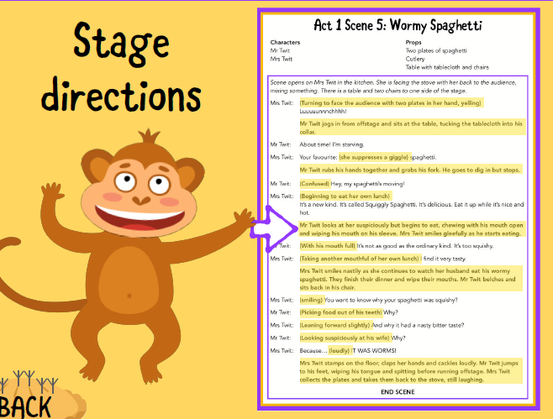

Your Task
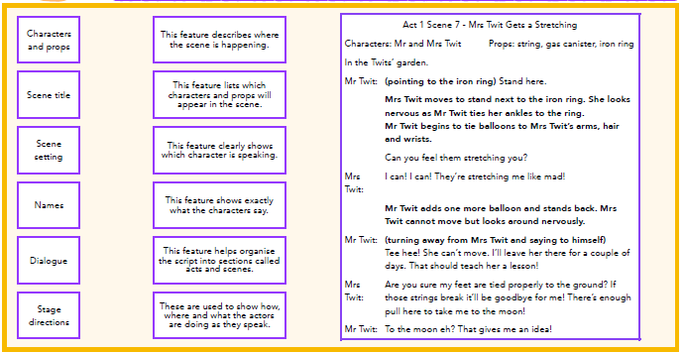
Match the features of a playscript to its definition and purpose. Then act like a teacher and mark the playscript by ticking the features they have used well and improving parts which were not done well.

Maths

- An angle measures 36⁰ , what type of angle is it?
- What is 72 divided by 9?
- 30 + ___ = 20 + 15

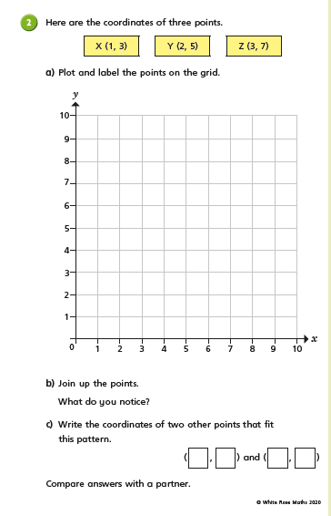

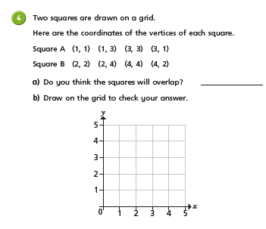

Science
Read these two definitions:
Digest: Break down food so it can be used by the body
Digestive system: A system of organs that get food in and out of the body and which make use of the food to keep the body healthy.
TASK: Without looking on the internet or in any books just yet (don’t peek!). Draw and label the body parts that you think are important for the digestive system. Think about the following to help you:
-How do humans digest food?
-How does food travel through the body?
-What parts of the body are involved?
Keep your drawing safe as we will learn more about this tomorrow and see how close you were. If you just can’t wait you might find this page helpful https://www.bbc.co.uk/bitesize/topics/z27kng8

TASK: use the text below to help you learn about digestion and answer the questions below.
TIP: You might find this page helpful https://www.bbc.co.uk/bitesize/topics/z27kng8

