NOVEMBER NEWSLETTER
12th November 2020
Dear Parents/Carers,
Welcome to our November newsletter. These newsletters are sent out on a monthly basis to keep you informed about what is happening in school.
As things are so ‘up in the air’ at the moment (to put it mildly), we will be taking each half term at a time. Please note events that are underlined and in italics are new since the previous newsletter. This that are crossed out, we are no longer able to run on these dates due to the second national lockdown, but we will reschedule them.
Monday 16th November – Anti-bullying week, Curriculum, Learning and Standards Governors Meeting at 6:30pm
Tuesday 17th, Wednesday 18th and Thursday 19th - Indian Dance Workshops across the school in class bubbles
Monday 23rd November – Road Safety Week, Year 1 Vision Screening
Tuesday 24th November – Year 1 Vision Screening
Wednesday 25th November – Hinduism Workshops – FS bubbles (Diwali) and Year 4 bubbles
Thursday 26th November – 7:30pm PTA Meeting (virtual)
Friday 27th November – Foundation Stage Maths Workshop to parents (video link will be sent home), KS1 and 2 Maths Workshops to parents (video link will be sent home)
Monday 30th November – Full governors meeting at 6:30pm, Santa Challenge begins, Santa Challenge Assembly
Tuesday 1st December and Wednesday 2nd December – Flu vaccinations
Wednesday 2nd December – Year 1 Phonics lesson modelled for parents (link to video sent home)
Wednesday 9th December – Christmas Dinner
Friday 11th December – Christmas Breakfast Morning/ Christmas Jumper Day
W/C 14th December – Pantomime week
Thursday 17th December – Class Christmas Videos sent home
Friday 18th December - Break up for Christmas

CHRISTMAS HOLIDAY MONDAY 21st DECEMBER – FRIDAY 1st JANUARY

Monday 4th January – INSET DAY – School CLOSED to children
Tuesday 5th January – Children return to school following the Christmas break

Please see the school website for more dates beyond this
More detailed information on the above events will follow in due course

Safety around the school site:
Thank you for continuing to support our staggered starts and finishes, and all the safety measures around school, including the use of face coverings. I am grateful for all your collective efforts to keep our community safe, and us all at school! Thank you.

Lockdown 2 and its impact:
In light of the latest Lockdown, please find below some resources that can support emotional wellbeing for both children and parents. Lockdown can be hard on all of us and can highlight some emotional issues leading to us experiencing challenges such as anxiety and low self-esteem. Attached and below are some sources of further information and handouts to assist with breathing techniques, changing negative thoughts, recognising anxiety, big feelings stories for young children and coping strategies. Some are designed for children, some for adults.

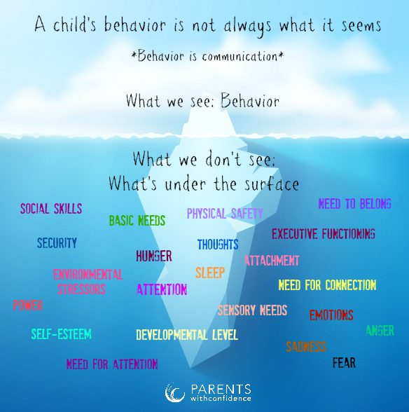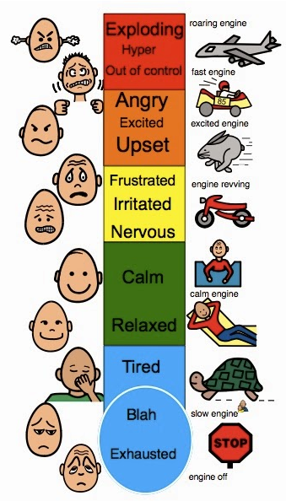

At school, we use a simple but effective 3 step strategy (called Emotional Coaching) to support children and de-escalate situations. You might like to try it at home too. With practice, it only talks a couple of minutes:

- We recognise, validate, label and empathise with the EMOTION – E.g. ‘I can see you are feeling really angry and that’s okay to feel angry.’
- We put limits on the BEHAVIOUR and say why it matters – E.g. ‘I understand that you feel angry, but it is not okay to hit people. At Russell Lower School (in our house), we keep each other safe, because it is never okay to hurt anyone, and we all have the right to be safe (Russell Rights/house rules).’

Once we are calmer – maybe via some deep breathing/mindful colouring/’down time’ we…
- We problem solve together – the SOLUTION – we think about what happened, how it made us feel (physically and emotionally) and talk about what we could do to help control those feelings (physical and emotional) and how we can BEHAVE differently next time. E.g. ‘It is okay to feel angry. I get angry too; we all get angry, but it is not okay to hit. Next time you could get an adult to help you/use your words/count to 10/walk away/ignore it. (context dependent, ideally child comes up with the ideas for solutions, but you can give appropriate choices if they struggle, but ultimately let them choose the ‘solution’ – this is what makes it coaching and builds their self-belief and confidence to solve their own problems in the future). I am always here to help you.’

Other helpful links:

Guidance for parents and carers on supporting children and young people’s mental health and wellbeing during the coronavirus (COVID-19) pandemic - provides information on how covid 19 can affect daily life and provides information and links for families with advice and actions to take care of your families mental health and wellbeing, together with help lines and websites, including:
Every Mind Matters for clear advice and actions to take care of your mental health and wellbeing
MindEd for families – free online educational resources on children and young people’s mental health

St Andrew’s Christmas Tree Festival:
We are already busy making decorations for our Christmas tree entry along the theme of ‘Our Favourite Christmas Pantos’. The tree and its decorations will then be entered into the St Andrew’s Tree Festival which runs over the weekend of the 12th and 13th of December (virtually this year!). Please try to find the time over this weekend to ‘log on’ to the festival (and vote for the Russell Lower School Tree of course!). Sadly, this will be our first year not being able to take the choir to sing at the festival (magical moment!), or to visit the church with KS2 to perform for parents. We are so sorry and know you will miss this opportunity as much as we will. As soon as I get details of how to ‘view’ and vote for the Christmas Tree, I will pass them on to you.

Christmas ‘Performances’ and plans:
Sadly, we will be unable to continue with our usual Christmas ‘shows’ where we invite you into school to watch the nativity and Christmas productions. However, each class will be planning to put together a short Christmas performance which we will record and ‘send’ to you.
Wherever possible, we are finding creative ways to carry on regardless! For example, our Christmas Breakfast Activity and Christmas Jumper Morning will continue for the children, but we will be unable to invite parents in, and we have found an on-line pantomime instead of our usual theatre trip. It is incredible how we are all adapting! Rest assured, we will still have lots of Christmas magic and fun at Russell!

Ampthill Happy Deer for Christmas Competition
Please see the information and poster below about the ‘Happy Deer for Christmas’ Competition from Roy Tebbutt from Ampthill District Rotary Club. It looks like lots of fun!

The competition is aimed at encouraging a bit of Christmas Cheer in Ampthill. We would be grateful if as many families as possible would take part in the competition.
Any material for a reindeer can be used and we look forward to seeing creative flair and a sense of fun.
We look forward to some wonderful entries of photographs of deer at ampthillrotarydeer@mail.com
Stay safe for Christmas.
Thank you.
Roy Tebbutt.
For ADRC

PTA Support:
You will be aware that schools across the country have also suffered enormous financial losses due to the Coronavirus (continued staff costs, no furlough option as we are state funded, huge increase in cleaning costs and lost income from clubs/Aviary etc.). We would be absolutely stumped without the support of the PTA (and of course all of your generosity that means they have the funds to give us! For example: the Autumn Dress up day on the 23rd October raised well over £300 – thank you!) Also, we cannot thank the PTA enough for pledges already made this year to support the buying of new Phonics and Accelerated Readers books (£1000), and for the hours of time they spent covering the books so we could get them onto shelves quickly, and for paying for the virtual panto. We really do appreciate it – thank you very much! We are all also excited to see the pond area developed further once the beautifully decorated ‘lockdown’ pebbles have all been weather-proofed. Watch this space.
Sports and events at Russell:
You will see from the calendar that we intend to continue with everything we possibly can in a Covid-secure way, albeit with adaptions for the latest national lockdown.
Sporting festivals continue too, but with adaptions so that we take part from school and in bubbles. This week, even during lockdown, we have had lots of fun with virtual festivals in Years 1 to Year 4:

- Y1 Rugby
- Y2 Tennis
- Y3 Dodgeball
- Y4 Table tennis

A massive thank you to Mrs Bunney for running and organizing these, and to the children who were fantastic and demonstrated some amazing sporting skills.

Sharing and Values Assemblies:
Sadly, we are currently unable to offer sharing assemblies. We will review this ‘offer’ later in the year. However please do take a look at the website to view out current values assembly. This half term we are focusing on ‘peace’.

Contact details:
You will be aware that we may need to contact you at very short notice if we have to close a bubble (class) due to a positive Covid-19 test result. We will contact you via email and mobile phone text alert so PLEASE ENSURE WE HAVE UP-TO-DATE MOBILE NUMBERS AND EMAIL ADDRESSES SO THAT WE CAN WORK TOGETHER TO KEEP OUR CHILDREN SAFE. Thank you. Please notify changes in writing via the office@russell-lower.co.uk and not via the class email address.

Reminder - School Admissions for September 2021:
Central Bedfordshire have now opened the school admissions process for children starting school for the first time in September 2021. Ampthill and the surrounding area is growing quickly and we were incredibly popular again this year (practically filling all 90 places very early on), so please make sure you make your application on time so that you do not miss out on a place at your preferred school. You have until 15th January to apply for a place. Anything after this is considered a ‘late application’ and your first choice may no longer be possible. Do contact the school office if you need to make an appointment to visit us: office@russell-lower.co.uk
Please note that you also have to apply for your child’s Middle School place if they are currently in Year 4, this is not automatic. The deadline for this is also 15th January and can be done through the Central Bedfordshire Admissions website. We have been made aware, that the local authority are concerned that a lot of our Year 4 parents have not yet done this. You can follow the link below to do this:
https://www.centralbedfordshire.gov.uk/info/5/school_admissions/495/school_admissions_applications

Term Dates 2021/22:
Please find attached our term dates for 2021/22 for your information. Please note that this is for NEXT academic year.

The Department for Transport consultation on pavement parking

If you believe this is an issue around Ampthill and would like to be represented in the consultation, please use the link below:
https://www.smartsurvey.co.uk/s/2XI2G/
In a recent parent survey, 416 respondents raised concerns about pavement parking in Central Bedfordshire, so we know it is an issue for many.

People with mobility issues or double buggies find pavement parking particularly challenging. It’s also nice for pupils and parents to be able to walk side-by-side for safety and to make the walk to school a sociable time. It can be particularly problematic when pedestrians are forced on to the road, as pavement parking can obscure the sight-lines of pedestrians and drivers. For smaller children, sight-lines are further impaired.

Sustrans is supporting Option 3 of the government consultation. The reasons for this can be viewed here:
https://www.sustrans.org.uk/our-blog/opinion/2020/october/pavement-parking-in-england-have-your-say-now/

You may or may not agree with this, but what is important is you have the opportunity to get your views across via the consultation before it closes on 22nd November. Please use the smartsurvey link above to do this. Thank you.

Thank you for all your on-going support, particularly during the tougher measures of this second national lockdown, and for taking the time to read this newsletter.
Many thanks and kind regards,
Nicki Walker
Headteacher

