Year 2 Phonics/Spelling Practice – w/c 7.5.20 Thursday
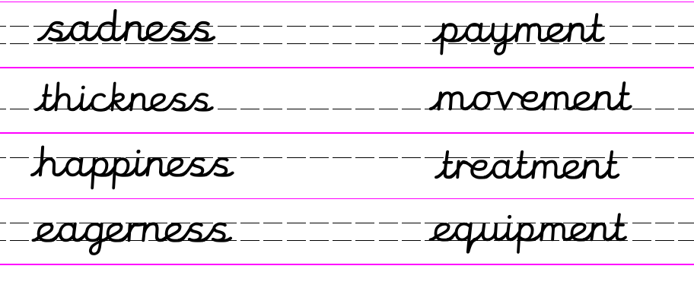
Look carefully at the spelling of the words ending in –ment that you have been practising writing. Try making some more using the words in the grid below:
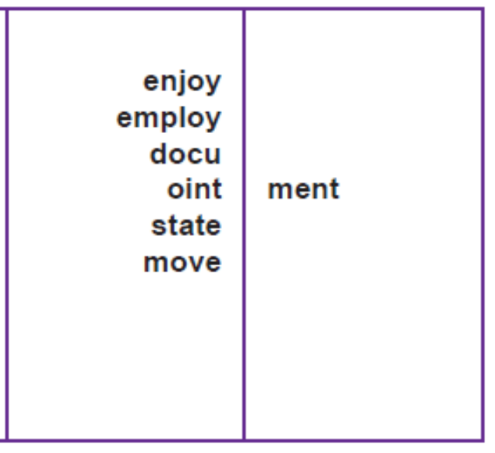
Now choose just one of them and practise writing it using rainbow Russell writing.
ie. equipment
Can you then put this word into a sentence of your own?
Dictation Sentence:
I made a payment for the equipment.

Maths 7.5.20
This week we have been revisiting our addition skills.
Representing the numbers through drawings is a reliable strategy to help up find the correct answer.

Another strategy that we can use is a number line. We always start on the biggest number so that we have a smaller number of jumps to make.

24 + 12 = 36
+2
+10

24 34 36
You don’t need any special resources, just draw a line and start with the biggest number, add on the 10s, then add on the 1s.

15 + 23 =

45 + 20 =

32 + 17 =

81 + 23 =

46 + 30 =

English - Thursday 7th May 2020
WALT write a diary entry. ^{T}
^{Word of the week ‘summary’}
^{Quote of the day}
Today we are going to be writing another diary entry but this time it won’t be our diary it will be one of the characters from our Eric Carle story collection. I have written an example as the Hungry Caterpillar.

^{Dear Diary}

What a gluttonous day today has been! I woke up bright and early but once again I was absolutely starving. "Get me food" my stomach growled at me. Do you think that I might be ill?

Luckily it was another beautiful, sunny day so I was able to set off in search of glorious, scrumptious food. Fortunately I didn't have to go very far, just to the end of the garden path where I came across a pear tree heavily laid with big, juicy pears. I couldn't believe my luck. How had I got so lucky! The happiness I felt when two dropped to the ground. I've been terribly lucky today haven't I? I wonder what tomorrow will bring.

Task: Can you write a diary entry as one of the characters from the Eric Carle stories. Remember to write in chronological order. You will probably need to read the story again.

D.T 7.5.20
WALT: make Teddy Bear biscuits and to be able to follow a set of instructions.
I have received a letter from the Teddy Bear this week. He wants us to help him plan a picnic.
Can you remember what picnic foods we identified last week? What do you think he could have in his picnic?

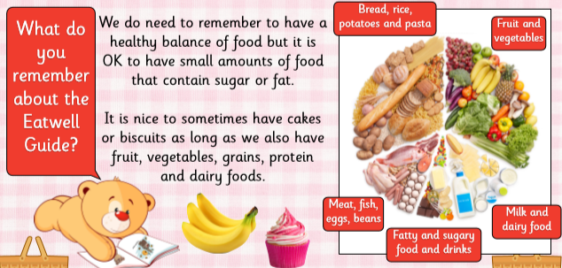

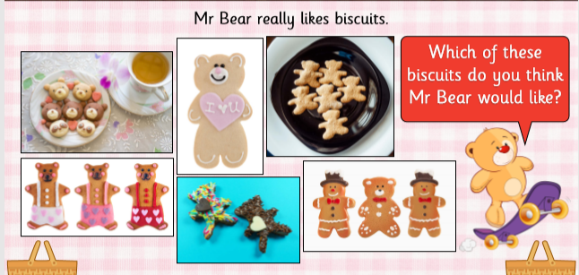

We are going to make some bisuits for Teddy’s picnic. But first let’s remind ourselves of a few rules.
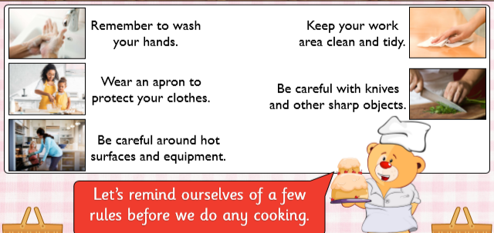

I have included below the instructions of how to make the biscuits. Don’t worry if you can’t make them you could draw them and decorate them with pencil crayons or felt tips. If you can make them I look forward to seeing a photograph or hearing how tasty they are. I will try and make some too.
