Year 2 Phonics/Spelling Practice – w/c 20.4.20 Day 2
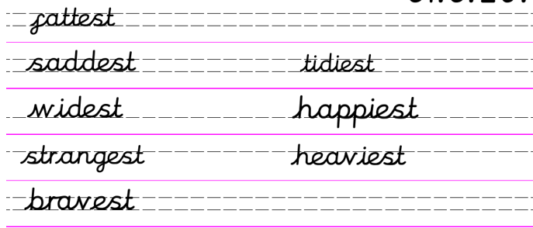
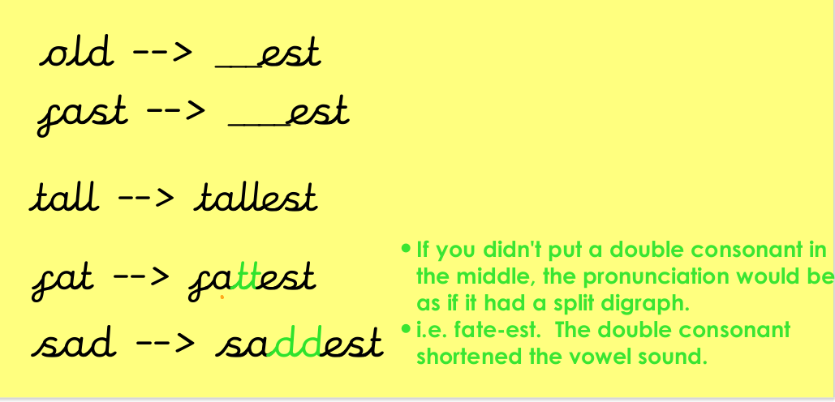

Quickwrite – how many ‘superlatives’ (words ending in –est) can you write down in 2 minutes? Can anyone in your house think of some more?
These root words may help you.
hot | dark | tall | Fast | big
sad | small | hard | Loud | poor

English 21.4.20
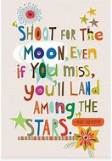
WALT read text for information.
Word of the day Swished.
Good morning Year 2. Today’s English lesson is a VIPERS lesson. Can you all remember what our VIPERS stand for?

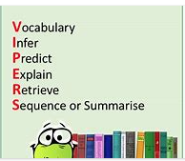
Today’s story is ‘The Frog Prince’.
- Do you know what genre this story is?
- Think carefully is it a fiction or non-fiction text?
- Is it an adventure story, a science fiction story, a comedy or a fairy tale?
Well done!
Before Easter we looked at the fairy tale ‘The Proud Little Apple Blossom’ by Hans Christian Andersen. Today’s story is by another famous pair of story tellers The Brothers Grimm. This is the first story in their famous collection of folklore stories collected in the 19th Century.
Read the story through with your adult then answer the questions.
Today’s VIPER is focussing on inference. 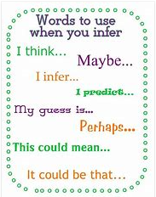
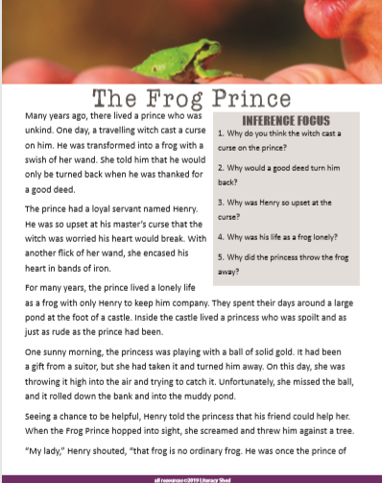
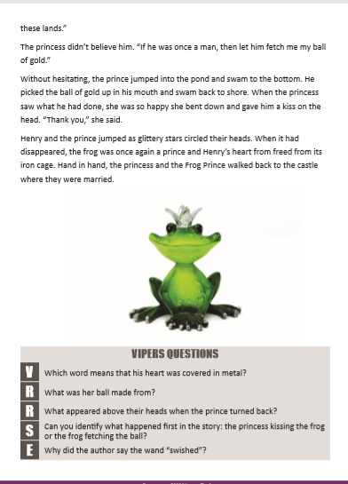
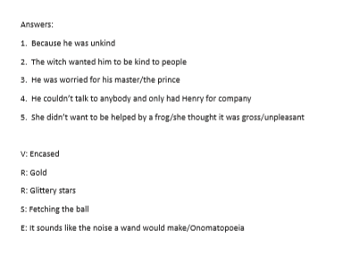

Maths 21.4.20
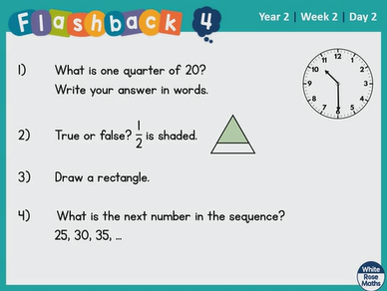
Find half of the following numbers:
1) 10 2) 8 3) 20

4) 14 5) 22 6) 100

7) 80 8) 26 9) 120

Can you continue the number sentences to 12 x 5?
Challenge yourself to go even further!
1 x 5 = 5
2 x 5 = 10
3 x 5 = 15
21.4.20 – History
Tuesday 21st April 2020
WALT understand the significance of historical events in our locality.

This term’s history topic is for us to learn about significant historical events, people and places in our own locality. Basically all about the past of Ampthill including important people and places.

You are living through the most important historical event in living memory and it is so very important that we remember this time and record what is going on at the moment. So whilst you are at home I would like you to think, look and record what is happening right now…..
Can you take photographs or you and your family at home, collect newspapers, get your adult to take a photograph as they queue to enter shops anything that will help us remember this important time in your and Ampthill’s history.

Today’s task is all about YOU!!!! In years to come your older self may not remember all the things that you liked and your children and grandchildren will want to know. Now is the perfect time to record all the things that are special to you right now in 2020.

I have included below some ideas of layout but as I said it is all about YOU! So you can record it anyway you like be it on paper, record yourself talking or how about you get really inventive and make a short video on your iPads or phones! Have fun making history.

