**Please find teaching clips linked to each activity online:**

<https://whiterosemaths.com/homelearning/year-1/>

**Introduce weight and mass**

**Day 1**

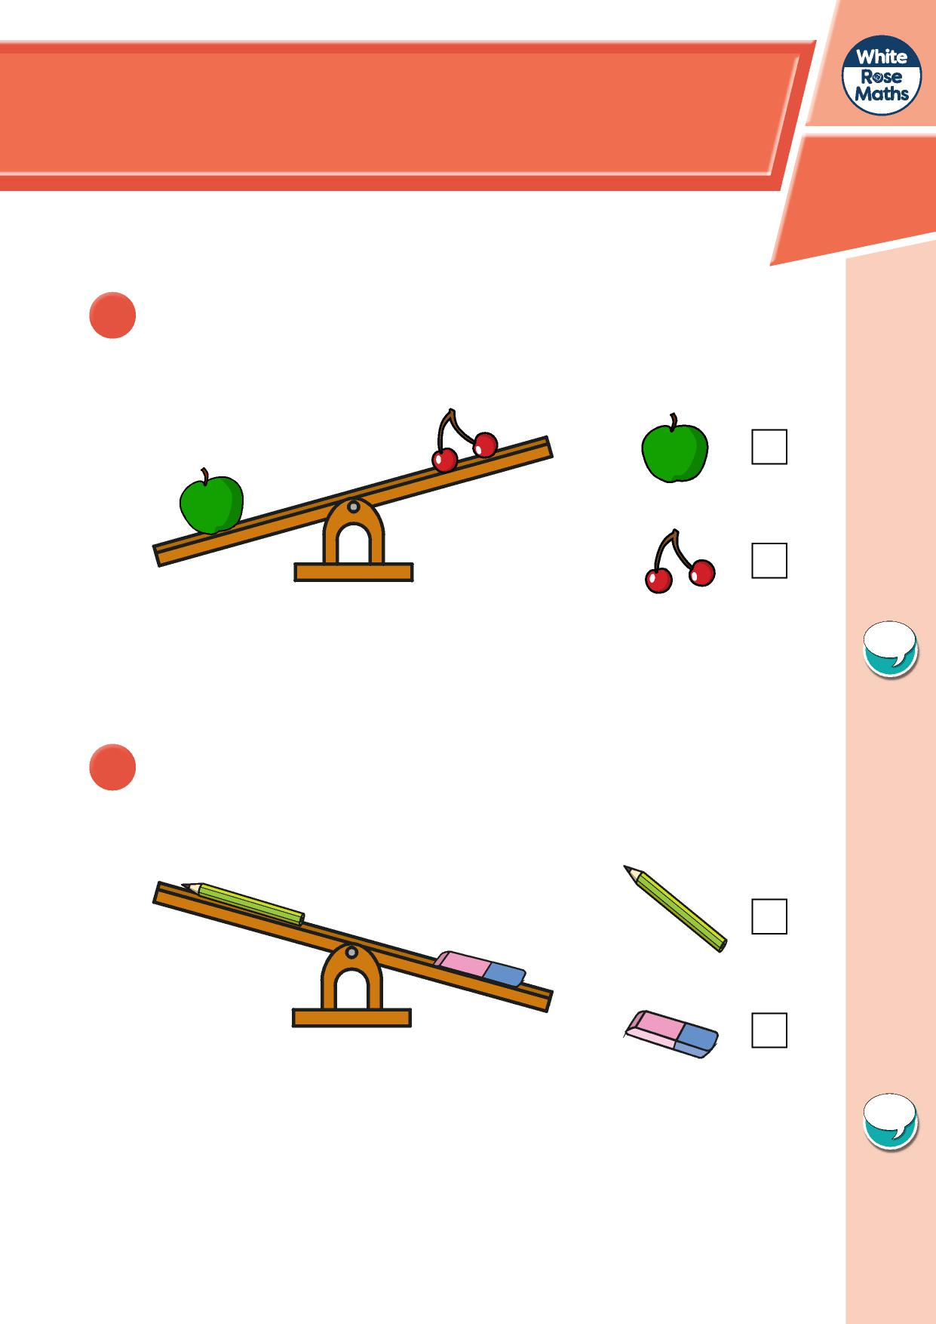

**1** Which object is heavier?

Tick your answer.

How do you know?

**2** Which object is lighter?

Tick your answer.

How do you know?

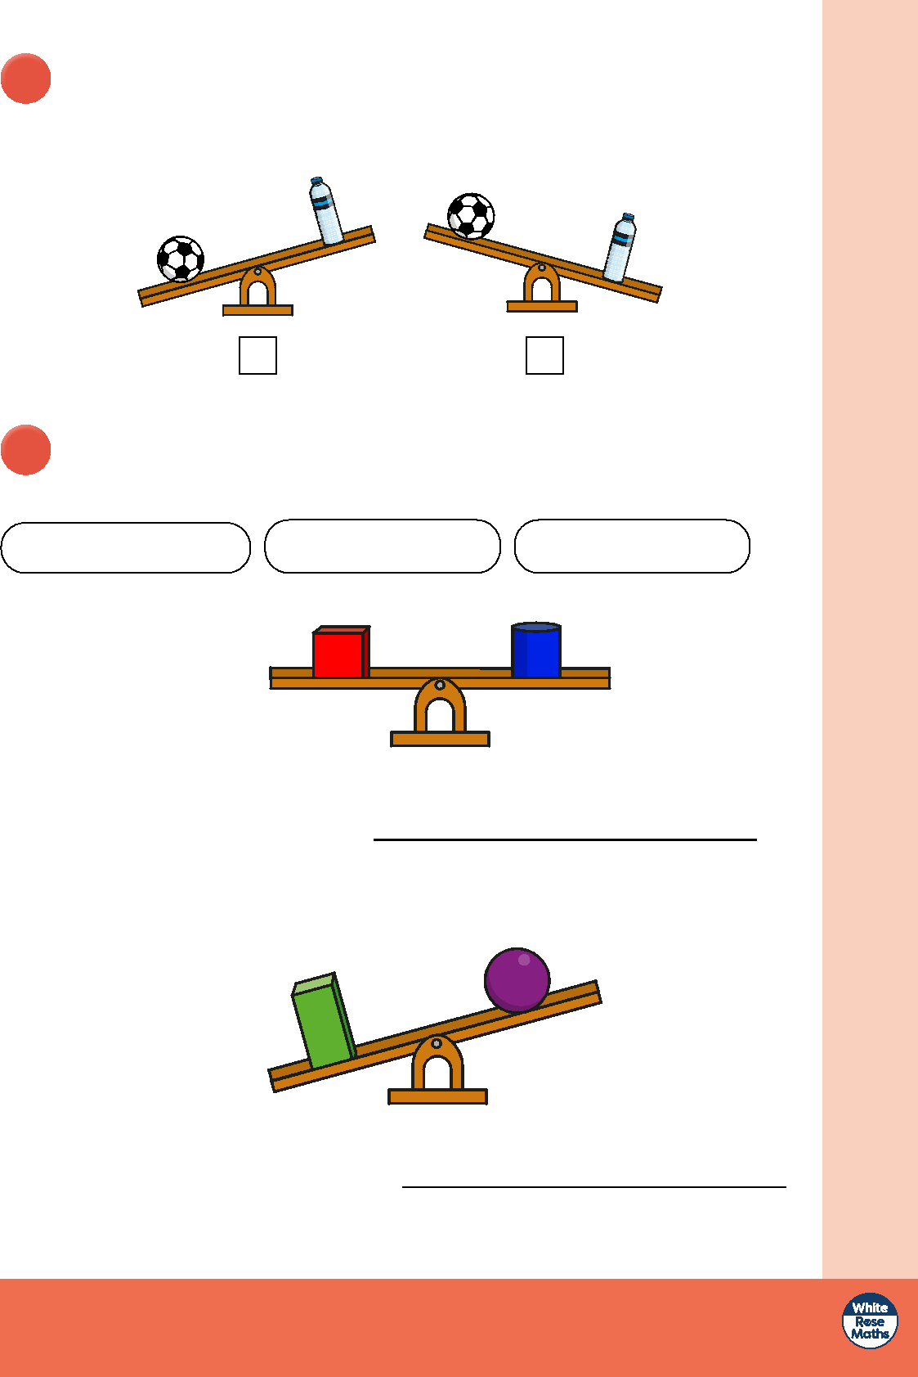

© White Rose Maths 2019

**3** The ball is lighter than the bottle.

Tick the picture that shows this.

**4** Choose a phrase to complete the sentences.

more than less than the same as

**a)**

The cube weighs

the cylinder.

The cuboid weighs

the sphere.

**b)**

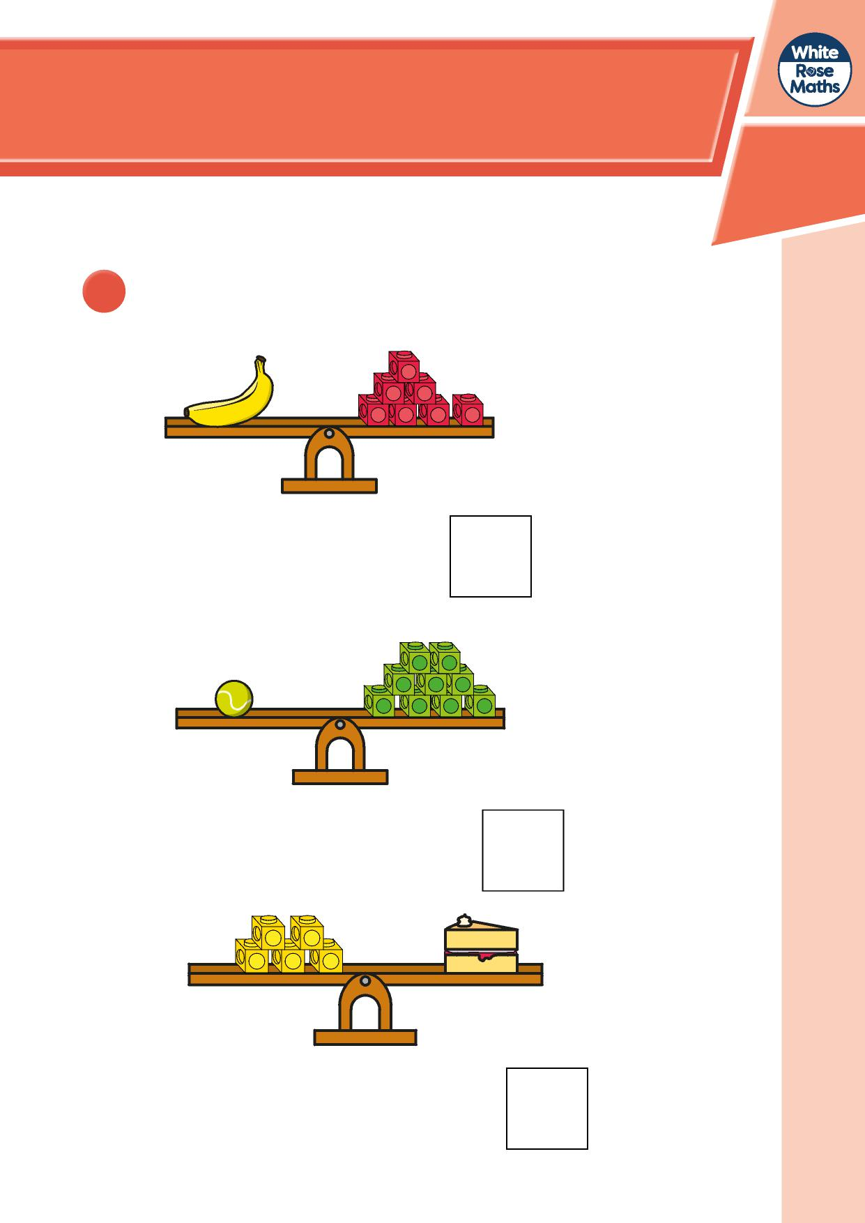

**Measure mass**

**1** How much does each object weigh?



The banana weighs

cubes.



The tennis ball weighs

cubes.



The slice of cake weighs

cubes.

**2** Draw cubes to balance the scale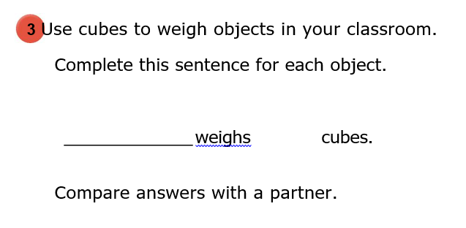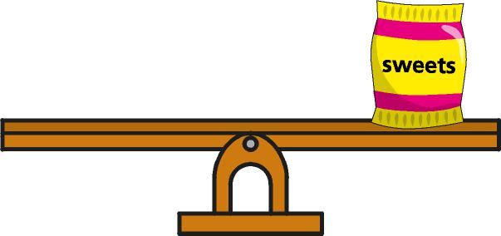





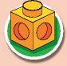



1. The toy car weighs 6 cubes.
2. The sweets weigh 4 cubes.

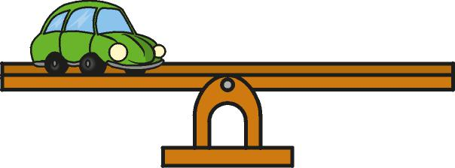

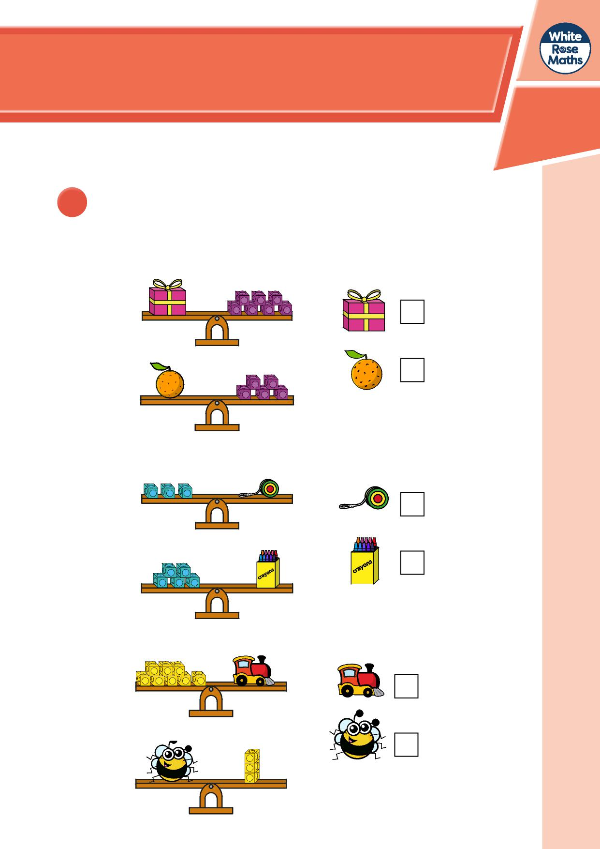

**Compare mass**

**1** Which object is heavier? Tick your answer.



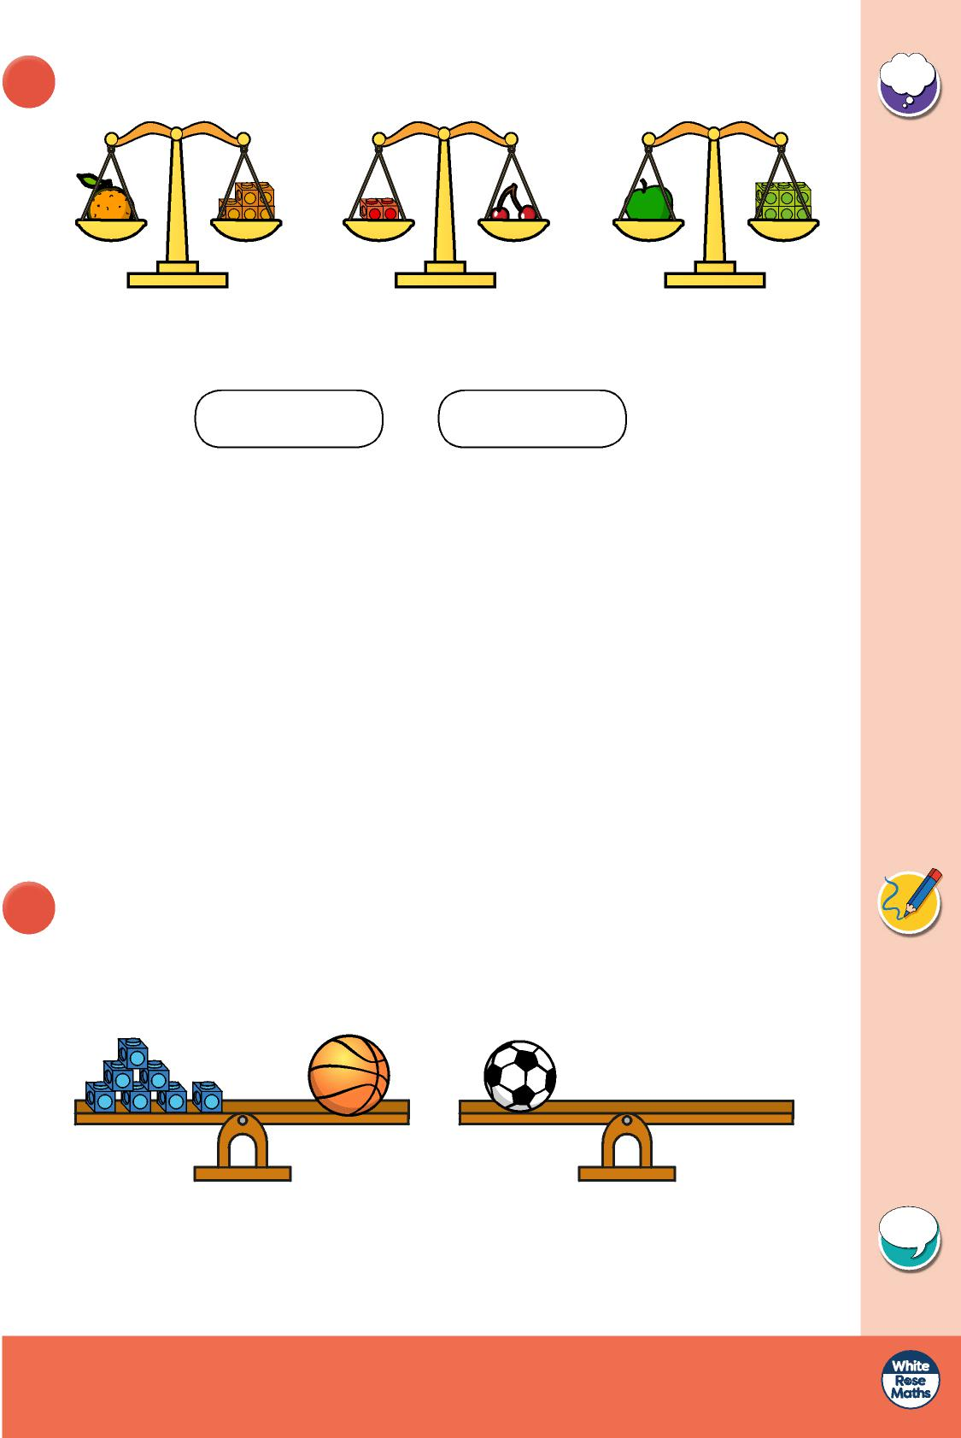

© White Rose Maths 2019

**2** Look at the scales.

Choose a word to complete each sentence.

heavier lighter

1. The orange is than the cherries.
2. The apple is than the orange.
3. The cherries are than the apple.
4. The apple is than the cherries.

**3** The basketball is heavier than the football.

Draw cubes to complete the scales.

Is there more than one answer?

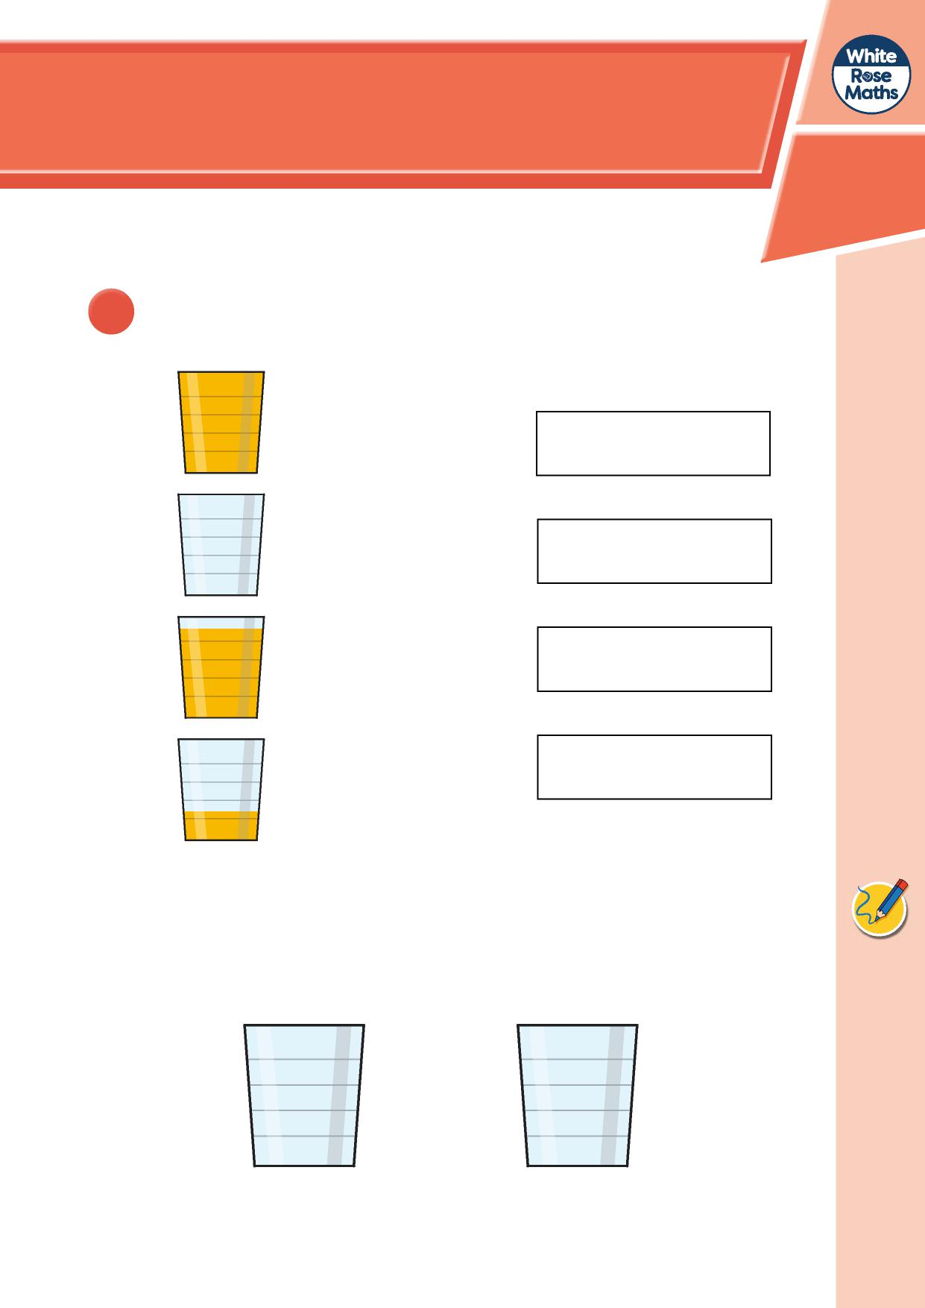

**Introduce capacity and volume**

**1 a)** Match the picture to the label.

empty

almost full

almost empty

full

**b)** Show ‘almost full’ and ‘almost empty’

another way.

almost full almost empty

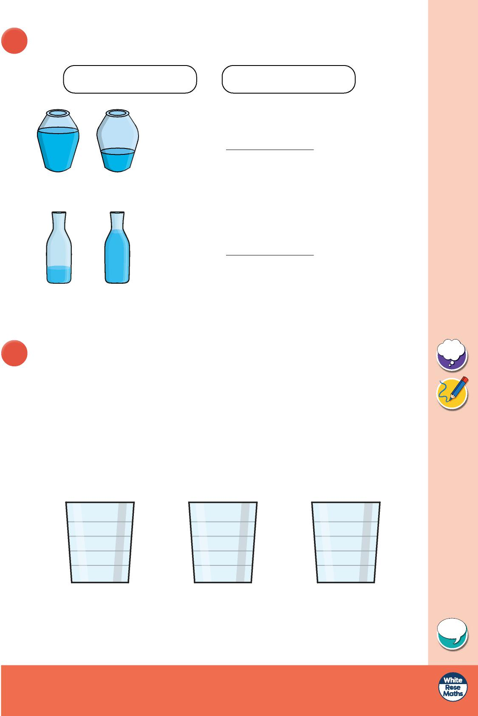

© White Rose Maths 2019

**2** Choose a word to complete the sentence.

more

less

A has than B.

A B

A B

**3** Show the volume in each glass.

* A is nearly full.
* B is nearly empty.
* A has more than C.
* C has more than B.

A B C

Compare answers with a partner.

A has than B.

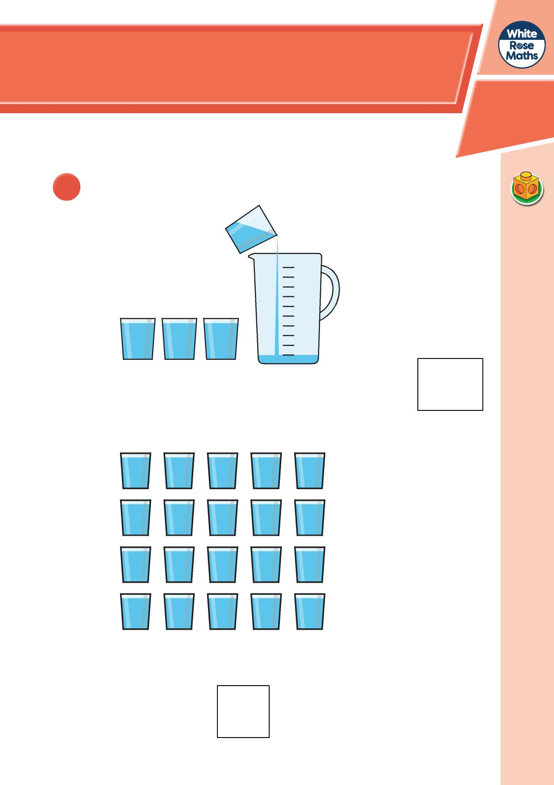

**Measure capacity**

**1** 4 glasses of water fill 1 jug.

1. How many glasses will fill 2 jugs?
2. Eva uses 20 glasses of water.

How many jugs can she fill?

Eva can fill

jugs.

It takes 8 glasses of water to fill a jug.

The bottle has a

capacity of 6 glasses.

It takes 3 jugs of water to fill a bucket.

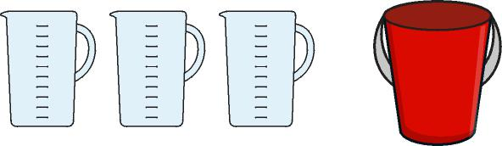

**2** Teddy pours these 6 glasses of juice.

He uses a whole bottle of juice.

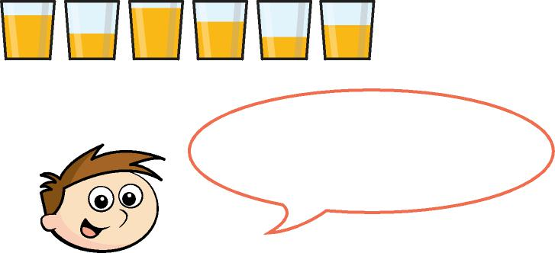

Do you agree with Teddy?

Talk about it with a partner.







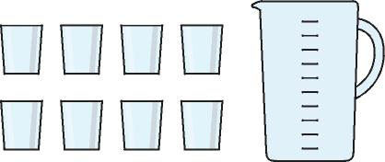

How many **glasses** of water fill

a bucket?

What else can you find out?