Friday 24th April 2020
SPaG
Spellings – To apply the prefix sub
subtotal | subtitle | substitute | subplot
subheading | subdivide | submerged | subtropical

Challenge! Unscramble the words to spell them correctly!

vdidebusi
subednhaig
lubspot
utoiasbrpcl
altotbus
lesuttbi
merbusged
tuteitubss

English

St George’s Day was yesterday. Research some facts about St George’s Day and record them in your own fact file or informative poster. Use these facts as a starting point for your research.
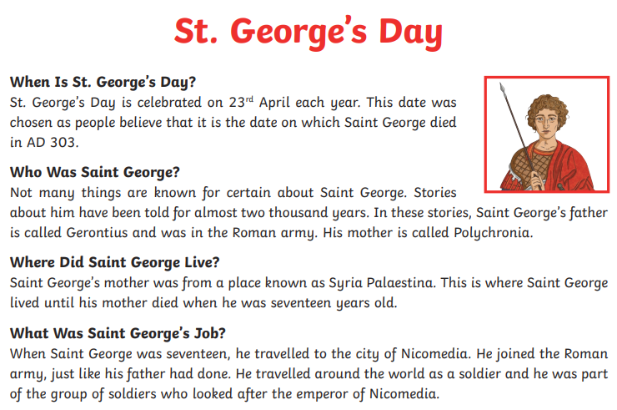
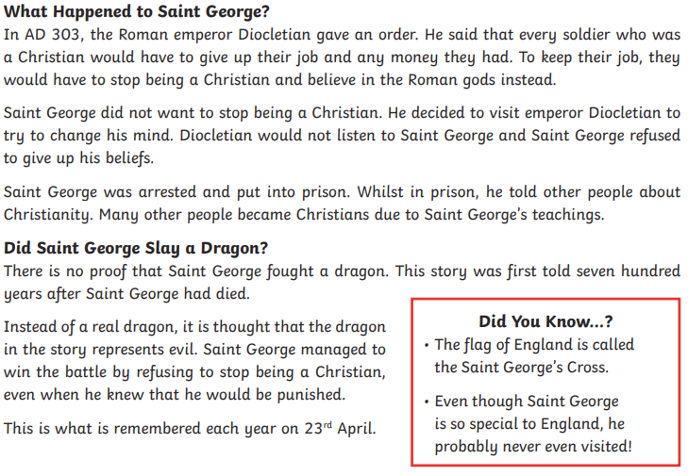

Maths
Four Awesome Operations
Addition (using column method)  101 + 202 | Subtraction (using column method)  428 – 231 | Multiplication (using grid method)  28 x 8 | Division (using sharing of place value counters)  27 ÷ 4
Money - Figure it Out Friday
Rows of Coins - 1
Take five coins: 1p, 2p, 5p, 10p, 20p.
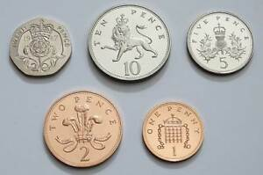
Put them in a row using these clues:
The total of the first three coins is 27p.
The total of the last three coins is 31p.
The last coin is double the value of the first coin.

Rows of Coins - 2
Take six coins: two 1p, two 2p, and two 5p.
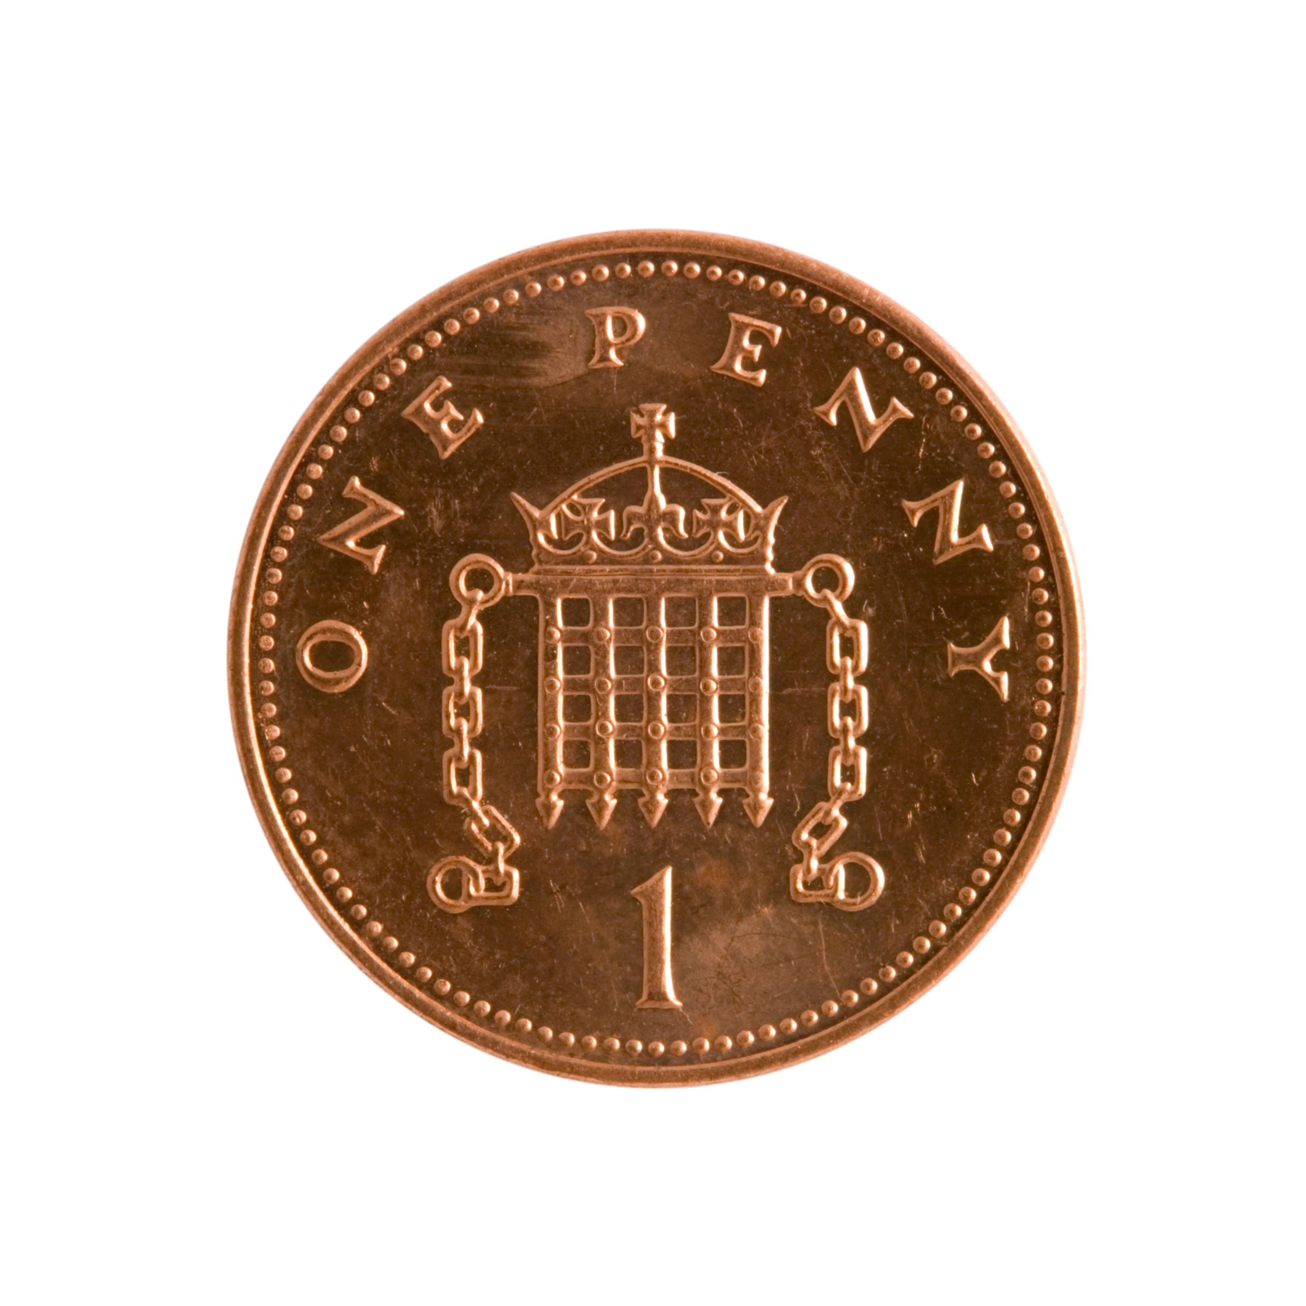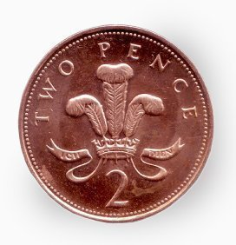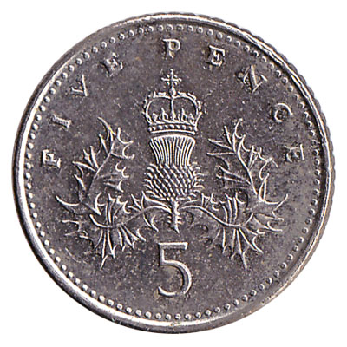
Put them in a row using these clues:
Between the two 1p coins there is one coin.
Between the two 2p coins there are two coins.
Between the two 5p coins there are three coins.

History

In History we are now moving on to learning about the Bronze Age.

Challenge! Watch the video introducing the Bronze Age and try to answer these questions.

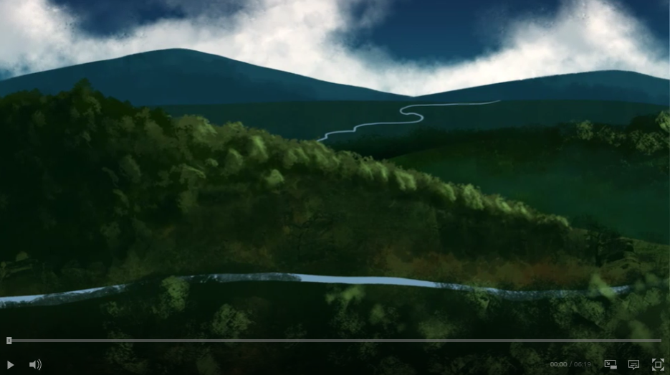

Video Link: https://www.bbc.co.uk/teach/class-clips-video/story-of-britain-bronze-age-britain/znrygwx

- What new invention was introduced to Britain at the start of the Bronze Age?
- What is needed to make bronze?
- What was made out of bronze?
- Why was metal important?
- Why did people dig mines?
- How did people make woollen cloth in the Bronze Age?
- What are ‘Stone Circles’?

Challenge! Make a list of questions that you would like to know the answers to all about the Bronze Age!

