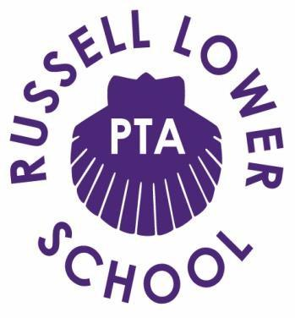

Chair Report - Wednesday 9th June, 2021

Welcome to the June PTA meeting. It has been an unusually quiet few weeks on the PTA for most of us which I am sure has been very welcome.

First of all, thank you to all those that made it to the drinks evening on the 18th May at The White Hart, it was lovely to sit down and have a chat face to face and feel a sense of normality. We will definitely be organising another one soon and hope to see you all there.
Thank you to all those that helped with the Sustainability Day, Karen for organising the planters and getting extra tomato plants and to Nina for counting the money donated by those who wore an earth colour to school. Despite having two bubbles in isolation we still managed to raise a great amount which will help towards sprucing up Nathans Garden. The pictures on the school website of the children planting their tomato plants are lovely to see and we cannot wait to see how they progress over the coming weeks. We think it would be nice to do regular posts about this on our FB page so parents can see how this is progressing.

Following on from the Sustainability Day we have a teamed up with Ampthill Climate Change Group for a community litter pick which is taking place this Saturday 12th June, we currently have 38 registrations and its looking around 105 people in total! This is an amazing amount of people and you will see some messages come back and forth over the coming days with the final details. This should be a great event and we look forward to seeing you there.

Amy and Jackie have been busy organising the year 4 leavers hoodies, thank you for ordering all 90 of those the children will love them, I believe you both had a meeting last night about the Year 4 leavers party, so we look forward to hearing an update from Jackie on that later.

We wanted to organise some Father’s Day treats and after being let down by a couple of people Lucienne has secured a great deal with Lydia’s Bakehouse, who will be making delicious pizza brownies. Lydia can only take a maximum of 50 orders, we currently have 16 orders placed of which we will be receiving £3 an order which is great for not having to do a huge amount, thank you Lucienne for organising all of this. Please if you haven’t done so already can you send the screenshot round about the brownies that is on the PTA Whatsapp group to any class Whatsapp groups you are in.

The Sunflower competition seems to be going well and we have sent extra packs to those who’s seeds didn’t grow. It would be great if we could post this again on FB and see if we can get a little more interaction and see how every one’s sunflowers are progressing, it would be great to see if we could a little competition going amongst parents, maybe we could do this via separate FB page that we could keep open for this annual event?

After our post on FB with regards to Nathans Garden we have had a few offerings of help and donations on materials, it would be great if we could look into this more over the next few weeks and get a better plan together, so any volunteers to help get this going would be great.

Grace is working on our first quarterly newsletter and will have this ready for Monday, this will be a great way to show all parents what we are doing for the school and what the money raised goes towards. I’m sure there will be a few looks of dread on the screen in a second as I ask if you can please send a headshot to Grace of your beautiful faces so these can be added to the Newsletter .

As mentioned before we would love to hold a Krispy Kreme event, Krispy Kreme do a deal where we can purchase a dozen original glaze donuts for £5.50, we can sell these for £1 each (54p profit) or a tray of 12 for £10 (£4.50 profit) and a tray of 6 for £5 £2.25 profit). We can take pre orders and payment for the boxes of 6 and 12 so we have a better idea on the quantity to order, we can then order extras to sell as individuals which we can bag up. We just need to set a date with Nicki, Krispy Kreme need 5 days notice and I think we should take pre orders two weeks before we look to order them to maximise sales.

Thank you all again for continuing to do all the day to day running of the PTA, whether it be social media posts, organising collections of the clothes bin, collating money, filling in Google forms etc. We as always appreciate the time it takes to keep these things ticking along.

As always, if you have any ideas for future activities, would like to provide feedback on how we could do things differently or if there is anything you’d like to get more involved in please drop me or Grace a message.

We look forward to seeing what else we can cram in before the Summer holidays!

Many Thanks,

Sarah and Grace

