Year 2 Phonics/Spelling Practice – Monday 8.6.20.
This week we are looking are words ending in ly– they are all adverbs – words which add information about the verb or doing word.
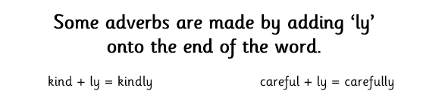

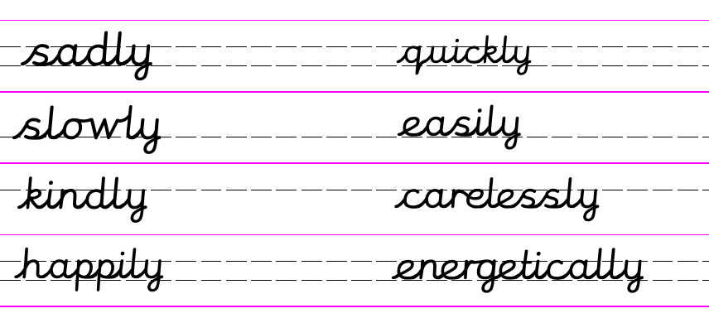
Practise writing your new spelling words each day using your best Russell handwriting.

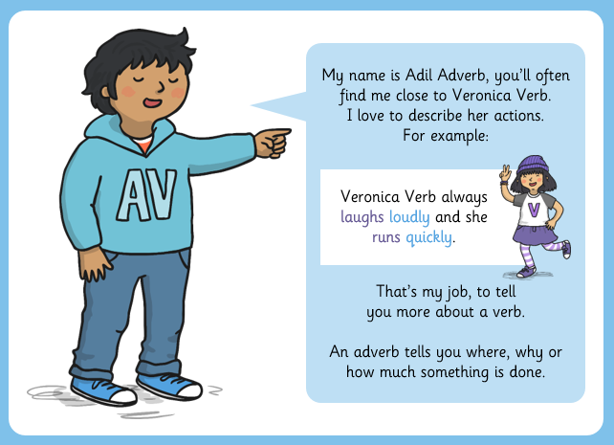

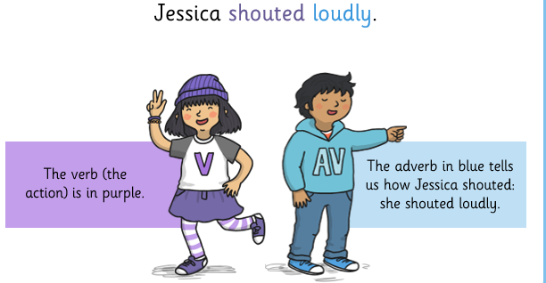

Dictation sentence:
The shy snail slid away slowly and sniffed sadly.
Write out the sentence from memory, then find the following types of word in the sentence and write them down:
Two verbs (doing words) __________________ ____________________
Two adverbs ______________________ _________________________
One adjective (describing word) ______________________
Maths 8.6.20
The ten times-table
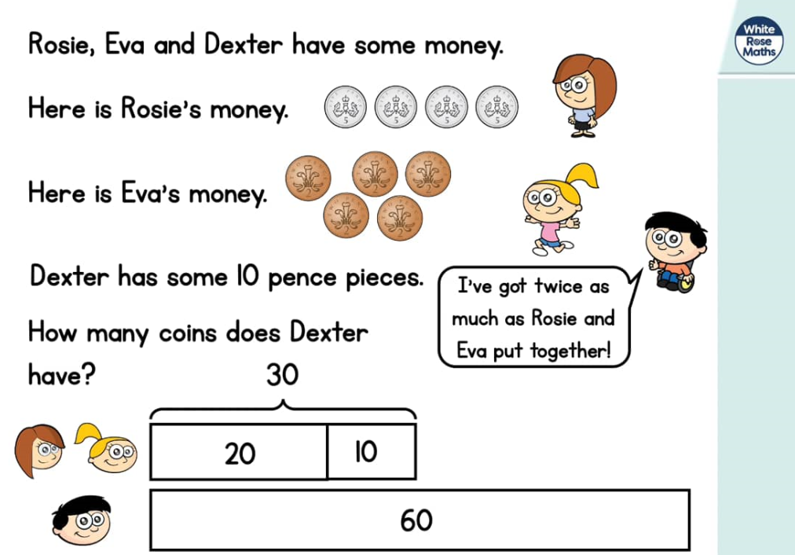
https://whiterosemaths.com/homelearning/year-2/ (Week 6 W/C 1.6.20)
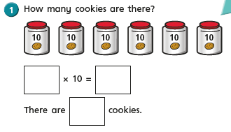
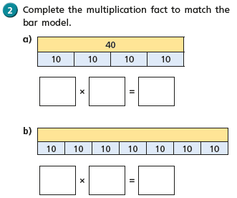
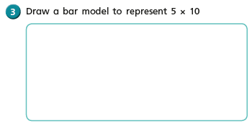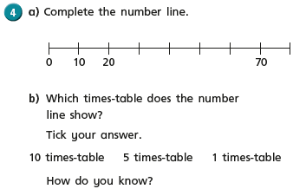
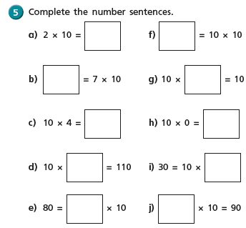
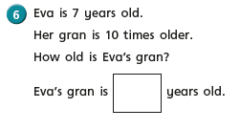
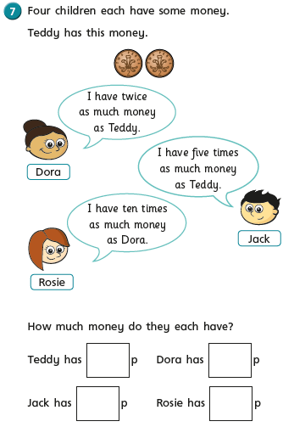
English - Monday 8th June 2020
Inspirational quote of the day!
Word of the day – repetition
WALT write a description of a scary setting using similes, repetition and metaphors..
WILF I can use repetition to add suspense.
Happy Monday, year 2.I know you are finding it difficult at the moment to feel inspired to do your home learning. BUT,if you could try to do some of the work sent home it will really help prepare you for year 3. I know you can do it!

I hope you are enjoying Wind In The Willows, so far and have managed to complete the work set last week. If not make sure you watch Wind in The Willows on youtube or listen to the story via the bbc website.
We will be continuing investigating the text this week and I would like you to start by listening to chapter 3 from the bbc website.
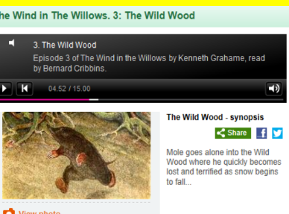Mole has been warned not to go into the woods! Why do you think that might be? (listen to 7m 32s)
Listen to the extract again, can you note down any words that you think make the setting sound scary? Can you hear any words that are repeated? Does this add to the suspense?
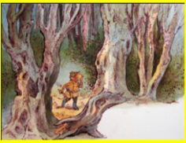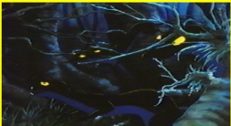

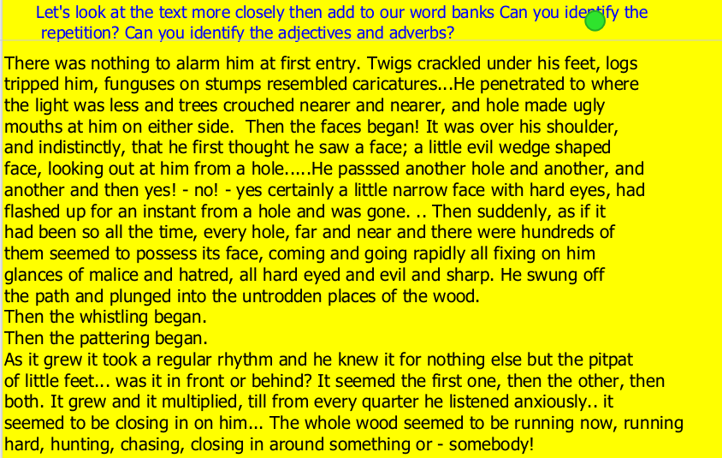

Challenge me:
Identify any verbs, adjectives
and adverbs and any repetition.
Use a dictionary to look up any words you don’t understand.

Feeling Confident
Identify any verbs, adjectives and adverbs.
Use a dictionary to look up any words you don’t understand.

Need more practise.
Ask an adult to help you look up any words you don’t understand.
Can you underline any words that make the setting sound scary?

PSHRE 8.6.20
WALT: to know where money might have come from and how we can keep it safe.
Why do we have paper money and coins?

Money changes over time and new money has to be produced....
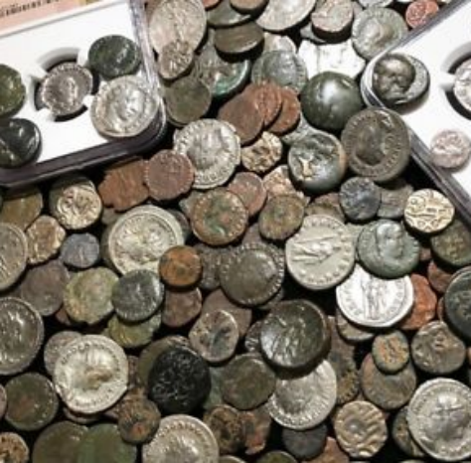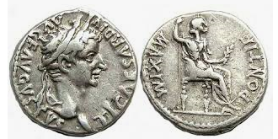

If you can, watch this Espresso video…
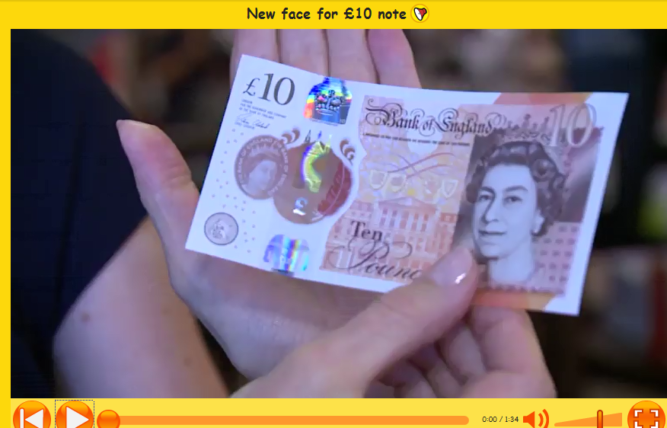

Where/When do you get money?
How do we keep our money safe?

Watch this YouTube clip of Sam and the Lucky Money - By Karen Chinn
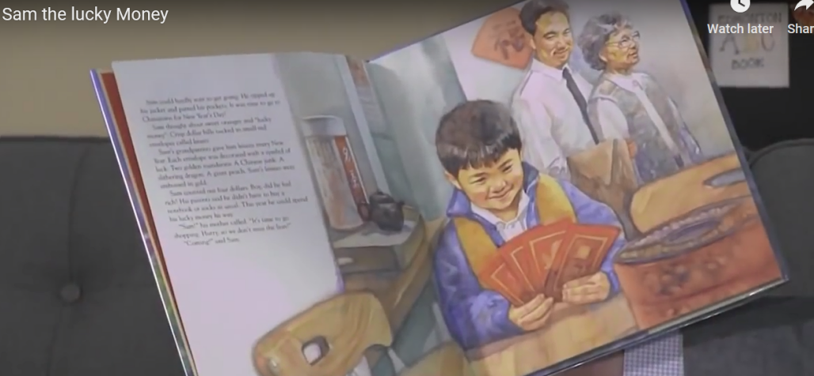
https://www.youtube.com/watch?v=wWuDJFUrfoc

What did Sam think he might buy?
What was the problem with the basketball?
How did that make Sam feel?
Can you remember a time recently when you received some money?

Your birthday? Easter? Christmas? Pocket money? Chores?

What did you spend your money on?

I received some money....
I spend my money on.....
I felt......

8.6.20 - Year 2 Music Summer Term 2 –
Consolidating Year 2 music learning – history of music, musical language.

Listen and Appraise - Brandenburg Concerto No 1 by Johann Sebastian Bach
https://www.youtube.com/watch?v=rz_KFLHjquc
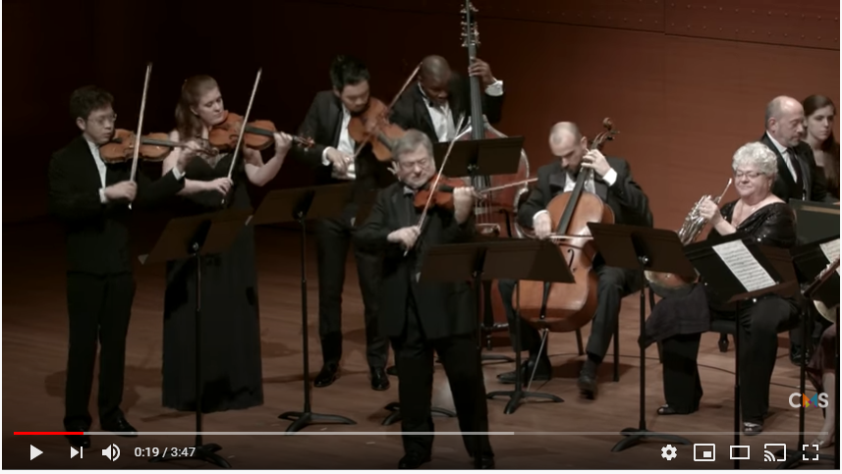
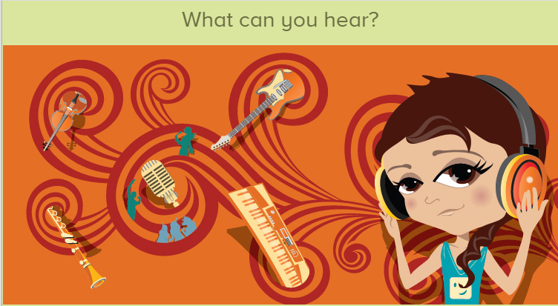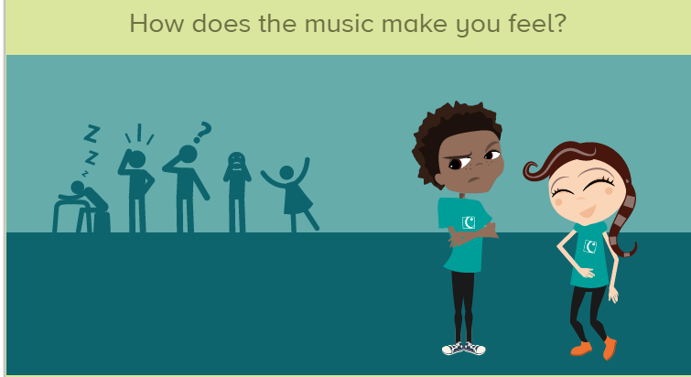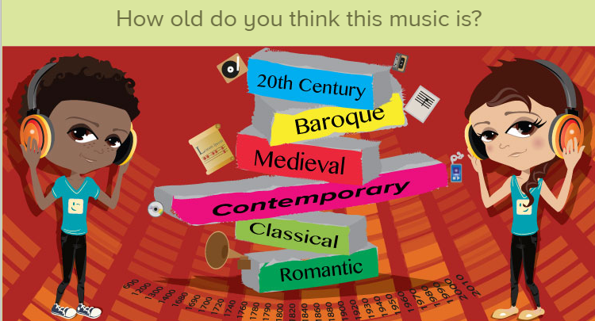
An orchestral composition from the Baroque Period. (Look back at the history timeline from last week). Stand or sit to ﬁnd the pulse or just listen to the music. Think about the music and what you can hear in it.
See if you can find out anything about the composer Johann Sebastian Bach.
In 1721, Bach presented the Margrave of Brandenburg with manuscripts containing six lively concertos for chamber (small) orchestra. He didn’t get paid or thanked!
The name ‘Brandenburg’ was given to the set of pieces after Bach died. He compiled them from short instrumental sinfonias and concerto movements he had already written, and then proceeded to re-write and re-elaborate where he saw ﬁt.
Rewind and Listen Out! Listen to Fly Me To The Moon sung by Frank Sinatra. Listen to the extract and name the instruments/voices that you can hear.
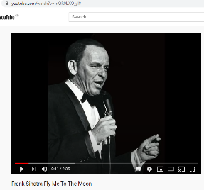
https://www.youtube.com/watch?v=mQR0bXO_yI8 You should be able to hear bass, drums, piano, male solo voice, ﬂute, saxophones.

