Monday 30th March 2020
SPaG
Spellings – To apply the prefix super-
superhero ________________________________________________________________
superfluent _______________________________________________________________
superman ________________________________________________________________
superstore ________________________________________________________________
superpower _______________________________________________________________
superstar _________________________________________________________________
supernatural ______________________________________________________________
supermarket ______________________________________________________________

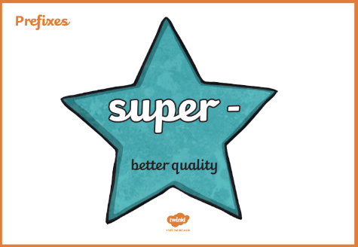
Challenge! Look up the meaning of each of these words in a dictionary so you understand what each word means.

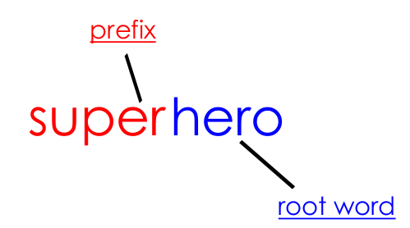
Hint! What does the root word mean? Use that to help you!

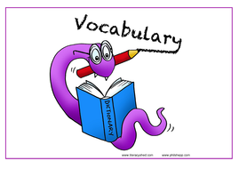
Vocabulary – Word of the Day!
jubilant
Definition _______________________________________________
_________________________________________________________
_________________________________________________________
Used it in a sentence: _____________________________________________________
___________________________________________________________________________
Synonyms: _______________________________________________________________________
English
Before watching the clip called, ‘The Catch’ can you predict what it might be about?
____________________________________________________________________________________________________________________________________________________________________________________________________________________________________________________________________________________________________________

The short animation can be found on: https://vimeo.com/76356335
After you have watched the animation answer the following questions:
How does the weather appear to change as the boy climbs the rocks? Why do you think this is? _____________________________________________________________________________________________________________________________________________________________________________________________________________________________________________________________________
In what way does it change again when the fox shows him the lake?
_________________________________________________________________________________________________________________________________________
How do you think the boy feels/what does he think when he sees all of the fish in the new lake?
_____________________________________________________________________________________________________________________________________________________________________________________________________________________________________________________________________

Maths
Four Awesome Operations
Addition (using column method)  323 + 518 | Subtraction (using column method)  451 - 218 | Multiplication (using grid method)  88 x 2 | Division (using sharing of place value counters)  36 ÷ 3

Perimeter
Calculate the perimeter of each of these shapes (remember that perimeter is the distance around the outside of a shape). The calculations get trickier as you go through and the shapes are NOT drawn to scale!
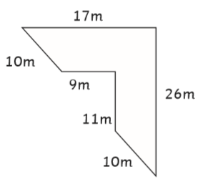
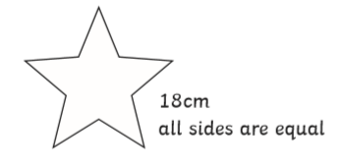
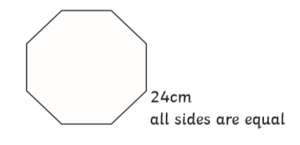
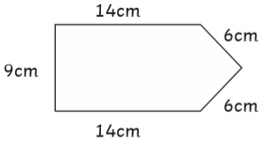
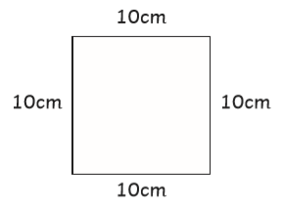
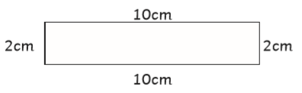
The Paper Investigation
Using a piece of A4 paper and some scissors:
-How could you make the perimeter of the paper larger?
-How could you make the perimeter of the paper smaller?

Geography

Challenge! Match each definition to the correct piece of volcanic vocabulary.
Mantle |  | Tiny pieces of rock or lava blasted into the air during a volcanic eruption.
Magma |  | A volcano which has not erupted recently but is expected to erupt again.
Volcano |  | A volcano that has erupted recently or is erupting now.
Active |  | Molten rock flowing from the vent of a volcano during an eruption.
Pumice |  | Molten (liquid) rock beneath the earth’s surface.
Lava |  | The rocky outer layer of the earth.
Eruption |  | A volcano that hasn’t erupted recently and is not expected to erupt again.
Extinct |  | A light, porous volcanic rock formed when  lava cools.
Crust |  | The centre of the earth which is made of nickel and iron.
Dormant |  | The layer between the crust and the outer core of the earth.
Core |  | The name of the process in which solids, liquids or gases are expelled through a vent in the earth’s surface.
Ash |  | A vent in the earth’s surface from which lava and gases pour during an eruption.

