Monday 18th May 2020 – English

SPaG

Spellings – Prefix - re

redo - ____________________________________________________________________

refresh - ___________________________________________________________________

return - ___________________________________________________________________

reappear - ________________________________________________________________

revenge - _________________________________________________________________

remember - _______________________________________________________________

retrieve - _________________________________________________________________

redecorate - _____________________________________________________________

Look up the meaning of each of these words in a dictionary so you understand what each word means.

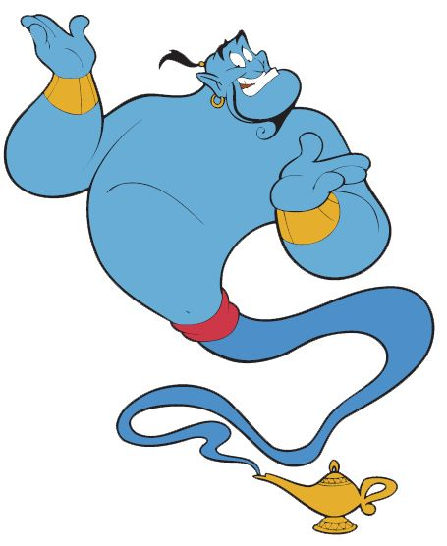

Word of the Day – **descend**

**Definition ____________________________________________**

**_____________________________________________________**

_____________________________________________________

**Used it in a sentence: ____________________________________________________**

**_________________________________________________________________________**

**Word Class: ____________________________________________________**

**Synonyms**

**English – Vipers**



Read the text carefully and then answer one question from each Viper section below.

|  |  |
| --- | --- |
| **Text Title: Queen Victoria** | |
| ../../../Desktop/Visual%20Vipers/VIPERS%20images/Screen%20Shot%202017-03-20%20at%2011 | MP – What does era mean?  FC – Find one word in the Family paragraph that means the same as isolated.  CM – Which keyword tells you how Albert’s death made Queen Victoria feel? |
| ../../../Desktop/Visual%20Vipers/VIPERS%20images/Screen%20Shot%202017-03-20%20at%2011 | MP – How do you think Queen Vitoria felt when she became Queen in 1837?  FC – What do you think Queen Victoria was thinking after Albert died?  CM – What impression of what type of child Queen Victoria was do you get from the passage? |
| ../../../Desktop/Visual%20Vipers/VIPERS%20images/Screen%20Shot%202017-03-20%20at%2011 |  |
| ../../../Desktop/Visual%20Vipers/VIPERS%20images/Screen%20Shot%202017-03-20%20at%2011 | MP – The mood of Queen Victoria changed after Albert dies. Explain how?  FC – Which paragraph was the most interesting? Explain how?  CM – Why is the text arranged in this way> |
| ../../../Desktop/Visual%20Vipers/VIPERS%20images/Screen%20Shot%202017-03-20%20at%2011 | MP – What happen to Queen Victoria in 1837?  FC – Which people did Queen Victoria take political advice from?  CM – Name the countries that Queen Victoria was empress over? |
| ../../../Desktop/Visual%20Vipers/VIPERS%20images/Screen%20Shot%202017-03-20%20at%2011 | MP – What happened once Victoria turned 18?  FC – Can you summarise in two sentences Queen Victoria’s family life?  CM – Can you summarise why Queen Victoria was called, ‘Grandmother of Europe’? |

Maths Starter

Partition the numbers to make them easier to add up in your head.

Add the tens first and then the ones

34 + 25 =

30 + 20 = 50

4 + 5 = 9

50 + 9 = 59

Add these in your head and write the answers.

1. 63 + 14 =

2. 51 + 46 =

3. 94 + 24 =

4. 73 + 28 =

Maths Main Lesson – decimal numbers on a number line

First watch this video - <https://vimeo.com/403311947> It starts with 4 questions then there are other tasks as you go through the video.

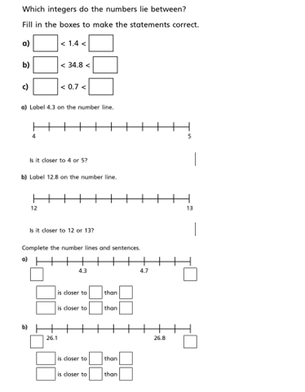

**Science**

Last week you did some research about food chains, hopefully you found out what food chains are and what the words ‘producers’, ‘consumers’ and ‘predators’ mean. Here’s a reminder:

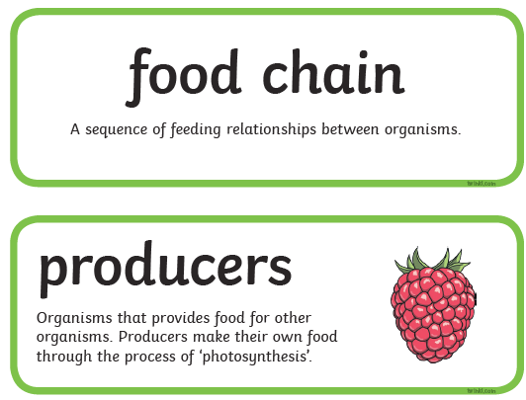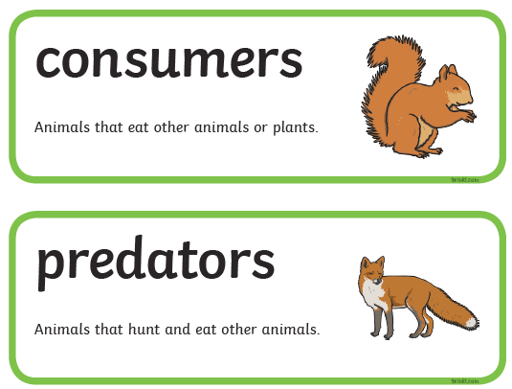

Use this knowledge to sort these animals and plants into the right columns below

