Year 4 Home Learning
English - Reading
- Please continue to hear your child read every day and ask questions about what they are reading. Read any books you have at home if you finish your class reading book.
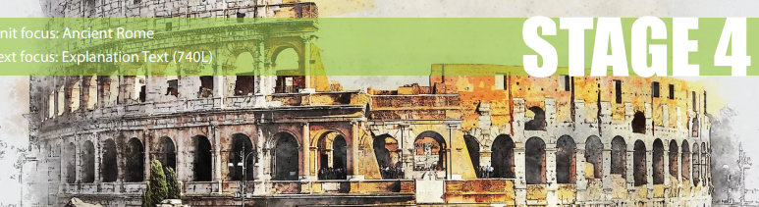
Comprehension using Vipers
Read the text below using a dictionary to find out the meaning of any new vocabulary.
Who Were The Ancient Romans?
Who were the Ancient Romans? It’s an interesting and valid question. It all started a long time ago. 753BC, to be precise. When the city of Rome was first formed, it was a small village in the heart of Italy. Over time, it grew to be the largest empire in the world. At its peak, the population of the empire accounted for roughly 20% of the world’s entire population.

In the beginning, Rome was a kingdom. It was ruled by a king and had a royal family. This continued until 509BC. Not much is known about Rome’s time as a kingdom. Almost all of the history was passed on orally (by speaking to each other).

In 509BC, Rome became a republic. A group of senators were elected to rule the city and the empire. It was in this period that Rome started to take control of Europe. In 264BC, Rome waged war against Carthage. The war lasted for 118 years. By the end, Rome had taken control of large parts of the Mediterranean. At the time, these wars were some of the largest the world had seen. By the time Rome became an empire in 27BC, it was in control of most of Europe. Their power reached as far as Arabia and North Africa.

The death of Julius Caesar in 44BC sparked another change in Ancient Rome. When Caesar Augustus took the throne in 27BC, Rome was already at war with Persia. The wars with Persia began in 92BC and went on for 721 years. This was long after the Empire had started to collapsed. Ancient Rome reached its peak in 117AD. The Emperor ruled between 70 and 100 million people at this time and covered over 5 million square kilometres.

Eventually, the empire of Ancient Rome came to an end. The leaders of the cities started to fight amongst themselves and smaller tribes in the west soon started to invade and the Romans lost control of the western side of their empire in the 5th century. They managed to hold on to the eastern part of the empire for another thousand years. That fell in 143AD. This part of history is often referred to as the Byzantine Empire, rather than Ancient Rome.
VOCABULARY FOCUS

1. Which word or phrase, in the text, means to be exact?

2. Which word or phrase, in the text, means not to be exact?

3. Which word or phrase means that Rome was at its strongest?

4. What does the phrase “the empire had collapsed” mean?

5. Which word or phrase means that Roman leaders fought with each other?

List the three different types of ruler that Rome went through.

Rome’s history as a kingdom was passed on orally. Why does this make it harder to know what happened?

For how long did the wars with Persia continue?

Why isn’t the population of Rome in 117AD more precise?

The author has used lots of technical vocabulary in this text. What effect does that have on the reader?

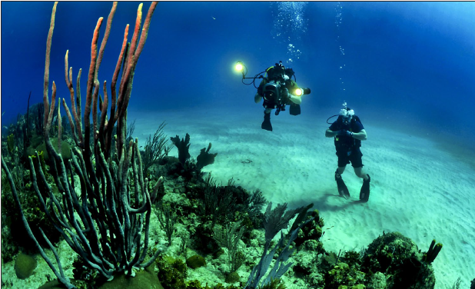
English – writing

Use DADWAVERS to write a descriptive passage on this picture. The idea is to try and start each sentence in a different way.
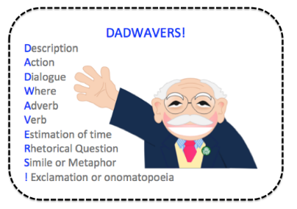

________________________________________________________________________________________________________________________________________________________________________________________________________________________________________________________________________________________________________________________________________________________________________________________________________________________________________________________________________________________________________________________________________________________________________________________________________________________________________________________________________________________________________________________________________________________________________________________________________________________________________________________________________________________________________________________________________________________________________________________________________________________________________________________________________________________________________________________________________________________________________________________________________________________________________________________________________________________________________________________________________________________________________________________________________________________________________________________________________________________________________________________________________________________________________________________________
Maths – Times Tables
- Daily get your child to go on Times Table Rock Stars and play in the garage, studio and complete regular sound checks.
Times Tables Games
Fizz Buzz
Choose ‘fizz’ for multiples of a number (e.g. 3), and ‘buzz’ for multiples of another number (e.g. 5). Starting with 1, players take it in turns to say the next number. However, each time a multiple of 3 or 5 is reached, the player must say ‘fizz’ or ‘buzz’ instead of the number. If the number is a multiple of both 3 and 5, the player must say ‘fizzbuzz’.
For example: one, two, fizz, four, buzz, seven, eight, fizz, buzz, eleven, fizz, thirteen, fourteen, fizzbuzz
You could try other multiples or adding another multiple for a more complex game.
Times Table Tennis
Choose a times table to focus on. Take it in turns to say the next number in the times table sequence. You could pretend to serve and pass a tennis ball between you or use a real one.
Times Table Corners
Label different areas/corners of your garden with 2, 5 and 10. Shout out a number. If the number is a multiple of 2, 5 or 10, your child must go to the matching area.
Fastest Times Tables Facts
Choose a times table to focus on and have a competition to see who can write down the times tables facts the fastest. You can decide whether to write the number sentences out in full (e.g. 1 × 2 = 2, 2 × 2 = 4, 3 × 2 = 6 ) or just the numbers (e.g. 2, 4, 6).
Times Tables Snap and Matching Cards
Create a set of cards with separate times table facts and answers. Challenge your child to find the matching cards in a game of snap. Alternatively, place the cards face down and take it in turns to turn over two cards. If the cards match, the player keeps the cards. If the don’t match, turn the cards back over and the next player takes their turn.

Review formal method for multiplication
Example
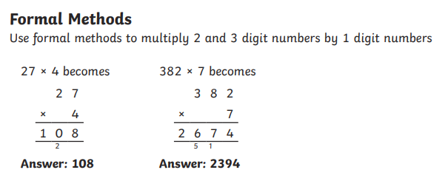
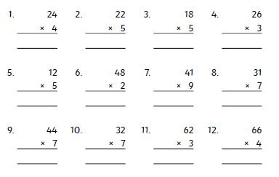

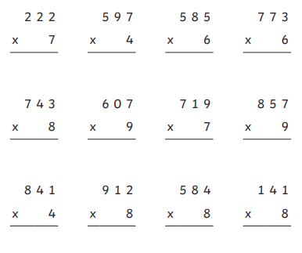

Science – Use the following website tohttps://www.bbc.co.uk/bitesize/subjects/z2pfb9q

to review this year topics taught already: Materials – solids, liquid and gases, sound and vibration, electricity and food chains/habitats.

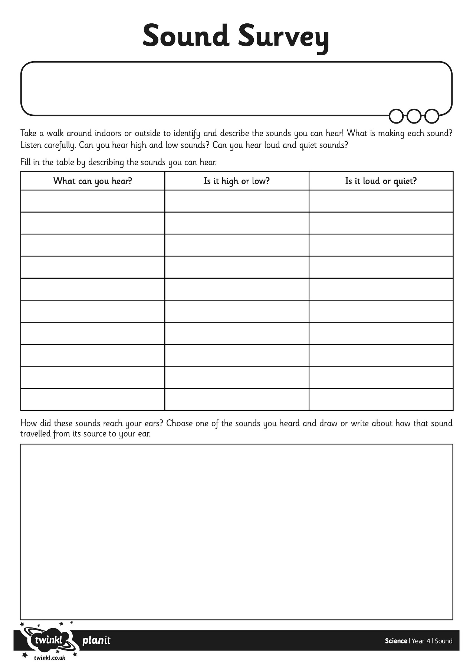

Geography
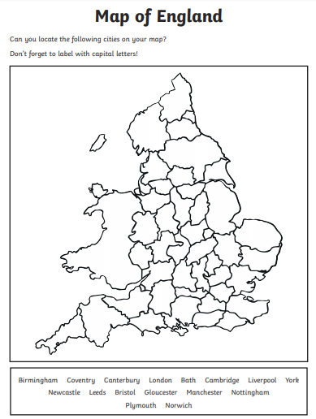

Extension
Can you find out which counties any of these cities are in?

Can you name any famous landmarks in these cities and write whether they are physical or man-made features?

