Tuesday 21st April 2020
SPaG
Spellings – To apply the prefix sub
subtotal | subtitle | substitute | subplot
subheading | subdivide | submerged | subtropical

Challenge! Roll a dice, whichever number you land on you need to complete the task with your spelling words.
Roll 1:  Bubble writing | Roll 2:  In the shape of a flower` | Roll 3:  Spell it backwards
Roll 4:  Spell it in a pyramid shape | Roll 5:  Spell it in an acrostic poem | Roll 6:  Rainbow words

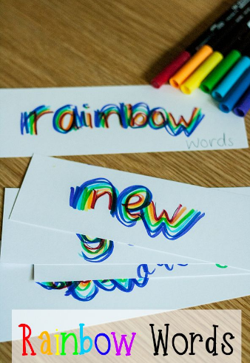
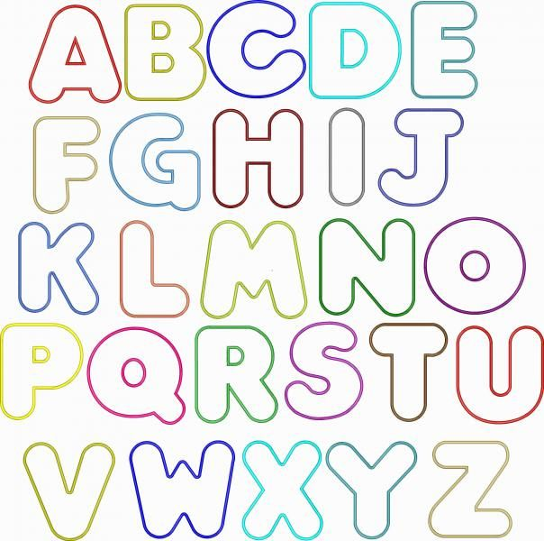

Make your own roll the dice rules and game!

English

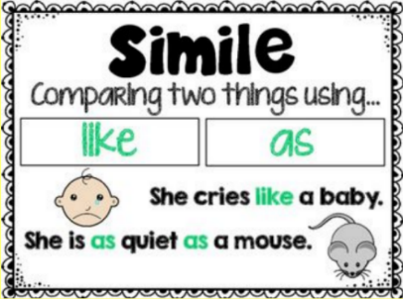
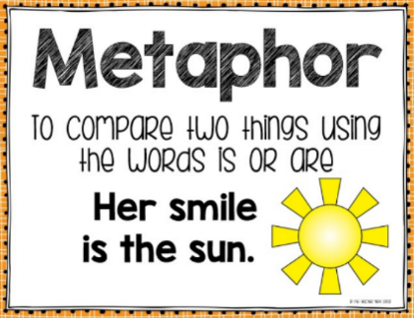
Similes and Metaphors

Finish the Metaphor or Simile!
Finish the start of these sentences to complete the simile or metaphor. Can you sort each sentence into two groups, a simile group and a metaphor group.

She ran like …
When she danced she was …
The man trudged down the road like …
The waves on the ocean were …
Jamie was in the water waving like …
On her way to her own birthday party, Maisie was as …
The rain was …
Challenge!
Change the Simile to a Metaphor
Put these similes into new sentences where they become metaphors.

She danced like she was floating on air.
The waves crashed on to the beach like charging horses.
George swam as gracefully as a dolphin.
Maths
Four Awesome Operations
Addition (using column method)  158 + 292 | Subtraction (using column method)  522 - 413 | Multiplication (using grid method)  72 x 4 | Division (using sharing of place value counters)  30 ÷ 4
Money
Add these money amounts:
Give your answer in pence
- 48p + 42p =
- 56p + 35p =
- 78p + 19p =
Give your answer in pounds: (In Year 3 we are not expected to add decimals so please convert these amounts to pence first BEFORE adding)
- £1.30 + £2.40 =
- £2.25 + £3.32 =
- £5.00 + £0.99 =
- £2.50 + £3.47 =
- £7.23 + £4.55 =
- £5.67 + £8.19 =
- £2.45 + £2.45 =
- £0.34 + £0.57 =
Muffin Problem
Dora bought these muffins.
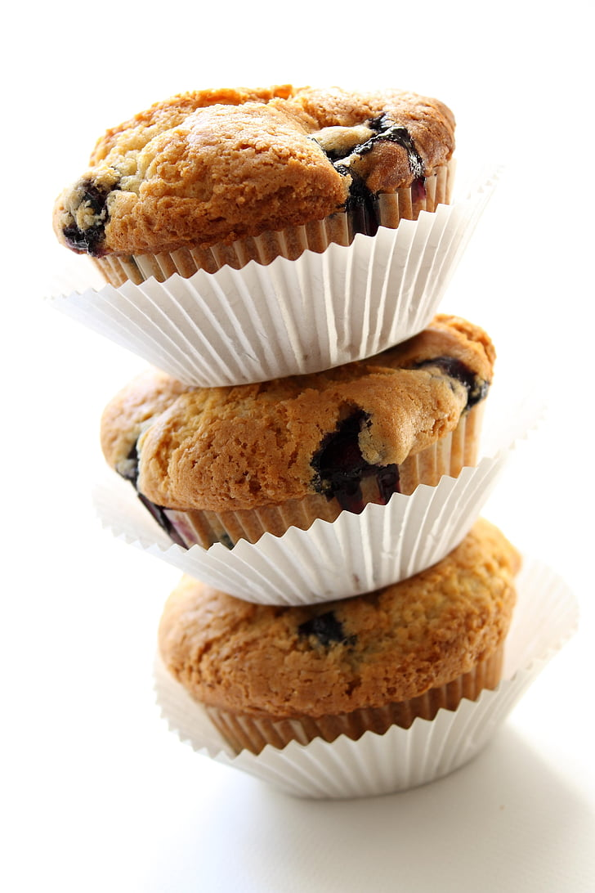
Muffins cost 35p each. How much did Dora spend?
Tommy bought three times as many muffins as Dora. How many muffins did Tommy buy?
How much money did Tommy spend on muffins?
How much more money did Tommy spend than Dora?

Science
This term in Science we will be learning all about forces!
What is a force? A force is a push or pull on an object. A force needs two objects where one pushes or pulls the other to make it move. We use forces all the time to move things and to make ourselves move.

Challenge! Look at these pictures and discuss these questions. Which pictures show push forces and which show pull forces? Which two things are touching in each picture to create movement?
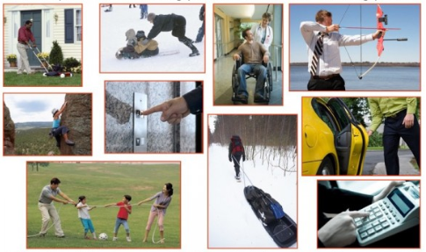

Over the next few days, see if you notice any push or pull forces happening in your home. For example, you might push the light switch to turn the light on or pull the towel off the radiator.

