Y1 Learning Log Activity Grid –The Powers of You and Me! –Autumn Term 2020
Choose your favourite learning style or subject. We suggest doing 4 Learning Log activities per term but feel free to choose to do more or less than this.
Activities have been chosen which will not repeat learning in class although there may be some overlap which will extend your child’s knowledge.
Writing | Number work | Art and Design /  Design and Technology | Science
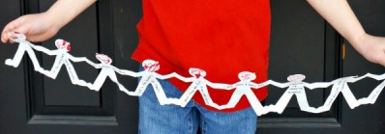  Make a Superhero chain. Write words to name them and  Describe them and their powers. | Using these numbers answer the following questions.  2 3 4 5 6  Use two cards to make a number: greater than 50; less than 30; that is odd; that is even; that is between 47-59; largest 2 digit number; smallest 2 digit number; | Make a model of a hide-out for a Superhero. | 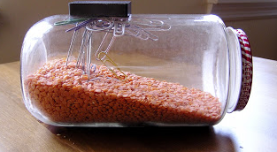  Make a magnet busy jar. Fill your jar with similar to above, add something magnetic. Then watch as they magically appear when you put your magnet on the top!
Draw or take photos of Superheroes. Write descriptive sentences to describe them. | Create a dot to dot of your Superhero. | What transport will your Superhero use? Make a model of it. Car, boat, plane etc.
Write a poem about a Superhero.  It can be any type of poem you want to, e.g. Acrostic, free verse. | Measure in non-standard units.  Measure one thing in your house using your hands.  Measure one thing using your foot.  Measure the length of a room using your whole body. | Draw, paint or collage any Superhero you create. It could be one already known, i.e. Superman. | 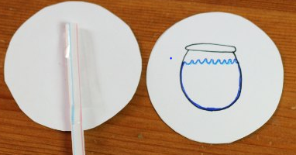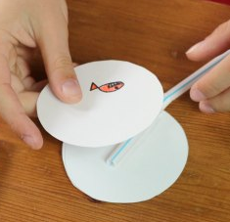  Make a Thaumatrope on a stick. Two circles that go together, stick on a straw or stick and spin the stick.
Make a word search using Superhero names, qualities and powers. | Use junk modelling materials to create a 3D model of something relating to our topic. | Make a game using superhero playing pieces. It can be based on a game you already know. ie. Snakes and ladders, twister or completely invented by you.

