Wednesday 24th June 2020
SPaG
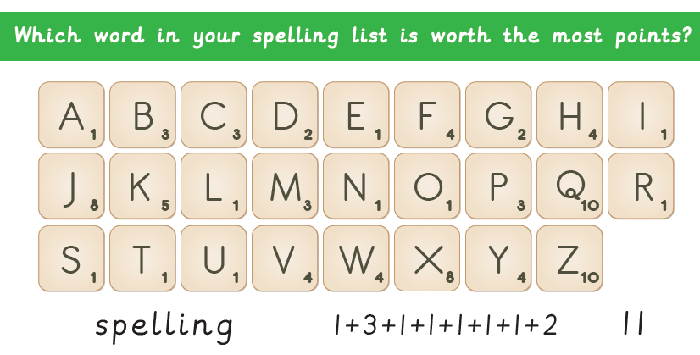
Words with the k sound spelt ch
echo
chorus
character
scheme
chemist
stomach
orchestra
technology

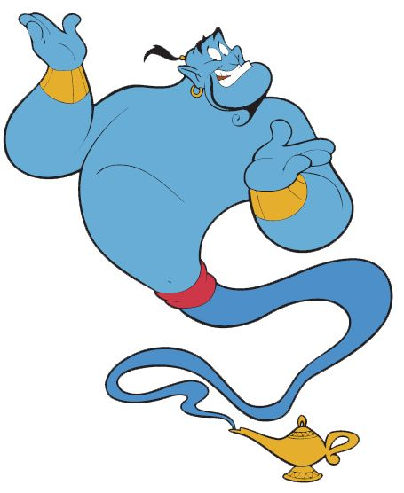
Word of the Day – blend

Definition ____________________________________________
_____________________________________________________
_____________________________________________________
Used it in a sentence: ____________________________________________________
_________________________________________________________________________
Word Class: ____________________________________________________
Synonyms

English
What nasty tricks have the Twits played on each other so far?

What is your opinion of the Twits' behaviour towards each other?

Do you think the Twits have always been like this towards each other? Why?
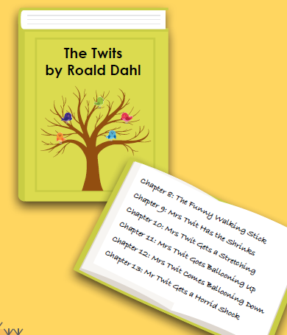

Now read the next six chapters

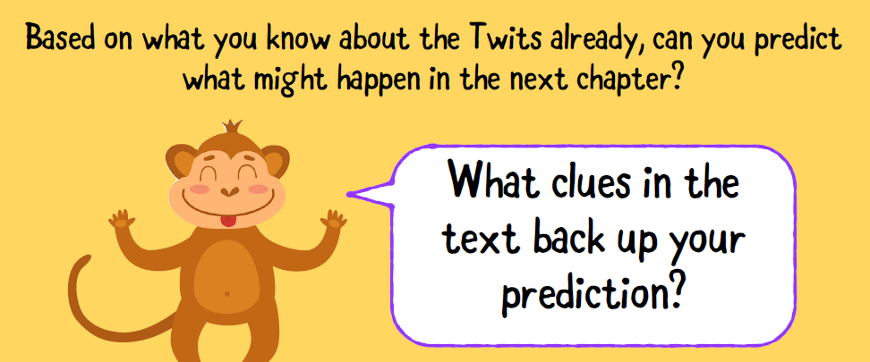
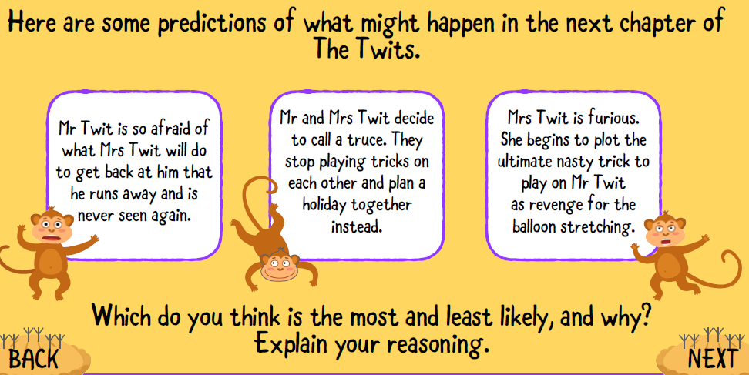
Task
Write a short summary of your prediction for what might happen in the next chapter of The 'Twits'.

Maths
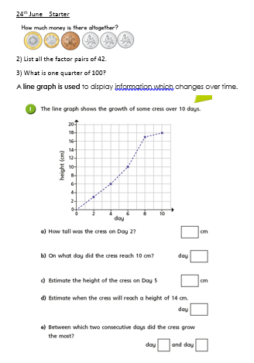

Music
Listen to a piece of music called ‘Ballet Egyptien’ which was composed by a man called Alexandre Luigini, who was a French opera composer. This piece became his best-known work and was composed in 1875. The piece was split into 8 different ‘chunks’ called movements.
Click here: https://www.youtube.com/watch?v=o1l3u7Gx3Mc&safe=active
Does it sound different to the traditional Egyptian music we listened to yesterday? Why?
What instruments can you hear?
Did you like it? Why/ Why not?
TASK: Listen one more time, this time try and create a story in your mind. Draw pictures to show your thoughts. What story do you think the music tells? Is it happy/scary/mischevious or something else? What makes you think that? Does it feel fast, excitable or rushed? Why? Which parts? Perhaps the different instruments represent different characters…
Below are some pictures to inspire you. I think the music is about 'tomb robbers' because I can hear a low pitch which must be cello/double bass. The low instruments make me think of the heavy feet of men with lots of tools. What do you think the metallic sounds and high-pitched instruments might represent?

