Friday 12th June 2020
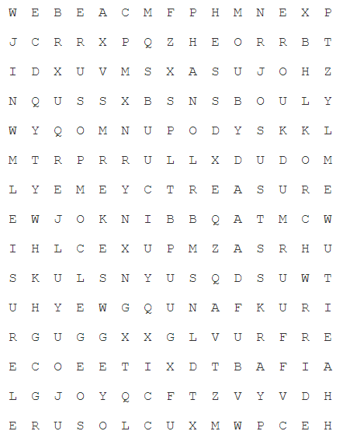
SPaG
Spellings – Words with a zhuh ending spelt sure
unsure
leisure
measure
closure
treasure
pleasure
composure
enclosure

Word of the Day – circular

Definition ____________________________________________
_____________________________________________________
_____________________________________________________
Used it in a sentence: ____________________________________________________
_________________________________________________________________________
Word Class: ____________________________________________________
Synonyms

English
Today you will be following a set of instructions in order to mummify a tomato using processes similar to how a body would be mummified in Ancient Egypt.

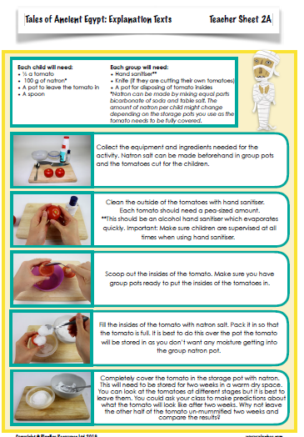

Maths
Starter
Remember find the difference tells us we must take away or subtract.
Ted has 95p. Joe has 50p, how much more money does Ted have than Joe. The words how much more tell us that we have to take away 50p from 95p. Ted has 45p more than Joe.
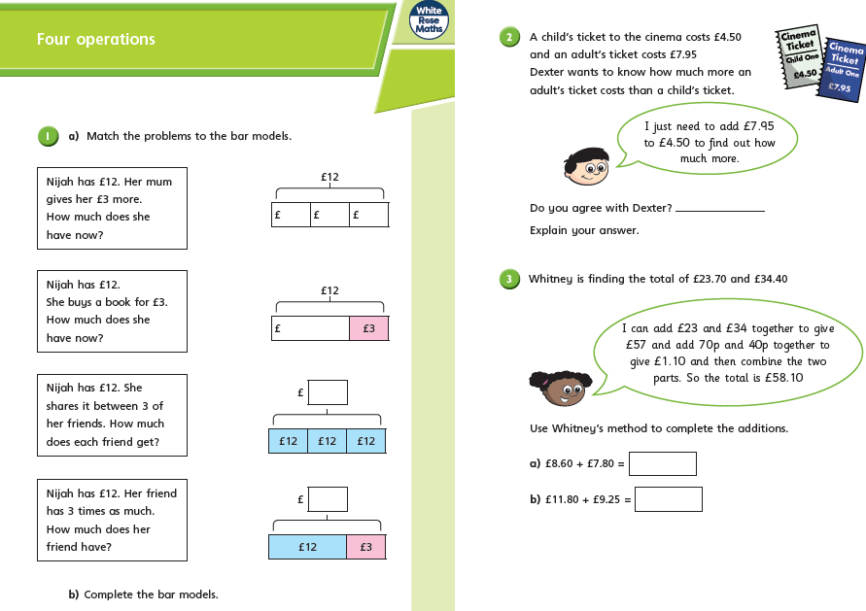

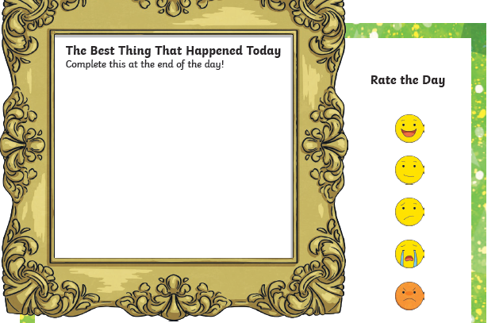
- PSHCE wellbeing journal

